Proposed disposal and change of use of Common Good land at Dornoch Links

What is proposed?
This consultation relates to the proposal to grant a new lease to Royal Dornoch Golf Club upon the surrender of the existing lease. The original lease was granted in 1973 (recorded 3 April 1974) for a period of 99 years at a fixed peppercorn rent of £150 per year. Since the granting of the original lease, there have been additional areas leased as well as areas of land surrendered and as a result the total area does not accord to the plan appended to the original lease.

The total area of Common Good land to be included in the new lease proposed is 85.629 hectares with a lease term of 99 years.

Royal Dornoch Golf Club wish to undertake the construction of a new clubhouse that will provide larger and more up to date facilities for members and course visitors alike. As a result, it is considered sensible to review the lease as a whole and rationalise the complete land footprint within one lease. Part of that review process has included the negotiation of a fair market rent of £25,000 per annum together with a provision for regular 5 yearly rent reviews linked to Consumer Price Index including owner occupier housing costs (CPIH).

Proposed area to be leased to Royal Dornoch Golf Club
Image 1
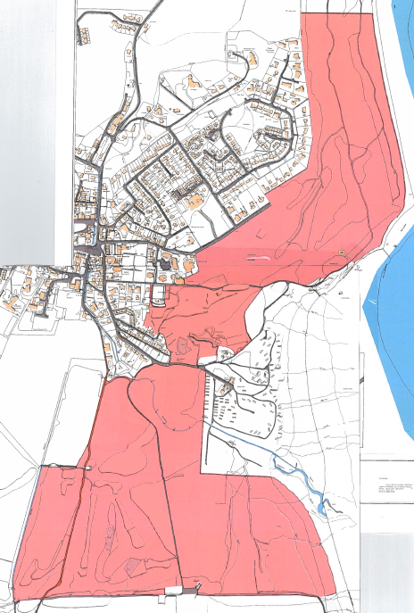
This image shows the full area now proposed to be leased to Royal Dornoch Golf Club

Image 2 and Image 3 – these show the close up of the change proposed to the access road, Bowling Club and tennis court (image 2) and the area incorporating the 2014 lease for the Green Keepers buildings (image 3).

Image 2 Image 3
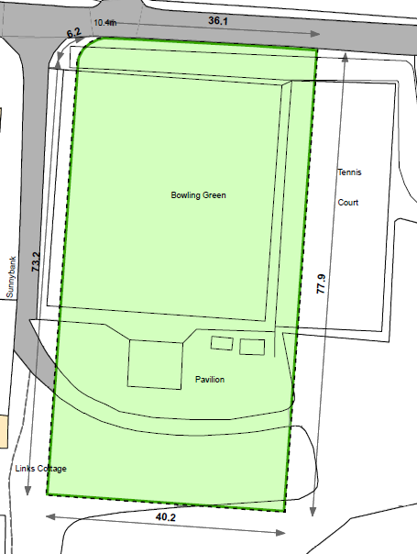
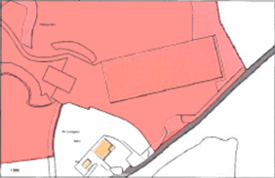

Image 2
Royal Dornoch Golf Club wish to construct a new clubhouse which, due to its suggested location (image 4), would require wider access. In addition, the golf club would wish to layout additional and improved parking facilities. It is proposed that the Bowling Green will be moved 4 metres to the east into part of the existing tennis court. The remainder of the tennis court will form part of the new lease to Royal Dornoch Golf Club and be incorporated into their parking area. The area of land surrendered by the Bowling Club be added to the width of the existing access road and also be included in the proposed new lease to the golf club.

Royal Dornoch Golf Club will be covering the costs of the changed layout to the land in the area highlighted in image 2 and have also agreed to fund the construction of a new/replacement tennis court/multi-games area at Dornoch Academy campus.

Image 3
The area highlighted in image 3 relates to the parcel of land leased to the Golf Club in 2014 for the location and construction of the Green Keepers buildings. As it is proposed that there should be a new lease, it would seem sensible for the 2014 lease to be surrendered and this area to be included in any new full lease.

Image 4
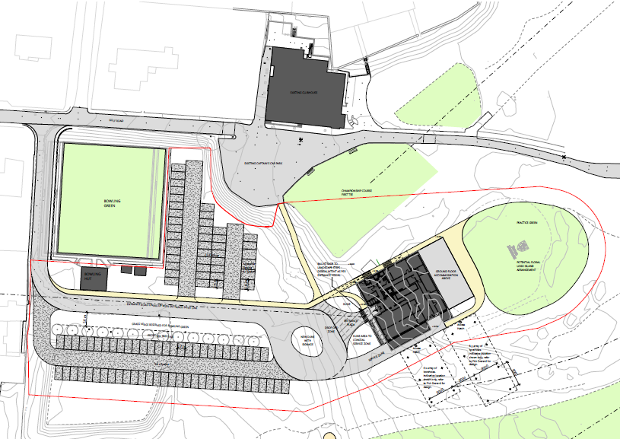

Image 4 shows the planned location for the new clubhouse (lower right quadrant of the image) and also shows the proposed improved access and parking facilities.

It is proposed that the period of lease should be for 99 years and, as it will also involve a change of location for the construction of the new clubhouse to land otherwise used for playing golf, it will constitute both a disposal and a change of use.

Consultation
Section 104 of the Community Empowerment (Scotland) Act 2015 requires the Council to consult local communities when considering disposing or changing the use of Common Good assets. This includes where the proposal is to grant a lease of over 10 years. Therefore, before taking any decision, and to inform the decision making process, we are keen to hear the views of the community, in particular:
- What are your views on the proposed disposal by lease of this piece of Common Good land?
- Do you have any views on potential benefits of the proposal?
- Do you have any issues or concerns arising from the proposal?
- Do you have any additional comments?

The Council will take all representations into account in reaching a decision.

Depending on the representations received the possible outcomes are:
- The proposal goes ahead subject to consent being given by the Sheriff Court
- The proposal is amended significantly, and a fresh consultation takes place
- The proposal does not go ahead

Representations
Consultation closing date – 10 March 2020

Please submit written representations to:-
Email: commongood@highland.gov.uk
Post: Sara Murdoch, Highland Council, Headquarters, Glenurquhart Road, Inverness, IV3 5NX.

Additional information
There are specific regulations governing the management of Common Good. This is to ensure protection for assets held. One such area is where property is considered ‘inalienable’. This means that there is a restriction regarding the property, its purpose is clearly stated in the deed or gift to the Common Good Fund (often specifically dedicated for public use) or it has to be used in a certain beneficial way for a lengthy period of time (time immemorial). Land that derives its Common Good title from the original Burgh Royal Charter is invariably considered to be inalienable.

The piece of land that is the subject of this proposal derives its title from the original Burgh Royal Charter dated 14 July 1628 and is considered by the Council to be inalienable. It will be necessary to seek the consent of the Sheriff Court to any proposed disposal. Any application to the Court will include information about this consultation and the responses received. It will also have an impact on any likely timescales involved with leasing the property should a decision be made to proceed with the proposal.

