CONSULTATION on:-
proposal to sell (for development) common good property known as Sandown Lands at Sandown Road, Nairn
What is proposed?
A sale of 38 hectares of Common Good property lying either side of the A96 at the western boundary of Nairn. The extent of property included in the proposal is shown in the plans and images below and is described in the Highland Council Common Good Asset Register for Nairn as follows:

Inverness Road, IV12 5NT.
UPRN: 130111934.
The lands run either side of the A96.
On the left/north side (heading towards Nairn) the lands are bordered by road to Ruthven, A96, Sandown Farm Lane & properties to the rear of Tradespark Road.
On the right/south side the lands are bordered by A96, Sandown Road, Rear of properties on Wyvis Road & Moss-side Road.

The allotment gardens together with a parcel of land for extension of the gardens will be excluded from the proposal.

The current value of the land is estimated to be around £6m - £7m (value at October 2020). This figure has been estimated after taking into account possible variables including the potential for increased developer contributions.

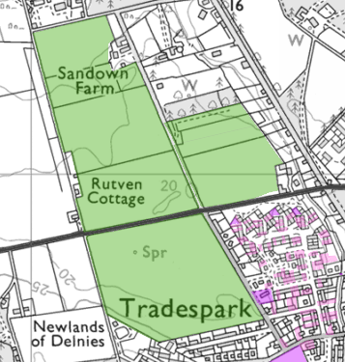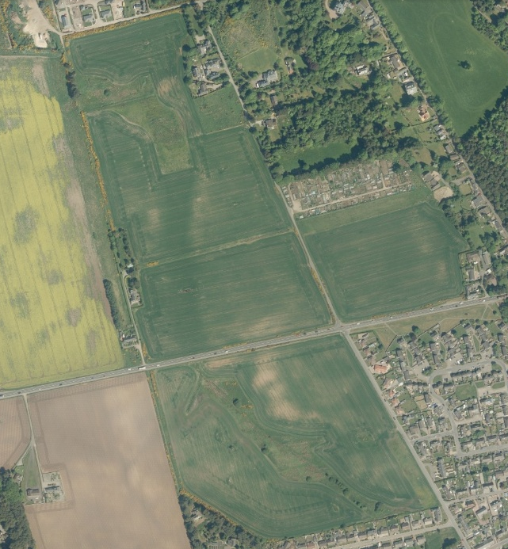

Background to the proposal
In 2013 the Council adopted the Sandown Development Brief which represented the results of an intensive Charette conducted from 30 January 2012 to 2 February 2012. The Charette was open to all and attended by members of the Community and other interested parties. The Brief incorporated the areas of consensus but also reflected those areas where agreement had not been reached during the Charette.

The brief covered site layout, building design, open area planning, housing density, affordable housing, employment-generating uses, phasing, flood risk, access provisions, infrastructure and delivery of development. In doing so, it considered the nature and type of land and the appropriate use of the area. A zoning plan was developed – see below:

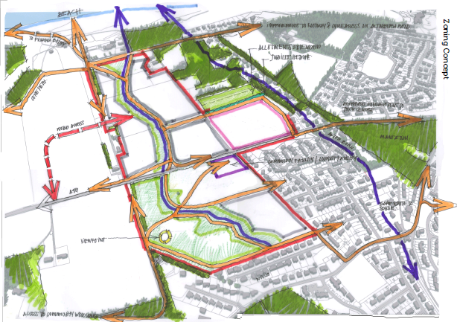

The Brief suggested the proposed uses for the zoned areas as being:
- Grey areas represented housing (and live/work unit) compartments
- Pink and white areas represented undecided future use
- Purple area potentially to include a mixture of wetlands interpretative centre, café, small retail spaces, restaurant, licensed premises, community meeting space, small business spaces, tertiary education, children’s play space
- Green area to comprise wetlands, public open space and extended allotment provision.

This proposal seeks to sell the property for purposes identified in the Sandown Development Brief.

Timing of the consultation
The Council has not received any offer for the land, nor has it put the site on the market. However, the Council considers it is appropriate to undertake the consultation at this stage for the following reasons:
- Investment in and development of Nairn and Nairn Common Good assets.
The Council is the custodian of the Common Good funds and, as such, has duties and responsibilities regarding its ongoing management and maintenance. In managing the Common Good Fund, the Council has the responsibility for ensuring best value for the fund and its assets. Strategic planning is also important to protect and maintain the fund for future generations. Currently, the land contained in this proposal returns a nominal rent. The most recent valuation of the land indicates this is estimated to be worth £6m-£7m. By realising the asset, it would provide significant funds for fresh investment in the town as well as providing for the potential development of existing Common Good assets.

- There is an identified need for more housing in Nairn, both private and affordable. The Council analysis of housing need across the Highlands for 2019/20 indicates that the greatest pressure on social housing is in Nairn. This proposal would ensure that additional social and affordable housing would be available to address some of that need for people of the Nairn community. The provision of more private accommodation would be of benefit to residents of the town wishing to move and also encourage people to relocate to Nairn which would benefit the economy of the town.

- Volatility of the market and property values. Whilst land values have been static over recent years, it is impossible to predict what will happen in the future and what the ongoing effect of Covid-19 will be. By commencing the consultation at this stage, and should support for the proposal be achieved, this would allow the Council to move quickly to secure the best possible value for the benefit of Nairn Common Good and the residents of the former Burgh.

- Ongoing implications of Covid-19. The impacts of Covid-19 are expected to be ongoing for some time and strategic planning is needed to assist Nairn in recovery and rejuvenation. The Common Good Fund would wish to be in the best possible position to help with this process and by realising this asset, resources would be provided to support and lead recovery for the town.

Process
Section 104 of the Community Empowerment (Scotland) Act 2015 requires the Council to consult local communities when considering disposing or changing the use of Common Good assets. Therefore, the consultation is seeking views on the proposal in order to inform the decision making process.

The consultation relates to the proposed disposal of the land. It is not a consultation on the merits of any detailed layout or housing/other property design. These matters will be addressed through the formal planning process.

Consultation
We are keen to hear the views of the community on the proposal to sell Sandown lands for development as outlined above in the Sandown development brief previously agreed.

Key questions:
- What are your views on the proposed disposal of this piece of Common Good land?
- Do you have any views on potential benefits of the proposal?
- Do you have any issues or concerns arising from the proposal?
- Do you have any additional comments?

The Council will take all representations into account in reaching a decision.

Depending on the representations received the possible outcomes are:
- The proposal goes ahead subject to consent by the Sheriff Court.
- The proposal is amended significantly, and a fresh consultation takes place.
- The proposal does not go ahead.

Representations
Consultation closing date – 12 February 2021

Please submit written representations to:-
Email: commongood@highland.gov.uk
Post: Sara Murdoch, Highland Council, Headquarters, Glenurquhart Road, Inverness, IV3 5NX.

Additional information

The Highland Council have a statutory obligation to seek court consent before disposing of Common Good land which may be ‘inalienable’.

In this context ‘inalienable’ refers to Common Good property that falls into at least one of the following categories: -

- The Title Deed of the property dedicates it to a public purpose, or
- The Council has dedicated it to a public purpose, or
- The property has been used for public purposes for many years (time immemorial) without interference by the Council

In this case the title for the property derived from the Royal Charter of James VI dated 16 October 1589. It is considered that this property may be inalienable and therefore, the proposed sale cannot be concluded until Sheriff Court consent has been obtained. If after this consultation, the proposal progresses to a court application the public will have a further opportunity to make representations. A statutory advertisement will be placed in the Nairnshire Telegraph to inform the local public that the court process has been commenced.

