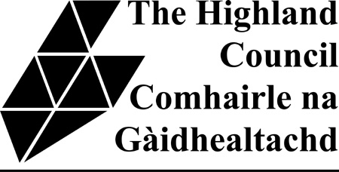

CIVIC GOVERNMENT (SCOTLAND) ACT 1982

CERTIFICATE OF COMPLIANCE

I, ..............................................................., being the applicant for a.............................................. licence, hereby certify that a Notice has been posted at or near the premises at ....................................………………………………………………………………………………….. from .................................. to ................................. , containing such information as is required by paragraph 2(3) of Schedule 1 to the above Act.

* Where the said Notice was removed, obscured or defaced during the above mentioned period, I took reasonable steps for its protection and replacement as follows:
(give details and circumstances)

Date ........................... Signature .....................................................

* Delete if not applicable.

Please return this form duly completed (when the required Public Notice has been displayed for the specified 21 days) to the area office for where the premises are situated. Please see addresses below or scan and e-mail it to licensing@highland.gov.uk

Caithness, Sutherland and Easter Ross - The Highland Council, Council Offices, Caithness House, Market Place, Wick, Caithness, KW1 4AB.

Ross area - The Highland Council, High Street, Dingwall, IV15 9QN

Skye area - The Highland Council, Tigh Na Sgire, Park Lane, Portree, IV51 9GP

Lochaber area - The Highland Council, Charles Kennedy Building, Achintore Road, Fort William, PH33 6RQ

Inverness, Nairn and Badenoch and Strathspey area - The Highland Council, Town House, Inverness, IV1 1JJ.

