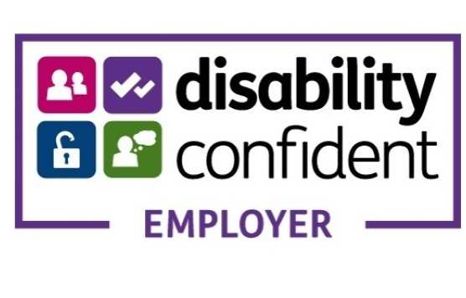

As a Disability Confident Employer we aim to remove barriers to recruitment that disabled people and those with long-term health conditions may face and aim to ensure that individuals can fulfil their potential. We have a commitment to employ and retain disabled people and those with long-term health conditions and will guarantee an interview where the essential criteria for the vacancy is met.
For more information, please visit the links below:
https://www.gov.uk/government/collections/disability-confident-campaign
https://disabilityconfident.campaign.gov.uk/

