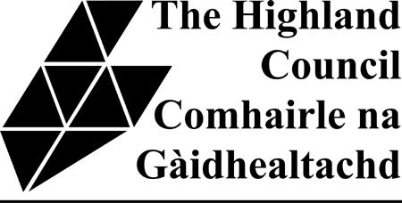

FOR HOUSING ASSOCIATION TENANTS ONLY

If you are entitled to housing benefit, we can pay it to you personally or we can pay it straight to your landlord. You must tick one of the boxes below to say which method you prefer.

Payment direct to your landlord
Payment direct to you

(give your bank details on page 18)

If your landlord is a housing association and you have opted to have your housing benefit paid direct to them you do not have to ask them to sign the Direct Payments to Landlords – Their Responsibilities section at the bottom of page 17 of the application form.

Please return this form with your completed Application for Housing Benefit, Council Tax Benefit and Second Adult Rebate.

