

**-INCLUDE-**

**Equality, Diversity and Inclusion Guidance and Self-Evaluation for Educational Settings**



|  |  |  |
| --- | --- | --- |
| **Section** | **Title** | **Page** |
| **-** | **Foreword** | **3** |
| **-** | **About the Nairn Academy Equality Group** | **4** |
| **1** | **Ins and Outs** | **6** |
| **2** | **Need** | **8** |
| **3** | **Consider** | **10** |
| **4** | **Longevity** | **15** |
| **5** | **Us** | **17** |
| **6** | **Direction** | **19** |
| **7** | **Evaluate** | **23** |
| **-** | **Display Posters** | **35** |
| **-** | **Glossary** | **37** |

**Contents**

**Foreword**

The Northern Alliance Equality Workstream includes representation from each Northern Alliance local authority. Members of the group have a responsibility to promote equality, diversity and inclusion and to ensure a rights approach is taken across all of the work of the group. The group can support equalities training for local authority staff and contributes to the development and provision of policy and advice in relation to approaches to embedding children’s rights. Over the past few years the group has worked very closely with the Equality Forum from Nairn Academy, in Highland, where pupils have been surveying peers and staff across the Northern Alliance, to gather local evidence of knowledge, skill and experience, to help frame guidance on equality and diversity. The pupils themselves have written this guidance and it draws directly from the experiences of pupils and staff across the Northern Alliance. They have used the acronym INCLUDE as a title, which indicates the contents of the 7 sections, each of which highlights a particular aspect that should be focused upon when considering where you are in your journey to embed equality, accept and celebrate diversity and promote inclusive practice and children’s rights and participation in your setting.

Equality, Diversity and Inclusion is about fairness, acceptance, rights, partnerships and the development of a sense of belonging. It should support children and young people to achieve their full potential within their educational setting. **Equality** is about removing barriers and **diversity** is about supporting and reflecting different beliefs and cultures, enabling all voices to be heard. **Inclusion** is about creating opportunities for people to experience, engage with and participate in education, appropriate to their needs and abilities, either in an early learning and childcare setting or within the context of a school or other educational setting.

Experience shows that children and young people in educational settings that embrace equality, diversity and inclusion are more successful, as they are valued and recognised for the richness of the diversity they bring. They have their individual needs identified and met appropriately and have opportunities to have their views listened to while working in partnership with the adults around them.

The Equality Act (2010) provides a comprehensive legal framework to protect the rights of individuals and to advance equality of opportunity for all. As a public body, local authorities have a responsibility as part of the general duty under the Equality Act (2010), to promote a fair and more equal society and show ‘due regard’ to:

* eliminate unlawful discrimination, harassment and victimisation,
* advance equality of opportunity between people who share a protected characteristic and others,
* foster good relations between people who share a protected characteristic and those who do not.

I would like to thank the Nairn Academy Equality Forum for their work in creating this guidance, which has been completed in difficult circumstances over the school session 2020-21. Once again, our children and young people have shown that they are clear about what is required - we only have to ask the questions and listen to the answers they give. I believe that this guidance provides a really helpful framework for individual settings to consider whether their commitment to Equality, Diversity and Inclusion is evident across the school or early learning and childcare setting. It is focused on educational settings but would have equal value in community settings, youth groups etc, so feel free to use the reflective questions creatively. Using the framework as a self-evaluation tool and engaging in partnership with the children and young people in your setting will provide sources of celebration and also support the creation of an Equality Diversity and Inclusion Action Plan, for those aspects requiring further development.

Bernadette Cairns, Principal Educational Psychologist, Highland Council

Chair of the NA Equality and Diversity Workstream

**About the Nairn Academy Equality Forum**

Our Equality Forum was created in 2017 and has been flourishing ever since. We joined in the hope of making our school a safer, more inclusive place where everyone will feel comfortable, respected and heard. Over the past few years, we have enjoyed fuelling our passion for helping others and standing up for what we believe through our Equality Forum, where we have seen a change that we are exceptionally proud of. Through joining, all of us have learnt a lot and have been given many amazing opportunities to both develop our own knowledge and understanding of equality, and to share the work we have done with others. The chance to write this guidance and to make a difference, not just in our own school but all across the Northern Alliance is one that we all feel privileged to have received. We feel honoured to be a part of creating something that will make educational settings and learning environments happier places to be in for both staff and students.

Since starting in early 2019, we have been working on INCLUDE to make sure it is detailed and accessible as a tool for all to engage with. We would like to thank all of the staff and pupils both in Nairn Academy and within the wider Northern Alliance for their support and help with developing this guidance.

As senior members of the Equality Forum, we hope that you find this guidance helpful and that it will have a lasting impact. Equality is something that we constantly need to be striving towards and we can only hope that after reading INCLUDE, that is the message that you will take away from it.

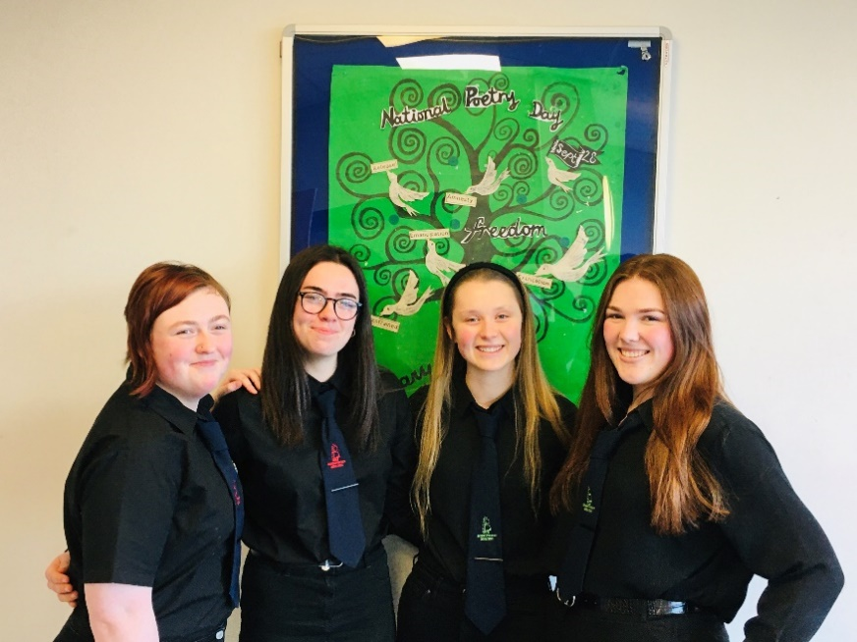

*Coming together is a beginning.*

*Keeping together is progress*

*But working together*

*Is a success.*

*We are only as strong*

*As we are united;*

*Weak as we are*

*Divided.*

*Anything is possible*

*When we all work together.*

*Life gets better together.*

*Together we will succeed.*

*by Jo Fitzpatrick Nairn Academy (they/them)*

Section 1 **INs AND OUTs**

INCLUDE strives towards creating an equal, safe environment for all those in an early learning or education setting. We recognise and celebrate differences within a culture of respect and fairness and aim to meet the needs of every child regardless of their protected characteristics; age, disability, gender reassignment, pregnancy and maternity, race, religion or belief, marriage or civil partnership, sex or sexual orientation. Every child has the right to be supported by their caregivers, staff members and communities to grow, learn, and develop throughout their lives and educational experiences.

An inclusive early learning or education setting values diversity and recognises the unique contributions that each individual brings. This involves enabling all young people to become; Successful Learners, Confident Individuals, Effective Contributors and Responsible Citizens, in accordance with the Curriculum for Excellence, whilst taking into consideration **HGIOS 4- 3.1 Ensuring wellbeing, equality and inclusion.**

**INCLUDE aims to ensure all members of our early learning and education settings feel included through:**

* Promoting positive attitudes and behaviours towards equality and diversity in all settings.
* Widening understanding of equality and diversity through the curriculum and ethos.
* Assisting early learning and childcare settings in fulfilling their obligations in encouraging diversity and equality at an early stage.
* Providing settings with resources which will assist them in their efforts in supporting pupils.

This guidance is based on the current legislative framework that professionals, leaders and senior managers should be fully aware of. These legal requirements support our moral drive towards promoting and ensuring equality and inclusive practices.

**Current Equality related legislation**

Equality Act (2010)

<http://www.legislation.gov.uk/ukpga/2010/15/contents>

This Act brings together pre-existing legislation and covers the discrimination law for Britain which safeguards rights.

UN Convention on the Rights of the Child (1989)

<https://www.unicef.org.uk/what-we-do/un-convention-child-rights/>

Lays out the rights that every child is entitled to and the Government’s responsibility in protecting these rights.

UNCRC (Incorporation) (Scotland) Bill (2020)

<https://beta.parliament.scot/bills-and-laws/bills/united-nations-convention-on-the-rights-of-the-child-incorporation-scotland-bill>

The main purpose of the Bill is to “incorporate” the UNCRC, which means it will make it part of Scottish law. This Bill was passed unanimously on 16th March 2021 and will now be incorporated into Scots law.

Children and young people Scotland Act (2014) <https://www.gov.scot/publications/children-young-people-scotland-act-2014-national-guidance-part-12/pages/3/>

This is the major framework for child welfare and protection in Scotland and provides the basis for the National Practice Model (GIRFEC).

Human Rights Act (1998)

<https://www.equalityhumanrights.com/en/human-rights/human-rights-act>

This Act lists what rights we all are entitled to in the UK e.g. freedom from torture, right to an education and freedom of expression, religion and beliefs.

At the end of each section of **INCLUDE** there are reflective questions. They provide an opportunity to consider your setting’s equality journey. Additionally, there is an **EVALUATE** section to allow for thorough reflection and aspiration.

**Reflective Questions**

* Does your early learning and childcare setting or school ensure that all children, students, staff and partners are aware of the legislation and duties with regards to equality and children’s rights that are in place to protect them? How do you know and how can you further promote this knowledge?
* Does your setting apply the laws that are in place and ensure respect for all young people and staff?
* Does your setting have measures in place to support all of the protected characteristics outlined in the Equality Act:
  + age
  + disability
  + gender reassignment
  + pregnancy and maternity
  + race
  + religion or belief
  + sex
  + sexual orientation
  + Marriage and Civil Partnership

Section 2 **NEED**

Below are statistics that show the wider picture of Equality related issues across the UK. These high figures show why there is a need for guidance such as INCLUDE, and we hope that information and advice given in this document will help to ensure that these statistics are not sustained into the future:

* Data from Stonewall[1] shows that in 2017, 45% of LGBT pupils were bullied in British Schools due to their sexuality or gender identity.
* Between 2017-2018, 496 temporary exclusions for racism were made in Primary Schools[2].
* In 2019, Disabled people were 50% less likely to hold any formal qualification compared with non-disabled people[3].
* In 2018, Over three quarters of female secondary school pupils said that they had been on the receiving end of sexist comments from their peers[4].
* In 2014, A UK-wide survey[5] of Muslim experiences by the Islamic Human Rights Commission found 35.8% of respondents had experienced Islamophobia in an educational or school setting.
* Jewish charity the Community Security Trust[6] says the number of antisemitic hate incidents recorded in the UK has reached a record high. It recorded 1,805 antisemitic incidents in 2019, an [increase of 7% on the findings in 2018.](https://www.bbc.co.uk/news/uk-47147568)
* The Intercultural Youth Scotland Insight report (<https://interculturalyouthscotland.org/in-sight-report>) notes that over 50% of respondents disagreed with the statement “Teachers at my school were knowledgeable about the processes they were required to follow if a racist incident happened at school.”

In order to gauge how Equality related issues are dealt with in settings within the Northern Alliance we surveyed both staff and students in late 2020. For young people, the focus was on whether they felt that they had ever been treated unfairly with regards to their Protected Characteristics; how it made them feel and whether or not they knew where to access support. The survey found that:

* 34% of pupils felt they may have been treated differently because of their age, disability, gender, race, religion or gender reassignment.
* Only 22% of pupils felt they got help or support when they had been treated unfairly.
* 1 in 5 pupils either didn’t know or were unsure of where to get support if they were treated unfairly.
* 71% of pupils who responded said that their school did not have a group focusing on Equality or were unsure if there was one in their school.
* When we asked pupils how being treated unfairly affected them, a common theme was that they had missed school and that it affected their performance in classes. Many also answered that it affected their mood, making them feel sad or angry with many not wanting to socialise as a result.

For staff, we asked how often they had witnessed discrimination between pupils; how comfortable they would feel with addressing it; whether they themselves had faced discrimination; and what support they were aware of for both pupils and themselves. In our survey of staff, we found that:

* 48% of staff were not confident in their own knowledge of the Equality Act.
* A fifth of staff felt they had experienced discrimination in school.
* 12% of staff would be unsure where to go for support if a pupil reached out and said they had experienced discrimination.
* 17% of staff would be unsure of where to go for support if they experienced discrimination themselves.

50% of staff wished for work embedded into the curriculum on equality themes whilst 31% would like a clearer policy. 64% of respondents would like further training.

These statistics show that we still have a long way to go to promote equality and diversity and thus demonstrates the need for INCLUDE as guidance to support staff in engaging in a regular self-evaluation process.

**Reflective Questions**

* Do you regularly survey staff and pupils within your setting to gather information with regards to Equality and track your progress?
* Are survey statistics published to staff, young people and partners to the school?
* What do the statistics tell you about your settings?
* If necessary, are you actively promoting steps and resources to improve these statistics?
* Are you celebrating and sharing good practice within your setting, across your council or authority?

Section 3 **CONSIDER**

The following section offers ideas on how equality can be embedded into all areas of life within a school or an early learning and childcare setting. It’s important that change is measurable, meaningful, immediate and has long term impact. There is a need for appropriate and inclusive educational experiences for all children and young people with diverse examples of those with Protected Characteristics woven through the curriculum.

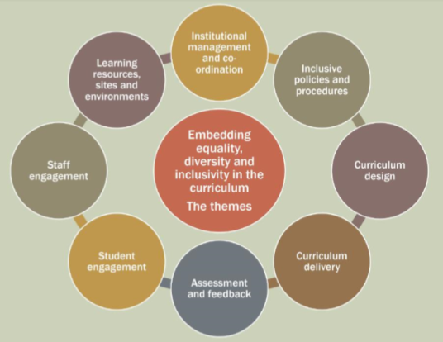

For further ideas and information on how this can be achieved, visit the ‘Education Scotland - Embedding Equality in Resources’ link in the **Direction** section of this policy.

**Curriculum**

We believe that it is important that teaching materials where possible use images and contexts that all learners will be able to relate to. Subject areas should also try and promote equality within their curriculum and ensure consistency, breadth and depth of teaching. For example, when reflecting on teaching on race in your setting is Anti-Racism covered as well as Black History? Think about what elements of history are covered is it only the Slave Trade or is there an opportunity to consider the root causes of racism whilst also including empowering examples of positive roles of Black people and people of colour. Is this embedded in learning across subjects and year groups or ad hoc?

Stereotypes are established early in the life of a child, so at all levels, review your curricular resources, equipment and activities to ensure there is no bias built in that would reinforce stereotypes eg pink folders for girls and blue for boys; the appointment of head boy and head girl, the use of older reading schemes that may use outdated terms such as ‘Eskimo’ or ‘Red Indian’ etc.

There are many ways for equality to be advanced across the curriculum and in all subject areas. There are however some key principles as identified below:

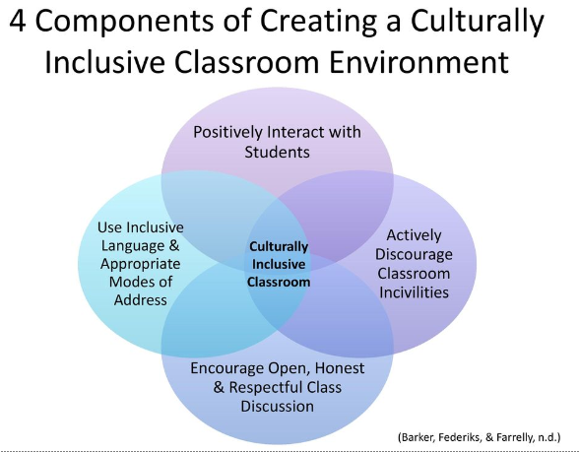

However, promoting equality during lessons goes beyond the activities and content of a lesson, it also should be implicit in general classroom practice. A whole school approach is essential as we need to be mindful that young people particularly in secondary school may choose different pathways and qualifications so will have different experiences.

**Language**

Within an educational setting, staff must encourage the use of supportive language to help pupils feel as welcome and supported as possible. This includes the use of pupil’s preferred pronouns and encouraging the use of gender neutral language; using vocabulary that is accessible to all and giving definitions when necessary. Keeping in mind that all pupils will be coming from a different background and have different cultural or religious beliefs. Not everyone will celebrate holidays such as Christmas and it won’t be appropriate for everyone to make Mother’s Day or Father’s Day cards or similar. In addition, ensure that images and language are appropriate and sensitive when dealing with matters like Black History Month and the Holocaust as this could otherwise engender a trauma response for young people, especially if these are issues identified within their families. This responsibility also falls upon pupils who should try as much as they can to support one another and use appropriate language.

In our survey, we asked pupils how they felt when language used in their educational setting did not include them. They said:

* “It makes me feel like I’m not a part of the class”
* “I feel sorry for the people who aren’t included through language and the people who feel overlooked and ignored.”
* “It makes me feel helpless when others are ignored or singled out through language.”

We also asked pupils what difference it would make if more of an effort was made to use inclusive language. They said:

* “It would make me feel better and happier about going to school and I wouldn’t worry as much.”
* “I would feel I was more supported in the school environment and be more confident in myself.”
* “Students will be more willing to contribute in class knowing they’re in a safe environment.”

**Policies/ Letters**

In order to make sure that all letters and policies are inclusive, we suggest the following ideas:

* Use the singular “they/them” pronoun instead or as well as “he/she” to include all pupils who may not identify as male or female. Likewise, consider using “child” or “young person” as opposed to “son/daughter”.
* Make sure letters are addressed to ‘parents or carers’ to acknowledge all family situations.
* Consider printing letters and policies on multiple colours of paper to make them accessible to all.
* Ensure that language used within all documents is accessible for all.
* Consider translation where English is an additional language and potential impairment.

**Activity**

Within your setting, it is crucial that activities are inclusive:

* **Social Dance:** settings must encourage diversity and choice when it comes to social dancing by allowing students to pick who they dance with regardless of gender, race, sexuality or any other Protected Characteristic.
* **Clubs:** extra-curricular activities offered in settings should not discriminate based upon one of the Protected Characteristics, for example, instead of a girls football team, open out the football team to all who wish to participate to encourage inclusion and diversity.
* **Events:** when settings are coordinating events, they must take into account how accessible the events are for all pupils and staff with regards to the Protected Characteristics for example, support for students with physical disabilities on sponsored walks etc. Ask ‘how can this be made accessible to all? Rather than ’What will we provide for those who can’t attend?’

**Areas**

It is very important that you have areas in which everyone feels safe and included, it is crucial to consider a day in the life of your children/young people:

* **Toilets:** Toilets should have accessible facilities for everyone. Gender neutral toilets are a great way to make everyone feel included and can reduce bullying and segregation. There must be at least one toilet in your school which has no specific gender and is in a location that is easy to get to for both pupils and staff. Remember, accessible toilets will also need to be available for parents and family members who may have needs when they attend meetings or events in the school/setting.
* **Changing Rooms:** When changing for PE or any other activity, it is important to make sure that all young people feel comfortable. Try and provide different areas for pupils such as a gender neutral space and a changing area with additional space for children and young people who have physical disabilities or if you can’t, give people who do not wish to change in front of others time before or after everyone else goes in to get changed.
* **Classroom**: In the classroom, make sure that young people are not singled out because of one of the protected characteristics. For example, do not separate boys or girls into groups for activities or make a seating plan that goes boy, girl, boy, girl. Enable seating to allow a child in a wheelchair to sit beside friends and not on an isolated table.
* **Social Area:** In social areas, it is good to keep an eye on how people are being treated and if there are any issues with disrespect towards any of the protected characteristics. Try and check in with pupils and other staff members often to ensure that nobody is being singled out or just left out because of these things.
* **Safe space:** There will be times when pupils may feel like they are completely overwhelmed and may need a quiet place to ‘breathe’. Making sure a safe space is known to pupils and that they feel okay asking to use it is a great way of reminding pupils that there is always a place for them in the school, even when things get a bit too much. Furthermore, make sure pupils are supported in finding areas within your setting that can accommodate any of their needs such as an area for prayers.

**Partners**

No one can do this work independent of the social context and change takes communication and support at all levels:

* **Connections:** Could your young people link with other schools, Scottish Youth Parliament or Intercultural Youth Scotland to explore personal reflections or lived experience on learning, discrimination, racism etc.?
* **Diversity:** Consider diversity of representation in visitors and speakers to the school. E.g. if Christian Ministers are invited in as chaplains are other faiths also represented? Consider positive examples for underrepresented groups in the school.

**Expectations**

Expectations regarding equality, including the above, should be clearly communicated to young people, parents and carers at regular intervals. Ensure also that pupils know who to talk to if they have any queries or would like support with any of the above.

**Dress Code**

Dress code may not stand out as an obvious issue in relation to equality within educational settings. However, it needs appropriate consideration to ensure that young people do not feel singled out or are uncomfortable with regards to protected characteristics. Encourage your pupils to talk to staff members if there are any issues with the dress code to help make everyone feel as comfortable as possible.

* Make sure your dress code is gender neutral e.g. not listing it as “boys and girls” uniform. Instead, have just general uniform options for all.
* Having options/flexibility that allow all students to be comfortable in what they have to wear to school.
* Make sure that protected characteristics are respected in your dress code e.g cultural/religious awareness of hairstyles/coverings and being inclusive of people’s needs.
* Consider the financial implications for young people and their families.

**Reflective Questions**

* Is encouraging and fair language used widely in your setting towards children, young people, parents and staff members? How can you be sure?
* Does your setting accommodate and educate a wide variety of religions and cultures and do your activities and curricular materials reflect the population?
* Do the procedures, processes, activities and opportunities in your setting accommodate **all** needs?
* Does your setting use diverse examples and resources in lessons? E.g. What fiction is being covered in English? Does it represent a diverse authorship?
* Does your setting provide support so all students can participate in lessons?
* Do you take account of the cost of the school day in all activities and do you advertise the availability of free school meals, benefits and clothing grants?

Section 4 **LONGEVITY**

In order to create a supportive learning environment within your educational setting it is important to create a long-lasting legacy by embedding equality and inclusive practice and supporting diversity across your community. As young people, we know how important it is to ensure there is a secure support network within your setting and as such it is important to revisit this guidance throughout the year and over many years, to ensure consistency in your approach.

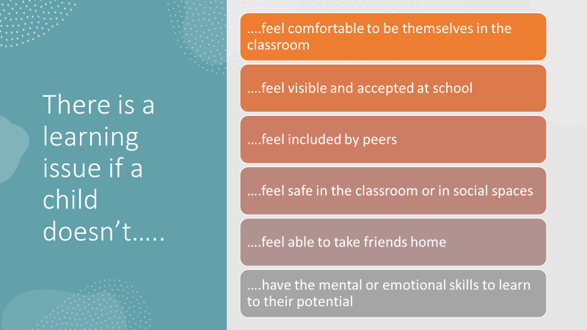

**Student Voice**

* Create an Equality and Diversity student group.

Having a student led group means that there is a set place for pupils and staff to go if they want to do more to promote equality and also means pupils can get involved in organising activities and holding school-wide events to celebrate diversity. If pupils are actively engaging with equality related issues, there is more chance of keeping up the momentum on improvement work surrounding equality as pupils will be able to bring a new perspective and raise issues they have noticed and want to address. Furthermore, this gives students from different year groups a chance to connect and work together.

**Planning**

* Make an Equality related year plan.

Having a set space to note down the steps you are taking to promote equality is a great way to track the progress being made. This could be done by creating a calendar with dates that you feel are important to recognise eg Transgender Day of Remembrance, Holocaust Memorial Day, religious holidays, Carers Week, Black History awareness month, International Women’s Day, etc. and also marking in any events or projects being worked on. It is important to meaningfully and sensitively include these in the curriculum, thinking about including positive examples and contexts e.g. Black history and heritage. By having a year planner with long-term goals laid out, staff, young people and partners will ultimately become more involved and motivated to make their setting a better place. This will help promote equality in the long run as this plan will need to be reflected on and added to throughout the year.

**Partners**

* Make links with local charities and support groups.

For example, does your area have an LGBT support group or a support system for individuals with a disability? It is important to involve partners as they can help with projects and ideas, as well as offer advice to both young people and staff within education settings. Involve parents and carers in your work perhaps by having a stand at Careers or Parent’s Evenings focused on equality issues to gauge current concerns and make links for support. Seek involvement of those with lived experience to widen understanding. This can also help to provide positive role models for discriminated groups.

**Reflective Questions**

Staff

* Does your setting have a set place or process where staff can speak about any equality related issues they may have? Is this space clearly highlighted to staff?

Pupils

* Does your setting have a set place or group where children/young people can speak about any equality related issues they may have? Is this space clearly highlighted to children/young people?
* Do children/young people have the opportunity to get involved with promoting equality within your education setting? eg a student-led equality group.

Parents/Carers and Partners

* Does your setting work closely with parents or carers to tackle any issues that students may have? eg. feeding back to parents/carers bullying surveys etc
* Does your setting provide information that parents or carers may require for a broader understanding of equality?
* Does your setting have links to equality related local support groups and charities and if so, could you use them more to support or advise?

Section 5 **US**

In order to work towards an inclusive early learning or education setting, everyone needs to work together. It is not the responsibility of one individual but all of us. Below shows a diagram on how different people can promote equality and how they link together.

**Staff**

* Keep equality in mind when lesson planning and think about how to incorporate equality related issues.
* Allow students time to talk about equality related issues when they arise.
* Be familiar with the process if they witness discrimination or need to support a colleague
* If a discriminatory incident

occurs, allow time for reflection and take appropriate action.

**Pupils**

* Have knowledge of who to talk to if they witness

discrimination based on the protected characteristics.

* Know that it is always good to speak with an adult if they think that someone is being treated unfairly, no matter how big or small it may seem

**Both**

* Report any incident of discriminatory behaviour.
* Promote a positive atmosphere with mutual respect

**WHO**

Senior Managers have an overarching responsibility for promoting equality and have the responsibility to challenge discrimination in the workplace and so can use this document in response to emerging issues. Ideally, equality, diversity and inclusion should be part of the remit of a senior member of staff.

Every school or early learning and childcare setting should have an Equality and Diversity Champion whose role it is to promote inclusion and diversity across the school/setting and coordinate activities. This role can be taken on by various members of staff or a team, including parents/carers and/or pupils. This will vary depending on your setting.

There should be a clear system in place for recording and reporting discriminatory incidents. This may differ across settings and councils however there should be consistency and clarity in your setting which is communicated to all partners. All bullying incidents should be recorded on SEEMIS in line with the local authority policy.

All staff should be aware who has responsibility for equality within the school and how to access support and advice. This was a clear gap in the knowledge of staff within our survey.

Children and young people should have the opportunity to reflect on equality issues within their setting and a platform for them to take action in an age appropriate way.. For older pupils, this could include reflecting on this document and providing feedback to senior managers about their experiences.

**WHEN**

The **INCLUDE** guidance should be a helpful reminder to staff on the first in-service in August. This gives an opportunity to promote an inclusive ethos within the school and remind staff of signposting to supports and available resources, as well as their responsibilities to support pupils, parents and colleagues within the Equality Act (2010) and the UNCRC.

At a time of the setting’s choosing, at least once a year, staff should meet together to engage with the reflective questions. This self-evaluation process should be used to form a plan for the upcoming year. The Equality and Diversity Champion in the school should take a lead on this with support from Senior Management.

When new staff join the setting, this guidance and the setting’s Equality Action Plan should be included in the welcome pack or induction to ensure that all staff are aware and confident of their responsibilities surrounding equality, diversity, inclusion and children’s rights.

**Reflective Questions**

* Do staff know how to take action upon witnessing discrimination to ensure the situation is defused?
* Are consequences for staff, children/young people clearly communicated and restorative in nature?
* Do consequences for staff, children/young people who discriminate against others have a clear purpose and opportunity for reflection and learning?
* Are incidents of discrimination logged and is there a commonality in how this is done? This is particularly important in relation to incidents of prejudice based bullying
* Do pupils know where to go to report incidents of discrimination?
* Do pupils trust their concerns will be taken seriously? How do you know?
* Is feedback provided on outcomes of the issue to those discriminated against?
* Are the views of children and young people on various aspects that may be seen as a priority, gathered regularly and actioned, in a way that is appropriate to their age and stage of development?

Section 6 **DIRECTION**

In the 2020 survey of Northern Alliance staff, a number noted that they did not feel confident in addressing equality issues due to a lack of knowledge. As young people, our hope is that this section can provide tools or point you in the direction of useful resources.

The following websites offer useful information and guidance in the hope of ensuring that a range of resources are available to everyone. To aid staff, below each website we have noted which Protected Characteristics are highlighted and also a brief summary of what support and resources they offer.

**Holocaust memorial day** :

<https://www.hmd.org.uk/>

Groups: Race, Religion/Belief, Sexual Orientation

Resources to teach interactive lessons and assemblies about the Holocaust and genocide remembrance. Discusses how people were affected by the Holocaust.

**Scottish travellers education program:** <http://www.step.education.ed.ac.uk/making-learning-relevant/>

Groups: Race, Religion/Belief

Ideas and information about learning for young people from a mobile culture.

**Anti-Racist Education Resources**

Collated list of various new anti-racist education resources

<https://www.eis.org.uk/Anti-Racism/NewAnti-RacistEducationResources>

**Show racism the red card:**

<https://www.theredcard.org/>

Groups: Race

This Charity Provides educational workshops and training sessions. Educators and ex-professional football players can be booked to visit schools and talk about racism. They produce educational resources and educational films which address a range of issues surrounding racism. They work across the whole of the UK. (Podcasts, magazines and newsletters are also available)

**Stonewall:**

<https://www.stonewall.org.uk/about-us/stonewalls-history>

Groups: Gender Reassignment, Sexual Orientation

Provides information on LGBT+ issues including how to combat discrimination, hate crime, laws and rights.

**Time for Inclusive Education**

<https://www.tie.scot/>

Groups: LGBTI+

Resources for LGBT inclusion across the curriculum.

**Centre for studies on Inclusion Education:**

<http://www.csie.org.uk/>

Groups: Disability

Offers training programs to help children become aware of disabilities.

**Respect me:**

<https://respectme.org.uk/>

Groups: Race, Sex, Sexual Orientation, Gender Reassignment

Discusses bullying and gives advice for young people such as how to communicate with adults and vice-versa. Also informs on bullying in person and online and how to report it.

**Stonewall Curriculum Guide:**

<https://www.stonewall.org.uk/system/files/inclusive_curriculum_guide.pdf>

Groups: Gender Reassignment, Sexual Orientation

Examples on how to encourage LGBT education through lesson ideas and activities.

**For Scotland’s Disabled Children**:

<https://www.fsdc.org.uk>

Groups: Disability

Charity/ group provides other useful links relating to disability.

**LGBTUA+ Initiatives**:

<https://warwick.ac.uk/services/equalops/getinvolved/initiatives/lgbtua/>

Groups: Gender Reassignment, Sexual Orientation

Offers support and guidance on being trans. Also includes group events and guides to gender neutral language and pronouns.

**It's just everywhere-sexism:**

<https://neu.org.uk/advice/its-just-everywhere-sexism-schools>

Groups: Sex

Advice on how to deal with sexism and what sexist language looks like.

**Age UK Equality Act:** <https://www.ageuk.org.uk/information-advice/work-learning/discrimination-rights/the-equality-act/>

Groups: Age

Provides details on the Equality Act (2010) itself and how it applies. Suggests what to do if you are illegally discriminated against due to your age and also how the law protects individuals from age discrimination.

**Equality and human rights commission:**

<https://www.equalityhumanrights.com/en>

Groups: Disability, Religion, Age, Gender Reassignment, Race, Marriage

Tells you all of the human rights and about the Human Rights Act. Helps with disability discrimination. An advice line has been provided.

**See Me Scotland:**

<https://www.seemescotland.org/young-people/resources/partner-resources/>

Groups: Disability (Mental Health)

Provides resource packs and information to teachers on how they can educate young people about mental health in a respectful and well-rounded way. It also provides tool kits to help teachers deal with loss and bereavement and resilience in young people.

**Make it count:**

<https://www.mentalhealth.org.uk/campaigns/mental-health-schools-make-it-count>

Groups: Disability (Mental Health)

Provides podcasts and guides for pupils, parents and teachers. personal stories and current projects they are working on are also available on the website.

**Stonewall Scotland - Glossary Of Terms**

<https://www.stonewallscotland.org.uk/help-advice/glossary-terms>

Groups: Sexual Orientation, Gender Reassignment

Provides insight through terminology.

**GTC Equality and Diversity HUB**

<https://www.gtcs.org.uk/professional-update/equality-diversity-hub.aspx>

Groups: All

The resources available are to support teacher professionalism and professional learning and are not learning and teaching resources for the classroom. By gaining greater knowledge and understanding of all types of bias teachers can then consider any necessary changes to their learning environment, their employers' policies and practice, and their learning and teaching materials to support equality and diversity.

**Education Scotland - Embedding Equality in Resources:**

<https://education.gov.scot/media/0ddfwen2/equalitiesguidingprinciples.pdf>

Groups: All

Suggestions of ways that teaching materials can promote Equality and Diversity.

**Mentally Healthy Schools- Resource Library**

<https://mentallyhealthyschools.org.uk/resources/>

Groups: All

Variety of resources for differing age ranges on themes of Equality.

**Talking Race - Podcasts**

Groups: Race

Series of podcasts by Professor Vini Lander who leads CRED (Centre for Race, Education and Decoloniality) at Leeds Beckett University.

<https://open.spotify.com/episode/0kUYEI3Ok2mH4Pw95tUjv4?si=LptHBJxpQ_aBXVN4DY3Kdg>

**Race Equality Education Wakelet**

Groups: Race

This collection of wakelets signposts educators to a range of websites and resources which promote race equality education and ensure that all learners can flourish in an inclusive environment which actively promotes equality and tackles racism.

<https://wakelet.com/wake/EKpqdexEpY3JoNdrlJp36>

**Insight**

Groups: Race

An eye-opening new report into the Black, Asian and Minority ethnic experience in Scottish Schools. This report summaries how young people in Scotland perceive and experience secondary school education.

<https://interculturalyouthscotland.org/in-sight-report>

Some of the resources above are suitable for adults and children/young people but may be age specific. All people can experience discrimination or harassment at any point in their lives. It is important that staff know where and how to access support.

Senior Managers/Line Managers should always be available for staff. Unions and the General Teaching Council will offer advice, support and signposting. Additionally, there are a range of useful resources available online. It may be helpful for your setting or council to provide signposting to local support groups.

**Reflective Questions**

* Are children/young people, parents and staff aware of the resources that are available to them to aid them with equality related issues?
* Do children and young people have access to books surrounding themes of equality and show the diversity of the population? eg in their school library, book corner, classroom?
* Are children/young people aware of the support that staff can offer them and know how individual staff members or specific departments can aid them with equality and diversity related issues?
* Are children/young people, parents/carers and staff aware of the steps that they can individually take to address issues and promote equality?
* Is there an area within the setting or virtually that collates support and resources for staff? Is this highlighted throughout the year?

Section 7 **EVALUATE**

This section provides an opportunity for colleagues to reflect on current practice, features of highly effective practice and next steps for your setting.

Top tips

* Include a variety of staff in this process to ensure varying perspectives.
* Try to be as honest as possible to give a clear baseline to work from.
* Evidence can be varied and can take the form of statistics, time given, dates of discussions, surveys, policies, updates to parents/carers; or can be anecdotal.
* Next steps should be doable within the next year before review.
* Next steps should identify clear timelines and responsible parties.
* You might want to simply highlight your responses to the reflective questions as RED, AMBER or GREEN, to quickly identify those areas that require further development and those that are going well.

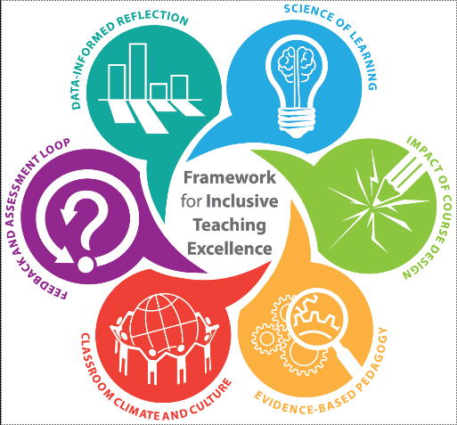

**INS & OUTS**

**Highly Effective Practice**

* All members of the school or early learning and childcare setting have a clear understanding of the legal framework surrounding equality and rights and their duties to ensure the protection of all.
* We have measures in place to support the protected characteristics outlined in the Equality Act (2010) and all staff, children/young people, and parents/carers are aware of these.
* Young people are knowledgeable about equality and diversity and understand their rights. The young people feel confident in challenging injustice.

|  |  |
| --- | --- |
| **Reflective Question 1**  Does your early learning and childcare setting or school ensure that all children, students, staff and partners are aware of the legislation and duties with regards to equality and children’s rights that are in place to protect them? How do you know? | |
| Where are we? |  |
| Evidence |  |
| Next Steps |  |
| **Reflective Question 2**  Does your setting apply the laws that are in place and ensure respect for all young people and staff? | |
| Where are we? |  |
| Evidence |  |
| Next Steps |  |
| **Reflective Question 3**  Does your setting have measures in place to support the protected characteristics outlined in the Equality Act? | |
| Where are we? |  |
| Evidence |  |
| Next Steps |  |

**NEED**

**Highly Effective Practice**

* We regularly gather information about the current measures supporting equity and equality in our setting.
* There is a shared understanding of strengths, areas for development and next steps, so that all parties are working together towards a common goal.
* Our staff and pupils are made aware of the evidence, including the lived experience and statistics, relating to aspects of equality in our setting.
* Results of surveys inform learning and decisions made within the setting.
* We actively take steps and promote resources to help improve our current situation.
* We track progress in becoming more inclusive and can clearly evidence this

|  |  |
| --- | --- |
| **Reflective Question 1**  Do you regularly survey staff and pupils within your setting to gather information with regards to Equality and track your progress? | |
| Where are we? |  |
| Evidence |  |
| Next Steps |  |
| **Reflective Question 2**  Are survey statistics published to staff, young people and partners? | |
| Where are we? |  |
| Evidence |  |
| Next Steps |  |
| **Reflective Question 3**  What do the statistics tell you about your setting and your practice? | |
| Where are we? |  |
| Evidence |  |
| Next Steps |  |
| **Reflective Question 4**  If necessary, are you actively promoting steps and resources to improve these statistics? | |
| Where are we? |  |
| Evidence |  |
| Next Steps |  |
| **Reflective Question 5**  Are you celebrating and sharing the good practice within your setting, with others across your council or authority? | |
| Where are we? |  |
| Evidence |  |
| Next Steps |  |

**CONSIDER**

**Highly Effective Practice**

* Our setting uses encouraging and inclusive language.
* Young people have the opportunity to learn about a wide variety of religions, beliefs and cultures. The curriculum offers opportunities for young people to learn about genocide, racism and religious intolerance and to challenge ideologies.
* We use varied examples in our work to ensure we represent the diverse make up of Scotland.
* We support all of our learners so that they can fully participate in the curriculum.
* Across our curricular resources and experiences, children and young people from all backgrounds can see themselves reflected without bias, judgement or stereotypes.
* Staff are aware of any Equality issues that young people in their setting are experiencing and have the skills and knowledge to ensure that a young person is well supported.

|  |  |  |  |
| --- | --- | --- | --- |
| **Reflective Question 1**  Is encouraging and fair language used widely in your setting towards children, young people, parents and staff members? How can you be sure? | | | |
| Where are we? |  | | |
| Evidence |  | | |
| Next Steps |  | | |
| **Reflective Question 2**  Does your setting accommodate and educate a wide variety of religions and cultures and do your activities and curricular materials reflect the population? | | | |
| Where are we? |  | | |
| Evidence |  | | |
| Next Steps |  | | |
| **Reflective Question 3**  Do the procedures, processes, activities and approaches in your setting accommodate **all** needs? | | | |
| Where are we? |  | | |
| Evidence |  | | |
| Next Steps |  | | |
| **Reflective Question 4**  Does your setting use diverse examples and resources in lessons? | | | |
| Where are we? |  | | |
| Evidence |  | | |
| Next Steps |  | | |
| **Reflective Question 5**  Does your setting provide appropriate differentiation, support and reasonable adjustments so that all students can participate in lessons? | | | |
| Where are we? |  | | |
| Evidence |  | | |
| Next Steps |  | | |
| **Reflective Question 6**  Do you take account of the cost of the school day in all activities and do you advertise the availability of free school meals, benefits and clothing grants? | | | |
| Where are we? |  |  |  |
| Evidence |  |  |  |
| Next Steps |  |  |  |

**LONGEVITY**

**Highly Effective Practice**

* Staff and young people feel well supported and have a shared understanding of equality, diversity and children’s rights.
* There is a safe place for staff and young people to talk about any issues they may have.
* The setting works closely with caregivers to support and understand family circumstances and to create a culture of equality and mutual support.
* There are opportunities for information and workshops for caregivers to better understand current issues of equality. Eg. Feedback to parents/carers in respect of surveys undertaken with children/young people and the implications of these.

|  |  |
| --- | --- |
| **Reflective Question 1**  Does your setting have a set place or process where staff can speak about any equality related issues they may have? Is this space clearly highlighted to staff? | |
| Where are we? |  |
| Evidence |  |
| Next Steps |  |
| **Reflective Question 2**  Does your setting have a set place or group where children/young people can speak about any equality related issues they may have? Is this space clearly highlighted to children/young people? | |
| Where are we? |  |
| Evidence |  |
| Next Steps |  |
| **Reflective Question 3**  Do children/young people have the opportunity to get involved with promoting equality within your setting? eg a student-led equality group. | |
| Where are we? |  |
| Evidence |  |
| Next Steps |  |
| **Reflective Question 4**  Does your setting work closely with parents or carers to tackle any issues that students may have? Eg. Feedback to parents/carers on bullying surveys etc. | |
| Where are we? |  |
| Evidence |  |
| Next Steps |  |
| **Reflective Question 5**  Does your setting provide information that parents or carers may require for a broader understanding of equality? | |
| Where are we? |  |
| Evidence |  |
| Next Steps |  |
| **Reflective Question 6**  Does your setting have links to equality related local support groups and charities and if so, could you use them more to support or advise? | |
| Where are we? |  |
| Evidence |  |
| Next Steps |  |

**US**

**Highly Effective Practice**

* The vision and aims of the setting place an emphasis on developing positive relationships at all levels, equality, acceptance and inclusion.
* Young people and staff feel they belong, are able to be themselves and challenge issues or language related to inequality and discrimination.
* There is a shared understanding of what is unacceptable language or slang and this is understood and supported by all. Derogatory or discriminatory language is always challenged. Pupils feel confident in seeking support with this.
* There is a strong student leadership group that focuses on Equality within the setting. This has a varied membership and they have the opportunity to make a difference within the setting.
* Children and young people feel confident and are able to comment on injustice in good faith that their views will be taken seriously.
* Partners work with the setting to ensure high quality care for young people.
* The setting actively involves partners in equality work to ensure consistency across the associated school community.

|  |  |
| --- | --- |
| **Reflective Question 1**  Do staff know how to take action upon witnessing discrimination to ensure the situation is defused? | |
| Where are we? |  |
| Evidence |  |
| Next Steps |  |
| **Reflective Question 2**  Are consequences for staff, children and young people clearly communicated? | |
| Where are we? |  |
| Evidence |  |
| Next Steps |  |
| **Reflective Question 3**  Do consequences for staff, children/young people who discriminate against others have a clear purpose and opportunity for reflection and learning? | |
| Where are we? |  |
| Evidence |  |
| Next Steps |  |
| **Reflective Question 4**  Are incidents of discrimination logged and is there a commonality in how this is done, especially in relation to prejudiced based bullying? | |
| Where are we? |  |
| Evidence |  |
| Next Steps |  |
| **Reflective Question 5**  Do pupils know where to go to report incidents of discrimination? Do pupils trust their concerns will be taken seriously? How do you know? | |
| Where are we? |  |
| Evidence |  |
| Next Steps |  |
| **Reflective Question 6**  Are consequences for children/young people clearly communicated and restorative in nature? | |
| Where are we? |  |
| Evidence |  |
| Next Steps |  |

**DIRECTION**

**Highly Effective Practice**

* CPD on issues that support equality, diversity, inclusion and children’s rights is well publicised by the setting. Staff are supported and encouraged to attend these sessions.
* Continual professional learning is encouraged as a tool to improve learner outcomes and good practice is shared throughout the year. There is the opportunity to discuss equality issues in the calendar.
* Staff have access to resources to help them with equality related issues which are specific to the setting.
* There is a clear system in place for staff and young people to raise equality and diversity issues. There are staff members who have particular responsibility for this.
* Equality and diversity is a theme that is embedded in all learning and across all curricular areas.

|  |  |
| --- | --- |
| **Reflective Question 1**  Are children/young people and staff aware of the resources that are available to them to aid them with equality related issues? | |
| Where are we? |  |
| Evidence |  |
| Next Steps |  |
| **Reflective Question 2**  Do children/young people have access to books covering equality themes and that represent diversity? eg. in their school library, book corner, classroom? | |
| Where are we? |  |
| Evidence |  |
| Next Steps |  |
| **Reflective Question 3**  Are children/young people aware of the support that staff can offer them and know how individual staff members and specific departments can aid them with equality and diversity related issues? | |
| Where are we? |  |
| Evidence |  |
| Next Steps |  |
| **Reflective Question 4**  Are children/young people, parents/carers and staff aware of the steps that they can individually take to address issues and promote equality? | |
| Where are we? |  |
| Evidence |  |
| Next Steps |  |
| **Reflective Question 5**  Is there an area within the setting or virtually, that collates support and resources for staff? Is this highlighted throughout the year? | |
| Where are we? |  |
| Evidence |  |
| Next Steps |  |

**Ins and outs**

**Need**

**Consider**

**Longevity**

**Us**

**Direction**

**Evaluation**

**INCLUDE - Highly Effective Practice**

* Our vision and aims emphasise the importance of developing positive relationships, equality, acceptance and inclusion at all levels.

* Everyone is aware of the legal duties with regards to equality and children’s rights and ongoing professional development supports this.
* Measures in place to support the protected characteristics outlined in the Equality Act.
* We regularly check where we are with Equality and track our progress.
* We use encouraging and inclusive language. Derogatory or discriminatory language is always challenged.
* We aim to represent the diverse make up of Scotland, in our staffing, resources and experiences.
* Children and young people from all backgrounds can see themselves reflected without bias, judgement or stereotypes.
* Procedures, processes and activities accommodate **all** needs and reasonable adjustments are made so that everyone can participate.
* There is a safe place for staff and young people to talk about any issues they may have and to challenge issues or language related to inequality and discrimination.
* Children/young people have the opportunity to get involved with promoting equality.
* Everyone feels they belong and are able to be themselves.
* Support and resources are available for staff, children, young people and families, to help them celebrate diversity and to promote equality and children’s rights.

**GLOSSARY**

To ensure this guidance is accessible to everyone reading, we have provided a Glossary of Key Terms that are discussed throughout.

**Ageism** - prejudice or discrimination on the grounds of a person's age.

**Confident individuals**- Have self-respect, a sense of physical, mental and emotional wellbeing and secure values and beliefs.

**Diversity**- Many different [types](https://dictionary.cambridge.org/dictionary/english/type) of things or [people](https://dictionary.cambridge.org/dictionary/english/people) being [included](https://dictionary.cambridge.org/dictionary/english/included) in something; a [range](https://dictionary.cambridge.org/dictionary/english/range) of different things or [people](https://dictionary.cambridge.org/dictionary/english/people).

**Effective contributors**- Have an enterprising attitude, resilience, and self-reliance.

**Equality**-the state of being equal, especially in status, rights, or opportunities.

**Ethos-** the characteristic spirit of a community as manifested in its attitudes and aspirations.

**Gender expression -** How a person chooses to outwardly express their gender, within the context of societal expectations of gender. A person who does not conform to societal expectations of gender may not, however, identify as trans.

**Gender Identity -** A person’s innate sense of their own gender, whether male, female or something else, which may or may not correspond to the sex assigned at birth.

**Homophobia** – dislike of or prejudice against homosexual people.

**Inclusion**- the action or state of including or of being included within a group or structure.

**Prejudice** - Preconceived opinion that is not based on reason or actual experience.

**Protected characteristics**- Groups protected by existing Equality legislation: Age, disability, gender reassignment, pregnancy, race, religion or belief, sex, sexual orientation, marriage and civil partnership.

**Racism**- prejudice, discrimination, or antagonism directed against someone of a different race based on the belief that one's own race is superior.

**Responsible citizens**- Have respect for others and commitment to participate responsibly in political, economic, social and cultural life.

**Sexism**- prejudice, stereotyping, or discrimination, typically against women, on the basis of sex.

**Successful learners-** Have enthusiasm and motivation for learning, determination to reach high standards of achievement and openness to new thinking and ideas.

**Transphobia** - dislike of or prejudice against transsexual or transgender people.

**Unconscious bias** - learned stereotypes that are automatic, unintentional, deeply engrained within our beliefs, universal, and have the ability to affect our behaviour.

1. <https://www.stonewall.org.uk/media/lgbt-facts-and-figures>

   Taken from [*Leagues Behind (2009)*](https://www.stonewall.org.uk/system/files/Leagues_Behind__2009_.pdf)*,* [*Out for Sport (2012)*](http://www.equality-network.org/wp-content/uploads/2013/03/Out-for-Sport-Report.pdf)and ​[*LGBT in Britain - Hate Crime (2017)*](https://www.stonewall.org.uk/system/files/lgbt_in_britain_hate_crime.pdf).
2. <https://www.theschoolbus.net/article/tackling-the-issue-of-racism-in-schools/7587>
3. [Office for National Statistics](https://www.ons.gov.uk/peoplepopulationandcommunity/healthandsocialcare/disability/bulletins/disabilityandeducationuk/2019)
4. [Sexual harassment in education](C://Users/bernc/Downloads/CBP-8117.pdf), House of Commons Briefing Paper, January 2020
5. Cited in [Tacking Islamophobia in Scottish Schools](https://www.sacc.org.uk/sacc/resources/tackling_islamophobia_v3.pdf), a SACC Briefing, 2017
6. [Statista](https://www.statista.com/chart/16928/antisemitic-incidents-in-the-uk-annual/)