Parksmart

Parksmart is one of our Road Safety and Active Travel Initiatives which aims to reduce congestion and improve safety at the school gate.

School gate parking is a major issue at schools around Highland that affects the safety and well-being of those walking and wheeling to school by blocking sight lines and increasing pollution.

Designing and use of a Parksmart banner is a direct method used in tackling school gate congestion and has proved very effective if implemented properly!

Frequency & Timescale

- Parksmart is a flexible initiative that can be run on a cyclical basis, running when / if congestion problems occur.
- Parksmart is most effective when used in ‘short bursts’ of 1-2 weeks at a time. If the banner is left up for any longer, it tends to lose it’s its effect.

Promotion

Some of these tasks are perfect for JRSOs or Eco Committee members to undertake.

- Design a banner. The Road Safety Team can supply a personalised banner, along with pre-printed leaflets if required.
- Give parents warning of when the initiative is likely to be run. Posters, leaflets, social media posts all work.
- Visibility is key! Display your banner in a prominent place that targets the majority of ‘School Gate Parkers’.
- Enforce the initiative. Ensure that anyone not adhering to the banner is reminded of the initiative and why it is happening.
- You could also try contacting your local police for some presence/support during the initiative.

Promotional Materials

What better way to get the Parksmart message across to parents than from the children themselves!

We encourage schools to design their own Parksmart banner, JRSO’s could run this as a competition, with the best entries being printed on a banner.

The Road Safety Team will fund the printing of a banner through the Safer Routes to School scheme. Banners will be digitally printed, 3000mm x 1000mm, full colour with hem and eyelets.

The design can be text only, picture only or text and picture, see examples below. Schools will need to provide the text and 1 or 2 clear pictures, A4 or A3 size, landscape or portrait. Any text included in a picture will require to be very clear.

If you would like to implement Parksmart at your school, email: road.safety@highland.gov.uk.

Example Banners/Text

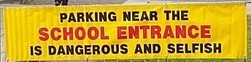Text Only

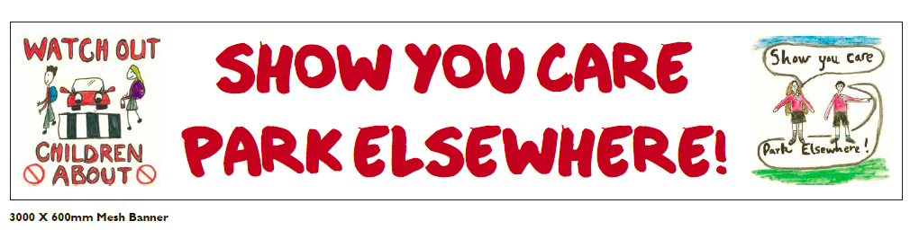
Text and Picture

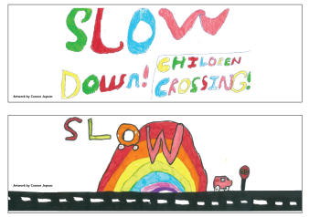
Picture Only

