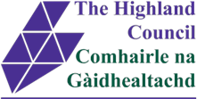

English as an Additional Language
Policy and Guidance
Updated July 2017
Introduction
Historically, only a small number of pupils with English as an Additional Language were enrolled in schools and Early Years centres in Highland, but since the accession of the A8 countries in 2004, numbers have consistently risen, so that the vast majority of schools and centres across Highland now teach pupils with EAL. Pupils come from a variety of backgrounds, ranging from indigenous communities to those who are new to the language and culture of this country. Highland is also active in the Syrian Vulnerable Persons Relocation scheme (SVPR).

As of 2017, nearly a third of Highland’s EAL learners’ families have migrated from Poland, but with around 65 different languages spoken in schools, many pupils with EAL are isolated learners: they may be the only speaker of their language in the class or school.

The majority of newly arrived pupils have previous educational experience and can transfer literacy skills which tend to be taught from around age 7, however some pupils may have interrupted learning and be new to literacy, as well as English.

Other Additional Support Needs differ greatly and language acquisition can often mask other needs. Dyslexia, for example, is under-identified nationally, with only 6% of learners with EAL in comparison with 10% of their native English-speaking peers. Assessing language progress is therefore an essential part of provision to monitor progress and differentiate appropriately.

Children and Young People’s experience of transition to a new country, home, language and school varies and this policy recognises the impact on Wellbeing such changes incur and the additional support required to facilitate their welcome to Scotland.

Rationale
This policy and guidance has been prepared in response to requests from education staff to have Highland-wide, agreed and clearly stated advice with regard to enrolment and educational provision for bilingual learners ie those learners for whom English is an additional language (EAL). The Highland Council acknowledges Learning in 2+ Languages as the framework for providing support for bilingual learners. (It should be noted however, that this guidance does not cover Gaelic Medium Education, for which separate guidance is available.)

This policy aims to provide a plan of action for schools/educational establishments with respect to their requirement to provide an appropriate education for all pupils for whom English is an Additional Language. It aims to support schools/educational establishments to meet obligations regarding the planning and delivery of inclusive, effective teaching and learning and also for assessment and review procedures which comply with the Highland Practice Model/ Getting It Right For Every Child.

The policy promotes appropriate use of all resources and strategies to ensure wide ranging and co-operative practices and to raise levels of attainment for all bilingual pupils.
CONTENTS

Section | Theme | Page
1 | Bilingual Learners - a definition | Page 3
2 | Working in Partnership | Page 3
3 | SQA ESOL | Page 4
4 | The EAL Service | Page 5
 | 4.1 EAL Support Teachers
 | 4.2 EALT Typical Involvement
5 | Continued Professional Development | Page 7
6 | SEEMiS | Page 8
7 | Support to parents | Page 8
8 | Interpreters (oral) and Translation (written) services | Page 8
9 | Enrolment and Assessment | Page 8
10 | Post-enrolment and induction period | Page 10
11 | Ongoing plan for pupils | Page 11
12 | Pupils with ASN | Page 11
13 | Scottish Attainment Challenge and Pupil Equity Fund | Page 11
14 | HGIOS 4 | Page 11
15 | The Future | Page 11
Appendix - Context and Legislative issues |  | Page 13

1. Bilingual Learners – a definition

‘Bilingual learners’ are pupils who function in more than one language in their daily lives. The term bilingual emphasises that learners already have one language and that English is a second or additional language. The term does not imply an equal or specified level of fluency in two or more languages’. (Learning in 2+ Languages, LTS 2005)

Bilingual learners differ from each other in many ways including:
- The language(s) they speak at home
- The number of languages they speak
- The cognitive benefits of being bilingual
- Their cultural, religious, social and economic backgrounds
- Their previous educational experience
- Their level of proficiency in English and their first language
- Their individual personalities, learning styles and other individual differences
- Other additional support needs they might have including, for example, potential for high achievement, general or specific learning difficulties, sensory impairment
- The level of support they have from their home and community
- Their breadth of exposure to English language and Scottish culture.

Some bilingual children and young people will require additional support if they are to maximise their progress in school and achieve to their fullest potential. This policy recognises that bilingualism is a strength which can also be drawn upon.

- Working in Partnership

The support needs of bilingual learners/ pupils with EAL are part of the continuum of additional support needs, and will be met within the overall policy, procedures and resources for additional support needs. The support provided will be proportionate to individual need and may vary from differentiation as part of a teaching group to specialised support.

There is a focus on capacity building to ensure all staff are equipped with and can access the specialist knowledge and interventions needed to meet the needs of children and young people with EAL. CPD, advice and support are provided by the EAL team.


For almost all Bilingual pupils with EAL needs, inclusion in English-medium education will be the most effective way to develop English language competence, cultural awareness and understanding both by them and their peers. Staff should be aware that pupils and their parents /carers may require additional support over an extended period to facilitate access to and understanding of services. Those staff who work most closely with pupils, i.e. class and subject teachers and other staff, will require awareness raising of the needs of pupils with EAL and access to strategies that can support them and their pupils (see section on CPD). Advice and support for those pupils for whom British Sign Language (BSL) is their first language should continue to be sought from Highland Deaf Education Service (HDES). Likewise, support for Gaelic speaking learners is provided by Gaelic Education.

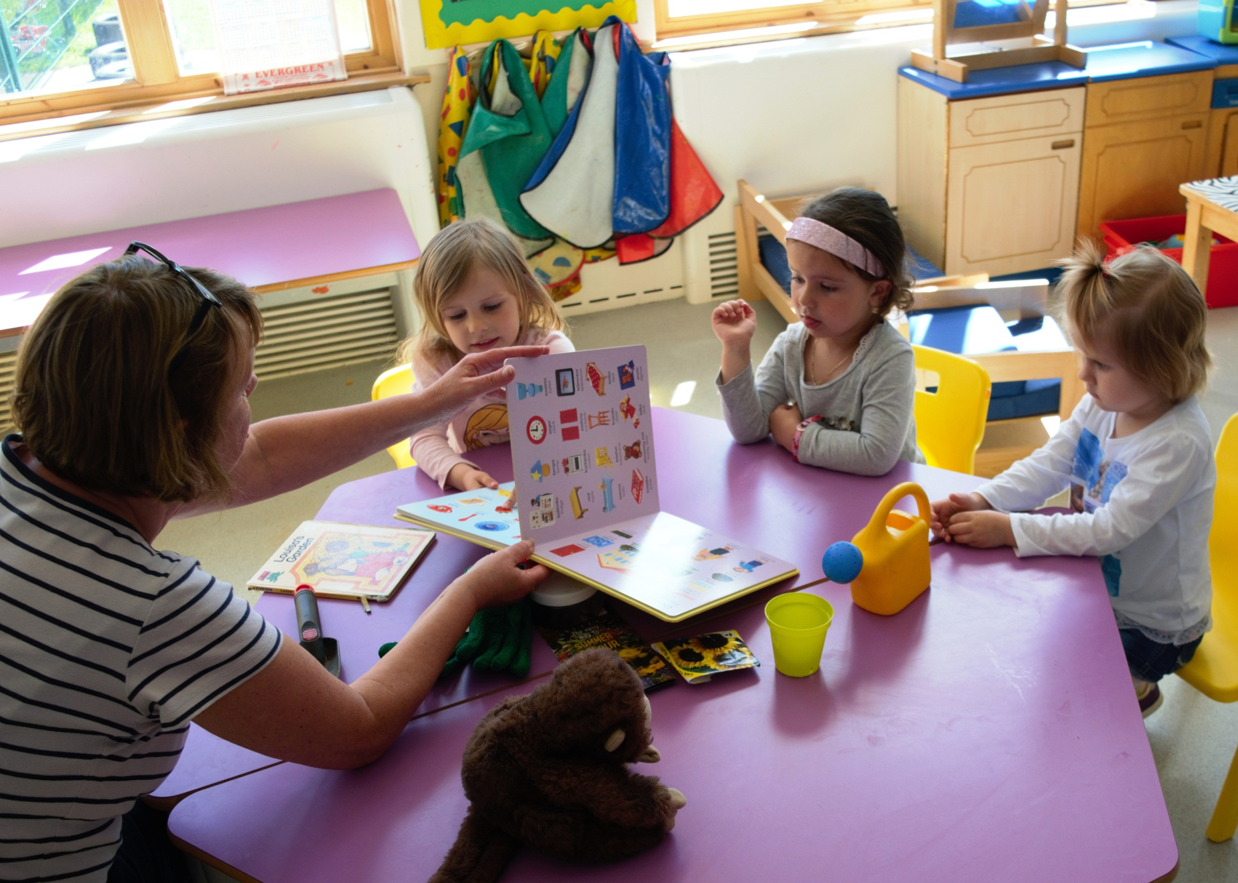
For pupils who are new to English, an initial induction period of up to 12 weeks may be necessary to develop essential language skills. These are delivered in regular, short group sessions out with the classroom/nursery setting, at the class teacher’s discretion. This is delivered by staff in centres and training and materials are available from the EAL team.

- SQA ESOL

SQA ESOL (English for Speakers of Other Languages) is available at National 2 level through to Higher and may be appropriate for pupils in the senior phase. ESOL is recognised by UCAS for the majority of courses, but currently is not accepted for those wishing to study primary teacher training, medicine and some law courses. The decision to study ESOL in preference to English depends on a variety of factors, including language level and career path and the decision should involve pupils and family – the EAL team can support with this. This policy recognises that, where appropriate, pupils be kept in mainstream English, so as to benefit from the recognised support from monolingual peers and exposure to language, culture and literature. Where ESOL is deemed an appropriate alternative, EAL staff team teach pupils and support centres with SQA ESOL.

- The EAL Service
4.1 EAL Support Teachers have specialist expertise and are available to provide advice, training and support to schools, nurseries and relevant agencies. EAL Support teachers operate within Integrated Children’s Services framework to ensure:

- Diversity is valued
- First language is maintained
- Inclusion and equality of access to the curriculum
- Identification and assessment of need
- Appropriate level of support for the individual and school/pre-school centre
- Effective teaching strategies and resources
- Teaching support to individuals/small groups of pupils
- Holistic and robust approach to assessment
- Awareness of linguistic, religious and cultural matters
- Effective home/school liaison
- Access to SQA ESOL

EAL Support provided is offered at 4 levels.

- Assessment
- Consultation
- Direct teaching
- CPD

EAL teachers have representation on local and national EAL agencies, including: Highland English for Speakers of Other Languages (ESOL) Providers group, Scottish English as an Additional Language Co-ordinating Council (SEALCC) and Scottish Association of Teachers of English as an Additional Language (SATEAL)

4.2 English as an Additional Language Teachers (EALT) - Typical Involvement

EAL teacher involvement can be accessed by an email requesting the service. There are various levels of involvement that may be engaged in, depending on the needs of the child/young person and the level of support that may be appropriate.

The following graphic provides a summary of the various interventions from the EAL team, working with others.

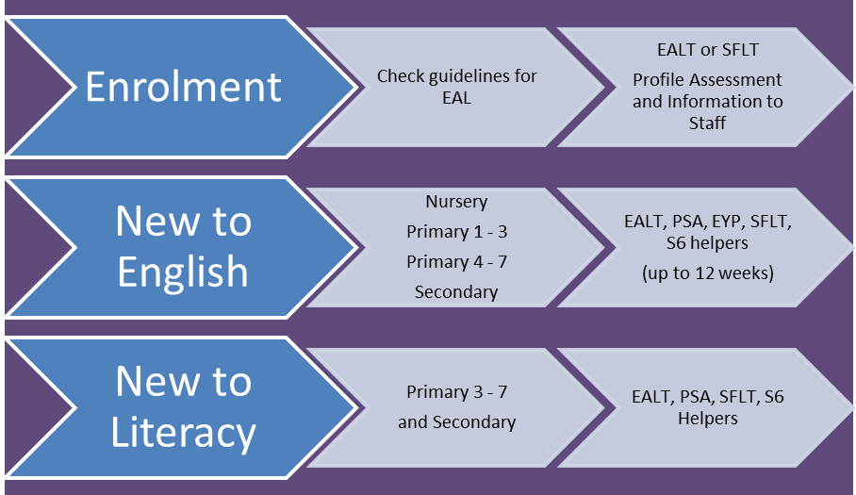

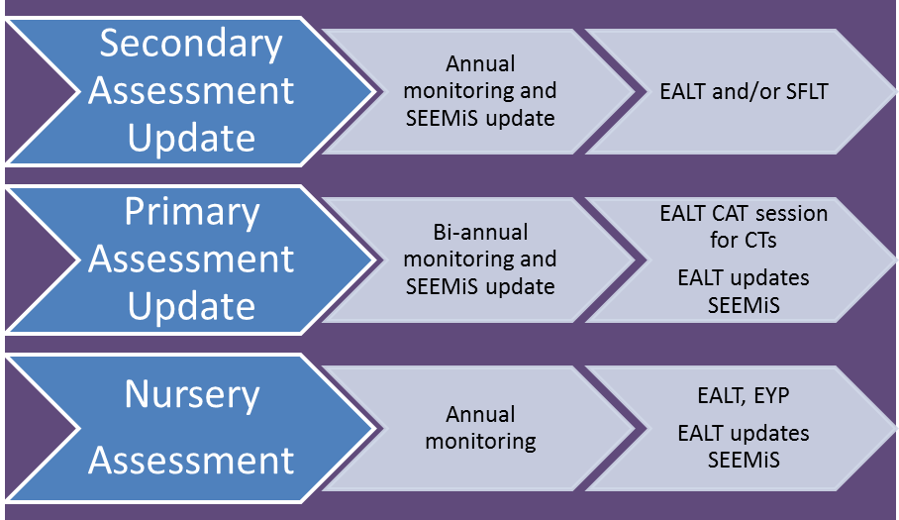

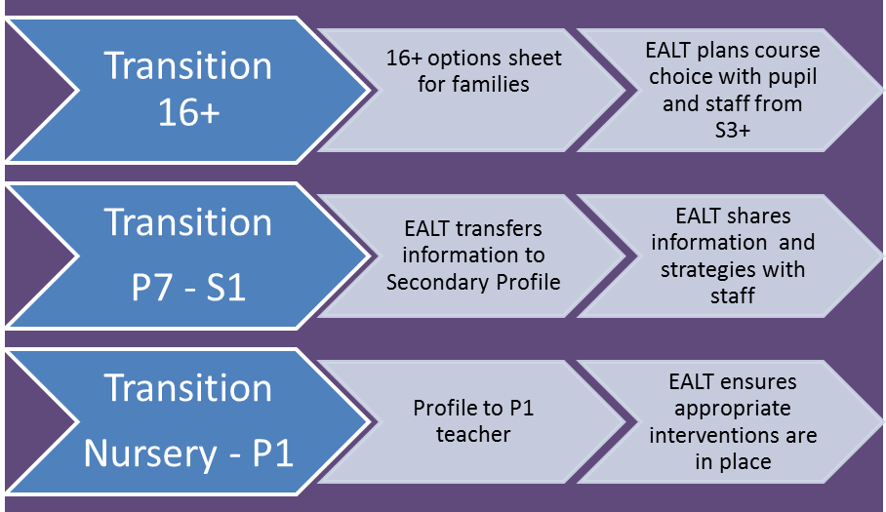

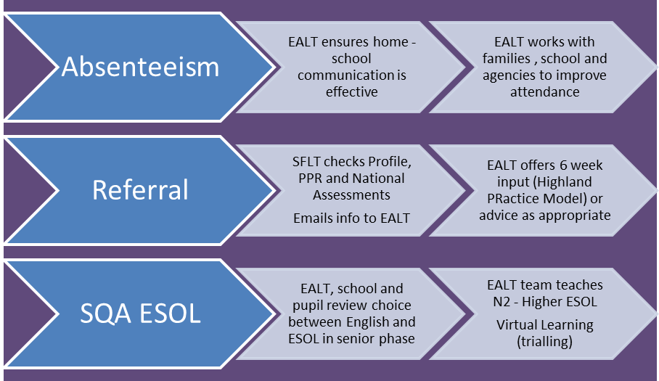

- Continued Professional Development

Supporting children’s learning is everyone’s job and all staff should assume that at some point they will be expected to work with a child or young person whose first language is not English. The Highland Council offers training for staff with regard to supporting bilingual pupils in our schools and pre-school centres, typically as follows:
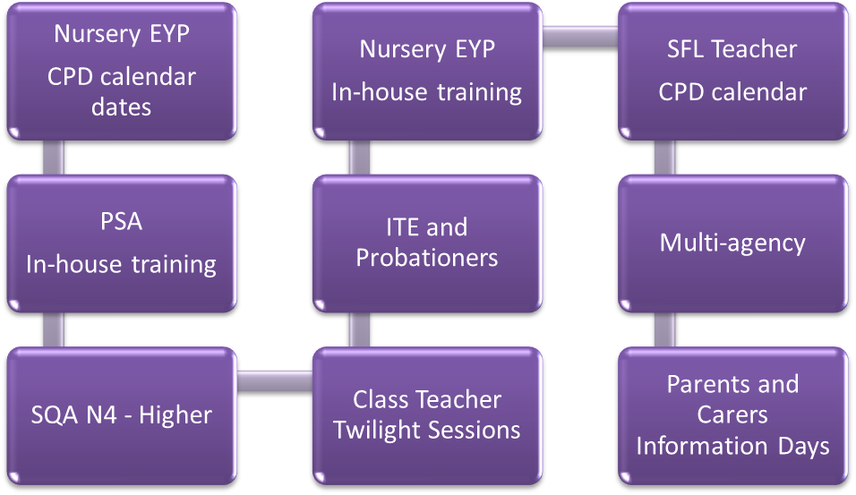
Training is also available nationally, eg through SEALCC in May and November of each year, or through University courses. These tend to be run in the Central Belt.

Moray House and Strathclyde University also currently offer certificated courses in Bilingual Support as part of their Masters in Education programmes.

Support to attend these courses will require to be approved by the appropriate Care and Learning Manager.

- SEEMiS

SEEMiS data provides numbers, language(s) spoken and English language levels of pupils with EAL both to the authority and to the government in their scotXed report. It is important that this data is maintained on a regular basis, to support the Council in its strategic developments and planning.

- Support to parents

There should be close links between schools, associated school groups and EAL staff. In this way school staff, support for learning staff including EAL specialists, can work collaboratively to meet the needs of children and families.

Further information about the EAL Service background and support can be accessed here.

- Interpreters (oral) and Translation (written) Services

Further information about interpreting/translating as well as how to access an interpreter, either face to face or by phone, can be found here.

General educational information can be translated centrally. Specific school information, which requires translation, requires the school to have direct contact with translating services as above. The translation of any school documentation will be funded by the school.

- Enrolment and Assessment

Enrolment is an important first step in identifying and gathering information about any child but is particularly important for new bilingual pupils and their families. The following guidance has been developed to assist schools and pre-school centres with this process. It acknowledges the published national guidelines on the needs of bilingual learners, Learning in 2+languages, and takes full account of the HC Promoting Diversity and Equality Policy. Head Teachers/Centre Managers should therefore ensure that this guidance is followed within each school/pre-school centre. In particular the Head Teacher or Centre Manager must either undertake such enrolments or delegate them to a designated member of management/pastoral team.

Enrolment may take place at the time the parent first makes contact with the school/pre-school centre. However, where circumstances may be problematic,
(eg the need for an interpreter to be present) it may be more appropriate to set a later date for enrolment to allow the school/pre-school centre to make the necessary arrangements. Interpreting service (centrally funded) can be found here.

The EAL team needs to be informed of the enrolment of a new bilingual pupil to assess the needs of the new learner. The Additional Support Needs teacher / department in the school should also be immediately informed. If significant issues are envisaged, the Area ASN Manager should also be contacted.

At initial contact, or as soon as practicable thereafter, the school/pre-school centre should ascertain the child’s eligibility for enrolment by checking, with due sensitivity, the following documentation as appropriate:

- birth certificate
- passport
- evidence of relationship between child and adult enrolling her/ him (example parent’s name on birth certificate or child’s passport
- proof of residency (example: property rental agreement, utility bill)

(Please note that checking does not require photocopies be kept.)

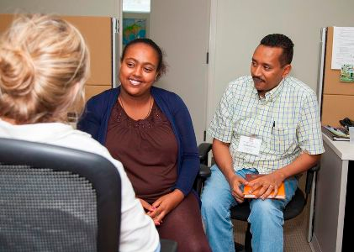
The school/pre-school centre should also ascertain the home language(s) of the family and whether an interpreter is required. Staff should also enquire about the availability of any previous school reports, samples of the pupil’s work or textbooks which have been used. The school/pre-school centre should then set a date for completing the process of enrolment.

The discussion at enrolment is an opportunity to welcome new families, alleviate any potential anxieties and provides accurate information for them on the school and Highland processes. The discussion will also provide an opportunity to gather accurate information from the family. Typically for pupils with EAL this includes:

- The correct spelling and pronunciation of the learner’s name.
- The language(s) spoken at home.
- The learner’s experience of reading and writing (including pre-literacy experience) in their first language.
- Previous education, subjects studied, likes and dislikes and any previous experience of English.
- Family expectations (social, academic).
- Any dietary, health, religious or cultural requirements
- Lines of communication with home, whether communication should be verbal or written (or both), and the need for an interpreter.
- Whether the learner has any other additional support needs and any steps taken to identify these.
- A suitable timetable for pupils entering secondary, in particular the senior phase, where initial language levels may not yet mirror potential for qualifications. Some pupils, therefore, may do N5 in S5 and go onto Highers in S5.

Assessment is carried out by a member of the EAL team, or a trained staff member in the school.

At the time of enrolment, the following should be recorded on SEEMiS:
- the main language(s)
- level of English language acquisition eg New to English. This is assessed by the EAL team or a trained member of school staff.
- ASN needs, eg EAL and ASN level (typically 1 for differentiation in class and 2 for support). If pupils are fluent and families do not require additional arrangements, they would not be recorded as having an ASN level.

- Post-enrolment and induction period

This comprises the first few weeks following enrolment and during this time the school/pre-school centre should make sure that parents/carers:
- Are introduced to the class or pastoral care teacher, pre-school staff and other school personnel such as support staff, as appropriate
- Understand they have an important part to play in developing the learner’s first language
- Are made fully aware of the Authority’s procedures for managing attendance within schools and lines of communication for achieving this
- Are aware of school transport arrangements and school term dates
- Are familiar with the Authority’s arrangements for interpreting where applicable
- Know about any relevant language classes including English for Speakers of Other Language, and Community Languages, eg Saturday Polish School, SHIMCA, Inverness Masjid.
- Are encouraged and enabled to take full part in the school community
- Understand school rules concerning uniform, punctuality and absences
- Are aware of their rights regarding free school meals and clothing grants
- Know about the school and authority procedures for managing racism and other forms of bullying
- Are provided with copies of the school handbook and information about EAL support. These documents can be translated for them if required and/or an interpreter should take them through it

and make sure that learners:

- Who are New to English have the necessary induction period and are also included in mainstream classes and activities
- Experience the regular classroom routine so that they can adapt quickly and become familiar with it
- Are grouped with pupils who provide good models of English
- Are involved in games to help the child to develop vocabulary and build friendships
- Experience collaborative working so that the pupil can benefit from hearing other children discussing the task
- Have access to some ‘time out’ in the school day as they will become very tired having to deal with all the new demands. For example, time could be spent on the computer, listening to a tape or reading books in their first language, listening to music and playing games.

- Ongoing plan for pupils

Resources, guidance and strategies can be found on the EAL Highland blog and through the EAL team.

- Pupils with Additional Support Needs

Pupils with other additional support needs may require specific assessment and interventions. Please refer to the EAL service for the appropriate support.

- Scottish Attainment Challenge and Pupil Equity Fund

This policy recognises that all pupils be included in all school activities, unless they have an additional need requiring intervention listed under the typical interventions above. Please email the EAL team for assistance in providing additional support, advice on materials and other input.

- HGIOS4

The Scottish English as an Additional Language Co-ordinating Council has produced a resource which to help School Management evaluate their provision for pupils with EAL. This can be accessed here.

- The Future

The EAL Profile, which monitors language acquisition, should be updated at least annually. Surface English (social English) is acquired within two years, however it takes between 5 and 11 years to develop higher order listening, talking, reading and writing skills (academic English), depending on a variety of factors, including previous schooling, language and personality. Therefore, tracking language as well as curricular progress ensures that pupils are achieving at their appropriate level.

Strategies that work for monolingual pupils will also work for bilingual pupils and have been proven to raise attainment for many learners. Effective teachers always consider the language demands of a lesson and plan to support pupil’s language and cognitive needs. In this way the learning needs of all pupils are supported.

Advice on alternative assessment arrangements (AAA) for those pupils where English is a second or additional language can be sought from EAL staff and found at the SQA

Pupils and parents/carers may require further consideration at times of transition and subject choice to ensure they are well informed and supported.

For pupils entering education in the senior phase, it may be appropriate to consider S7.

Appendix - Context and Legislative issues

The Education (Additional Support for Learning Act) (Scotland) 2009 introduced a new framework for children and young people who require some additional support with their learning. Bilingual learners are included in this group if they require support additional to that which might normally be provided in a school to ensure they make good progress with their learning.

The Standards in Schools etc Act 2000 placed duties on all education authorities to ensure that schools meet the needs of all their pupils, encourage them to achieve their full potential and raise educational standards.

Learning in 2+ Languages identifies key issues when working with bilingual learners including:
- Effective teaching and learning: Bilingual pupils may already have fully developed skills in their home language and possess a wide range of achievements and abilities.
- Communication with parents: Interpreter/translator support may be required for parents. This ensures full participation in the life of the school/educational establishment and helps encourage support from home for further development for learning.
- Valuing and promoting first language: Schools and educational establishments should recognise and respect abilities in First language and
encourage further development to enhance personal achievement and aid success with learning in English.
- Staff support and development: There is a requirement to support all school staff with respect to EAL issues and for training at all levels.

The Equality Act 2010 makes it unlawful to discriminate against pupils or prospective pupils because of the sex, race, disability, religion or belief, sexual orientation or gender reassignment. Race is defined as ethnicity, colour or nationality. The Act, and the principle of non-discrimination, covers all the activities in the life of a school including:

• Admissions
• Provision of education
• Access to any benefit, facility or service
• Exclusions
• It is also unlawful to harass or victimise a pupil or applicant

The Highland Council Promoting Equality and Diversity Policy/Toolkit provides a toolkit which schools can use to ensure the needs of their children and young people with EAL are being met.

Getting it Right for Every Child (GIRFEC) states: ‘Every child and young person is on a journey through life: as they progress some may have temporary difficulties, some may live with challenges that distract them on their journey and some may experience more complex issues. No matter where they live or whatever their needs, children and families should know what support might be available and whether that help is right for them. We want all our children to be:
- Safe
- Healthy
- Achieving
- Nurtured
- Active
- Respected and Responsible
- Included.

A Curriculum for Excellence aims to ensure that our children and young people are:
- Successful learners
- Confident individuals
- Effective contributors
- Responsible citizens

The SEALCC Guidelines (Scottish EAL Co-ordinating Council) provide evidence of good practice in supporting bilingual Learners. This guidance is based on:
- Learning in 2 + Languages and
- HMIe How good is our school 4
The SEALCC group cross referenced the Quality Indicators in EEBPL with those of How Good Is Our School 4 and the SEALCC guidance should be used as a self evaluation tool by teachers, schools and authority managers.

Count Us In-A sense of belonging. HMIe report (September 2009) outlines the outcomes of a survey exploring key issues in addressing the needs of migrant children and young people. It includes information gathered on:
- the strategies and approaches being used,
- the views of staff on the challenges and barriers to meeting needs
- and emerging good practice in meeting the needs of immigrant children and young people.

