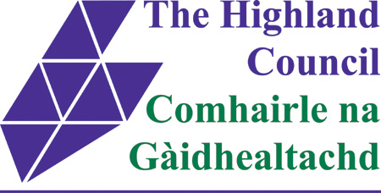

………………………………………..Community Council

Thursday 3 March 2016

NOTICE OF WITHDRAWAL

I, ...............................................................................................................................

hereby withdraw my nomination as a Candidate for election to the

……………………………………………………………………………………

Community Council for the above election being held on 3 March 2016.

Dated ..................………………….. ................................………..
Signature of Candidate

This form must be returned by close of the Withdrawal period at 4.00 p.m. on Friday, 5 February 2016 to the appropriate Ward Manager detailed below.

- Ardgay and District Community Council:
Garry Cameron, Ward Manager, The Highland Council, Drummuie Council Offices, Golspie, Sutherland, KW10 6TA.
Email address: garry.cameron@highland.gov.uk

- Ardgour Community Council; Arisaig Community Council; Kinlochleven Community Council; Mallaig Community Council; Morvern Community Council; Wester Ardnamurchan Community Council:
Dot Ferguson, Senior Ward Manager, The Highland Council, Lochaber House, High Street, Fort William, PH33 6EL.
Email address: dot.ferguson@highland.gov.uk

- Balintore and Hilton Community Council; Inver Community Council:
Helen Ross, Senior Ward Manager, The Highland Council, Drummuie, Golspie, KW10 6TA.
Email address: helen.ross@highland.gov.uk

- Ballifeary Community Council; Holm Community Council; Lochardil and Drummond Community Council; Muirtown Community Council:
Stewart Wardlaw, Ward Manager, The Highland Council, Town House, High Street, Inverness, IV1 1JJ.
Email address: stewart.wardlaw@highland.gov.uk

- Bower Community Council; Sinclairs Bay Community Council:
David Sutherland, Ward Manager, The Highland Council, Wick Area Office, Caithness House, Wick, KW1 4AB.
Email address: david.sutherland@highland.gov.uk

- Coigach Community Council; Contin Community Council; Kyle Community Council; Lochbroom Community Council; Strathpeffer Community Council; Stromeferry and Achmore Community Council:
Robbie Bain, Ward Manager, The Highland Council, Council Offices, High Street, Dingwall, IV15 9QN
Email address: robbie.bain@highland.gov.uk

- Conon Bridge Community Council:
Diane Agnew, Ward Manager, The Highland Council, Council Offices, High Street, Dingwall, IV15 9QN
Email address: diane.agnew@highland.gov.uk

- Dulnain Bridge Community Council; Grantown on Spey and Vicinity Community Council; Laggan Community Council:
Liz Cowie, Ward Manager, The Highland Council, Council Offices, Ruthven Road, Kingussie, PH21 1EJ
Email address: liz.cowie@highland.gov.uk

- Glendale Community Council; Raasay Community Council:
Willie MacKinnon, Ward Manager, The Highland Council, Tigh na Sgire, Park Lane, Portree, IV51 9GP.
Email address: willie.mackinnon@highland.gov.uk

- Kiltarlity Community Council:
Charles Stephen, Ward Manager, The Highland Council, Town House, High Street, Inverness, IV1 1JJ.
Email address: charles.stephen@highland.gov.uk

