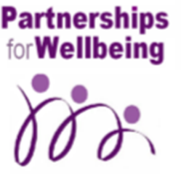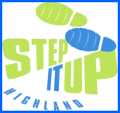
Partnerships for Wellbeing
Scottish Charity No: SCO 36055

‘Volunteering changed my life around’
Snapshot 1
‘This organization played a major part in my recovery and has given me a brand new lease of life. Something I never suspected was possible.’

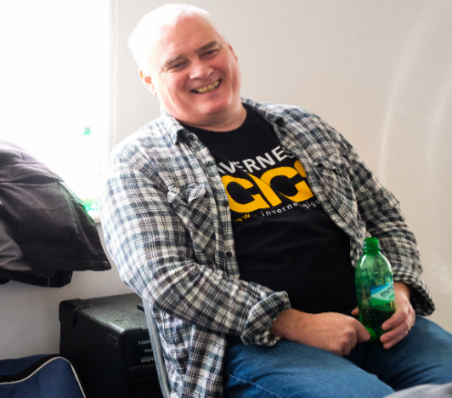

People volunteer for a variety of reasons; to become involved with something they are passionate about, to meet new people or to help their communities. We could not do what we do without our fantastic volunteers.

But, did you know that volunteering can have huge health benefits for you, even contributing to a longer life. Volunteering also helps to develop self-confidence, provides a sense of belonging and can even lead to a change of career. Dougie our Administrator tells us more

‘I joined the organisation after a period of volunteering with Inverness Voluntary Transport (IVTS). I was in the Civil Service my entire adult life but after a period of illness I was left in the house all day becoming bored and withdrawn.

In an effort to shake this off and get back into a routine I decided to seek voluntary work I could do whilst being off sick. My GP and

other medical professionals involved in my care were really supportive of my idea and
I found IVTS and volunteered. I started driving the IVTS car and thoroughly enjoyed every rewarding and fulfilling minute of it.

I eventually retired from my job on ill health grounds at the same time as PfW were advertising for a new Administrator. I decided to apply and was successful. I think the extra confidence and my knowledge of IVTS helped me to land the job – a complete change of career!

Volunteering to help others is a fantastic and valuable thing to do but, if you want to experience something new, develop your CV or explore a change of career volunteering can be a great way to do it.

If you are interested to find out more about our volunteer roles contact us on 01463 729997

