

**Inverness Voluntary Transport Scheme is a project managed by 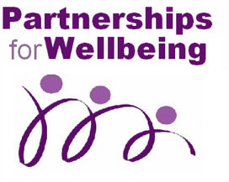Partnerships for Wellbeing**

Scottish Charity No: SCO 36055

**Inverness Voluntary Transport Scheme**

* affordable transport to community health facilities

Snapshot 1: *“Would you like a lift?”*

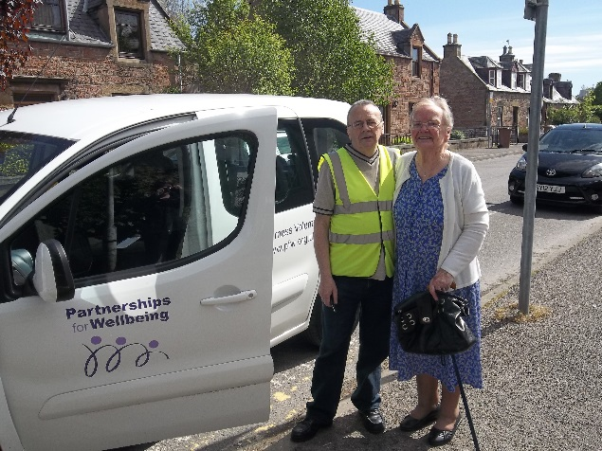

***Inverness Voluntary Transport Scheme offers value for money transport to health care appointments in Inverness with dedicated volunteer drivers.***

Many people struggle to get to their health care appointments, for various reasons:

* Access to public transport is limited
* It’s difficult to get on a bus or walk any distance
* They are recovering from an operation or injury
* The driver in the family has had to give up the car
* Family/neighbours aren’t always available.

**Inverness Voluntary Transport Scheme can take you.**

The service operates on weekdays between 9.00am and 4.30pm. Patients are asked to pay a small charge of £5 return or £3 single toward the cost of this service.

To register, or for more information, phone Fiona on **01463 226662.**

What our clients have to say about the service –

***“The only alternative for me would be a taxi, which as a pensioner I cannot afford.”***

***Your drivers are a very cheerful and helpful lot. I like them all.”***

***“I use the transport regularly, it’s a first class service. I like to travel First Class!”***

***“It’s like having a friend come to pick you up.”***