Step It Up Highland Health Walks – local, volunteer led walks in the company of others

Snapshot 2: Walking in Alness, Ross-shire

Step It Up Highland supports people to safeguard their own wellbeing and fitness, breaking down social isolation and loneliness in a positive, fun and empowering way.

Our Alness group have been walking in their community for 12 years and to date have not missed a single week!
Walk leaders are committed to ensuring those least able in their community are able to join in the weekly walks and estimate that the average age of those attending is in the high 70’s, with many walkers managing a range of health conditions.
Bernard is one of our active, caring and reliable walk leaders helping to support local people to take these first steps towards better health. He himself knows the benefit regular walking can bring as he uses it to manage his own long term health condition, diabetes.
What our walk leader says about managing his long term condition:
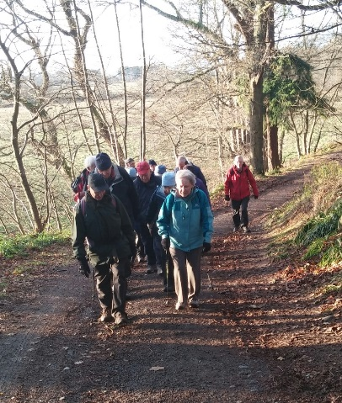

Bernard enjoying his walk - on right in photo

“On finding out I had type 2 diabetes 10 years ago, I asked Diabetes UK what I could do to best help myself and heard that exercise would be helpful. As I enjoy walking, that was my first thought – to get fit.
I subsequently moved up to the Alness area and heard about the health walks through the local Heritage Centre and joined Step It Up Highland, eventually becoming a walk leader myself.
I feel that joining the group has helped me enormously in managing my condition. One of my relatives had a limb amputated due to not managing the same condition, so I am careful to do all I can to help myself and this works for me – weekly walks in the company of others, enjoying the beautiful scenery.
Through the group I’ve heard about other exercise opportunities, such as dancing and table tennis too!”

