Step It Up Highland Health Walks – local, volunteer led walks in the company of others

Snapshot 4: Walking in Broadford, Isle of Skye

Step It Up Highland supports people to safeguard their own wellbeing and fitness, breaking down social isolation and loneliness in a positive, fun and empowering way.

Formed in October 2013, Broadford Step Out health walk group has 2 volunteer walk leaders who lead walks twice a week. Both have successfully lost a lot of weight (one nearly 5 stone) and champion the benefits that regular walking bring towards maintaining a healthy weight and a positive outlook. A walk leader adds….“I was a very overweight couch potato 5 years ago, now I enjoy walking & the improved health it’s given me so much, that I can’t bear that other people may be missing out – so I just want to share it with everyone!”

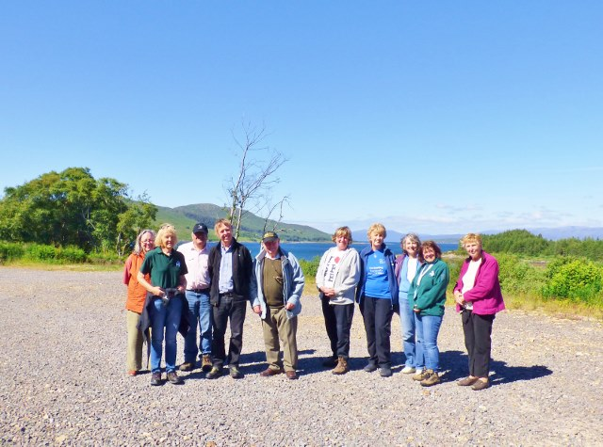

What our walkers say about the group –
“I initially didn’t want to come as I felt I’d hold everyone back but I can now walk at a good pace – though not usually too far”

“I can’t believe how much I’ve improved despite a lot of health problems”

I wasn’t confident enough to walk on my own”

