Step It Up Highland Health Walks – local, volunteer led walks in the company of others

Snapshot 8: Walking in Thurso, Caithness

Step It Up Highland supports people to safeguard their own wellbeing and fitness, breaking down social isolation and loneliness in a positive, fun and empowering way.

Thurso is one of our newer health walk groups, starting out in August 2013 to offer Step It Up core walks of up to an hour.
Having established particularly strongly the group has taken our ‘top spot’ in terms of recorded group walker numbers over a 6 month period in 2015, managing to offer 25 walks with 693 individual walks taken. What an incredible achievement!
Stuart is one of the 2 founding walk leaders in the Thurso group. He trained as a GP in Aberdeen, moved to Thurso in 1990 but, like many folks, suffered mental health issues which eventually led in 2011 to him being signed off from work and eventually taking early retirement. Here he shares how his involvement with Step It Up helped him mange his mental health.

Thurso group taken in September2013
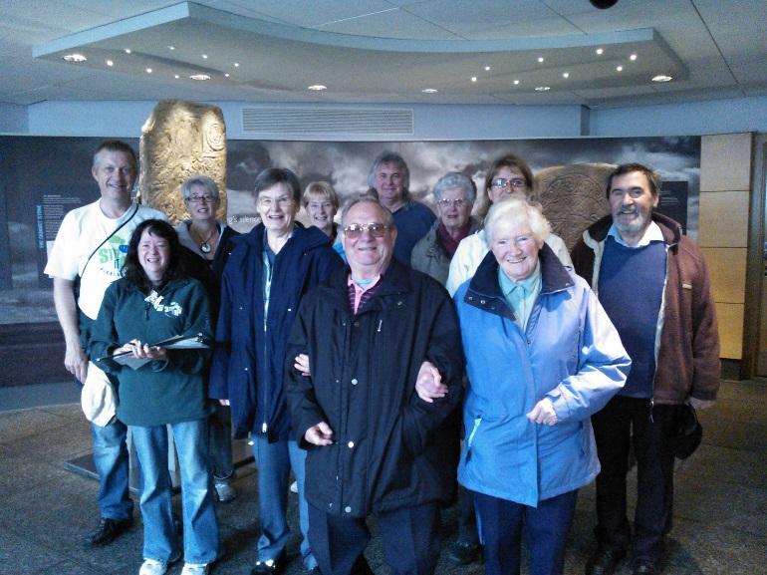
What our walk leader says about managing his mental health:
“I think it could help folks know that doctors, like anybody else, get mentally ill and also if one seeks out the right help then there can be quite a bit of light at the tunnel's end”.
“Following a complete breakdown in mental health, leading to an admission to New Craigs Hospital for 3 weeks, essentially brought my medical career to an end. Pensioned out at the rather early age of 50, I needed time to recover before being able to do much extra to basic survival!”
See overleaf for more….
Stuart adds “Then in May 2013 while attending a psychiatric outpatient clinic in Thurso I picked up a SIUH leaflet. The rest, as they say, is history!”
The Step It Up co-ordinator explains that Thurso had no health walks, so Stuart & another WL were trained and set about advertising and encouraging walkers to join the weekly free walks.
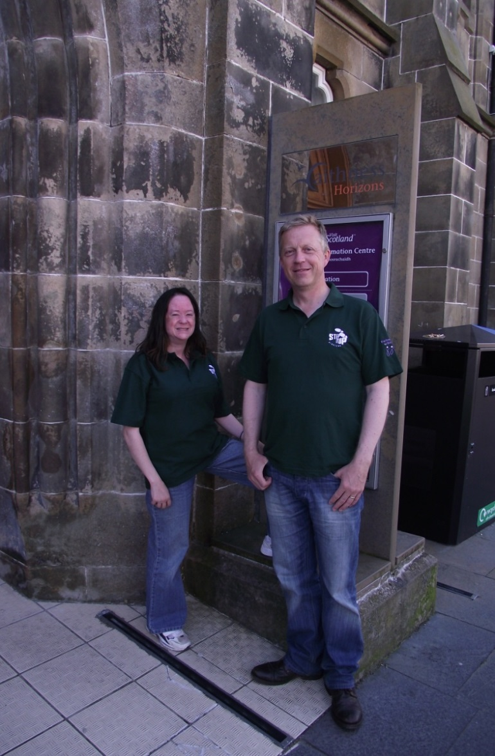
Pictured our 2 newly trained walk leaders pose in 2013 at the meeting point – Caithness Horizons, ready to begin duties!

Thurso group in action 2015
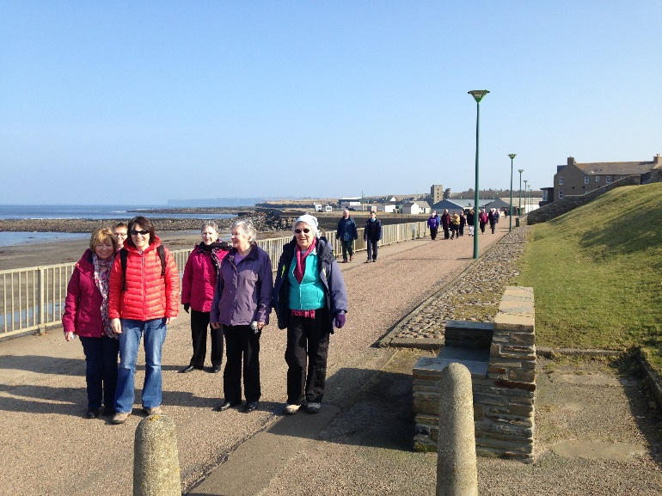
Stuart says “It quickly became apparent that I enjoyed leading, whilst Olivia (the other walk leader), had a forte of planning themed walks of an appropriate length around Thurso”
Adding “More recently, we have attracted in 2 further walk leaders. This has been excellent to help plan out further walks. We must have around 10 different walks around Thurso all of about the hour in duration. Each takes us to different parts of the town, which people, even long term locals, enjoy. On an average Wednesday morning we would now have between 25 and 35 walkers, although one morning we hit the big time with 40 walkers!”
“For me this has been a journey with many threads to it but I enjoy being part of something bigger which has a direct benefit on people’s health- a matter clearly close to my heart, given my previous life!”
“If anybody reading this is daunted at the task of setting up a new group, don’t be! Help is out there and you get back a lot more than you put in”.

