your island, your cash,
YOUR CHOICE
your choice

You can change your Island
Do you have an idea that will make Skye and Raasay a better place for everyone?
Do you need £100 to £1,500 to put your idea into action?
If your answer is YES then ‘Your Island, Your Cash, Your Choice’ is the opportunity for you to make your project happen.
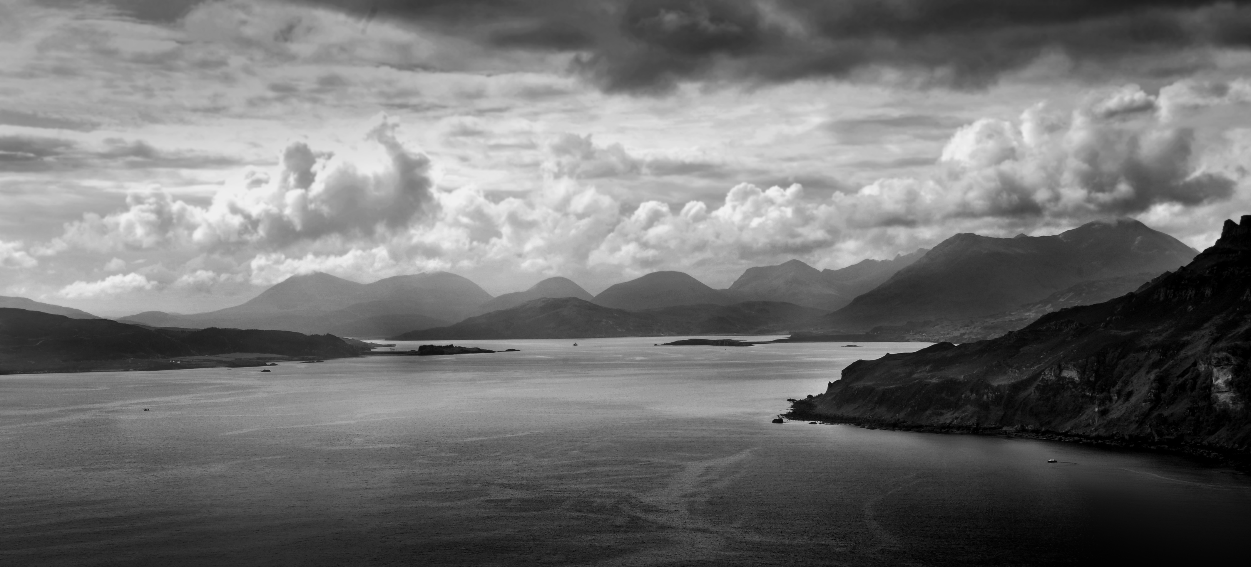
Deadline for applications is
Wednesday 29th April 2016.
If you need information or assistance with the application please contact
annie.davidson@highlifehighland.com, - 07795825573
Skye & Lochalsh CVO, info@slcvo.org.uk, 01478612921

A Community Group Event
Who can apply?
Any local community, voluntary or non-profit organisation – even informal groups– can apply for funding from £100 to £1,500 to put ideas into action.

You don’t have to come from an existing organisation to apply for this fund but all activities will have to happen in Skye and Raasay and benefit local people.
The Skye and Raasay Councillors have set aside £15,000 from the Ward Discretionary Budget and want to put YOU in control of how it’s spent.

The ‘Your Island, Your Cash, Your Choice’ Initiative lets the local community decide for themselves which projects are needed in their area.
REGISTER YOUR IDEA: APPLY TODAY
What can you apply for?
We need your ideas for projects that will:
- Benefit as many people as possible from across the community.
- Help to make Skye and Raasay a better place for everyone.
- Any project large or small welcome.
- Add value to existing projects.
Whether you want to organise a healthy living project, a crime prevention idea, a lunch club for older residents, a community art project, the only limit is your imagination and your project or idea happening within 12 months.

How do you apply?
To apply for the funding you must return this form before 4pm Friday 29th April 2016. If your idea fits, the community will get to vote for the best ideas at an event to be held on Saturday 28th May 2016, 11am – 3pm.

Event
The event will be held at Fingal Centre, Portree High School, doors open at 10.30am. At the event you will be required to present your idea to the community. Those in attendance will then vote on all the applications and a decision will be made on the day.

Refreshments will be provided.
Your full name:
Address where we can write to you. (Your own address or the address of the organisation you represent)
Your postcode:
Telephone number:
Email:
If you represent an organisation what is its’ name?
What is the name of your project/idea?
Where in Skye and Raasay will the project take place?
Briefly describe the project you would like funding for:
How will the project make Skye and Raasay a better place for everyone?
How many people do you think will benefit from your project?
For example this could be the number who will attend a lunch club weekly.
What particular need will it address for the community?
How much money do you require and what will you spend it on?
Please give a breakdown of the costs of your project and when you expect to spend the money by. Please detail any other funding sources and if it has been confirmed.

Please return this form via email to: Policy6@highland.gov.uk

or post/hand it in to: The Highland Council,
Tigh na Sgire, Park Lane, Portree, IV51 9GP

DEADLINE FOR APPLICATIONS: 29th APRIL 2016
