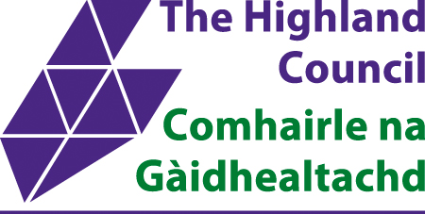
Highland Licensing Forum
Application Form

Name:

Address:

Post Code:

Email:

Tel:
Which one of the following categories apply to yourself (you may tick more than one box):
- Health, education or social work
- Young people
- Resident in forum area
- Holder of premises or personal licence
- Other

If a licence holder, please give address details of the licence you hold in the forum area:

The Forum’s role is to keep under review the Licensing Board’s decisions and consider the impact of those decisions at a local level. Keeping in mind the objectives of the Licensing Act, the Forum may give advice and make recommendations to the Licensing Board.
Why do you want to be part of the Forum?

Please give a brief statement about what you can bring to the forum, detailing membership of any organisations or network groups/community partnerships you are part of. (Please continue on a separate sheet if necessary).

Please return completed form to either of the undernoted Licensing Standards Officers :
LICENSING AREA | LSO | CONTACT DETAILS
SOUTH  Inverness, Nairn, Badenoch & Strathspey | Ian Cox | Tel: 01463 785089  E-mail: ian.cox@highland.gov.uk
NORTH  Caithness, Sutherland and Ross | Garry Cameron | Tel: 01408 635217  E-mail: garry.cameron@highland.gov.uk
WEST  Skye and Lochalsh and Lochaber | Chris MacKinnon | Tel: 07760 703222  E-mail: ewenchristopher.mackinnon@highland.gov.uk
Highland Licensing Forum Web Page:
www.highland.gov.uk/info/1125/licences_permits_and_permissions/339/liquor_licence/6

