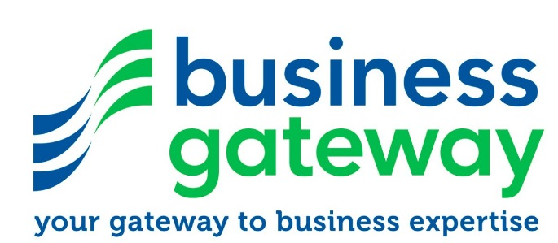

Is becoming self-employed an option and how do I get started?

This is a 90 minute awareness workshop which includes a group discussion and then the option of a one to one consultation with Business Gateway which will consider the following.

- Consider your motivation for wanting to start your own business.
- Understand the skills required in running a business.
- Know how to find and develop a winning idea.
- Be introduced to the support and facilities provided by Business Gateway.

If you are serious about becoming self-employed but don’t have a clear cut idea that you could develop, then a useful tool is our idea generation session/workshop. This session can coax and nurture ideas as well as very early checks on viability etc.

The ideas generation workshop leads onto a workshop with networking, group discussion etc.

Idea Generation Workshop

- Where do ideas for business come from?
- What could be a great business idea for you?
- How to develop an idea into a viable business.
- Think about what your own business could mean for you.

If you are interested in attending a workshop contact Lesley Allan to book a place 01463 898 466.

