Dingwall & Carnoch Registration Office
The Service Point
Ross House, High Street
Dingwall IV15 9RY

Tel: 01349 868507
Office hours: Mon-Fri 0930 – 1630

Fort William & Ballachulish Registration Office
The Service Point
Lochaber House, High Street
Fort William PH33 6EL

Tel: 01397 704583
Office hours:
Mon–Fri 0930 – 1230 & 1330 – 1630

Portree & Raasay Registration Office
Tigh Na Sgire
Park Lane
Portree IV51 9GP

Tel: 01478 613277
Office hours: Mon - Fri 0930 – 1600

Thurso, Strathy & Mey Registration Office
Service Point
Rotterdam Street
Thurso
KW14 8AB
Tel: 01847 892786
Office Hours: 0930 – 1630

Wick Registration Office
Service Point
Girnigoe Street
Wick
KW1 4HW
Tel/Fax: 01955 609524
Office Hours: 0900 – 1630

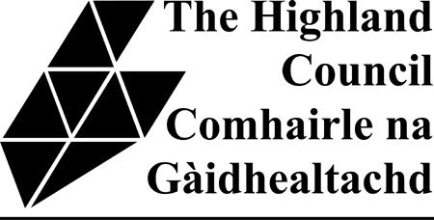

TRACING YOUR
SCOTTISH ANCESTRY

Begin with a search of the
Genealogical Records of Scotland
at a Registration Office in
the Highlands.
Details in this leaflet or on the
Highland Council website
www.highland.gov.uk
(Ancestry Research)

Contact:

inverness.registrars@highland.gov.uk

Inverness Registration Office
Highland Archive and Registration Centre
Bught Road
Inverness
IV3 5SS

Tel: 01463 256400
Office hours: Mon – Fri 0900 – 1630 (0930 opening on Thursdays)

What records are available?

All Scottish Birth, Death and Marriage Records from 1855 to the present day
Old Parish Records from 1553 -1854
Census records from 1841 – 1911
(A Census was taken every ten years)

What form do the records take?

There is on-line access to all the Scottish records shown above using the ScotlandsPeople system

You can either

Book one of the four ScotlandsPeople computers in The Family History Centre in Highland Archive and Registration Centre which are available for unassisted research (please see separate leaflet for information www.highland.gov.uk/scotlandspeople)

or

Book an appointment for a General Search with a Registrar
Ideally contact us in advance to avoid disappointment, particularly if you are travelling any distance. However, if this is not possible, staff will always do their best to accommodate you.

Where do I start?

It is always better to work backwards from the known to the unknown. So you should start with a family member whose place and date of birth, death or marriage is already known to you. This event should, of course, have taken place in Scotland and may be as recent as your own birth or your parents’ marriage. It should then be relatively simple to trace a direct line back to 1855, the beginning of statutory registration.

Please bring any documents/information you already have to assist your search.

How much will it cost?

A Particular Search is a search made by the Registrar for a specified entry over a period of five years and costs £5.00 per entry whether or not the entry is traced.

A General Search costs £30.00 per hour or part hour using ScotlandsPeople with a Registrar conducting the search for you.

When you have identified an entry which relates to your family you may

- Make pencil notes from that entry.
- Purchase a certified extract for £10
- Purchase historic paper copy for 50p

For this purpose, historic entries are:-

- Births over 100 years old
- Deaths over 50 years old
- Marriages over 75 years old
- Census Records
- Entries in the Old Parish Registers

What if I can’t come to the Registration Office?

Particular Searches are only available to personal callers, but you can buy individual extracts (certificates) by post for £15.00 per copy. We offer a postal service and will be happy to undertake a General Search on your behalf at the rates quoted.

You can order a copy certificate online using the following link:

www.highland.gov.uk/certificates

