EILEAN A’ CHEÒ WARD
CIVIC RECOGNITION AWARDS 2019

NOMINATION GUIDANCE

BACKGROUND

This is the 9th year of the Eilean a’ Cheò Civic Awards. The Awards recognise outstanding ability and/or significant contribution by a voluntary group or individual to the communities of Skye and Raasay.

AWARDS CATEGORIES

- SPORTS
- ARTS / MUSIC
- ENVIRONMENT
- COMMUNITY
- ENTERPRISE
- YOUNG PEOPLE

NOMINATION CRITERIA

This is a civic recognition award in respect of the Eilean a’ Cheò Ward which includes the Isle of Skye and Raasay.

All nominees must:
- Be resident on the Isle of Skye or Raasay
- Or can demonstrate their actions or activities have resulted in a significant benefit to the population of Skye or Raasay and as such would be eligible for civic recognition from the Ward
- Be nominated for voluntary effort – nominations for the award in respect of paid members of staff will not be eligible

The nomination form is attached but is also available on the EILEAN A’ CHEÒ page of the Highland Council Web site.
http:www.highland.gov.uk/downloads/file/16831/civic_award_application_and_guidance Please state clearly which category you are nominating your candidate for and state clearly why this person or group should receive civic recognition.

ALL NOMINATION FORMS MUST BE RETURNED BY 5pm on FRIDAY 22nd NOVEMBER 2019

DECISION MAKING PROCESS

The nomination forms will be considered by Elected Members at the next Ward Business Meeting following the closing date for nominations.

The person/ organisation making the successful nomination will be contacted following the Ward Business Meeting and a formal letter will be sent to the nominee advising them of the decision of Elected Members and the award they are to receive and for what.

AWARD CEREMONY

The awards will be presented by Elected Members at the next available Ward Forum – the date will be advised at the time of notification of the award. This is likely to be held at the Ward Forum on 9th December 2019.

AWARD

The award will take the form of a commutative plate designed and made by Uig Pottery, which will be presented at the Ward Forum. The plate will be retained by the successful nominee for a one year period whereupon it will be returned to the Council to be awarded at the 2020 ceremony.

Each successful nominee will receive a certificate which will detail the purpose of the award and signed by Elected Members.

PLEASE RETURN THE COMPLETED NOMINATION FORM TO:

THE HIGHLAND COUNCIL
TIGH NA SGIRE
PARK LANE
PORTREE
IV51 9GP
willie.mackinnon@highland.gov.uk

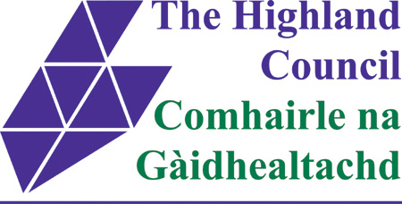

EILEAN A’ CHEÒ CIVIC RECOGNITION AWARDS 2019

CLOSING DATE FOR NOMINATIONS
FRIDAY 22nd NOVEMBER AT 5PM

CONTACT DETAILS OF NOMINTING GROUP/INDIVIDUAL
NAME
ADDRESS

TELEPHONE NUMBER
E MAIL

CATEGORY

PLEASE TICK ONE
SPORTS
ARTS / MUSIC
ENVIRONMENT
COMMUNITY
ENTERPRISE
YOUNG PEOPLE

NAME OF GROUP/ INDIVIDUAL BEING NOMINATED
ADDRESS

TELEPHONE NUMBER
E MAIL

REASON FOR NOMINATION

SIGNED | DATE

For official use :
Date received
Comments
Outcome

