Do you have an idea that will help improve your local area?
A helping hand for Hilton

Do you live in Hilton?
Do you need £100 to £700 to put your idea into action?
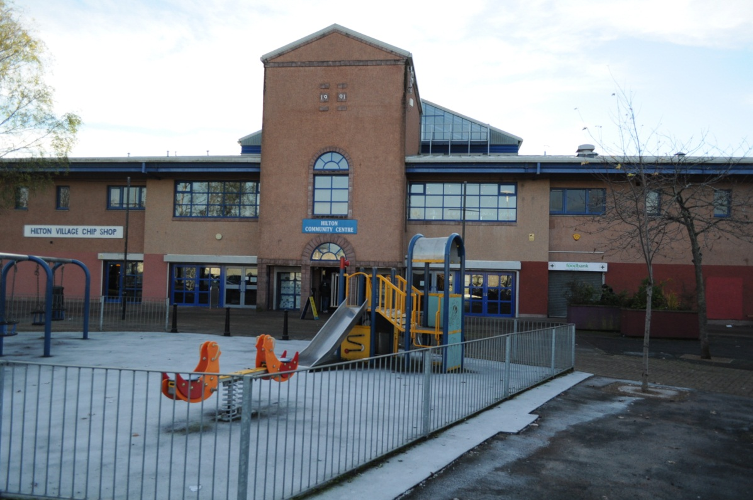
If your answer is YES then ‘A Helping Hand for Hilton’ is the opportunity for you to make your project happen.
Deadline for applications is
Tuesday 31st of January.
If you need information or assistance with the application please contact
Angus at Hilton Community centre
or email: helpinghandforhilton@outlook.com
Or phone the Policy team at the Highland Council on (01463) 702867

How do you apply?
To apply for the funding you must return this form before 5pm Tuesday 31st January 2017. If your idea fits, the public will get to vote for their favourite ideas at an event on Saturday 11th March 2017, 10:30am – 1:00pm.

Event
The event will be held at Cauldeen Primary School, Inverness doors open at 10am. At the event you will be required to present your idea to the community. Those in attendance will then vote on all the applications and a decision will be made on the day

Who will decide which projects are funded?
Local people will be invited to come along to the event to hear about the projects and then will be asked to vote to determine which projects are funded.

.

What can you apply for?
We need your ideas for projects that will:
- Benefit as many people as possible from across the community
- Help support people living in the Hilton area
- Be delivered within 12 months

REGISTER YOUR IDEA: APPLY TODAY
Who can apply?
Any local community, voluntary or non-profit organisation – even informal groups– can apply for funding from £100 to £700 to put ideas into action.

You don’t have to come from an existing organisation to apply for this fund but all activities will have to happen in the Hilton area and benefit local people.
The only limit is your imagination, whether you want to organise a healthy living project, start a new fitness group, put on a lunch club for older residents – all applications are welcome as long as the project supports local people in the Hilton area and will happen within 12 months.

Your full name:
Address where we can write to you. (Your own address or the address of the organisation you represent)
Your postcode:
Telephone number:
Email:
How much money are you requesting? (£100 - £700)
If you represent an organisation what is its’ name?
What is the name of your project/idea?
How will the project deliver a benefit to the Hilton area?
How many people do you think will benefit from your project?
For example this could be the number who will attend a lunch club weekly.
What particular need will it address for the community?
How much money do you require and what will you spend it on?
Please give a breakdown of the costs of your project and when you expect to spend the money by. Please detail any other funding sources and if it has been confirmed.
Please return this form via email to: helpinghandforhilton@outlook.com

DEADLINE FOR APPLICATIONS:31st January 2017
or post/hand it in to the Hilton Community Centre

