**Highland Council**

**Employee Early Release Scheme (EERS) Guidance**

**1.** **What is Employee Early Release Scheme (EERS)?**

The Employee Early ReleaseScheme is an opportunity for eligible employees to leave the Council by resigning and in return the employee will receive benefits in line with the scheme.

**2. Who is eligible for the EERS?**

The scheme is voluntary and is open to all Highland Council employees with more than one year’s continuous service (as at the 5th January 2017), with the exception of Teachers and employees delivering NHS commissioned services under our integration scheme.  
NB: Highland Council employees **do not** include those who work for Assessors and Highlife Highland.

**3. If I decide to take Employee Early Release when will I leave?**

Once it has been confirmed that you will leave the council via the EERS you will then be required to resign, sign settlement agreements and then work your period of contractual notice. Therefore leave dates will differ but would be between March and May 2017.

**4. If my application is declined, can I appeal against the decision made?**

No, there is no right of appeal.

**5. I’ve changed my mind. How do I withdraw my application?**

If you wish to withdraw your application you will need to confirm this in writing to your senior manager before you sign a settlement agreement document.

**6. What is a settlement agreement?**

A Settlement Agreement (just like its former name, Compromise Agreement), is a legally binding contract made between an employee and employer, either during or after employment, which formally agrees the leaving terms between the parties and prohibits the employee from bringing legal action against the employer in respect of their employment and/or its termination, usually in exchange for a termination payment.

**7. I am a temporary/fixed term member of staff. Would I be eligible to apply for the Employee Early Release Scheme?**

Yes, if you are an employee of the Council.

**8. Am I an employee?**

An employee is defined as someone with a contract of employment. The following non- exhaustive list provides examples of non-employees:-

• Consultant

• Temporary worker (paid via an agency)

• Volunteers

• Casual workers (as and when required)

If you have a full-time, part-time, term-time, permanent or fixed-term contract of employment and are paid regularly by the Council you are likely to be an employee.

**9. If I apply, am I guaranteed to get Employee Early Release?**

There is no automatic right to Employee Early Release.

**10. If not enough people apply for Employee Early Release, will there be compulsory redundancies?**

The Highland Council is committed to minimising the requirement for compulsory redundancies wherever possible. As well as the recent voluntary redundancy exercise the Council is currently operating corporate scrutiny of vacancies and agency usage, and a managed programme to reduce overtime. An initiative to further support intelligent redeployment and retraining will be launched early in the New Year.

**11. If I apply for Employee Early Release, what would the payment be?**

There will be two options available under the Employee Early ReleaseScheme:

* Receive 26 weeks basic pay as a compensation payment and access to actuarially reduced pension entitlement , if applicable

**OR**

* Access to unreduced pension, if applicable and no additional compensation payment

Compensation payments up to £30,000 are not subject to deductions for tax.

Estimates of potential benefits are available on the workforce change web page.

**12. Is it possible for me to select Option 1 - Reduced Pension and Compensation and defer taking my pension until a later date?**

You can apply on this basis and elect to defer **all** your pension benefits (Pension **and retirement grant (lump sum)). The earliest date deferred benefits can be accessed is normally age 60**. If you wish to apply on this basis please do so through the web page and also email the Pensions Section ([pensions.section@highland.gov.uk](mailto:pensions.section@highland.gov.uk)) informing them of your desire to defer.

**13. If my application for Employee Early Release is successful, when would I leave?**

If successful, you will sign a settlement agreement and resign from the organisation. Your leave date will be after you have worked your contractual notice so depending on your length of notice between March and May 2017.

**14. What is my notice period?**

Notice periods are determined by your grade, as follows:

HC1 - HC8 - 4 weeks

HC9 - HC13 - 8 weeks

HC14 and above – 12 weeks

However if the statutory provisions, based on length of service, are greater than the above then you will receive the statutory notice period, as outlined below.

|  |  |
| --- | --- |
| Period of Continuous Employment | Minimum Period of Notice |
| 2 years or more, but less than 12 years | One week for each year of continuous employment |
| 12 years or more | 12 weeks |

**15. If I leave the Council’s employment via Employee Early Release Scheme, I am resigning from the council. Therefore can I work for the Council again in the future?**

One of the terms of the settlement agreements will be that you are unable to return to the council for a period of 5 years**.**

**16. Do I have to take all outstanding annual leave before I leave?**

Annual leave should be taken before your agreed leave date.

**17. Will notice be paid in lieu?**

No, as part of the settlement agreements you will be required to work your full contractual notice period (see Q13). This is to ensure you receive your compensation payment tax free (up to the first £30,000).

**18. Why is there no right to appeal?**

The Employee Early ReleaseScheme is not an employment right. It can only take place with the agreement of the Council.

The aim of the scheme is to help the Council to achieve significant salary savings and contribute to its long term sustainability whilst doing everything possible to avoid compulsory redundancies. It will not be possible to accept all applications.

**19. What is my position with regard to making an application to the Council’s Employee Early Release Scheme if I have two or more contracts of employment with the Council?**

If you wish to apply for the scheme, your application must be in respect of all contracts of employment that you hold. It will not be possible to apply for and be accepted for the EERS otherwise.

**20. I am on maternity leave, can I apply?**

Yes, you can apply. Employees who apply for and are accepted onto the Employee Early ReleaseScheme but are unable, as a result, to fulfil the requirements of the Councils Maternity and Adoption Schemes will not have the excess occupational maternity pay amount that they have been paid under those schemes deducted from their compensation payments.

**21. I am absent from work due to sickness, can I apply?**

Yes, you can apply.

**22. Should I get legal advice?**

Independent legal advice will be provided when you sign the settlement agreements.

**23. Will I be entitled to benefits if I leave under EERS?**

There is further guidance available on your entitlement to benefits. This can be accessed via the workforce change portal [www.highland.gov.uk/eer](http://www.highland.gov.uk/eer). Alternatively you can contact the Welfare Support Team by phoning 0800 090 1004 or by email to [welfare.support@highland.gov.uk](mailto:welfare.support@highland.gov.uk).

**Employee Early Release Scheme process**

**24. How do I apply for the Employee Early Release Scheme?**

You must apply by submitting a form online (via the workforce change webpage) or if you do not have access to the internet please contact the Workforce Change Helpline on (01349) 886669.

**25. Who will decide if my application is accepted for the scheme?**

Directors will collate details of all applications, business cases and recommendations in a standard report and submit these to the Director of Finance for consideration before full scrutiny by the Executive Leadership Team and then final decision by Highland Council on 16 February 2017.

**26. What are the criteria for selection?**

Applications will be considered based on savings and the impact on service provision, including the ability to reorganise services within budget, and the impact on other posts and redeployment opportunities.

**Payroll & Pensions**

**27. Can I get help to understand my pension figures?**

There is a glossary of terms document available which explains this further. This can be accessed via the workforce change portal [www.highland.gov.uk/eer](http://www.highland.gov.uk/eer)

**28. How do I calculate my 26 weeks compensation payment?**

If your application is accepted your compensation will be based on 26 weeks basic pay. You can check your pay by accessing your electronic payslip on **MyView**.

In order to calculate an estimate of your basic pay you should look at the ‘Basic Payment’ figure(s) on your payslip. If you receive additional pay elements, such as enhancements, standby, overtime etc., these elements are not included for the calculation of compensation.

**Non variable pay**

If your basic pay does not vary from month to month your compensation will be as follows:

*Your compensation = ((Total Basic Payments X 12) / 52), X 26*

**Variable pay**

If your basic pay varies from month to month your payment will be based on an average of your last 3 months pay.

*Your compensation = ((((Average Total Basic Payments) / 3)  X 12) /52), X 26*

Please note that this is only as estimate. If your pay varies significantly month by month this will affect you final compensation figure.

***For further guidance and screenshots see Appendix 1***

**29. When will I be paid my compensation pay?**

Every effort will be made to have payments made on your leave date but this will be subject to:

1. Date the application is approved
2. Volumes of applications approved
3. Applicants completing the relevant pension forms

**30. Will I have to pay tax and national insurance on my compensation payment?**

Payments up to the first £30,000 are not subject to tax. There is no national insurance liability.

**31. Can I request my pension estimate and who do I contact to get it?**

Estimates can be obtained via the workforce change webpage.

**32. Will I be paid any outstanding holiday pay that may be due to me?**

Holidays should be taken prior to your leaving date.

**33. What is basic pay?**

This is your standard rate of pay before any additional payments are made. If you receive additional pay elements, such as enhancements, standby, overtime etc., these elements are not included for the calculation of compensation.

**34. Should I obtain independent financial advice?**

Yes. However, the Highland Council does not specifically recommend any individual or organisation with regard to this requirement.

**Appendix 1**

**Calculating your 26 weeks compensation**

Calculate your compensation payment using your basic pay from your latest payslip:

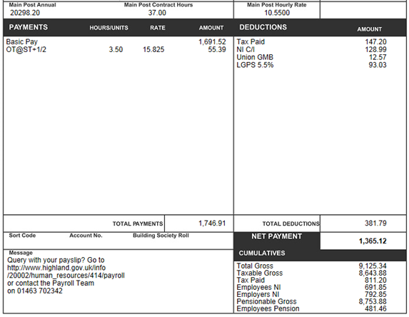

This is the figure you will need for your calculation

* Multiply your monthly basic pay figure by 12 to find out your annual basic pay:

**£1691.52 (monthly basic pay) x 12 = £20298.24 (annual basic pay).**

* Divide you annual basic pay by 52, then multiply by 26 to calculate your 26 weeks compensation payment:

**£20298.24 ÷ 52 × 26 = £10149.12 (26 weeks compensation payment)**

If you receive additional pay elements, such as enhancements, standby, overtime etc, these elements are not included for the calculation of compensation.

The compensation payment is tax free up to £30,000. If your compensation payment exceeds this amount, the amount over £30,000 will be taxable.

**If you are an employee who works variable hours, you will need to use your last 3 payslips to work out an average of your basic pay:**

Payslip 1: 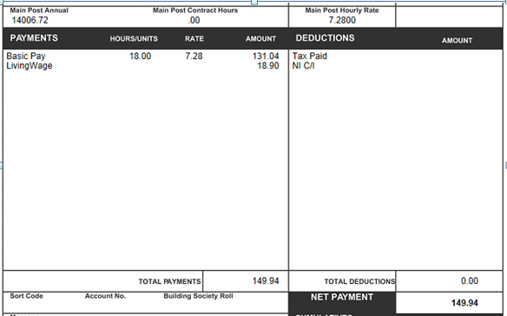

£131.04

Payslip 2: 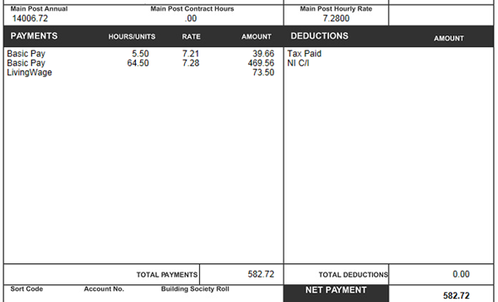

£39.66

£469.56

Payslip 3: 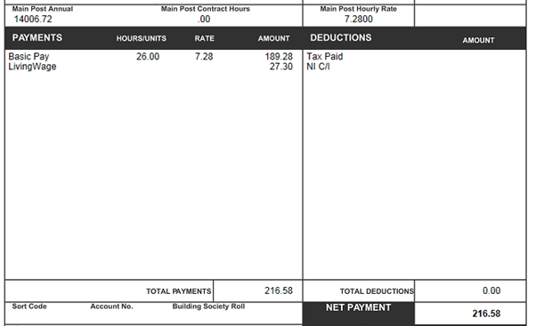

£189.28

* Add up each basic pay line from your last 3 payslips:

Payslip 1 £131.04

Payslip 2 £ 39.66

£469.56

Payslip 3 £189.28

**TOTAL £829.54**

* Divide the total by 3, then multiply by 12 to work out your average

annual basic pay:

**£829.54 ÷ 3 × 12 = £3318.16 (average annual basic pay).**

* Now, divide your average pay by 52 and multiply by 26 to calculate your 26 weeks compensation:

**£3318.16 ÷ 52 × 26 = £1659.08 (26 weeks compensation payment).**