The Association of Registrars of Scotland

Ceremony
Enhancements

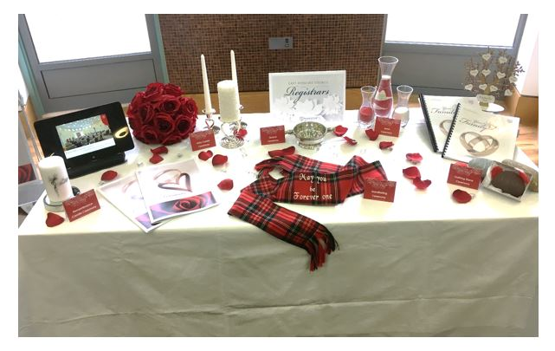

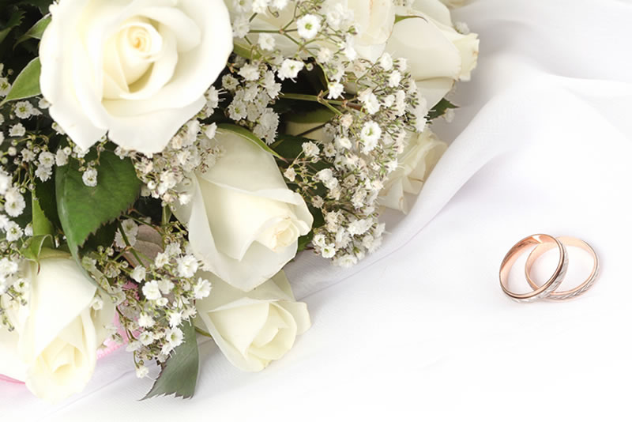

Some examples of Ceremonies
Put together by
AROS
Although there
Are many more

Oathing Stone Ceremony

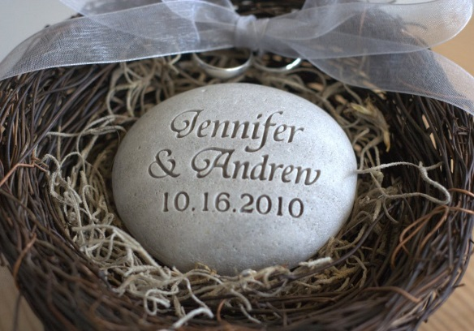
The Oathing Stone is an old Scottish tradition where the couple place their hands upon a stone while saying their wedding vows. Taken from the ancient Celtic custom of "setting an oath in stone", inclusion of the oathing stone ceremony in the vows can be deeply moving.
During the declaration of wedding vows or civil partnership promises, the couple hold the Oathing Stone, together in their hands. It is believed that holding the stone during the vows in turn casts or sets them in stone.
Any stone can be used for this purpose. One collected by the couple from a favourite place i.e. beach, local beauty spot etc would be appropriate. The stone should then be washed and scrubbed and treated with almond oil then wiped dry in order to give it a satin sheen (if desired).
The stone can also be engraved with a Celtic knot etching, the date of the ceremony and your initials if you wish, although it isn't necessary.

What you will need to do:
- Collect a stone suitable for use as an oathing stone.
- Prepare the stone and have it engraved if desired.

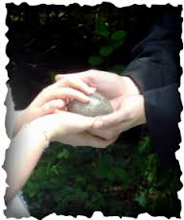
Example Wording:
Family and friends, _____ and ______, will now make their vows using the Scottish tradition of the oathing stone.
Can I please ask ______ to come forward with the stone.
For those of you not familiar with this Scottish tradition it is when the couple either hold or put their hands together on a stone as they repeat their wedding vows, as an oath given near a stone or water was considered to be more binding.
Some believe that it is where the phrase 'set in stone' comes from.
Hand-fasting

Hand-fasting is an ancient Celtic/Medieval custom, especially common in Ireland and Scotland, in which a man and woman came together at the start of their marriage relationship to declare of their own free will that they intended to marry.
While facing each other, the couple will join hands while a cloth is tied around their hands in a knot. This is where the term "tie the knot" came from. Couples often choose to use a cloth made of a particular clan tartan or a specific colour of cloth symbolising something important to them.
Hand-fasting is suitable for use in both weddings and civil partnership ceremonies.

What you will need:
- A cloth or ribbon suitable for hand-fasting

Example Wording:
There is an ancient Celtic tradition of binding a couple in marriage by hand-fasting -- literally, tying their hands together with cord or ribbon as a symbol that they are bound together not just for a lifetime, but for eternity.
_______ and _______ have decided to include a hand-fasting in their wedding ceremony to emphasize their eternal bond and reinforce the feeling that they never wish to be parted from one another.
In Scotland, until the mid 1700’s, marriages were celebrated by a simple hand fasting ceremony in which the two partners joined hands. The couple would link hands to form an infinite circle, and then, their hands or wrists would be bound together, symbolizing the binding together of their two lives into one. It is from this practice that the expression "tying the knot" probably comes from. _______ and ______ have chosen this day to engage in a traditional hand fasting ceremony.

PLACE THE TARTAN RIBBONS AND TIE ROUND WRISTS
With this cord I bind _____ and _____ to the vows they make to each other.
The knots of the binding are not formed by this cord, but by your vows. You hold in your hands and hearts the making and breaking of this union.
Just as your hands are now bound together, so too are your lives. May you be forever one, sharing in all things, in love and loyalty for all time to come.
May your marriage be blessed with patience and dedication, forgiveness and respect, love and understanding.

Unity Candle Ceremony

This ceremony involves the bride and groom or civil partners, using individual candles which they will in turn use to light one unity candle. Family and friends will then be invited forward to light their own candles from the unity candle flame in a symbolic act of togetherness and the merging of both families. This ceremony is suitable for all civil ceremonies.
The Unity Candle Ceremony is often used in naming ceremonies too as a gesture of unity, symbolising that those present will always surround the child(ren) in a circle of love.

What you will need:
- 1 large candle (this is the unity candle).
- 2 smaller candles (1 each for the bride and groom or two civil partners) and tapers to light them.
- Enough tea-light candles for everyone you wish to light a candle from the flame of the unity candle.
A suitable heat resisting container for the unity candle.
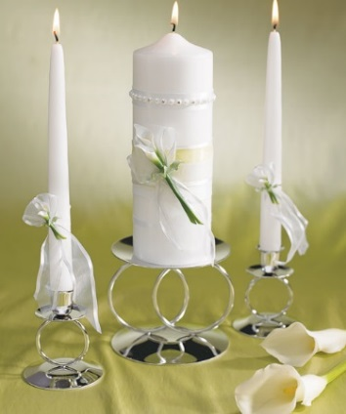
Example Wording:
________ and ________ have chosen to affirm their love by the lighting of a unity candle. They have also asked their families to participate in the lighting ceremony. In so doing, they signal their desire to not only join as one in their union, but to unite two families together as one.
I want to take a moment to explain what the lighting of these candles represents to them:
From every human being there rises a light. And when two souls that are destined for each other, find one another, their streams of light flow together and a single brighter light goes forth from their united being.
________ and _______ the brightness of the candles that your families have lit - and the brightness of the unity candle that you will together light - will shine throughout your lives, giving you courage and reassurance in the darkness. May the candle's warmth give you shelter from the cold. May its energy fill your spirits with strength and joy.
As you light the Unity Candle, I want to ask you - and all your friends and family that are present today - to see the brightness of the flame as a symbol of the brightness that your own life brings to this new family. As you lift your candles to light your family unity candle together, so may your love for each other light up your life as a family.
Your mothers have each lit a candle for each of your families. _______ and ______, please use those candles to light the Unity Candle together.

The Sand Ceremony

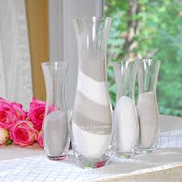
This ceremony requires the couple to provide three containers of coloured sand – one colour for the groom or first civil partner, one for the bride or second civil partner and one for the celebrant.
The three containers of sand are then poured into a fourth larger container at different points in the ceremony, each symbolising a different aspect of the couple, their relationship and their families. The sand then forms a pattern in the container, which is kept by the couple as a keepsake of their day.

What you will need:
- Three containers of sand, a different colour in each.
- One large container capable of holding the sand from all three smaller containers.

Example Wording:
Today, _______ and ________ have sealed the marriage into which they have entered by the exchange of vows and the giving and receiving of the wedding rings. They have committed to share the rest of their lives with each other.
This relationship is now going to be symbolised with a Unity Sand Ceremony, which may be new to many of you. Their relationship is symbolised through the pouring of these individual vases of sand into one. To symbolise the importance of the individuals within the marriage, and the joining of two lives into one entity, three colours of sand will be layered into this beautiful large vase.
______ and ______, as you each hold your sand, these separate vases of sand represent your lives until today, individual and unique. As you then combine the sand together, so your lives also join together as one.
Love is the eternal force of life and allows us to face fear and uncertainty with courage. Although you are sharing one life, never forget that you are two separate people. Cherish and affirm your differences. Love each other. Together you will laugh and cry, be sick and well, be happy and angry. Grow - sometimes together, sometimes separately.
I will begin with a layer of neutral sand - which symbolises that their marriage is grounded (Registrar to pour all the neutral sand into the vase)
Now we will layer the individual colours. This symbolises that the marriage is based on the strength of _____ and ________.
(Groom pours some in, then same amount by bride)
Finally, we combine the sands to symbolise two lives joined as one together, forever (Bride and Groom both pour remaining sand into large vase together so that they mix)
Just as these grains of sand can never be separated and poured again into the individual containers, so will your marriage be, united as one for all your days.

The Rose Ceremony
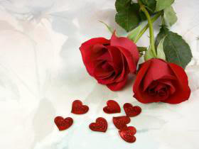

For this ceremony the couple need to give each other a rose.
This can involve the bestman/ witness or other person bringing the roses forward and doing a reading.
A fitting example being Robert Burns' 'My Luve is like a Red, Red Rose' before handing them to the couple who will then exchange them during this ceremony.
Some couples prefer to opt for a straightforward exchange of the roses during the ceremony and others have even chosen to involve their children in the ceremony.
The rose ceremony is particularly apt for Valentine's weddings but works equally well throughout the rest of the year.
This ceremony is suitable for both weddings and civil partnership ceremonies.
Example Wording:
Your first gift to each other for your wedding today has been your wedding rings - which shall always be an outward demonstration of your vows of love and respect and a public showing of your commitment to each other. In addition, you both have given and received one of the most valuable and precious gifts of life - one I hope you always remember - the gift of true and abiding love within the devotion of marriage.

Registrar hands each a red rose bud/or invites mothers to present the roses
The rose is considered a symbol of love and a single rose always means only one thing - it means, "I love you." So it is appropriate that for your first gift - as wife and husband - that gift would be a single rose bud.
Please exchange the rose buds as your first gift to each other as wife and husband.
Within these rose buds, if given proper loving care, is the potential for an even more beautiful expression of Life and Love in the form of the mature flower. And so it is with your marriage. At this point your marriage is like these rose buds - ready, with proper loving care - to unfold into a very beautiful expression of life.
____________ and ____________, if there is anything you remember of this marriage ceremony, it is that it was love that brought you here today, it is only love which can make it a glorious union, and it is by love which your marriage shall endure. Whatever the situation, love, understanding, acceptance and forgiveness can make everything right.

Including Children in a Ceremony

You may like to involve children in your ceremony in some of the following ways:
- Have them bring the rings forward
- Have them do a reading/poem/song
- Tie the knot for a hand-fasting ceremony
- Giving the child(ren) a ring or gift as a welcome to new family unit.
- Holding the stone in an Oathing Stone ceremony.

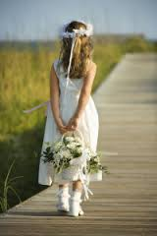
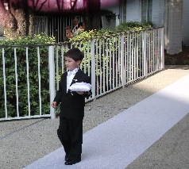

Remembering Absent Loved Ones

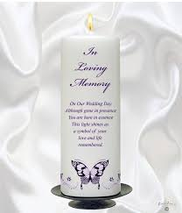
There are many ways you may like to remember loved ones on your day, the most obvious of which being asking your Registrar to mention loved ones in your ceremony. However you may also wish to include one of the following acts of remembrance:
- The lighting of a memorial candle in memory of an individual or a group of individuals.
- A table of remembrance with a photograph of your loved one(s) – you can also include a memorial candle here.
- Have a friend or family member do a reading or small speech in memory of the person/people.
- Include a favourite song of your loved ones within your ceremony music.

Example Wording:
It is ___ and ___’s wish that as we get started today you all join with them in a moment to remember those who, for whatever reason, could not be here physically, but who are here in spirit and wishing them a lifetime of happiness.

Example Poems:

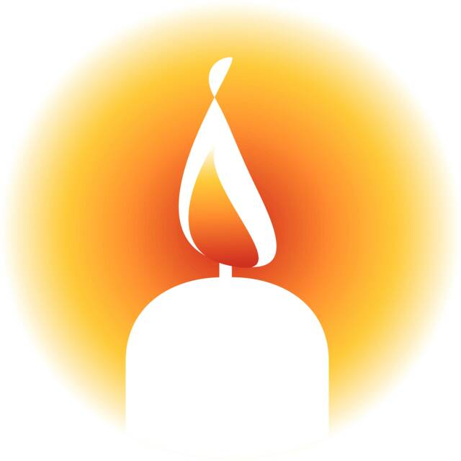
Although we can’t see you
We know you are here
Smiling down
Watching over us
As we say “I Do”
Forever in our hearts
Forever in our lives
And so we say our vows
In loving memory of you

Close to Us
When those we love
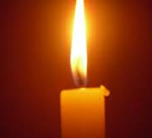
have left this earth,
we still can feel them near ~
we'll see a picture, hear a song,
and it's just like they are here.
when we believe and trust,
we know the ones
we care about
are always close to us.

Pinning of the Tartan

Following the proclamation that they were now married, the pinning of the tartan would take place. Each family would customize this, depending on whether the bride or the groom was being accepted into the other’s clan.
For instance, if the bride were marrying into the groom’s clan, any member of the groom’s family would present the bride with clan tartan. This might have been a rosette or a sash fashioned from their tartan. It would be fastened with the clan badge to the bride’s dress symbolically accepting her into the groom’s clan. Many times the groom himself would pin on the rosette or sash. It can be quite emotional when the groom’s mother does the pinning.
Likewise, if the groom is being accepted into the bride’s family, the roles are reversed.
Whichever way you would choose, this is one of the wedding ceremony customs that’s easy to incorporate in your wedding plans.
Example Wording:
The ancient Scottish Tradition of the Pinning of the Tartan will now be performed by ________ to welcome ______ into the Clan of __________.

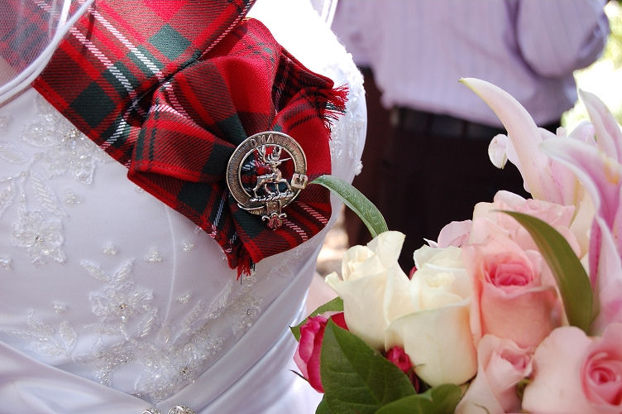

The Quaich Ceremony

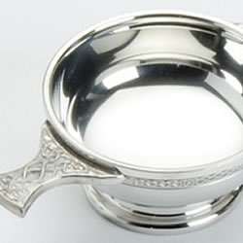
The Quaich was a two-handled loving cup for the wedding feast. From it the couple took their first communion together as a married couple. They also used the Quaich at the reception for their first toast together.
Symbolic of the sharing between the couple, it's an ancient vessel used by two families or clans, to celebrate a bond, with each leader partaking of the offered drink.
The Groom drinks from the Quaich and then offers it to his bride. The order in which it is then passed is purely a matter of choice although historically it would have been the leaders of each family or clan who would have passed the Quaich around.

What you will need:
- A Quaich (sometimes the couple have this engraved with their names and date of marriage)
- Preferred drink to fill the Quaich

Example Wording:
Example 1
Registrar: The years of your life together are like a cup of preferred drink poured out for you to drink. This Loving Cup contains within it a preferred drink that is sweet - symbolic of happiness, joy, hope, peace, love and delight. This same preferred drink also has some bitter properties that are symbolic of life's trials and tribulations. Together the sweet and the bitter represent "Love's Journey" and all of the experiences that are a natural part of it. As you share the preferred drink from this Loving Cup, so will you share all things in your life.
Registrar pours drink into the Loving Cup and holds it up

Registrar: This cup of preferred drink is symbolic of the cup of life. As you all share the preferred drink from the Loving Cup, you undertake to share all that the future may bring. All the sweetness life may hold for each of you will be the sweeter because you drink it together. Whatever challenges it may contain will be less difficult because you share them. Drink now from this cup, and acknowledge to one another that your lives have now become one

Registrar hands the Loving Cup to Bride and Groom.

Registrar: Now drink to the love you've shared in the past.

The Bride and Groom sip from the Loving Cup.

Registrar: Drink to your love in the present, on this your wedding day.

The Bride and Groom sip from the Loving Cup

Registrar: And drink to your love in the future and forever more!

The Bride and Groom sip from the Loving Cup and hand it back to the registrar.

Registrar: As you have shared the ___________from this Loving Cup, so may you share your lives. May you explore life’s mysteries together and find life's joys heightened, its bitterness sweetened, and all of life enriched by the love of family and friends.
(The Loving Cup may be passed around family and friends if desired)

Example 2
The Quaich which I am holding is a traditional drinking cup which is unique to Scotland. Drinking from a Quaich was part of a long established tradition of hospitality. If you shared a cup like this with somebody, you couldn't do harm or injury to the other; so you got the term 'loving cup'. King James VI (sixth) gifted this to his bride Anne of Denmark and thereafter sharing a Quaich became part of Scottish ceremonies. [name1] and [name2] would like to continue with this tradition today. As their first act together as a married couple, they are going to drink from this Quaich. In doing so they are symbolising their commitment to sharing everything in life and sealing the bond between them, whilst signifying the blending of their families."

Registrar fills the Quaich with whisky, wine or other preferred drink and says:

Strike hands with me, the glasses brim,
The dew is on the heather.
For love is good and life is long,
And two are best together.
Bless the union of these two,
Eager for marriage, eager for love.
May they begin life together,
Live that life together
And come to the end together.

_________ and _________, it is now time to complete your bond.

Registrar steps forward and presents Quaich to ________ and _______, then to the wedding party.

Registrar: The Quaich will now be passed between the families whilst ________ and ________ sign the marriage schedule.

Ring Warming Ceremony

A ring warming is when you give your loved ones the opportunity to hold and imbue the couple’s wedding bands with a wish, blessing or prayer for your marriage. By the time your rings make it on to the fingers of the couple they will be saturated with the love of their friends and family.

What you will need:
- Wedding ring/s
- Run a string or ribbon down the rows of seats, then as part of your ceremony you can have someone introduce the ring warming and start the rings on their voyage through your sea of guests
- Other options would be to simply tie the rings together or to use a little dish to pass the rings along the rows

Example Wording:
Later during the ceremony _______ and ______ will exchange rings as a physical symbol of the vows they are making to one another.
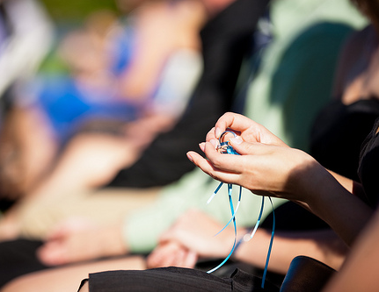
As the ceremony proceeds, will family and friends please warm these rings by passing them down the row. As you hold them in your hands, pause for a moment, and make your wishes for the couple and for their future together before you pass them on to the next person.
These rings will not only be a gift from one to another, but will be given with the love, support and wisdom of their loved ones.

Guest Vows

Some couples have been asking their guests to join in on the vows. After the couple makes their vows to each other.
Example Wording:
Now that you, beloved friends and family of ______ and ______, have heard them recite their vows, do you promise, from this day forward, to encourage them and love them, to give them your guidance, and to support them in being steadfast in the promises that they have made?

Guests respond: “We do!”

Children’s Gift Ceremony

Many couples like to acknowledge children they bring to the marriage. Here
are some examples.
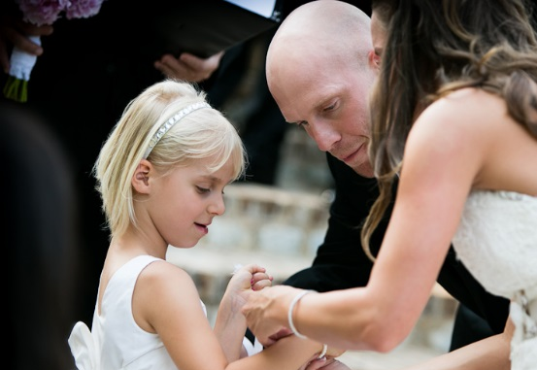
(name(s)) you are the most important
part of your mum and dad’s life – today
they are making a promise to one
another; this promise is also a promise
to you. You are already a family.
They love you with all their hearts, and
no matter how big you get or where life
takes you, they want you to know that
that’s forever!

During a wedding ceremony, rings are exchanged with a promise. (name)
and (name) thought it appropriate that their children should receive a token
of their promise. They wanted to find a way to let them know how special
and wonderful they are in your own way, and how blessed they feel to be
their parents. They also wanted them to have a physical reminder for the
future as they grow and become young men and women in their own
rite. There may come times when there are things going on in their lives
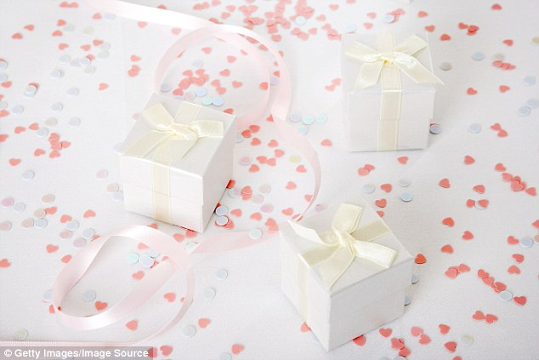
that they feel no other human would ever understand – (turn to the children)
– but there is nothing that any of you can ever say that will not be met with
unconditional love. So is the bond of trust that your parents establish with
one another, and extend to all of you this day. (Children step forward to
receive their gift).

The Hands Ceremony
(Partner 1) and (Partner 2) – please face each other and take each other’s
hands, so that you may see the gift that they are to you.

These are the hands of your best friend, young and strong and full of love for
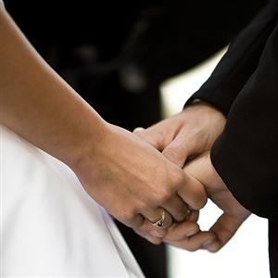
you, that are holding yours on your wedding day as you promise to love each
other today, tomorrow and forever.

These are the hands that will work alongside yours as together you build your
future.

These are the hands that will passionately love you and cherish you through
the years, and with the slightest touch will
comfort you like no other.

These are the hands that will hold you when fear or grief temporarily comes
your way.

These are the hands that will countless times wipe the tears from your eyes;
tears of sorrow and tears of joy.

These are the hands that will tenderly hold your children.

These are the hands that will give you support and encouragement to chase
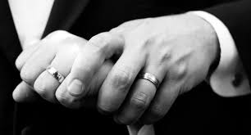
down your dreams.

These are the hands that will hold you tight as
You struggle through difficult times.

These are the hands that will give you strength
When you need it.

These are the hands that will lift your chin and brush your cheek as they raise
your face to look into eyes that are filled with overwhelming love for you.

And lastly, these are the hands that, even when wrinkled and ages, will still
be reaching for yours, still giving you the same unspoken tenderness with just
a touch.

