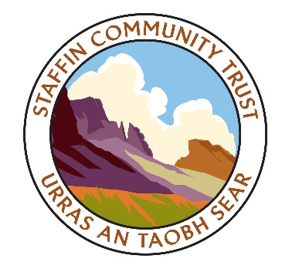
www.staffin-trust.co.uk

Willie MacKinnon Staffin Community Trust
Ward Manager Eilean a’Cheo Church of Scotland annexe
Highland Council Staffin
Tigh na Sgire Isle of Skye Portree IV51 9JX
Isle of Skye 18.2.16
IV51 9GP

Expression of Interest in the Storr

Dear Willie,

Following on from the productive Storr meeting in Auchtertyre that Staffin Community Trust had in January with Highland Council, Highlands and Islands Enterprise and the Community Ownership Support Service, the SCT held a special board meeting to discuss the project last week (11.2.16).

The SCT board agreed that that the potential project’s potential is hugely important for the Staffin and wider Skye community (as demonstrated by the strong support in the recent consultation), and its key objectives of creating local employment, marketing Staffin better and meeting its sustainability targets.
Prior to the proposed Options Appraisal, SCT board agreed that it would like to declare an intent to purchase the Storr site.
The exact size of site which SCT would seek to purchase would be determined through the work of the Options Appraisal.
I would be grateful if this letter could be accepted as a formal Expression of Interest in the Storr site owned by Highland Council, please.

Parking meters’ recommendation

On another matter relating to the Storr site, the SCT fully recognises and appreciates the challenging economic circumstances Highland Council is facing, and indeed its own community will likely be among those across the region to feel the impact of the proposed budget cuts.
However, the SCT board is concerned that a move to install parking meters at the Storr in time for the 2016 visitor season – as mentioned at the Auchtertyre meeting - could affect the project and undermine the recent local community consultation, which asked if Staffin residents/businesses would be supportive of parking fees “…if the income was going towards upkeep of the Storr site and other local projects”.
The response was positive in the consultation but that was dependant on direct community involvement at the Storr. There is no guarantee that the parking income would be retained in Skye and the local community could lose confidence in the SCT project, and feel aggrieved at the machines’ arrival so soon after the local consultation. In short, the council could be open to public criticism that the SCT had in effect tested the water with the consultation question and it had now proceeded with the move, but without the Council carrying out its own consultation with the local community.
SCT fully appreciates that it is a Highland Council-owned site but would like to respectfully request that a decision on the parking meters is postponed until the Options Appraisal is completed, given the project’s importance to the north-east of Skye and the rest of the island.

Yours sincerely,

Hugh

