The Highland Council
Redesign Board: Grey Fleet Review 10 October 2017
SCOPE
1. Definition
An organisation’s grey fleet are all vehicles, owned by its employees, which those employees use for business purposes. Grey fleet travel refers to mileage in employee-owned vehicles making journeys for business purposes.
2. Background
The Council has three categories of fleet:
- Heavy fleet – vehicle above 3.5 tons. These are procured by the transport manager in collaboration with operational managers. Day to day deployment is managed by operational managers and maintenance managed by the transport manager.
- White fleet – vehicles below 3.5 tons. Arrangements are as above.
- Grey Fleet – vehicles owned by employees and used on Council business. This applies Council wide. An employee using their own vehicle for HC business is covered by the same legislation as vocational drivers. HC has obligations in relation to the driver:
  - does the driver have a valid licence?
  - are they fit to Drive?
  - how is this checked?
and the vehicle:
- is it roadworthy - does it have an MOT and business insurance cover?
- How is this checked?
Travel and Subsistence Policy covers the rates of reimbursement. Grey fleet travel is not generally approved in advance.
Travel should be made in accordance with the Travel Hierarchy but it appears not to be widely understood or implemented.
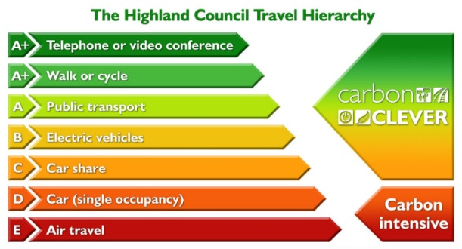
There is no clear owner of the grey fleet process.

Spend on Grey Fleet
Grey Fleet Analysis | 2015/16 |  |  | 2016/17
 | Mileage | Cost | CO₂e (tonnes) | Mileage | Cost | CO₂e (tonnes)
Staff | 5,861,331 | £1,925,959 | 1,837 | 6,024,756 | £2,243,531 | 1,887
Members | 412,150 | £185,162 | 129 | 371,890 | £167,380 | 117
Total | 6,273,481 | £2,111,221¹ | 1,966 | 6,396,646 | £2,410,911² | 2,004

¹ Average cost per mile 2015/16 = £0.336p
² Average cost per mile 2016/17 = £0.377p

Staff and Member grey fleet costs have reduced by £690,000 since 2011/12, which equates to a reduction of 27% in business mileage claimed when compared to 2016/17. However, there was an overall 2% increase in staff & Member mileage claims in 2016/17 compared to 2015/16, which requires analysis. Measuring and understanding the different levels of grey fleet claims year on year is clearly challenging, as no two years are exactly alike in respect of the business conducted by the Council.

3. The Objectives of the Review
Using the Peer Review 10 Options for Service Delivery model prepare proposals to:
- Reduce the spend on grey fleet mileage claims by recommending alternatives to grey fleet, whilst recognising that not all areas have access to alternative methods of travel.
- Reduce the risk to the Council in terms of liabilities relating to staff using their own vehicles.
- Reinvigorate the travel hierarchy and promote lower cost and more carbon efficient methods and alternatives to travel.
- Review the Travel and Subsistence Policy.
- Recommend Directorate ownership for travel.
- Develop an Implementation Plan.
4. Out of Scope
- Fuel procurement
- Staff not employed directly by HC (eg. HLH, Assessors)
5. The Review Team
Name | Designation
Caroline Campbell | Head of Performance and Resources, Community Services
Angela Mackenzie | Payroll Operations Manager
Keith Masson | Climate Change Officer
Kateryna Zoryk | HR Business Partner
Roy Cattle | Union Representative
Councillor Loudon | Redesign Board Member
Councillor Gray | Redesign Board Member

Supported by Bill Alexander, Director of Care and Learning.

