**The Highland Council**

**Redesign Board Workshop: Car Parking**

**14 November 2017**

**SCOPING DOCUMENT FOR DISCUSSION**

## Background

Following the Decriminalisation of Parking Enforcement, the Car Parking Service is in the process of being fully rolled out.

The key objectives of car parking are:

* To ensure consistent traffic management through car parking
* To recognise the effect car parking charges can have in our cities, towns and villages
* To be cost effective
* To manage long-term and short-term parking opportunities
* To raise public awareness, consider the needs of all users and encourage behavioural change where appropriate

There is currently no overall Vision on how off-street parking and on-street parking should be delivered.

There are presently a range of tariffs across the Highlands with 18 off-street car parks charging for use.

In 2015/16, the gross revenue (excluding permits and fines) from the charging car parks in Aviemore, Fort Augustus, Fort William, Inverness and Portree totalled £1.37M.

As well as income budgets, there are costs associated with staffing, transport, repairs & maintenance costs as well as supplies & services and these are summarised below and set out in more detail (excluding the Transportation Team) in an Income & Expenditure breakdown at Appendix C.

|  |  |  |
| --- | --- | --- |
| **Area** | **Income** | **Expenditure** |
| Inverness | - £1,011,200 | £423,543 |
| Badenoch & Strathspey | - £20,000 | £800 |
| Sutherland | - | £13,300 |
| Skye | - £64,600 | £12,900 |
| Lochaber | - £363,890 | £75,200 |
| Ross & Cromarty | - | £44,500 |
| Caithness | - | £13,500 |
| Nairn | - | £13,800 |
| Headquarters | - £1,075,000 | £683,456 |
| Transportation Team | - | £174,029 |
| **Total** | **- £2,534,690** | **£1,455,028** |

The Service faces a budget pressure of £0.4M in relation to a reversal of previous pricing conditions, sale of assets and some fee increases not being implemented.

The Car Parking team structure (including the Transportation Team) is set out in Appendix B

Those supporting the review include:

## Community Services

|  |  |
| --- | --- |
| Name | Designation |
| Tracey Urry | Head of Roads & Transport |
| Shane Manning | Principal Traffic Officer |

## Peer Review Team

|  |  |
| --- | --- |
| Name | Designation |
| Councillor Baxter | Redesign Board Member |
| Councillor Boyd | Redesign Board Member |
| David Haas | Inverness City Area Manager |
| Robbie Bain | Ward Manager |
| Alasdair Bruce | Service Delivery Manager |
| Paul MacPherson | Union Representative |

## Supported by: Stuart Black, Director of Development & Infrastructure

## Objectives

1. Assist the Service set out a Vision for Car Parking – both off-street and on-street parking
2. Guide the Service in the component parts which should be contained within the Vision to achieve consistent traffic management
3. Appraise current financial management and business planning
4. Review current administrative processes
5. Consider the available information on the Council’s parking estate and help the Service identify additional parking opportunities.
6. Consider the views of stakeholders and staff
7. Look at the relationship between car parking and public transport, e-cars and cycling and help the Service identify any opportunities for changing behaviours
8. Consider the 10 options for service delivery
9. Consider how car parking is viewed by visitors to the Highlands and assist the Service identify where enhancements can be made
10. Assist the Service in identifying opportunities for commercialism
11. Include recommended pricing strategies and business processes within the detailed options appraisal
12. Recommend a preferred option; including direction for further business planning that also takes into account the Council’s localism agenda

**Methods that will be used to undertake this review**

1. Desk-top analysis of existing information, reports and methods of delivery etc. (not limited to Scotland)
2. Meetings / workshops / focus groups with staff and managers
3. Stakeholder engagement
4. Customer engagement
5. Visits to see the service being delivered
6. Discussions with other councils on best practice

**Appendix A – Peer Review 10 options**

**10 Options for Service Delivery**

Peer reviews will consider the following options for service delivery:

1. **In-house services** – running these better, more efficiently and identifying where a Lean Review should be undertaken.
2. **In-sourcing** of services currently contracted out.
3. **Shared services** – both provided by us and provided for us.
4. **Outsourced services** – see if a different approach is needed e.g. commissioning by outcomes, payment by results, a shared or coordinated approach.
5. Services delivered in **partnership and/or integrated** with others, this could be place-specific.
6. **Arms-Length External Organisation** or other Council owned or created organisation to enable freed up, commercial or more sustainable practice.
7. **Commercial opportunities** within the service. By generating more income we can off-set grant reductions and support services and jobs across the region.
8. Transferring to a **community-run** service. This could be place specific.
9. **Reducing demand** for the service or more preventative approaches.
10. **Reducing service standards** (re-setting these with affordability in mind) **or stopping services**.

**Appendix B**

**The Car Parking Team Structure**

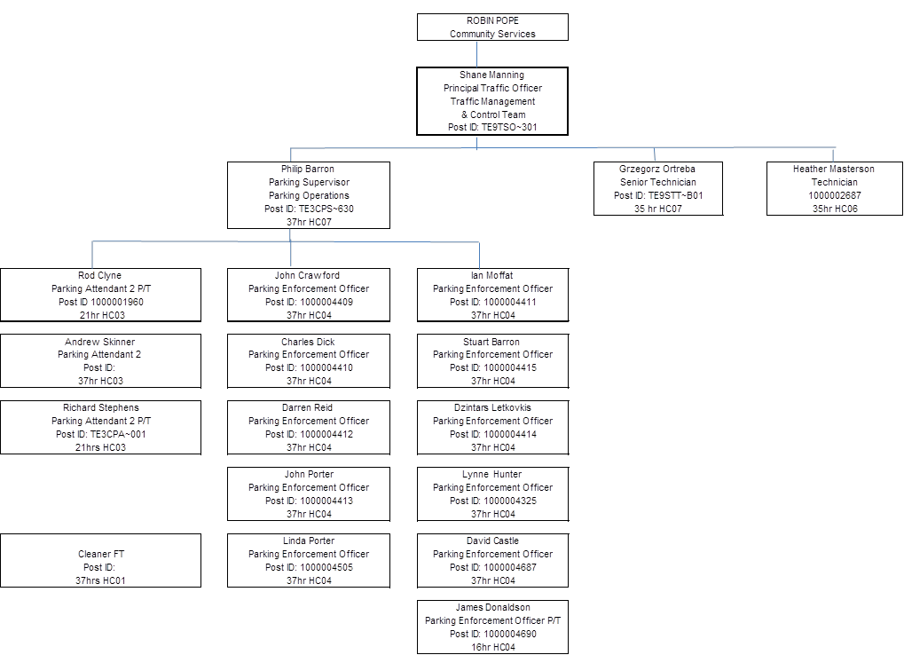

Appendix C

Income and Expenditure Breakdown

