Developing a Redesign Communications Plan
November 2017/18 Draft for Discussion

Purpose of the plan
A managed approach to communications, using a variety of methods, is required to support the Council’s programme of change and to reduce the associated risks to the performance, culture and reputation of the Council.

The Redesign Board’s Communications Plan identifies the key messages for internal and external stakeholders affected by the Redesign programme of work and supports stakeholder engagement.

Aims of the plan
The Council has agreed that it must adapt to changing needs with less funding. To do this it will redesign how it operates and what it does. Its approach to redesign is be open, transparent, honest and inclusive. The communications plan must provide clear communications of the reasons for redesign, explain what redesign means for internal and external stakeholders and what redesign is achieving. The plan must also set out how stakeholders can be involved in redesign: understanding the decision-making process, recognising how redesign will affect them and how they can contribute ideas and action.

Redesign activity includes the redesign approach and activity agreed to date by the Council, the work of the current Redesign Board until June 2018 and the related work currently underway in four other budget groups covering: prioritisation; efficiency; income; and commercial themes. These theme groups will also help to redesign the Council to be more open-minded to new ways of delivering services, more commercially-minded and more community-minded.

Stakeholders
Those affected by redesign are:
- Elected members
- Staff
- Trade Unions
- Highland citizens, general public and specific service users
- Private sector operating in Highland
- Third sector organisations, community groups and community councils operating in the Highlands
- Other public bodies operating in the Highlands
- The Scottish and UK Governments.

Are these the right descriptions of stakeholders?

Key messages
- The reasons for redesign
The scale of the Council’s funding gap, estimated to be £160m over the next five years means that the Council’s financial resources from current sources are assumed to reduce by 25% by 2022/23. Having already made savings totalling £150m since 2010/11, this continued reduction fundamentally changes what the Council can afford to do and what can be expected of it. We must reduce our costs.

By increasing income from other sources we can reduce the funding gap, lessening the severity of budget cuts.

However, at the same time the Council must also respond to new statutory and Government requirements, some of which constrain the extent to which some services and expenditure can be changed. This means the funding gap will have more impact on some services than others. Also we have to respond to growing demand for some services largely arising from demographic change and arising from citizen expectations of regional development and improving infrastructure.

The scale of further significant budget reductions after seven years of savings means that the role of the Council has to change. The Council can no longer do everything it has been doing and for the things it will continue to do, it can no longer do them the same way.

Redesign gives us an opportunity to review what we do, whether and to what standard we should do it and how to do it affordably. It will mean change in our operations and change in what can be expected of us as well as what we can expect others to do. Redesign also allows us to understand the impacts on those affected by it to help us with workforce planning and how best to engage with communities and partners.

Is this the best way to express the reasons for redesign?

- What redesign means
The Redesign Board in 2016/17 listened to a range of evidence from a variety of sources within the Highlands and elsewhere in the UK. It concluded that redesign means the Council must be:

- More open-minded to new ways of delivering services, with 10 options identified and a drive for more innovation;

- More commercially-minded, raising income to sustain services and jobs across the region; and

- More community-minded, supporting more community-run services, helping people to help each other, widening public involvement in Council decisions and listening locally. It also means targeting support to particular people and places in most need.

Redesign also recognised the importance of staff not only in making change happen but also in identifying what needs to change as experts in their field of work and as sources of local knowledge. The people employed by the Council are Highland citizens using Council services and many volunteer in their communities. Each year even more staff will become actively involved in reviewing services directly. Staff are also represented by Trade Unions through their involvement in the Redesign Board, with their contribution constructive and influential.

Redesign recognised the importance of elected members working together and with staff and Trade Unions early on and constructively to redesign the Council.

We have graphic images of redesign for use in communications:

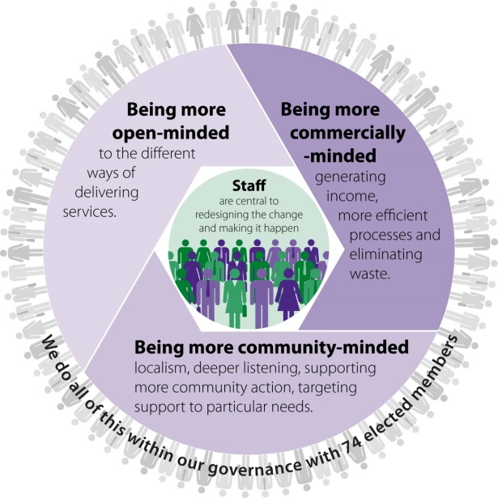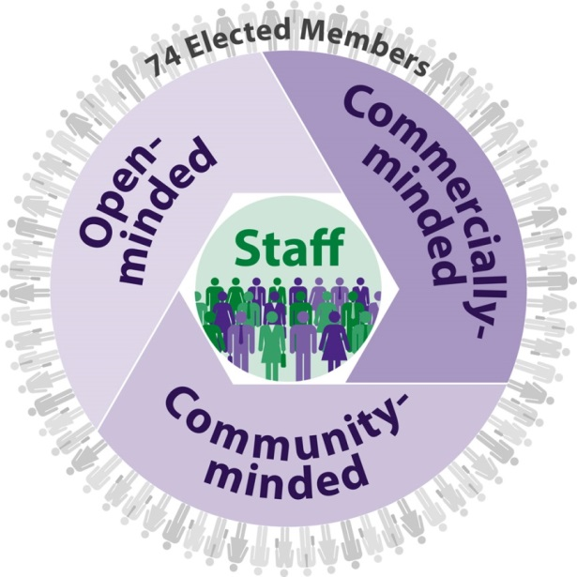

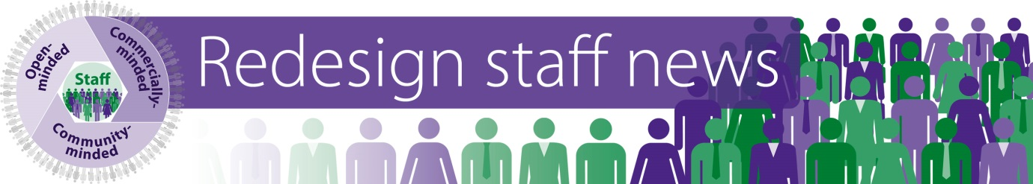

- What redesign is achieving already and to June 2018
This aspect of the communications plan will need regular review for key messages to be refreshed and to encourage further involvement of stakeholders.

Progress as at October 2017 is described below:

- More open-minded
Reviews of services by peers have identified how to redesign in seven significant service areas so far. These are in services for children, children with additional support needs, waste services, street lighting, street cleansing, public transport and administration in schools. Savings and/or income of around £5m over 3 years have been estimated, with up to £1.5m savings and income already achieved in services. Business cases are also in development to follow through on reviews. All have identified improvements to the services reviewed and these are being supported by Lean reviews involving staff in streamlining our processes.

Five new service areas are being reviewed in 2018 so far: music tuition; commissioned services for children; grey fleet; car parking and procured legal services. They will make their recommendations over the next few months and these will inform the budget process. A programme of Lean reviews is underway and up to 30 staff are trained so far in applying the process.

Budget theme groups, led by Members on the budget group and Directors are identifying further savings from efficiency and re-prioritisation of services. Some of their work may instigate new peer and Lean reviews too.

- Commercially-minded
The Council has established a Commercial Board to develop and oversee a commercial strategy to generate significant income streams for the Council. This will mean being more open to risk and developing new commercial services operating in the market. Business case development is underway.

Member led budget theme groups on commercial and income opportunities are also in place to support this work. They will build on the work of the former income generation board and benefit from re-structure with a new focus for a Commercial and Continuous Improvement Team.

- Community-minded
Engagement with community bodies since August 2016 advised us what we need to do differently to support more community action and community-run services in Highland. If we expect people to help each other more and be less reliant on the Council then we need to make that as easy as possible for them. Community bodies developed practical ideas for this and told us that attitudes and processes in public bodies need to change to be more supportive and appreciative of community efforts.

In 2017 we have been discussing the feedback from community bodies with our community planning partners who are also affected as many provide support to community groups too.

We are now working on how to provide a single point of contact to help community groups in the Council and are prototyping some new web-based tools to help them as well. This work will also help us to develop our localism approach, a key priority in the Council’s programme.

We will be creating new training and development for staff and refreshing the competencies required in a redesigned council. These will include how the Council can support community bodies better and to help people help each other in their communities.

- How to be involved in redesign - Redesign is everybody’s business.
The impact of redesign is far-reaching for Members, staff, partners and communities. It needs to be everybody’s business.

So far most attention has been paid to involving Councillors, Trade Unions, staff, community bodies and to some extent partners. New methods have been introduced for engagement. This is described more fully below.

As well as mainstreaming these new approaches, attention needs to be turned to communication with other stakeholder groups too, as set out below for discussion.

Communication methods to use and opportunities for each stakeholder to be involved

- Elected members
The methods in use for Councillors are: participation in workshops and Board meetings, as team members for peer reviews, considering reports to Council, communication through Group Leaders and information on the redesign page of intranet. Board Members are also involved in face to face briefings with staff twice a year for managers and other staff locally.

The Redesign Board includes 16 Councillors, including all Group Leaders and most of the Budget Group leaders. Workshops and formal meetings of the Board are open to all Members to participate in and some attend regularly as non-Board Members. Members are also attached to individual peer reviews to provide challenge, support and ideas for the review. Progress reports are made to every meeting of the Council. By end 2017 there will be Member workshops locally to begin to develop the Council’s approach to localism. This will include the redesign context and how to support more community-run services. The Commercial Board was established in September 2017. The Leader and Deputy Leader convene meetings with Local/Area Committee Chairs 6 weekly, with scope for redesign to be discussed. There is a dedicated page on the intranet for redesign information. It is up-dated and includes all Board activity and review outputs.

Are these sufficient?
What other opportunities are there for engaging elected members further?
What more can the Board propose / do?
How might an approach to engage MSPs and MPs assist the Council – linked to Governments as a stakeholders as set out below?

- Staff
There are nearly 10,000 staff employed in the Council. They are well aware of the impact budget challenges and savings have had on them and their teams, including voluntary redundancy, vacancy management, the Early Release Scheme and restructuring. Redesign and the workforce strategy both aim for planned rather than reactive change for staff.

New methods for engaging staff
Through redesign the following new methods were developed in 2016 to engage staff and these are now mainstreamed as normal business. They include face to face and digital methods as listed below.
  - Involving staff in peer and Lean reviews – directly in teams and by supporting teams through consultation and data provision. Briefing sessions are scheduled to raise awareness of the Lean programme, with roll out from November 2017. More staff will be involved as more reives are done.

  - Local face to face staff forums - These are run for staff across the region in offices and depots twice a year. They are led by the Executive Leadership Team and have involved Heads of Service too. Since late 2017 they have involved Redesign Board Members and in 2018 Trade Union representatives from the Board have participated.

  - Creating a staff panel to respond to e-surveys. Around 900 staff have signed up to take part in the panel. They have responded to two surveys in 2017 on the Highland Outcome Improvement Plan and the Commission on Highland Democracy with scope for future surveys to be done.

  - Creating a staff Facebook group - Currently there are over 700 members of staff signed up to the group. This enables quick dissemination of a variety of Council news.

  - Dedicated page on the intranet on redesign - This page is up-dated regularly and includes information about the Board workshops, the reviews and any external engagement. It also describes what redesign means and how staff can be involved in it. A blog to include on the page is under development. Current thinking is to include video clips of staff involved in peer and Lean reviews and for Board member interviews.

  - Asking for staff ideas on-line
This is done through:
    - A dedicated redesign mailbox redesign@highland.gov.uk for staff to contact. It is promoted through all user emails and in local staff forums. It enables staff to pass on ideas and issues directly without raising them through their line managers.
    - A new on-line ideas tool which when used in late 2016 generated over 150 efficiency ideas and over 50 commercial ideas. The tool was procured initially for 1 year and to avoid further costs the development of an in-house tool is under consideration.

These new approaches are in addition to methods already in use to communicate with staff. These are:
- Management Briefings;
- Senior Leadership Team sessions;
- Arrangements for cascading information through line managers (e.g. team meetings and service briefings); and
- Staff newsletters (In Brief). The last staff newsletter in September generated two new ideas for Lean reviews.

Trade Unions will also have methods for engaging with their members on redesign.

Are there other opportunities for engaging staff further?
What more can the Board propose / do?

- Trade Unions
Methods in use for involving Trade Unions in redesign are: as Board Members in directing redesign (2 representatives are on the Redesign Board), as representatives involved in all peer reviews, through reports to the Staff Partnership Forum and by involvement in face to face staff briefings for Managers and staff locally. In addition, where reviews are underway that might affect teaching staff, meetings with teaching staff-side representatives are held to brief them on progress and to listen to any questions, issues or concerns they may have. Engagement is constructive and positive.

Anything to add here from the Trade Union representatives?
Are there other opportunities for engaging Trade Unions further?
What more can the Board propose / do?

- Highland citizens, general public and specific service users
The scale of further significant budget reductions after seven years of savings means that the role of the Council has to change. It can no longer do everything it has been doing and for the things it will continue to do, it can no longer do them the same way. Current engagement has focused on:
- Surveys of the Citizens’ Panel – on budget consultations, service choices and impacts, views on communities doing more and expectations of the Council
- Understanding user views for services subject to review – although this draws on information already available and not always from new engagement.
- Conducting impact assessments for equalities groups and for people living in poverty and in rural settings is part of the process for peer reviews.
- Engagement with the media: media briefing when the first Board was initially established, circulation of press releases and press reporting from Council meetings including on budget decisions.
- Opportunities through service led engagement with service users e.g. events for parents in schools where budget pressures raised.
- To some extent the work of the Commission on Highland Democracy that highlights changes to practise to enable wider and better participation.

A more open, proactive and planned approach is needed to communicate with communities about the potential impact of 25% less resources in 5 years, how redesign is responding, how public expectations of the Council will have to change and how people will need to do more for themselves and in their communities.

The feedback from the most recent Citizens’ Panel Survey (2017) highlights the following issues to consider in engaging with the public on redesign:
- We need to be far more proactive in being open and honest about funding choices. There does appear to be a public appetite for that and people expect us to do more about it.

- There is clear interest from the public in being involved in discussions around redesign and affordability at a local level.

- We need to enable more involvement of the public in how we spend Council money and there appears to be public interest in it.

- We have very positive interest in people being involved in participatory budgeting.

- Overall the trend shows a decline in the Council being seen to meet public expectations and this raises questions about how to re-set expectations of the Council given the ongoing budget challenges.

- With ongoing budget reductions expected, it will be very difficult to sustain high satisfaction ratings unless we can redesign services effectively and affordably.

- If we are to shift public expectations from the Council maintaining good quality local services to helping people to help each other we have the biggest gap to bridge. The former is seen as the most important quality and the latter is seen as the least important quality for us to demonstrate.

- Shifting expectations towards helping people to help each other will require far greater attention as while on balance we’re not seen as doing this; it is not seen as an important task for us. On the other hand these are more positive views around active citizenship so shifting expectations of the Council in this direction may be regarded more positively.

- As most people define their community as a local place, we should focus supporting community-action around places.

- The high level of volunteering can be viewed very positively and a feature of community life in the Highlands, and it raises questions about how the Council can build capacity for people to do even more in their communities.

- Listening to local people has been consistently placed in the top 5 most important quality for us to demonstrate (usually 3rd place), on balance we’re only just viewed positively on it; so more attention is needed to this quality.

- Enabling people to have more influence is as much about how public bodies, including the Council, operate and encourage it, as it is about people’s individual capacity. The more we do to improve that the more we can meet the appetite and interest among the majority who seek to be fairly or very involved. Currently it seems that we and public bodies fall short.

- All of these responses indicate a preference for active citizenship. Redesign should mean supporting and enabling this.

- 1 in 5 people have contact with their community council and that is not insignificant; but the current reach needs to be extended if community councils are to be seen as vehicles of redesign in one way or another. Planning how to work with community councils differently and to reform their reach and purpose needs consideration. Early discussions with local members in workshops are scheduled between 30th October and 8th December 2017.

- When we asked people for ideas on how to do things better we were rated positively; but only 14% included it in their top 5 most important qualities for the us to demonstrate. To find redesign solutions we need to do more to encourage people to see the value of them being asked for their ideas on how to do things better.

- We are viewed negatively on inviting challenge and different views to help make decisions and very few feel this is important; but if we get better at this we could change public opinion in how effective their contribution can be.

Board members are asked to share views on how best to develop the approach for citizen engagement. This will include considering how to reset expectations.

- Private sector operating in Highland
Opportunities for engaging the private sector on redesign could follow current avenues, e.g. through the Economic Forum, Chambers of Commerce, joint work with HIE and other community planning partners, through our City/Region deal, liaison with specific businesses of scale, our support for business development and through our shared procurement approach.

Board members are asked to share early views on how best to develop the approach for engagement with the private sector in Highland. These and other ideas can be discussed with the Director of D&I.

- Third sector organisations, community groups and community councils operating in the Highlands.

Engagement events with community bodies were held in August and November 2016 to understand how to support more community-run services as part of redesign. These were well attended (around 100 organisations) and new ideas emerged. The most favoured idea was the development of Community Gateway; a single point of contact for help, advice and know-how for community bodies and providing 10 services. Mapping of current provision was done with a group of organisations supporting community bodies in April and this showed many overlaps in provision, but with little appetite among partners to reform what they currently do. This will need to be re-visited with partners in the future.

Further engagement with community bodies in August 2017 highlighted the need for the Council to lead the development of a Community Gateway, working closely with the Highland Third Sector Interface. How to organise face to face and telephony support in the Council as a single point of contact is being considered, linked to our approach to localism, and new web based tools are being prototyped. When these tools and arrangements are made there is an opportunity for promotional launch activity.

Other ideas from community bodies were around changing attitudes and processes within public bodies to be more supportive of community-run services and easy access to small grants. The CPP is considering how to take these forward.

As well as engaging community bodies to do more, it is possible that budget pressures will be passed onto third sector groups. The Communications plan will need to include how best to handle potentially mixed messages for the sector.

Engagement with community councils is normally by email and in person through training and member attendance at community council meetings. New opportunities for working with community councils will be explored in Local Committee workshops.

While there is much work in progress arising from engagement events, Board member are asked to discuss:
Are there any other examples of engagement to include?
Are there other opportunities are there for engaging community bodies and community councils further?
What more can the Board propose / do?

- Other public bodies operating in the Highlands
Budget challenges are not unique to the Council. Fiscal austerity impacts on all public services; although the scale and pace of savings to be made and the discretion to change services will vary across individual partners.

The Redesign Board has engaged with the CPP at both Board and Chief Officers Group levels. This has influenced the early development of redesign and focused on how as a partnership we might support community bodies to do more. No partner approach to the latter has yet emerged.

A partnership approach is evolving on how to tackle place-based inequality. Communications around this work with partners will be led by different partners chairing community partnerships.

Partner views of the impact of Council budget reductions being passed on to them requires engagement with them on impact assessment and management of
Communications.

Further discussion with partners to share future change plans is required to be able to present a public sector message to the public we all serve.

The workforce strategy identifies the need for engagement with the CPP on workforce plans.

What other opportunities are there for engaging community planning partners further?
What are the risks involved?
What more can the Board propose / do?

- The Scottish and UK Governments

Members are asked to identify the opportunities for engaging with the Scottish Government. Some aspects of Council business affected by redesign may need engagement with the UK Government too, e.g. on non-devolved functions.

Desired Outcomes
The desired outcomes from the successful implementation of a communications plan would include:
- Clearer understanding by all stakeholders of the need for the redesign
- Clear understanding among stakeholders of what redesign means, what it is achieving and how they can respond
- Encouragement and willingness of stakeholders to be involved, contributing to the process and sharing ideas
- Balanced coverage in media reporting
- A positive vision of a redesigned Council for staff, sustaining staff morale and avoiding any increase in staff absence.

A number of ‘hard’ and ‘soft’ measures can be used to assess the impact of communications, bearing in mind that evaluation methods can be resource intensive and therefore may not always be possible to the full extent. These can include:
- Media and social media monitoring
- Staff feedback through various mechanisms
- Sickness and staff turnover levels
- Public consultation surveys and feedback
- Feedback from partners, service users and pressure groups

As the communications plan develops outcomes will be clarified and ways of knowing if they are being achieved can be confirmed.

The 10 options for service delivery are: in-house and lean; in-sourced; shared; outsourced; in partnership and/or integrated; through an ALEO; commercial opportunities; community-run; demand reduction; reducing service standards/stopping services.
A community gateway was requested to: be a single point of contact for help, advice and know-how; provide support to grow social enterprise; help to access and secure funding; enable training; help to gather views on community needs and different perspectives, including conflict resolution; offer advice on legal issues, good governance and business planning; help to acquire buildings and other assets; connect volunteers and volunteering opportunities and to assets held by others; share good practice; and offer HR support.

