your cash,
your choice!

Do you have an idea that will help improve your local area?
Do you need £100 to £500 to put your idea into action?
Do you live in Ward 12 - Aird and Loch Ness?
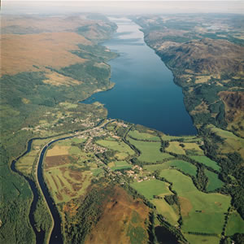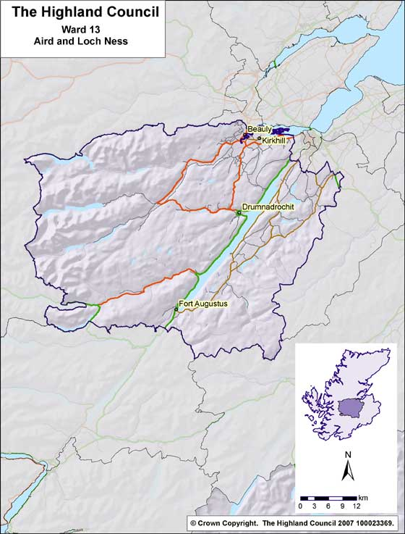
If your answer is YES then ‘Your Cash, Your Choice’ is the opportunity for you to make your project happen.
Deadline for applications is:
MONDAY OCTOBER 1ST AT 5PM
If you need information or assistance with the application please contact:
Brenda or Fran at the Craigmonie Centre
on 01456 459224
Or email: policy6@highland.gov.uk

How do you apply?
To apply for the funding you must return this form before 5pm on Monday October 1st 2018.

Who will decide which projects are funded?
If your idea meets the criteria, the public will get to vote for their favourite ideas at a public event where Your Community will get to decide who gets awarded the cash that they feel will make the most difference to our area, and the decision will be made ON THE DAY!

Event Information
Saturday 13th October 2018,
10.30am – 2pm. This will be held at the Craigmonie Centre, Drumnadrochit
Doors open at 9.30am and presentations start at 10.30am.
Don’t panic – no presentation will run for more than 2 minutes and no PowerPoints are allowed.
Once all the applicants have been heard those in attendance will then vote on all the applications, the votes will be counted and the awards will be announced. Refreshments will be provided to all who attend.

What can you apply for?
We need your ideas for projects that will:
- Benefit as many people as possible from across the community
- Help support people living Aird and Loch Ness Ward 12
- Be delivered within 12 months

REGISTER YOUR IDEA: APPLY TODAY
Privacy statement about your personal data can be viewed at: https://www.highland.gov.uk/directory/59/privacy_notices
Who can apply?
Any local community, voluntary or non-profit organisation, even informal groups– can apply for funding from £100 to £500 to put ideas into action.

You don’t have to come from an existing organisation to apply but all activities will have to happen in Aird and Loch Ness & benefit local people.
The only limit is your imagination, whether you want to organise a healthy living project, start a new fitness group, put on a lunch club for older residents – all applications are welcome as long as the project supports local people in Aird and Loch Ness and will happen in the next 12 months.

Your full name:
Address (your own address or the address of the organisation you represent)
Your postcode:
Telephone number:
Email (required):
How much money are you requesting? (£100 to £500)
If you represent an organisation what is its name?
What is the name of your project/idea?
Where in Aird and Loch Ness will the project take place?
Briefly describe the project you would like funding for:
How will the project deliver a benefit to Aird and Loch Ness?
How many people do you think will benefit from your project?
For example this could be the number who will attend a lunch club weekly.
What particular need will it address for the community?
How much money do you require and what will you spend it on?
Please give a breakdown of the costs of your project and when you expect to spend the money by. Please detail any other funding sources and if it has been confirmed.
Please return this form via email to: policy6@highland.gov.uk
DEADLINE FOR APPLICATIONS: 1st October 2018
Or post/hand it in to:
Craigmonie Centre, Glen Urquhart High School, Drumnadrochit, IV63 6XA

