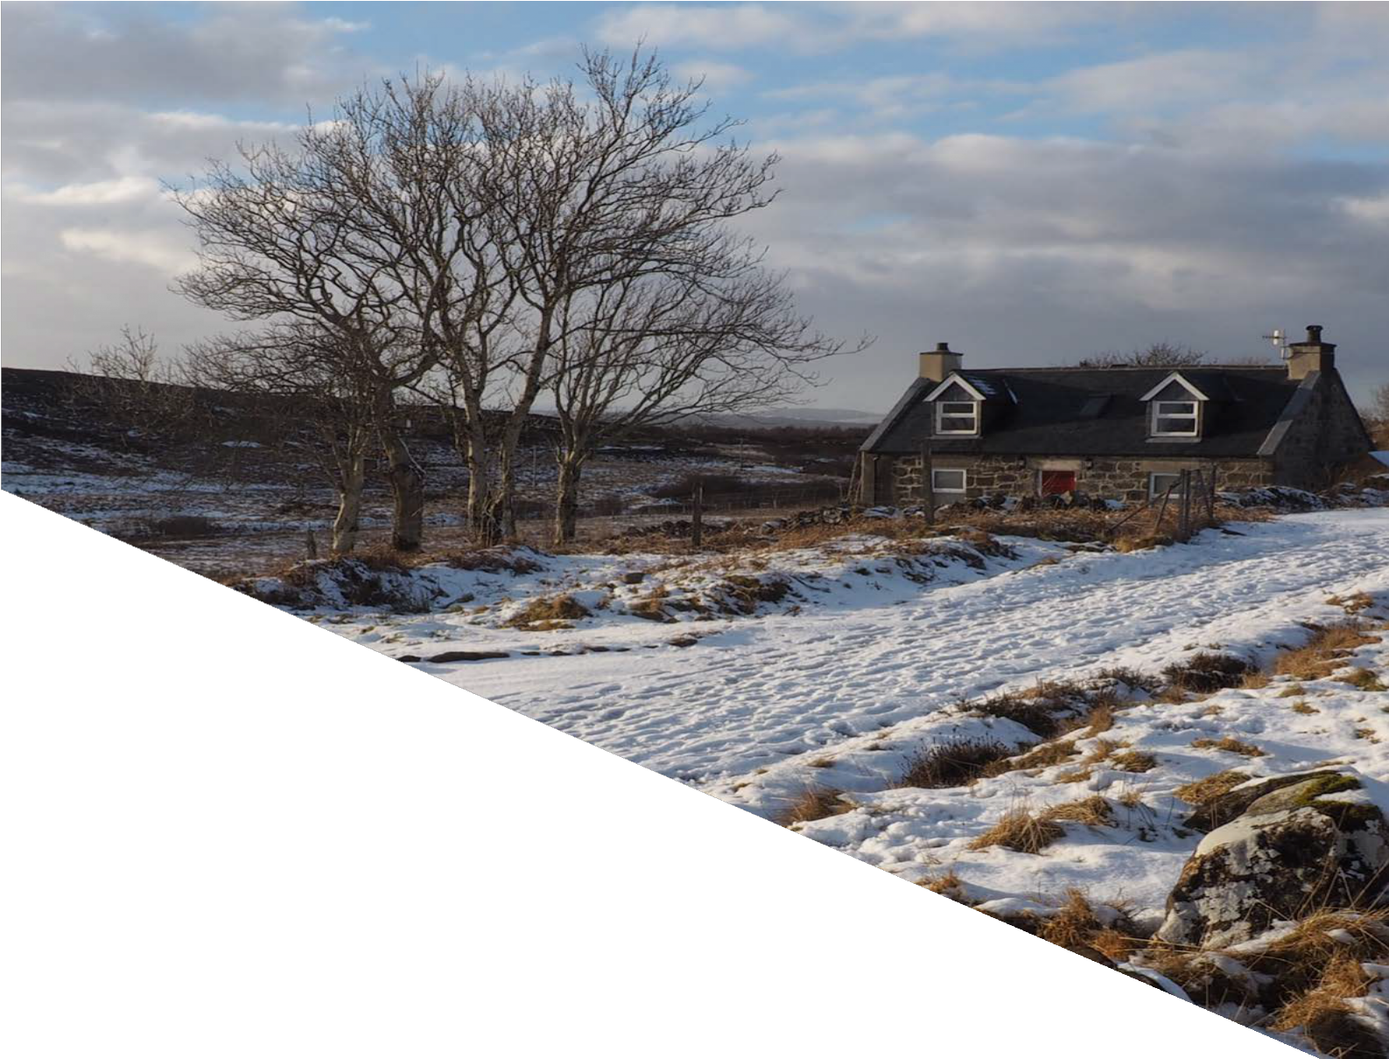
Front cover photos - Kiltaraglen Cottage, Portree by Joey Graham; and Winter in Flow Country by Andrew Tryon

Building Standards Verification
Annual Report
Aithisg Bhliadhnail Dearbhadh
Inbhean Togail
2023-24

Document Record

Version | Description | Date
1.0 | Performance Report Intro | Apr 2023
1.1 | Update for Quarter 1 | June 2023
1.2 | Update for Quarter 2 | Oct 2023
1.3 | Update for Quarter 3 | Jan 2024
1.4 | Update for Quarter 4 | Mar 2024

Key contact:
Glenn Campbell
Building Standards Manager
Council Headquarters (Block B – First Floor)
Glenurquhart Road
Inverness
IV3 5NX
Phone: 07825 357912
Email: glenn.campbell@highland.gov.uk

Table of Contents

1. Introduction to the verifier

2. Building Standards Verification Service Information

3. Strategic Objectives

4. Key Performance Outcomes and Targets

5. Performance Data

6. Service Improvement and Partnership Working

7. Building Standards – Additional Data

Introduction to the Verifier

This verification performance report is a strategic planning and management tool that provides information about the local authority building standards service, it communicates the vision and strategy, and sets out performance against strategic goals and targets.

Building standards verifiers in Scotland are required to utilise the performance report to manage, monitor, review and develop strategies for their business, and should focus on the performance framework’s core perspectives and cross-cutting themes.

  - The Highland Council –
Geographical Area; Population and Employment

The Highlands of Scotland is a part of the world renowned for its beauty, hospitality and culture. The Highlands measures a third of the area of Scotland with, including the islands, 26,484 square kilometers of land area: making it larger than Wales and almost the size of Belgium.

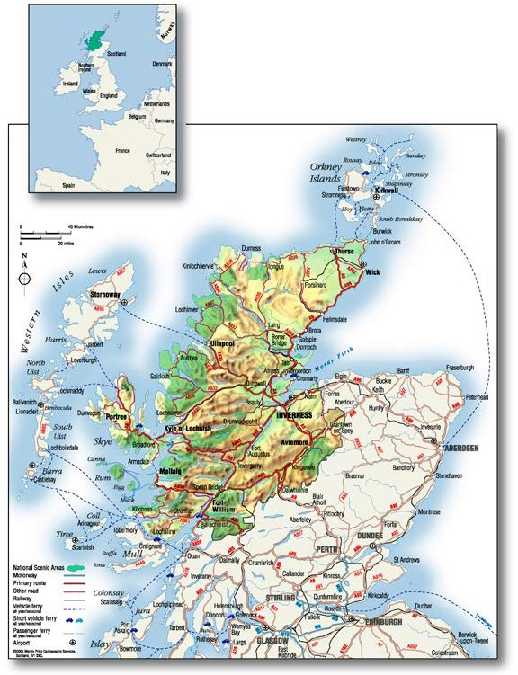
The length of coastline including islands at low water is 4,905 kilometers, 21% of the Scottish total, and excluding islands is 1,900 kilometers (49% of Scotland). Argyll and Bute have the next longest coastline with 3,723 kilometers, then Western Isles with 3,716 kilometers.

The population of the Highlands is 235,540. Inverness city has become the administrative and transport hub of the region; a city of some 63,000 inhabitants. It is fast growing and ambitious with direct air links to London and most European cities. It is a part of the world renowned for its beauty, hospitality and culture.

We are home to the Cairngorm; Scotland’s second National Park and the largest in the UK, and the UNESCO geopark in Northwest Sutherland. The Inverness campus is home to one of the most ambitious projects in Scotland. It is nationally and internationally significant location for business, research, education and a thriving life sciences community.

The Highland Council and partners have signed a City Region Deal worth £315m and this is delivering a range of exciting projects over 10 years, which is set to see Inverness and the Highlands become a region of digital and economic opportunity.
www.highland.gov.uk/cityregiondeal

1.2 Multi-member Ward Map
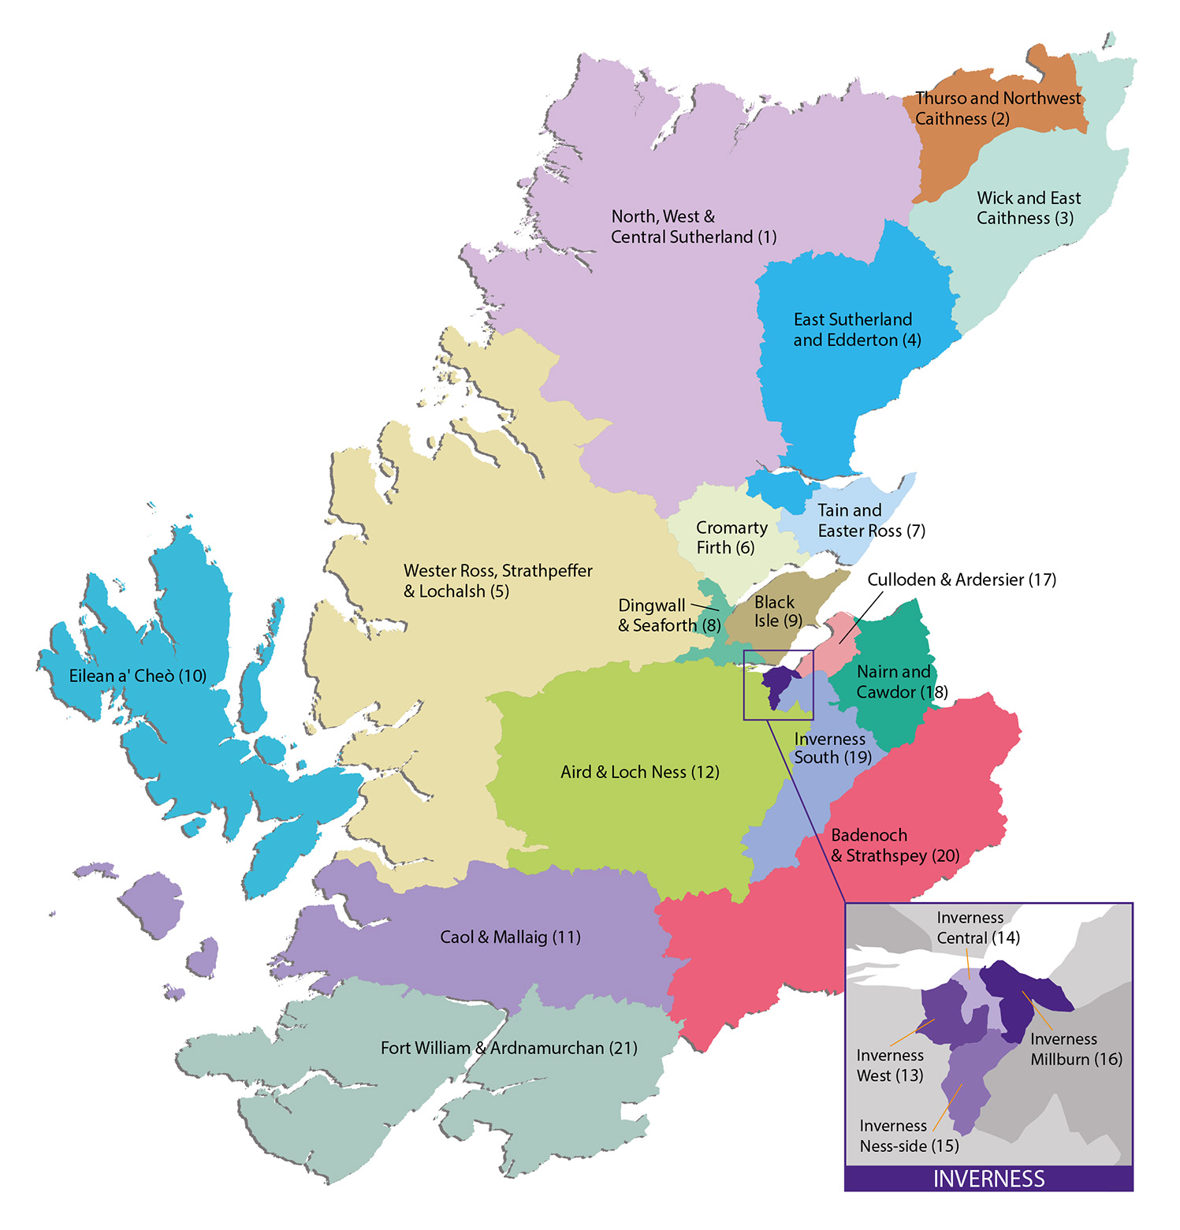The Highland Council area has 22 wards each served by 3 or 4 councilors, depending on ward population. Each ward has regular ward forum meetings where the public are encouraged to attend and participate in the development of their areas and improve service delivery.

Copyright The Highland Council
1.3 Council Structures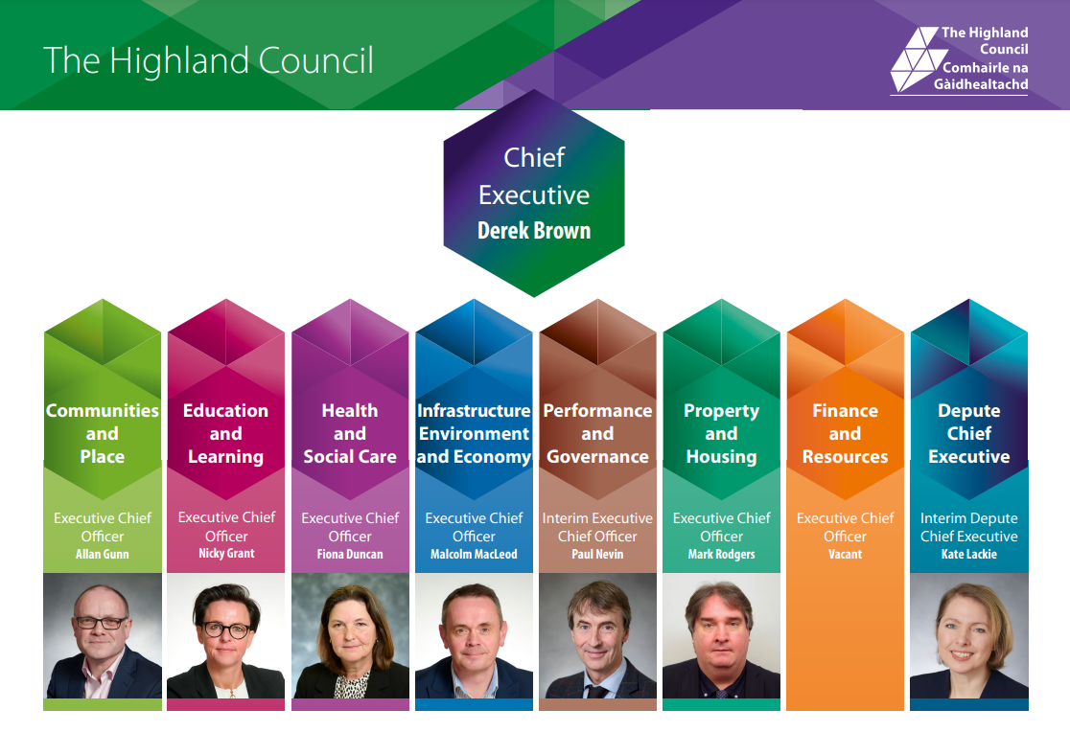
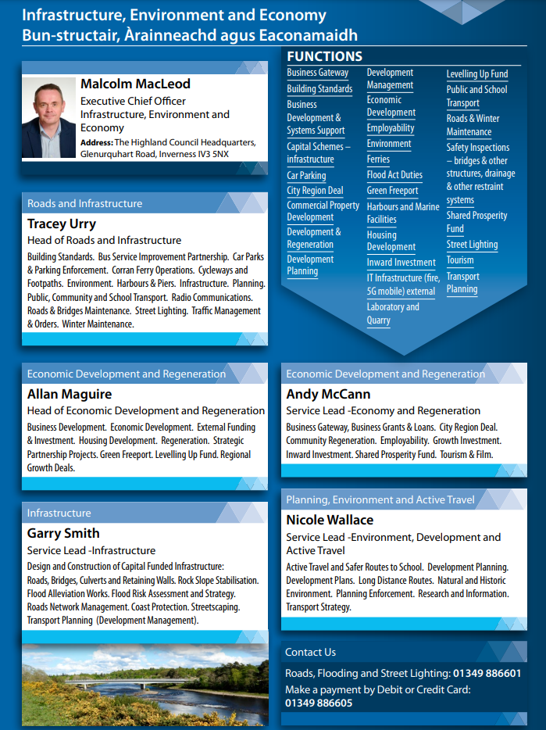

2.0 Building Standards Verification Service Information

2.1 Location and Accessibility of Services

The Highland Council’s Building Standards Service is delivered by the Infrastructure, Environment and Economy Service which has its base at Council Headquarters, Glenurquhart Road, Inverness. The Executive Chief Officer for Infrastructure, Environment and Economy Service (Malcolm MacLeod), The Head of Planning, Environment and Low Carbon Transport (Tracey Urry) and The Building Standards Manager (Glenn Campbell) are all based at this location.

The operational activity of the service is decentralised to 7 area offices which operate under a Building Standards Management Team. Area offices are in the following:

- Caithness House, Market Square, Wick – serving Caithness
- Drummuie, Golspie – serving Sutherland and East Ross
- Council Offices High Street, Dingwall – serving Ross-shire
- Service Point, Old Corry Industrial Estate, Broadford – serving Skye and Lochalsh
- Charles Kennedy Building, Achintore Road, Fort William – serving Lochaber
- The Courthouse, 36 High Street, Kingussie – serving Badenoch & Strathspey
- Council Headquarters, Glenurquhart Road, Inverness – serving Inverness City and Nairn

Building Standards is led by the Head of Planning, Environment and Low Carbon Transport. The Building Standards Manager is responsible for protecting public interest by delivering a professional Building Standards and Verification service to the Highland community through managing and directing the operational teams of building standards staff in the network of area offices Highland-wide. The manager in turn is supported by two Building Standards Team Leaders; each have a responsibility for warrant approvals and reasonable inquiry. Management of Non-Verification work e.g., Enforcement, Licensing, Defective and Dangerous Buildings etc is shared by the Building Standards Management Team.
The day-to-day management of the area office network is the responsibility of a Principal Building Standards Surveyor. The principal surveyor has delegated authority and responsibility for:

- Risk assessments and allocating building warrant and completion certificate workloads
- Dealing with all building standards local operations including taking enforcement action where unauthorised building operations are being carried out or where defective or dangerous building incidents occur.
- Monitoring performance and staff development against the LABSS Competency Assessment System (CAS)
- Dealing with minor personnel issues
- Absence management.

Copyright The Highland Council
2.2 Building Standards

The principal objective of Building Standards is:

- To secure the health, safety, welfare and convenience of persons in or about buildings and of others who may be affected by buildings or matters connected with buildings,
- To further the conservation of fuel and power, and
- To further the achievement of sustainable development.

Building Standards has two distinct roles, Verification and Enforcement.

Verification is principally achieved through the application of the Building Standards (Scotland) Regulations 2004, as amended, when considering applications for Building Warrants and submissions of Completion Certificates.

Enforcement responsibilities within the Building (Scotland) Act 2003, as amended; requires the Building Standards team to implement action necessary to ensure compliance and maintain public interest in respect of the following: -

- Unauthorised works
- Defective buildings
- Dangerous buildings
- Building Regulation compliance; and
- Continuing requirement conditions

The Building Standards team provides a dangerous building and structures call-out service 24hrs per day; 365 days per year; including Public Holidays.

2.3 Public Interest Statement

The purpose of the building standards system is to protect the public interest. The system sets out the essential standards that are required to be met when building work or conversion of a building takes place to meet building regulations.

The building standards system checks that proposed building work or conversion of a building meets standards; inspections are limited to a minimal necessary to ensure that legislation is not avoided. The control of work on site is not down to the system but is a matter for contracts and arrangements in place between a builder and client.

Verifiers, appointed by Scottish Ministers are responsible for the independent checking of applications for building warrants to; construct, alter or demolish buildings; to provide services, fittings or equipment within buildings and to provide for conversions of buildings.
Copyright The Highland Council
Building Standards Team – 2023/24 (Jan – Dec)
Sutherland
Inverness
Building Standards Manager
Caithness
Lochaber
Dingwall
Skye
Badenoch &
Strathspey
Team Leader: Approvals

Team Leader: Reasonable Inquiry

Principal Building Standards Surveyor

Principal Building Standards Surveyor

Principal Building
Standards Surveyor
Inverness East –

Principal Building Standards Surveyor

Principal Building Standards Surveyor

Principal Building Standards Surveyor Inverness West –

Building Standards Surveyor
Building Standards Surveyor
Building Standards Surveyor
Building Standards Surveyor
Building Standards Surveyor
Building Standards Surveyor

Graduate Apprentice Building Standards Surveyor

Building Standards Surveyor
Building Standards Surveyor
Building Standards Surveyor
Trainee Building Standards Surveyor

Graduate Apprentice Building Standards Surveyor

Building Standards Surveyor

Building Standards Surveyor

Principal Building Standards Surveyor

Building Standards Surveyor

Principal Building Standards Surveyor

Graduate Apprentice Building Standards Surveyor

Graduate Apprentice Building Standards Surveyor
Graduate Apprentice Building Standards Surveyor

Staffing Position – 2023/24
The tables below illustrate the staffing position for 2023. Staffing levels have remained consistent over the last 12 months with a full complement of 29 posts.
Table 1: Senior Management
 | Tier 1 | Tier 2 | Tier 3 | Tier 4
Head of Building Standards Verification Service |  |  | √

Note: Tier 1 = Chief Executive; Tier 2 = Directors; Tier 3 = Heads of Service; Tier 4 = Managers.

Table 2: Building Standards and support staff profile
 |  | Building Standards Verification Service | Other
Manager and Team Leaders | No. posts | 1 Manager (60% - Phased Retirement Plan)  2 Team Leaders
 | Vacant
Principal Surveyors | No. posts | 8 (1 working a Phased Retirement – 50%)
 | Vacant
Main grade posts (surveyors) | No. posts | 12
 | Vacant
Trainee/Graduate Surveyors | No. posts | 5 Graduate Apprentices; and 1 Trainee BSS)
 | Vacant
Shared Business Support | No. posts | 7 – see below*
 | Vacant
Total |  | 29 Professional staff  7 Shared Business Support

Note: The Manager and Team Leaders are responsible for operational/strategic management of the team. The line management and day to day responsibility for surveyors and distribution of workloads lies with the Principal Surveyors.
*Shared Business Support (SBS) is managed out-with the BS team; Performance and staffing levels of SBS is the responsibility of the SBS Manager.

Table 3: Demographic
Staff age profile | Number
Under 30. | 5
30-39. | 4
40-49. | 7
50 and over | 13
45% of staff are over the age of 50; 24% are over the age of 40; 14% are over 30yrs; and 17% are under 30yrs. The average age within the team is 45.5yrs.
3.0 Strategic Objectives

3.1 Corporate Objectives: -

The Council’s Programme for 2017 to 2022 ‘Local Voices, Highland Choices’ sets out a number of goals based on five themes:

- a place to live;
- a place to learn;
- a place to thrive;
- a welcoming place; and,
- a redesigned council.

The Council’s Corporate Plan is one of three strategic documents which together outline: - the priorities for the council; our approach to resourcing; and, how these will be delivered.

The Council’s Service departments have their own directorate service plans which feed into the council’s corporate plan. Directorate Service Plans can be found here.

The Infrastructure, Environment and Economy Directorate Service Plan is part of the Council that plans for future land use, and supports inclusive economic growth through Business Gateway and employability programmes. The service designs and develops new affordable homes, schools, roads, bridges and flood schemes and manages also council properties. Development Management; Development Plans; Building Standards and Transport Planning are located within Infrastructure, Environment and Economy Service.

Photo by CI Photography
3.2 Service Key Objectives: -

The Building Standards Service’s key strategic objectives for the coming year are: -

- Succession Management: - There are 29 surveyors in the building standards team with an average age of 43.6 years; despite 6 graduate apprentice posts backfilling vacancies as staff have left the service. Six further senior and highly experienced members of the team will retire within the next 2 years meaning it is critical that succession planning and management receives full support from council Members and senior management within the council to refill vacant positions.

- Building Standards Operating and Performance Frameworks: - The Scottish Minister appointed Highland Council in May 2023, as verifier for the Highland area for a further 6 years to April 2029. The condition of this appointment is for council to adhere to the terms stated in the Operating and Performance Frameworks. Maintaining the number of qualified, experienced and competent surveyors will ensure the council’s continued role as Verifier to serve the Highland communities.

- New Ways of Working: - While the risk of COVID remains, the BS team will work flexibly managing their time between office and home working to deliver warrant approvals and completion certificate acceptances.
Site inspection and compliance checking will also require more innovative ways to ensure compliance. The addition of Remote Verification Inspections (RVI) will have its place; with surveyors working with industry, to make inspection of work on site more efficient.

- IT: - Highland Council leads Scotland in receiving the highest percentage of electronic applications for warrant and completion certificates, with more than 96% of applications being submitted electronically. It is essential that the BS team have access to the most up to date IT kit to enable the continued delivery of a resilient, efficient and flexible hybrid working environment.

- BSD/LABSS/HUB: - the BS team will continue to participate and work with the Building Standards Division (BSD); Local Authority Building Standards Scotland (LABSS) and the LABSS Hub in developing; the Verifier’s Operating Framework; the Verifiers Performance Framework; Workforce Strategy and Competency Assessment System; etc in addition to responding to national consultations and reviews eg the building warrant fees review; the enforcement and sanction review; and, the Digital Transformation work currently being undertaken by Scottish Gov.

- The Highlands and Islands Consortia Group: - As part of LABSS commitment to improving consistency in interpretation of the Technical Standards and the processes nationally Highland will work closely with our consortium partners; Orkney, Shetland and Comhairle nan Eilean Siar Island councils to achieve this aim.

- Maintain a ‘High Performing Team’: - Continuous Improvement - is inherent in everything we do.

4.0 Key Performance Outcomes and Targets

The national verification performance framework is based on three core perspectives:
- Professional Expertise and Technical Processes;
- Quality Customer Experience; and
- Operational and Financial Efficiency.

There are also three cross-cutting themes, comprising:
- Public Interest;
- Continuous Improvement; and
- Partnership Working.

Table 4: Summary of Key Performance Outcomes (KPOs)
Professional Expertise and Technical Processes
KPO1 | Minimise time taken to issue a first report or issue a building warrant or amendment to building warrant.
KPO2 | Increase quality of compliance assessment during the construction processes
Quality Customer Experience
KPO3 | Commit to the building standards customer charter
KPO4 | Understand and respond to the customer experience
Operational and Financial Efficiency
KPO5 | Maintain financial governance
KPO6 | Commit to eBuilding Standards
KPO7 | Commit to objectives outlined in the annual performance report

Table 5: Summary of Key Performance Targets
KPO1 Targets
1.1 | 95% of first reports (for building warrants and amendments) issued within 20 days – all first reports (including BWs and amendments issued without a first report).
1.2 | 90% of building warrants and amendments issued within 10 days from receipt of all satisfactory information – all building warrants and amendments (not including BWs and amendments issued without a first report).
KOP2 Targets
2.1 | Targets to be developed as part of future review of KPO2.
KPO3 Targets
3.1 | National customer charter is published prominently on the website and incorporates version control detailing reviews (reviewed at least quarterly).
3.2 | 95% of BSD requests for information on a BSD ‘Verifier Performance Reporting Service for Customers’ case responded to by verifier within 5 days.
KPO4 Targets
4.1 | Minimum overall average satisfaction rating of 7.5 out of 10.
KPO5 Targets
5.1 | Building standards verification fee income to cover indicative verification service costs (staff costs plus 30%).
KPO6 Targets
6.1 | Details of eBuilding Standards to be published prominently on the verifier’s website.
6.2 | 75% of each key building warrant related process being done electronically  - Plan checking  - Building warrant or amendments (and plans) being issued  - Verification during construction  - Completion certificates being accepted
KPO7 Targets
7.1 | Annual performance report published prominently on website with version control (reviewed at least quarterly).
7.2 | Annual performance report to include performance data in line with KPOs and associated targets (annually covering previous year e.g. April 2016 – March 2017).

Photo by Ewen Weatherspoon

5.0 Performance Data
The tables on the next pages illustrate the Key Performance Outcomes (KPOs) updated and reported at the end of each quarterly reporting period to Scottish Government Building Standards Division (BSD).
Table 6: Key Performance Outcomes for 2023/24
 |  | Category (by building type) and Total per Quarter
 |  | Quarter 1 |  |  | Quarter 2 |  |  | Quarter 3 |  |  |  | Quarter 4 |  |  | Annual Total
KPO1 | Summary of KPOs | Domestic | Non-Domestic | Total | Domestic | Non-Domestic | Total | Domestic | Non-Domestic |  | Total | Domestic | Non-Domestic | Total | Domestic | Non-Domestic | Total
 | Number of BWs  and amendments  issued (all) | 475 | 104 | 579 | 454 | 93 | 547 | 472 | 104 |  | 576
 | Average number of days from receipt of a valid application to granting a BW or amendment | 77 | 70 | 76 | 70 | 77 | 74 | 78 | 72 |  | 79
 | % of first reports  issued within  15 days | 75.16% | 61.54% | 72,50% | 76% | 65% | 74% | 74% | 72% |  | 74%
 | % of first reports  issued in more than 15 days and within 20 days | 20.29% | 33.33% | 22.83% | 19% | 27% | 21% | 23% | 18% |  | 21%
 | % of first report issued in more than 20 days and within 35 days | 4.14% | 5.13% | 4.33% | 5% | 9% | 5% | 4% | 10% |  | 5%
 | % of first reports  issued in more than 35 days | 0.41% | 0.00% | 0.33% | 0.00% | 0.00% | 0.00% | 0% | 0% |  | 0%
 | % of BWs and amendments issued within 6 days from receipt of all satisfactory information | 77.16% | 65.93% | 75.15% | 75.06% | 75.86% | 75.21% | 75% |  | 80% | 76%

 | % of BWs and amendments  issued in more than 6 and within 10 days from receipt of all satisfactory  information | 18.51% | 19.78% | 18.74% | 19.79% | 14.04% | 18.91% |  | 18% | 14% | 17%
 | % of BWs and  amendments  issued in more than 10 and  within 15 days from receipt of all satisfactory  information | 4.33% | 14.29% | 6.11% | 3.34% | 8.05% | 4.20% |  | 5% | 6% | 6%
 | % of BWs and  amendments issued in more than 15 days from receipt of all satisfactory  information | 0.00% | 0.00% | 0.00% | 0.00% | 0.00% |  | 0.00% | 0% | 0% | 0%
KPO2 | Number of CCNPs for ‘accepted’ completion certificate | 392 | 78 | 470 | 357 | 87 |  | 444 | 375 | 57 | 432
 | % of CCNPs fully achieved for ‘accepted’ completion certificates | 41.33% | 47.44% | 42.34% | 26.61% | 24.14% |  | 26.13% | 31% | 33% | 31%

KPO3 | National Customer Charter is published prominently on the website | Published Prominently (with Review) | Published Prominently (with Review) | Published Prominently (with Review)
KPO4 | Overall customer satisfaction rating – out of 10 | 8.2 | 7.9 | 8.4
KPO5 | Building Standards (verification) fee income | £427,913.00 | £632,169.00 | £724,691.00
 | Building Standards (Staff) costs | £417,886.00 | £417,886.00 | £417,886.00
 | % fee income against (staff) costs | 102.40% | 151.28% | 173.42%
KPO6 | Details of eBuilding Standards are published on the website | Published Prominently | Published Prominently | Published Prominently
KPO7 | Annual Performance Report published on the website | Published Prominently (with Review) | Published Prominently (with Review) | Published Prominently (with Review)
 | Annual performance report includes performance date under KPO3, 4, 5 and 6 | Includes all performance data | Includes all performance data | Includes all performance data

Table 6a: Summary of performance against Key Performance Outcomes and Targets for 2023/24
 | 1.1 | 1.2 | 3.1 | 3.2 | 4.1 | 5.1 | 6.1 | 6.2 | 7.1 | 7.2
 | 95% of first reports (for building warrants and amendments) issued within 20 days ± all first reports  (including BWs and amendments issued without a first report). | 90% of building warrants and amendments issued within 10 days from receipt of all satisfactory information ± all building warrants and amendments (not including BWs and amendments issued without a first report). | National customer  charter is published prominently on the website and incorporates version control detailing reviews (reviewed at least quarterly). | 95% of BSD requests for information on a BSD ^{µ}Verifier Performance Reporting Service for Customers¶ case responded to by verifier within 5 days. | Minimum overall average satisfaction rating of 7.5 out of 10. | Building standards verification fee income to cover indicative verification service costs (staff costs plus 30%). | Details of eBuilding Standards are published prominently on the verifier’s website. | 75% of each key building warrant related processes being done electronically (Plan checking; BWs and amendments (and plans) issue; Verification during construction; CC acceptance). | Annual performance report published prominently on website with version control (reviewed at least quarterly). | Annual performance report to include performance data in line with KPOs and associated targets (annually covering previous year e.g. April 2016 ± March 2017).
Q1 | 95.33% | 93.89% | Published prominently (with review) | No cases referred to BSD ‘Reporting Service’ | 8.2 | 102.40% | Published prominently | 4 of 4 done | Published prominently (with review) | Includes all performance data
Q2 | 94.67% | 94.12% | Published prominently (with review) | No cases referred to BSD ‘Reporting Service’ | 7.9 | 151.28% | Published prominently | 4 of 4 done | Published prominently (with review) | Includes all performance data
Q3 | 94.92% | 93.17% | Published prominently (with review) | No cases referred to BSD ‘Reporting Service’ | 8.4 | 173.42% | Published prominently | 4 of 4 done | Published prominently (with review) | Includes all performance data
Q4

5.1. Professional Expertise and Technical Processes

Protocols for dealing with work

A number of risk management protocols have been developed for key processes and these are under continual review. Guidance notes, policies and protocols are stored electronically via a SharePoint site for team reference. Some of this information is also available for the customer to view via the council’s web pages.

Performance management systems

Internal Key Performance Indicators (KPIs) are reported to the Infrastructure & Environment Committee quarterly. These include:
- Provide a technical response or issue the Building Warrant within 20 working days. Target 90%
- Respond to the submission of a completion certificate within 10 working days. Target 90%
- Percentage of building warrants and amendments issued within 10 working days following receipt of satisfactory technical information. Target 90%

Training and development/CPD

Staff member’s training and development needs are identified through the Council’s annual Employee Review and Development Process (ERDP); this is reviewed 6 monthly. Training Plans are submitted to senior management for budget scrutiny.
Staff members are encouraged to attend internal and external CPD events hosted by industry and LABSS.

Benchmarking/shared services

The Council works in partnership with the three Island authorities; Orkney, Shetland and Comhairle nan Eilean Siar, forming the Highlands & Islands (H & I) consortia working group; in turn this group reports to Local Authority Building Standards Scotland (LABSS), and to Scottish Government Building Standards Division (BSD). Attendance by staff at LABSS general meetings and training events is encouraged.

Highland Council works in liaison with Moray Council’s building standards team as a shared boundary lies between each authority.

Succession planning

The importance of engaging a younger workforce is critical to the continued workforce in Highland; where 45% of the team is older 50 years of age; a further 38% is between 30 and 50 years of age; and 17% is under 30. The average age within the team is 45.5 years. This is higher than council’s demographic and an imminent threat to Building Standards’ workforce planning. There is also 4 staff retiring in the next 12 months; plus a further 2 leaving the following year.

5.2. Quality Customer Experience

Customer communication strategies

eBuilding Standards is a huge success in Highland; where 96+% of applications for warrant is via this mechanism. Customer communication is predominantly done via electronic means e.g. Email; MS Team; and telephone. The council is actively promoting flexible and agile working to improve the team’s work/life balance and is more efficient and better for the environment. The team will also this year proactively engage with Remote Verification Inspection (RVI) as a means of more efficiently ensuring compliance with work on site.

Customer Charter

The Building Standards Customer Charter is published here on the Council’s web pages and is reviewed quarterly and updated annually.

Customer feedback (national/local)/analysing and changes to systems

Customer feedback is encouraged; this is normally done via; customer Focus Group meetings or via e-mail or telephone. A new dynamic national customer satisfaction survey is available for all customers and members of the public to provide their experiences with the council’s building standards team.
The council’s annual survey results are published on the Council’s web pages here.

Accessibility of service

Building Standards services are available locally across Highland from 7 areas offices. A duty officer is available each day from 9:00am to 5:00pm to answer ‘first call’ inquiries via telephone. All building standards forms and guidance documents are available on the council’s web pages; and should a customer need/want a paper version these can be made available. Building warrant application are assigned to a ‘case surveyor’ whose name is recorded in the acknowledgment letter to the applicant/agent.

Pre-application advice

A pre-application service/advice is freely available to customers. This service is available via appointment at council offices during normal office hours Monday – Friday 9am – 5pm.
Special arrangements can be made where the customer has mobility issues.

Customer agreements

The council has a template for formulating ‘customer agreements’; normally adopted for complex or very large application types.

Customer dissatisfaction (procedural or technical)

If a customer wishes to complain to the Highland Council; complaints procedure guidance can be found here. For technical or procedural matters relating to the verification service we would direct customers to the LABSS - Dispute Resolution Process that can be found here.

5.3. Operational and Financial Efficiency

Team structures

The Building Standards Service is provided locally in the community via a network of area offices. The offices are managed by a Principal Building Standards Surveyor who is responsible for the day-to-day management of the team within the area and the distribution/allocation of workloads.

Time recording system

A simple but accurate time recording system was developed to assist in providing accurate reporting for costs associated with expenditure on the verification service.

Financial monitoring/governance

Financial monitoring is robust and undertaken monthly by the Building Standards Management Team and the Service Business Manager. The monthly statements identify income and expenditure between cost centres.

IT systems

Building Standards operate an electronic case management system provided and ‘hosted’ by IDOX (Uniform, Enterprise and EDRMS suites) via a Citrix security system. This operating system works in partnership with the Council’s corporate IT provider (WIPRO). The customer facing aspect of this system is a search-able Building Standards Register that can be found here.

Digital services

96+% of all application submissions (building warrants and completion submissions) are now submitted electronically via the eBS portal. 100% of all applications/submissions are handled electronically by surveyors; and the issue of building warrants and approved drawings including the completion certificate acceptance are issued electronically. Site inspections are undertaken by surveyors using SIM enabled tablet devices to refer to approved drawings.

The BS team is participating in two Scottish Government led projects investigating virtual site inspection processes and increased use of digital technology. The Highland Council is seen as an exemplar in digital and virtual systems technology.

Finance systems

The main finance system used by Highland Council is Integra supported by Capita for electronic and online payment services. Payments for all Building Standards services are received electronically; the Council no longer receives cash or cheque payments.

6.0 Service Improvements and Partnership Working

Table 7: In the previous 12 months (22/23) we did:
Number | Continuous improvement action | Status
1 | KPO1(a) - Improve time taken to issue a Building Warrant:  22/23 = 78.75 days  21/22 = 75 days  20/21 = 71 days | Ongoing
2 | KPO1(b) - Improve time taken to issue a First Report:  2022/23 = % within 15 days = 75.21%;  % more than 15 but less than 20 days = 19.32%  Total = 94.53%  2021/22 = % within 15 days = 61%;  % more than 15 but less than 20 days = 28%  Total = 89%  2020/21 = % within 15 days = 82%;  % more than 15 but less than 20 days = 16%  Total = 98% | Ongoing
3 | KPO1(c) - Improve time taken to issue a Building Warrant following receipt of satisfactory information:  2022/23 = % within 6 days = 70.89%  % more than 6 days but less than 10 days = 13.70%  Total = 84.59%  2021/22 = % within 6 days = 69%  % more than 6 days but less than 10 days = 20%  Total = 89%  2020/21 = % within 6 days = 76%  % more than 6 days but less than 10 days = 17%  Total = 93% | Ongoing
4 | KPO2 - Compliance during construction – improve customer recognition:  2022/23 = Number of CCNPs fully achieved = 35.92%  2021/22 = Number of CCNPs fully achieved = 35 %  2020/21 = Number of CCNPs fully achieved = 58% | Ongoing
5 | Reinvest building warrant fee income within the service:  2022/23 = Verification (staff) costs - £1,595,948  Fee income - £2,595,461  Staff costs V Fee Income = 163%  2021/22 = Verification (staff) costs - £1,577,422  Fee income - £2,710,547  Staff costs V Fee Income = 172%  2020/21 = Verification (staff) costs - £1,586,519  Fee income - £2,484,519  Staff costs V Fee Income = 157% | Ongoing
6 | Roll out tablet devices to surveyors for use during site inspections | Complete
7 | Appointment of consultant Fire Engineers | Complete

Table 8: In the next 12 months (year/year) we will do:
Number | Continuous improvement action | Timescales
1 | Continue working to improve key performance outputs that will ensure Highland Council’s reappointment in 2023. Building Standards Performance is published here | Quarterly
2 | Filling vacancies; succession management; and the development and mentoring of young staff is now inherent if the building standards profession in the Highlands is to continue. This ‘grow our own’ ethos is providing career and job opportunities to young people that live in the Highlands. | Ongoing/continuous
3 | Develop a mobile working for the team via the use and reliance on electronic devices and virtual use of site inspections. | Complete
4 | Engage and develop working arrangements with our: - consortia partners; LABSS; the Hub Pilot; and BSD | Ongoing
5 | Maintain a professional, courteous, and efficient service to the customers of Highland to maintain high scoring customer feedback | Continuous
6 | Maintain a ‘High Performing’ team | Continuous

7.0 Building Standards – Additional Data

Performance data contained in Table 9; is a dynamic summary of returns submitted to Scottish Government under the Key Performance Outcomes procedure.
Table 9: Additional Data
Activity |  | 2019/20 | 2020/21 | 2021/22 | 2022/23 | 2023/24 Q1 – Q4 = Total
Building Warrants and amendments to warrant | Applications received | 3095 | 2610 | 3019 | 2730 | 683 | 635 | 628
 | Applications determined | 2669 | 2535 | 2524 | 2325 | 560 | 517 | 543
Completion Certificates | Submissions | 4186 | 2895 | 3844 | 3562 | 847 | 774 | 769
 | Accepted | 3493 | 2207 | 3101 | 2911 | 717 | 671 | 651
 | Rejected | 620 | 442 | 664 | 650 | 130 | 103 | 118
Certification | Design – Structures | 2387 | 1637 | 1946 | 2414 | 642 | 554 | 297
 | Design – Energy | 130 | 63 | 15 | 35 | 1 | 3 | 2
 | Construction – Electrical | 2440 | 1466 | 1521 | 754 | 247 | 341 | 321
 | Construction – drainage/heating & plumbing | 1323 | 769 | 228 | 149 | 379 | 167 | 181
Energy Performance Certs | Domestic | 373 | 403 | 532 | 840 | 158 | 134 | 191
 | Non-domestic | 212 | 117 | 143 | 46 | 3 | 2 | 9
Statements of Sustainability | Domestic | 787 | 446 | 589 | 636 | 148 | 129
 | Non-domestic | 43 | 42 | 57 | 85 | 4 | 6
Fire Safety Summaries |  | 3 | 6 | 11 | 14 | 7 | 12 | 0
Enforcement | Notices served under Sections 25 to 30 | 22 | 41 | 27 | 21 | 4 | 4 | 0
 | Cases referred to Procurator Fiscal | 0 | 0 | 0 | 0 | 0 | 0 | 0
 | Cases where the Council has had to undertake work | 11 | 4 | 7 | 0 | 0 | 0 | 0
Customer Care | Complaints received | 3 | 6 | 4 | 0 | 0 | 0 | 0

Durness by David Martin

