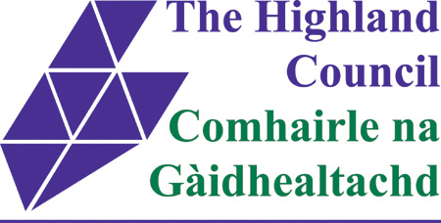

ASSET TRANSFER UNDER THE COMMUNITY EMPOWERMENT ACT

NOTICE OF ASSET TRANSFER REQUEST

Pavilion at Millburn Academy, Victoria Drive, Inverness, IV2 3QR

An asset transfer request has been made to The Highland Council under Part 5 of the Community Empowerment (Scotland) Act 2015.

The request has been made by Inverness Men’s Shed.

The request is for ownership of land/building comprising The Pavilion at Millburn Academy, Victoria Drive, Inverness, IV2 3QR, for the redevelopment as premises for Inverness Men’s Shed.

The documents relating to this request can be viewed online at:

[www.highland.gov.uk/cat](http://www.highland.gov.uk/cat)

Or, in person, at The Highland Council Service Point, Castle St, Inverness IV1 1JJ.

Anyone may make representations about this request to The Highland Council. Representations must be in writing and include the name and address of the person making the representation. A copy of the representation will be given to the organisation making the request with personal information redacted and will also be posted online, as above, also with personal information redacted.

Representations must be made by 23rd of January, 2019. They should be sent to Community Asset Transfer, Chief Executive’s Office, Highland Council Headquarters, Glenurquhart Road, Inverness, IV3 5NX or by email to cat@highland.gov.uk

General information about the asset transfer scheme is available at www.gov.scot/asset transfer and at [www.highland.gov.uk/community asset transfer](http://www.highland.gov.uk/community%20asset%20transfer).