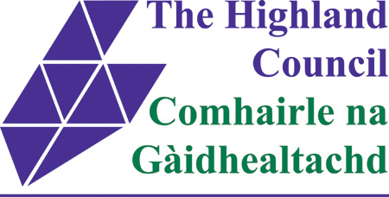

ASSET TRANSFER UNDER THE COMMUNITY EMPOWERMENT ACT
NOTICE OF ASSET TRANSFER REQUEST
Helmsdale Public Toilets, Dunrobin Street, Helmsdale, KW8 6JX
(UPRN: HC 04934)

An asset transfer request has been made to The Highland Council under Part 5 of the Community Empowerment (Scotland) Act 2015.
The request has been made by Helmsdale & District Development Trust.
The request is for ownership of Helmsdale Public Toilets, for its continued operation as a public convenience.
Documents relating to this request can be viewed online at: www.highland.gov.uk/cat or in person at The Highland Council, Helmsdale Service Point.
Anyone may make representations about this request to The Highland Council. Representations must be in writing and include the name and address of the person making the representation. A copy of the representation will be given to the organisation making the request with personal information redacted and will also be posted online as above also with personal information redacted.
Representations must be made by Friday 1st of March 2019. They should be sent to Pablo Mascarenhas, Community and Democratic Engagement Manager, The Highland Council, Glenurquhart Road, IV3 5NX or emailed to cat@highland.gov.uk
General information about the asset transfer scheme is available at www.gov.scot/asset transfer and at www.highland.gov.uk/community asset transfer.

