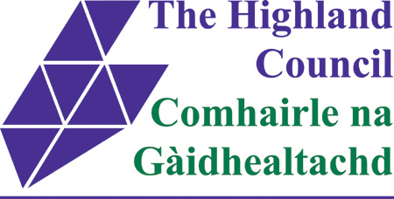

ASSET TRANSFER UNDER THE COMMUNITY EMPOWERMENT ACT
NOTICE OF ASSET TRANSFER REQUEST
Ormlie Centre, Henderson St, Thurso, KW14 7LD
An asset transfer request has been made to The Highland Council under Part 5 of the Community Empowerment (Scotland) Act 2015.
The request has been made by Ormlie Community Association Ltd.
The request is for lease of the land/building comprising the Ormlie Centre and adjoining garden, for continued community use.
The documents relating to this request can be viewed online at: www.highland.gov.uk/cat or in person at The Highland Council Service Point, Rotterdam Street, Thurso.
Anyone may make representations about this request to The Highland Council. Representations must be in writing and include the name and address of the person making the representation. A copy of the representation will be given to the organisation making the request with personal information redacted and will also be posted online as above also with personal information redacted.
Representations must be made by 15th of March 2019. They should be sent to Pablo Mascarenhas, Community and Democratic Engagement Manager, The Highland Council, Glenurquhart Road, IV3 5NX or emailed to cat@highland.gov.uk
General information about the asset transfer scheme is available at www.gov.scot/asset transfer and at www.highland.gov.uk/community asset transfer.

