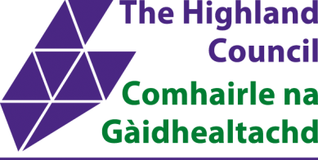

Tain Common Good Consultation

About this consultation
Under the Community Empowerment (Scotland) Act 2015, Local Authorities are required to consult local communities when considering changing the use of Common Good Fund assets.

The Highland Council is keen to hear your thoughts on the proposal outlined below relating to land at Blarliath, Tain owned by Tain Common Good Fund:

• What are your views on changing the use of this common good land?
• What do you view as the potential benefits?
• Would you identify any issues or concerns?
• Do you have any further comments?

Please note – in this instance, we will be running the community consultation in parallel with our planning application. This is to enable The Highland Council and Tain Common Good Fund to meet a funding deadline for a ‘Feed In Tariff’ (FIT) in early 2019 which provides income from the UK Government to support the generation of renewable energy. All applications must have planning permission.

After 31 March 2019 the FIT scheme is being withdrawn by the Government. Therefore, if we do not meet this deadline, we will miss out on significant funding that makes the project viable. This would endanger the project and all the additional benefits it brings for the area.

Please be assured – Our submission of a planning application now does not mean we have decided to take the project forward. We are keen to hear your thoughts and will have full regard to them before making a decision on whether or how to progress the proposal. All consultation representations, responses and any final decision will be published on the Council website.

Where is the proposed change?
This proposal concerns two parcels of land understood to be part of a site purchased with Common Good funds in the 1980s.

Plot A | Plot B
Blarliath grazings – 13 acre site, IV19 1PZ | Blarliath grazings – 4 acre site, IV19 1PZ
Located between the railway and mean high water springs and adjacent to the sewage works. UPRN: 130142783 | Located between the railway and farm land to the rear of the superstore and adjacent to the industrial estate. UPRN: 130142782

What is proposed?
This project would require investment from The Highland Council along with the use of Common Good land to install ground-mounted solar panels on areas of plot A and plot B (see Figure 1).
The renewable energy generated from the solar arrays would supply nearby buildings.
The benefits of the project are numerous, including: helping to reduce carbon emissions, and providing income for Highland Council to support key services and for Tain Common Good.

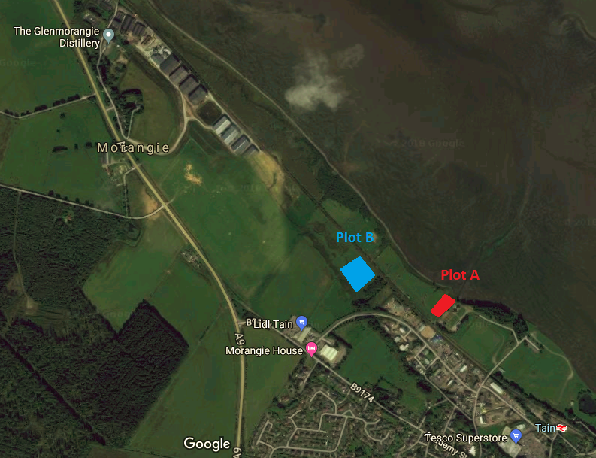

Figure 1 – Satellite image of Plot A and Plot B. Imagery ©2018 DigitalGlobe, Map data ©2018 Google.

The main changes proposed are in relation to the type of land use and the type of land let:

• Land use – both plots are grazing lets. The proposal is to use parts of them for solar panels.

• Land let – both plots are let on 364-day annual grazing lets. The project would require a long term lease over the life of the solar panels (25 years), with potential extension.

When might the proposed change take place?
After consultation, all feedback will be considered in order to determine which course of action overall is of most benefit. Depending on feedback, possible options and timescales might be:

- The project goes ahead with solar panels installed before September 2019.

- The proposal is amended to take account of consultation feedback. If the project is still viable, fresh consultation would be undertaken depending on the amendments.

- The project is withdrawn and does not go ahead.

Find out more at highland.gov.uk

Please submit written responses either by:
Email: sara.murdoch@highland.gov.uk
Post: Sara Murdoch, The Highland Council HQ, Glenurquhart Road, Inverness, IV3 5NX

Consultation closing date: 15 February 2019

