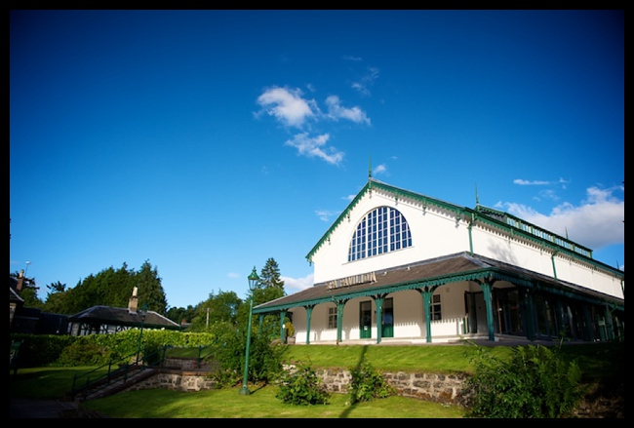**Strathpeffer Pavilion, Gardens and Pump House**

**Options Appraisal and Business Plan**

**February 2019**

**STRATHPEFFER PAVILION**

COMMUNITY TRUST

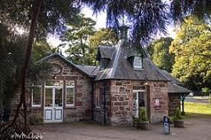

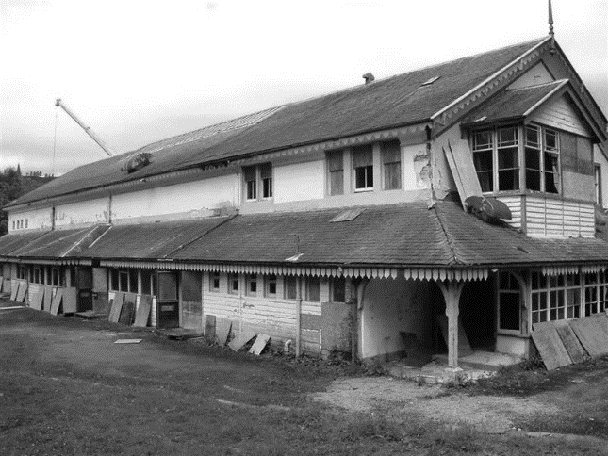

**Table of Contents**

1 Executive Summary 1

2 Vision and Objectives 3

3 The Story So Far 3

3.1 The Pavilion building 3

3.2 The Pavilion Gardens 5

3.3 The Pump Room 5

4 Shaping the Proposals: Serving the Community 7

4.1 Community survey 7

4.2 October drop-in event 7

4.3 Strathpeffer Action Plan Survey 8

4.4 November drop-in event 10

4.5 Community Engagement Outcomes summary 11

5 Shaping the Proposal: Working with Stakeholders 11

5.1 High Life Highland (HLH) 11

5.2 Highland Council 12

5.3 Strathpeffer Community Association Ltd (SCA) 12

5.4 Strathpeffer Community Council 13

6 Shaping the Proposal: The Site and Buildings 13

6.1 The Pavilion Building 13

6.2 The Pump Room 14

6.3 The Pavilion Gardens 14

7 Shaping the Proposal: Market Assessment 14

7.1 Weddings 15

7.2 Conferences 15

7.3 Shows and performances 16

7.4 Daytime events for tourists 16

7.5 A café / bar 17

8 Shaping the Proposal: Options Assessment 18

8.1 Options assessment - conclusions 19

9 The Proposal 20

9.1 The Pavilion and the Management Agreement 20

9.2 The Pump House 22

9.3 The Pavilion Gardens 22

10 Financial Viability 24

10.1 Development Costs and Funding 24

10.2 Revenue and ongoing costs 24

11 Governance and Operational Management 27

11.1 Strathpeffer Pavilion Community Trust 27

11.2 Board of Trustees 27

11.3 Board Skills and Filling Skills Gaps 28

12 Project Plan 29

13 Risks and Risk management 30

**Table of Figures**

Figure i. Initial community survey findings July 2018 7

Figure ii. November 2018 survey feedback: community priorities 9

Figure iii. Extract from Management Agreement 21

Figure iv. Strathpeffer Pavilion Community Trust Development Plan 23

Figure v. Purchase costs and funding 24

Figure vi. Summary of revenue and income projections 26

Figure vii. Summary of cash flow 26

Figure viii. Project Plan – Development Period 29

Figure ix. Risk Register 30

**Appendices**

Appendix A. Strathpeffer Pavilion Location Map 31

Appendix B. Strathpeffer Pavilion Floor Plans – ground floor 32

Appendix C. Strathpeffer Pavilion Gardens map 33

Appendix D. Board Skills Audit detail 34

Appendix E. Financial Tables 36

# Executive Summary

This Plan addresses the proposed purchase and use of the Grade B-listed Strathpeffer Pavilion, the surrounding Pavilion Gardens together with the Grade B-listed Pump House by the Strathpeffer Pavilion Community Trust (SPCT) as a facility owned by and operated for the benefit of the local community.

The Pavilion – but not the Pump House or Gardens – were acquired by the Scottish Historic Buildings Trust (SHBT) in 2003, and restored from dereliction by a successful application to Heritage Lottery Funding, European funding, and others. The Pavilion was run by the Strathpeffer Pavilion Association, a community-led charity, which was unable to reach a sustainable business model. The building was leased for 3 years by the Highland Council in March 2017 and operated by its arms-length cultural and leisure charity, Highlife Highland. SHBT are now

A Heritage Lottery funded study[1] demonstrated that the restoration of the Pavilion created 14.9 FTE local jobs and created Gross Value Added of £176,000 per year into the local economy, attracting 14,500 visitors per year. The SPCT wish to ensure that this is maintained and enhanced for the benefit of Strathpeffer.

The SPCT have engaged with the community throughout this process; the SPCSG was created from people in the community as a response to the proposed sale of the Pavilion in 2016. It carried out community surveys in 2017, summer 2018 to support the application to the Scottish Land Fund for business planning, and then held 2 events and gained input from a wider community survey in late 2018. At each stage there was strong support from the community for a community asset purchase.

SPCT’s strategy is to acquire and manage the assets to provide an events and social hub as:

* A venue for weddings and other life events
* A conference venue
* Arts / cultural events and performances
* A formal green space including tennis courts for the use of the community and visitors
* Car parking for the site and for the wider village centre
* Maintenance of the Pump House as a social enterprise, currently providing visitor information services and a museum;
* Facilities and land to meet future aspirations for the community.

The Plan explains how these can combine to form a coherent and integrated package of activities, which will achieve the community outcomes of increased community cohesion; increased economic activity from visitors and tourism; and safeguarding these historic assets which from the centre of the Conservation area and were the centre at the creation of the village of Strathpeffer.

The Pavilion Gardens are an integral part of the village Conservation Area and a Designated Landscape. Acquiring the Garden around the Pavilion will help secure key features of the Pavilion, including access to parking, and help support another much-loved community asset, with maintenance from local volunteers. The tennis courts on the area are relatively new and in excellent condition, and are run by the volunteers at Strathpeffer Tennis Club.

The Pump House, which sits within the Gardens, is currently occupied by a local gift-shop business who have a service level agreement with Highland Council for the provision of visitor information services. There are no plans to amend this tenancy.

The outline income, costs, and capital costs are considered in the financial options appraisal. The SPCT will fundraise to address the backlog repairs identified in the Pavilion 2016 conditions survey, the 2019 Garden Survey, and the 2019 Pump House Conditions Survey (£59,250 in the first four years) ; attract grants to undertake necessary improvements to heating and insulation of the Pavilion £35,000; to improve the amenity value and parking for the site at the heart of the village £30,000; and to renovate and improve the historic Pump House £35,000.

The funding mechanisms are explored, and risks associated with the project are considered. The choice of legal structure as a SCIO has been implemented to enable the community to deliver its vision.

The Appraisal confirms that this is a viable project for the community if the risks set out in the Risk Register are mitigated and managed. The key risks are:

* (High) Partnership funding cannot be obtained because the site / building / purpose are not perceived by funders and Highland Council as delivering sufficient benefit / financial viability. SPCT have mitigated this risk by entering into a Management Agreement with a charity with greater reserves and resources to manage the building while they build capacity and financial resources; and by implementing the findings of the community consultation, that the community wish the asset to continue to be managed for the benefit of the residents of Strathpeffer. Highland Council have agreed to transfer the Gardens and Pump House at a notional amount to minimise additional funding.
* (High) Partnership funding cannot be obtained because Governance and Board Skills perceived as insufficient to manage such a significant asset. To mitigate this risk, SPCT have carried out Skills Audit and are focussed on recruiting to help ensure additional strength. They will recruit additional skilled supporters and Board Members through community engagement processes including the launch event and ongoing engagement.

The summary of purchase costs and funding is as below:

|  |  |  |  |  |
| --- | --- | --- | --- | --- |
|  | Costs | Funding | | |
|  | **Total** | **SLF** | **HC** | **SPCT** |
| Pavilion value | 395,000 | 375,250 |  | 19,750 |
| Land value | 25,000 | 1 | 24,999 | 0 |
| Pump House value | 45,000 | 0 | 45,000 | 0 |
| Legal fees for transfers and lease to tenant (including VAT) | 15,694 | 15,694 | 0 | 0 |
| Total cost / funding | **480,694** | **390,945** | **69,999** | **19,750** |

The summary of cash flow, including backlog maintenance and capital investments. is as below:



# Vision and Objectives

Strathpeffer Pavilion Community Trust’s vision is to achieve the community outcomes of increased community cohesion; increased economic activity from visitors and tourism supporting 14.9 FTE direct and indirect jobs; and safeguarding the historic assets which were the basis for creating the village of Strathpeffer.

SPCT will deliver this vision through the acquisition and use of Grade B-listed Strathpeffer Pavilion, the surrounding Pavilion Gardens and Grade B-listed Pump House as an events and social hub providing:

* A venue for weddings and other life events
* A conference venue
* Arts / cultural events and performances
* A formal green space including tennis courts for the use of the community and visitors
* Car parking for the site and for the wider village centre
* Maintenance of the Pump House as a social enterprise, currently providing visitor information services and a museum;
* Facilities and land to meet future aspirations for the community.

The Strathpeffer Pavilion Community Steering Group (SPCSG) was created in April 2017 following a public meeting to debate the future of the Pavilion Building. There was a strong feeling that the Pavilion should remain at the heart of village life, and 600 signatures were gathered in support during an event in May 2017. A further on-line survey consultation held by the SPCT in June 2018, and the 190 responses from the village area of 431 households showed 85% who agreed or strongly agreed that the community should buy the Pavilion.

The SPCT has received training and support from public stakeholders including Highlands and Islands Enterprise and HISEZ to enable it to develop its constitution as a voluntary association, and funding from SLF and HIE to undertake this Appraisal and Social Enterprise Plan.

In order to fulfil its vision and to enable it to apply for funding, the SPCSG has submitted an application to become the Strathpeffer Pavilion Community Trust, a Scottish Charitable Incorporated Organisation (SCIO).

# The Story So Far

## The Pavilion building

Strathpeffer Pavilion was commissioned in 1881 by the Countess of Cromartie as part of the creation of Strathpeffer as a Victorian Spa Village. Visitors, including royalty and members of high society. Dubbed "the Quality" by locals – they came to the village to “take the water”, which was said to have health benefits. The Pavilion, with its attendant Pump Room, went on to provide entertainment for these visitors, including lectures delivered by Irish dramatist and political thinker George Bernard Shaw, Antarctic explorer Ernest Shackleton and Emmeline Pankhurst, one of the leading figures in the campaign for votes for women. During the first World War the pavilion was used as a hospital for US Navy sailors, and buildings in the village were again requisitioned by the military during World War II.

After the War, the popularity of the Spa declined and the Pavilion fell into disrepair. In the late 1950s, due to the rise in popularity of motorcar and coach travel and to changes in tourism trends, Strathpeffer once again became a destination in its own right. The Pavilion was bought by a private owner, restored and refurbished, and reopened in 1960 as an events hall and concert venue. The Pavilion set the stage for gigs by the Bay City Rollers, the Fortunes, Nashville Teens and Brian Poole and the Tremeloes. The Pavilion was then bought by a large hotel group to provide a venue to attract and entertain guests and locals, supporting the hotel trade. The advent of television, the development of Overseas Package Holidays and the recession in the 1970’s had a detrimental impact on the attraction of the Pavilion as a venue and consequently Strathpeffer as a tourist destination. By 1980, when Evelyn Glennie performed in the Pavilion, it is said she had to more her Xylophone around because water was pouring through the roof. By 1985 it was being used as an indoor football pitch by hotel staff.

The Pavilion lay almost unused thereafter before being bought by Highland Council and transferred to the Scottish History Buildings Trust (SHBT), the current owners. The SHBT restored the Pavilion to its former glory in 2004 at a cost of £2 million from Council, HIE, Heritage and Lottery funding, and European funding. The SHBT did not take ownership of the Pavilion Gardens or Pump House, which remain in the Council’s ownership and management.

The Strathpeffer Pavilion Association Ltd (SPA) (a company limited by guarantee SC187894 and a Scottish Charity SC028241), a community-led organisation, took up the lease of the Pavilion when it reopened in 2004. SPA set up Strathpeffer Pavilion Ltd (SPL), a wholly owned trading subsidiary and limited company, to carry out weddings, events and commercial bookings of the Pavilion and to covenant its profits to SPA, and this company commenced trading on 1 July 2012 when the commercial activity was passed from SPA to SPL. In addition to its own employment and profits, the indirect economic impacts of the restoration of the Spa were estimated by a 2013 study for HLF as contributing 8.1 jobs regionally and bringing £121,000 gross value added.

SPA struggled to make operating surpluses, despite significant donations from local businesses and the Friends of the Pavilion together with ongoing grants from Highland Council – collectively totalling around £100,000 each year - essential to ensure financial viability. The Trustee reports from 2008 onwards record the significant efforts of the SPA’s Directors to manage and maintain operating surpluses from its programme of weddings, events, and conferences via marketing and staff expertise, against ever higher staff costs, issues with heating and ventilation, and the very high costs of maintaining the Pavilion to its Grade B listed status. Improvements to organisational structure, programming, staffing, marketing, improvements to the conference rooms, and bringing catering in-house in 2013 were pursued diligently, but by 2015 the Pavilion group of companies was in financial trouble.

SPA noted in its accounts for that 2015 year:

“*3.1 Activities*

*The programme for 2015 was once again eclectic and high quality, In addition to 26 weddings, 10 conferences, 4 funerals, 9 dances, 2 wedding fairs, monthly cinema nights and 5 craft fairs the following events took place: Dingwall Choral, Circus of Horrors, Opera Bohemia, Declan Nerney, Cloudbusting – Kate Bush, We’ll Meet Again ,Torridon, Tiwtawoo, Faulty Towers, Night of Dirty Dancing, The Work, Whisky Galore, Elvis McGonagall, Phil & Aly, Hooey in the Highlands, The Edibles, Budapest Café Orchestra, Band Night, Scottish Chamber Orchestra, Highland Chamber Orchestra, Dick Gaughan, Blazin Fiddles, Paddy O’ Brien, Blas Festival, International Guitar Night, Mick Flavin, Fron Male Choir, Aly Bain, Ale Moller and Bruce Molsky, Sticky Kids, Isla Grant, Robin Hood and Del & Rodney Xmas Show.*

*The Friends of the Pavilion continued their sterling fundraising work with 2 Food and Craft Fairs, 1 Fashion Show, 1 Bingo Night and the ever-popular Art Fair which ran over four days in November.*

*3.2 The Pavilion Building*

*The building, being a restored historic building, continues to be costly and complicated to operate. Significant problems outstanding from the handover continue to be addressed and it must be appreciated that the requirements of today cannot be readily reconciled with a Victorian building.”*

Despite the significant levels of activity and donations from the Friends of £20,000, the SPA recorded a loss of over £10,000 in 2015 compared to a surplus of over £28,000 in 2014. The SPA during the period from opening in 2004 was dependant on Highland Council Grants of around £44 - £50,000 per year, Scottish Arts Council grants of £7,500, and European Regional Funds. All of these grants were reduced very significantly in 2016, including as part of Highland Council’s continuing requirement to reduce costs, and were forecast to be further reduced in 2017. Without these grants the Pavilion’s operations were no longer financially viable. The position was compounded by the aftereffects of a very difficult financial year in 2013, which had significantly depleted reserves. The accounts for the period to 31 December 2015 noted that the Charity was “unable to secure adequate funding since the year end to ensure the continuance of the level of service provision at current levels”.

Following the cessation of trading by its tenant, the SHBT proposed to sell the building on the open market. There was regional and national coverage of the perceived threat of transfer to a private owner, and of the desire for the Pavilion to remain a local community asset. The building was then leased from SHBT to Highland Council; In turn the Council’s arms-length Culture and Leisure Charity, High Life Highland (“HLH”), was asked to take on the management and operation of the venue from March 2017 for a period of three years. The purpose of the three year ‘window’ by SHBT was to allow the community time to put together a strong case for community ownership and to raise the necessary funding to make the purchase. SHBT reserve the right to put the Pavilion back on the open market after two years (in April 2019) unless there is strong evidence that the community will be able to purchase the Pavilion.

## The Pavilion Gardens

The Spa Gardens, Strathpeffer, are a [Designated Landscape](http://portal.historicenvironment.scot/designation/GDL00370), being an unusual example of pleasure grounds laid out as a part of the 19th centre health resort. The designations for their Historical, Arboricultural, Architectural, and Scenic values are all “High” due to the collection of exotic specimen trees and the presence of the gardens as an integrated feature in the landscape. Originally the Gardens included a croquet lawn behind the Pavilion, a Bowling Green, and a Curling Rink which was replaced by Tennis Courts.

The Gardens were sold in 1949 to the owner of the Ben Wyvis Hotel, and suffered the same decline in the subsequent years as the Pavilion itself. The Gardens were transferred to the Highland Council in the 1996 and remain under their ownership. The Council carried out a significant planting programme and environmental works in the Gardens in 2008 and for the subsequent three years. Council funding for all Council-owned green spaces has been substantially reduced and the Gardens were co-managed over the last several years by a volunteer Gardens group. This work has now fallen into abeyance as the Council’s budget restrictions have increased and the Group at that time were unwilling to take on full maintenance for a Council-owned asset, although recent approaches by the SPCT to the Gardening Group are positive.

The space for the Croquet Lawn remains to the rear of the Pavilion. The Bowling Green is now owned and managed by Strathpeffer Bowling Club.

The Garden’s land includes an area used as informal carparking for the Pavilion building, in a lower and an upper overspill car park. There is a registered Right of Access provided in the Garden’s Title to a small section of the lower car park.

The Gardens include within their designated area, the Pump Room.

## The Pump Room

The Pump Room is a separate building on the site of the Pavilion gardens, built in 1909 to replace the earlier Upper Pump Room. The Pump Room provided the Spa medical and health functions – taking the waters, massage and water therapy. The building is [B-listed](http://portal.historicenvironment.scot/designation/LB7833) for its building form and exterior, and also for its tile-lined floors; and is also listed as an Architectural Feature of the Strathpeffer Gardens.

The Pump Room is owned by Highland Council as part of the transfer of the Gardens in 1996. It has been occupied since 2008 by the current business, The Real Sweets & Gift Company. The Company also uses the Pump Room to house the visitor information services for Strathpeffer under a Service Level Agreement with Highland Council and runs a popular small museum in the Pump House showing how visitors used to “take the waters” and receive Spa treatments.

# Shaping the Proposals: Serving the Community

This section summarises the community engagement activities which have taken place as part of this project. From the outset, there has been a demonstrable desire to retain the Pavilion as functioning, accessible part of Village life; a need strengthened by the 25 years spent in a ruinous condition.

Long-term residents have clear memories of the Pavilion in the glory days of the 60s and 70s, when events pulled together communities from across Ross-shire; and of the Pavilion as it was from 1980 to 2004, a derelict and empty boarded-up shell in the centre of the village.

## Community survey

The initial survey in 2018 demonstrated this as the clear driver for the benefits from community purchase:

1. Initial community survey findings July 2018

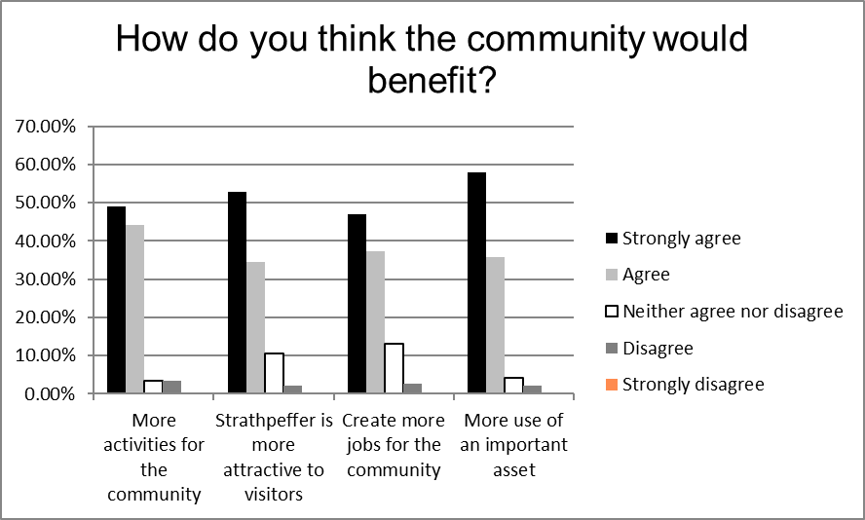

**Respondents demonstrated that they felt that the community acquisition would deliver on all of the identified benefits.** Over 93% strongly agreed or agreed that such a purchase would provide “more activities for the community” and “more use of an important asset”. 87% strongly agreed or agreed that it would “make Strathpeffer more attractive to visitors” and 84% that it would “create more jobs for the community”.

There was most uncertainty about “visitor attraction” (10%) and “jobs created” (12%).

## October drop-in event

The SPCT held an event in early October 2018 to gather further information from the community. This drop-in event was attended by 45 people, who had clear views on both the potential uses and on possible conflicts. Strathpeffer is fortunate in having a community-run Community Centre at a different location within the village, and many consultees were concerned about possible conflicts or competition with the Centre.

Current uses – the community are very aware of the continuing business brought in through HLH through weddings, and of the benefits from this activity to enable the Pavilion to remain in use. The most popular additional use identified was a café / bar / pub for the community. People also commented that since the Red Poppy, the previous tenant of the café space, had moved out to its own premises, there was no general access by locals or visitors during the day to the Pavilion. There was a clear need identified of making the Pavilion more accessible to these groups and “ensuring the community is welcome” through daytime events. People understood a possible conflict between weekend weddings and having the café open at weekends to the public. People commented that a café / bar had been open in the building when the Pavilion was previously under community management but also that access was restricted when private wedding functions were underway.

People suggested a wide range of events, including tea-dances, re-enactments, and a programme of evening entertainments as there had been in the past. Mainly people consulted emphasised that this should be an arts and entertainment venue, and not a community centre although there were also suggestions for youth activities, activities for older people, and other regular events to encourage the village to get together.

People who commented identified the need for the Pavilion to have a stronger identity in the entertainments market, and to have stronger links to businesses in the area who already provide a high level of accommodation. Strathpeffer has retained and grown its tourism identity as “the Victorian Spa town in the Highlands”, and its larger hotels have a significant couch-tour trade which helps deliver 30,000 tourists a year to the village. Several consultees expressed the view that these visitors currently bring little benefit to the village, as they are generally there for an evening and overnight. These consultees expressed a desire to encourage more spend in the village for example by adding to entertainments available to these tourists, or by encouraging the increasing number of cruise ship passengers docking at Invergordon to visit the village. Business owners present at the consultation expressed the view that the coach companies and drivers associated with coach tours were more interested in the longer drives to tourism attractions such as Ullapool, as this generated more income for the coach companies that a shorter drive from Inverness or Invergordon.

People expressed concerns at the ability of a community group to ensure the financial viability of a significant venue like the Pavilion, particularly given recent experience. They were concerned about potential displacement from the Community Centre; noise and rubbish from events; the perceived lack of disabled access; and additional traffic, particularly coach traffic, from increased events and entertainment.

**Protecting the quality of the site and buildings and keeping them in public use**

**is an important consideration for many local people.**

## Strathpeffer Action Plan Survey

The nearby Corriemoillie WindFarm came on-line in December 2016, and Strathpeffer is one of the Areas of Benefit. The Strathpeffer Community Council (SCC) took the lead in commissioning a Community Action Plan for Strathpeffer, which would help describe a collective vision for the community and prioritise applications for the £13,500 available annually from this windfarm and from future wind developments.

The Action Plan consultation process also commenced in October 2018, and the public events were carried out jointly partly to ensure consultation on the Pavilion’s role in wider village community-led development.

Following the October event, a full community survey was carried out for all 738 households in the SCC area, which includes hamlets to the east and north of Strathpeffer. 162 (22%) responses were received.

**Bringing the Pavilion back into community ownership was one of the top three choices**, as was a Community Café or Pub. “Safe and accessible walking links” was the highest priority.

The next three were bringing back “the Spa”, improving the Village Square (opposite the Pavilion) and environmental improvements including Strathpeffer in Bloom and the Pavilion Gardens.

These findings reflect the answer to the earlier question, “how do you feel about living here”. While people strongly agreed that Strathpeffer was a beautiful, safe place to live, they did not feel strongly about having opportunities for socialising or a feeling of community spirit.

1. November 2018 survey feedback: community priorities

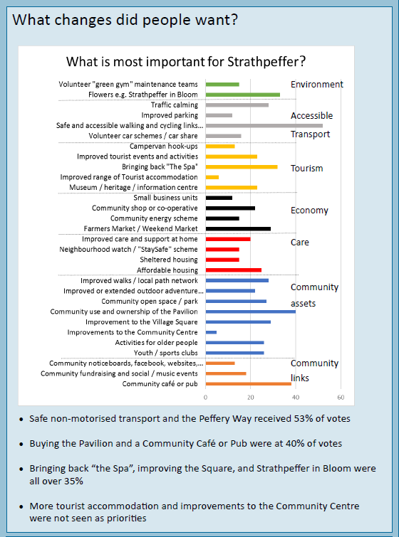

## November drop-in event

A joint SPCT and Strathpeffer Community Action Plan drop-in event was held in mid-November to publicise the findings from the survey, feedback on the first consultation and to identify potential uses and options for the Pavilion.

**The Community Action Plan consultation process identified as a proposal:**

**“A sustainable Community—owned Pavilion and Gardens providing a location for a additional visitor events; and acting as a “virtual” wedding and conference centre.”**

**as a key project priority to be completed in the next 5 years.**

Comments received in relation to this were entirely positive and supportive, although it was recognised at the consultation not all ideas would be financially viable:

**More activities for the community**

* Variety in performance and entertainment types – including suitable for all ages and tastes
* Open mic evenings
* Combine local groups so get a larger audience
* Reduced rates for hall hire for local people for parties e.g. 21st, 50th, then get bar takings etc
* Bring back (free) cinema club with bar for £1
* Family films / singalong
* Xmas films after hours in the Pump Room
* Kids Art Fair

**More use of an important asset**

* Need something in bar a little more imaginative than sandwiches / cake – everyone does that. E.g. tapas, small plates, etc
* It needs a family restaurant like a Harvester, not another café
* Open daily with good quality pub – maybe tapas
* Needs something with the bar – food as well as drinks – simple but good food different to what is available – no more cakes and buns needed!

**Strathpeffer is more attractive to visitors**

* Negotiate with coach companies for travel option with big events?
* For evening events – look to link up with coach companies so buy a ticket to event and click for some transport e.g. Ullapool, inverness, Alness, Invergordon, Dingwall with set drop off and pick up points
* Creche for visitors to allow to fish / golf / enjoy Strath
* Climbing wall
* Could the Pavilion also offer some holiday rental accommodation possible with workshops / activities?
* Conference venue (for the village) use not only hotels for the accommodation but the community centre as the break out rooms. To get from a to b by branded umbrellas
* Guided tours of the village starting at the Pavilion

Concerns were expressed again about the difficulties of a community organisation running a venue like the Pavilion, with its high maintenance and utility costs, and with an internal layout that is not flexible.

## Community Engagement Outcomes summary

The community engagement outcomes can be summarised as to bring the Pavilion into community ownership in order to:

1. Protect the quality of the site and buildings and keep them in public use;
2. Allow more activities for the community, including community -led or run performances
3. Create more jobs for the community, both directly in the Pavilion and indirectly through economic benefit to businesses in the area
4. Make Strathpeffer more attractive to visitors by providing an additional visitor asset e.g. scheduled performances to help support a visitor destination, providing access to the Pavilion during the day for visitors
5. Enable more community use of the asset and as a priority to provide a location for informal socialising

# Shaping the Proposal: Working with Stakeholders

The Pavilion is an important local community landmark, sited in the heart of the Conservation Village designation and opposite the Village Square with its shops, convenience store, post office, and delicatessen / café.

Stakeholders for the Pavilion are also part of the wider community, and include private, public sector, and third sector organisations active in the Village.

## [High Life Highland](http://www.highlifehighland.com) (HLH)

HLH are the current operator of the Pavilion, is an arms-length charitable organisation set up by Highland Council on 1st October 2011 to develop and promote opportunities in culture, learning, sport, leisure, health and wellbeing across nine services through the whole of the Highlands for both residents and visitors. The charity was formed on 1st October 2011 Their tenure operating the Pavilion is scheduled to end in March 2020.

HLH occupies a varied property estate of over 190 properties, which includes outdoor facilities and open spaces, leased for 25 years from Highland Council. In addition, HLH manage community-owned assets such as the North Coast Leisure Centre in Bettyhill, Sutherland and Poolewe Swimming Pool. HLH has an annual turnover of c£27million, and recorded 7.4 million visits to its properties in the year to March 2017.

Since taking over the lease in April 2017, HLH’s key focus was to identify a business model that would ensure sustainability of the historic venue. To date the charity has focussed on developing the Pavilion’s market particularly in weddings, this is followed by the conferences and events markets. HLH attracted 28 weddings to the Pavilion in 2018, a number consisted with previous years under the SPA. Indications are that this figure will be generously exceeded in 2019. Given these favourable indications, HLH is now also focussing on community/non-commercial activities.

HLH stated they had achieved trading income of £348,000 in the year to March 2018, but recorded a deficit of £20,000 after direct costs, pay costs, utilities and maintenance costs. Despite the financial losses (which do not include an allocation of overhead for finance, marketing, ICT, HR, and other central overhead costs) HLH believes its business model will demonstrate a surplus in the next and forthcoming years. HLH would welcome the opportunity to work with the Pavilion’s new community owners to continue their operational management role. They seek to extend the conference and tourism events markets as well as develop and increase the entertainment offerings at the venue. HLH is seeking to increase utilisation and would work with the new community owners to identify a solution to the heating infrastructure. HLH, as a third sector body, state that they are careful not to duplicate provision or to compete with the Community Centre and should the charity remain involved it will look to continue this principle.

HLH currently open the café and bar for any events taking place in the venue such as wedding/events catering*.* The bar is operated by HLH’s trading arm and the catering provision is undertaken by local restaurant and external catering company Red Poppy under contract awarded following the charity’s standard procurement procedures.

HLH had previously offered a tender for a full Catering and Beverage service which received no interest. However, HLH is prepared to revisit the potential for such an offering at any time in the future.

SPCT recognise the added costs and risks of operating a one-off single-site facility and has identified the benefits in working in partnership with an established and trusted charitable organisation like HLH which has a wider infrastructure to support SPTC with its aspiration for the growth and development of Strathpeffer Pavilion.

## Highland Council

Highland Council currently lease the Pavilion from theSHBT**.** They own the Pavilion Gardens, tennis court, and the Pump House**.**

The Council are keen to help ensure that the Pavilion and its associated Gardens and Pump House remain as community assets for the area, and worked with SHBT to obtain the current three year lease (due to end in April 2020) of the Pavilion Building following adverse public reaction to the proposed open market sale in 2017.

The Council are also keen to transfer the Pavilion Grounds and the Pump Room as part of a Community Asset Transfer, and have provided a written offer to transfer these assets for £1, subject to their legal fees being met.

## Strathpeffer Community Association Ltd (SCA)

SCA **are** a company and a charity, have owned and managed the Strathpeffer Community Centre, located next to the Strathpeffer Primary School, for over 25 years.The Centre provides a wide range of [services](http://www.strathpeffercommunitycentre.org.uk/home/4589880220) including leasing accommodation to community groups and for meetings, putting on a variety of activity classes, fun and educational activities, hosting conferences. As with all such bodies, the Centre balances accessibility and community need against financial viability and records a very small surplus each financial year with capital improvements made by way of grant. The Centre’s accommodation includes a small meeting room, two “small halls” one of which provides the local playgroup with accommodation and is also used for regular community group meetings; and the other which is used for larger conferences and meetings.

The Centre shares a large gym hall with the adjoining Primary School. This hall is equipped with a curtained stage, portable lighting and sound equipment, and is available outside of the school day, weekends, and in school holidays. It is also used for more celebratory events by using curtains to mask the blockwork walls. These rooms are all substantially smaller than the Pavilion Hall but are an important asset to the community for meeting rooms, social clubs, fairs and celebrations.

The Centre and the Pavilion have complementary markets; the Centre focusses on local and community provision while the Pavilion caters to a more regional market including the nearby villages of Dingwall, Contin, Garve, Maryburgh and more widely.

## Strathpeffer Community Council

Strathpeffer Community Council have taken an increasingly active role in community-led development of the village, including setting up the Strathpeffer Coordinating Group. This Group aims to bring together the many active community groups in the village and is currently developing the Strathpeffer Action Plan to help agree on key challenges and priorities for the village over the next 10 years.

The Coordinating Group and the SPCT have held joint Community Consultation Events (see above) as part of the development of this Social Enterprise Plan and of the Strathpeffer Action Plan, establishing successfully that the Pavilion and its Gardens are placed as key developments in overall community aspirations. The SPCT is a member of the Coordinating Group.

# Shaping the Proposal: The Site and Buildings

## The Pavilion Building

As explained above, the Pavilion building is owned by SHBT and was extensively restored and refurbished by them in 2004.

The building centres on the large Pavilion Hall with associated entrance hall, toilets including accessible toilets, changing rooms, storage including a portable bar, and an upstairs balcony. Many of these fittings and rooms are included in the listing, including the glass panes in the roof space.

The rear of the building’s ground floor includes a substantial commercial kitchen, a café space for 30 covers, and a separate bar in addition to a second set of ladies and gent’s toilets and the accessible toilet.

The rear of the building first floor, accessed only by stairs, includes 3 offices, two larger meeting rooms, and ladies and gent’s toilets.

Please see Appendix B for plans.

A building conditions survey, a mechanical and electrical survey, and a valuation of the Pavilion were carried out for Highland Council in November 2016.

A Conditions Survey and Mechanical and Electrical Conditions Report were instructed by Highland Council in late 2016, prior to taking on the lease in March 2017. The Conditions Survey stated that the Pavilion building was in reasonably good order, and identified a number of external repairs and improvements to the external roof, walls, and paving consistent with 13 years of weathering. There were no significant findings from the M&E survey. It is understood that no refurbishment or repair works to meet these requirements have been undertaken by the current tenants. An allowance of £40,000 including VAT has been included in the financial projections to meet these backlog maintenance requirements.

The financial history of the Pavilion and the recent experience of HLH as its operators demonstrated significant costs in maintenance, utilities, and staff costs. Information provided by the previous SPA showed that these were in large part driven by the structure of the building.

Maintenance costs are high as the building is listed and must be conserved to historic standard. Glass panes, tiles, guttering, and lights are all non-standard; and the high proportion of painted wood involved in the building’s exterior requires significantly higher maintenance costs than for other external materials. Maintenance costs, at around £30 - £40k per year, represented around 10-15% of turnover and are unlikely to be reduced given the nature of the building. The financial plan includes £40,000 of funds for backlog maintenance, with the ongoing repair costs to be met by the tenants, HLH.

Utilities costs are high as the building does not – and cannot – meet current standards on insulation. The Pavilion Hall Roof features are listed, and preclude the possibility of insulation other than that provided by the roof itself. Glass in the building is mainly single-glazed except for the glass walls to the sides. Although there is heating by sector in the building, the heat curtaining between the kitchen, the pavilion hall, and the rest of the building is sub-optimal so that heat from more occupied spaces such as the offices leaks into the poorly-insulated hall.

SPCT have instructed an energy survey to determine the key issues in making the building more heat-efficient; this was not available at the time of this Plan. An allowance of £35,000 has been made for this capital expenditure in the financial plan.

Members from the SPA, who previously operated the building, also commented that the kitchen ventilation was suboptimal for running a full restaurant kitchen, resulting in difficult working conditions and “false” fire alarms. The current plans for the Pavilion do not include re-opening a full restaurant in the building.

Staff costs relate to the type of activities carried out in the building. HLH report that their direct staff costs are in the region of £140,000 per year.

## The Pump Room

A Conditions Survey of the Pump Room was carried out in January 2019. Unfortunately, there was no access to the building itself. The survey made a number of recommendations for repairs and renovations to the Pump House to secure it as water-tight particularly relating to cracked slates, blocked guttering, and vegetation cleaning. The survey raised a concern over the possibility of dry rot and recommended further specialist survey work. There is an allowance of £5,000 for this work in the first year of the financial projections, with a provision of £35,000 for a more complete refurbishment to install water connectivity, heating, insulation and lighting in year three.

## The Pavilion Gardens

The Pavilion Gardens area wraps around the building, with the Pavilion site itself only the footprint of the building. The Gardens include the approaches to the Pavilion and the carparking for the site. Please see Appendix C for the map.

The Highland Council carried out a Tree Survey in 2017 and has completed work to remove or to maintain trees identified as dangerous.

The SPCT carried out a landscape architect survey of the Gardens as part of the acquisition process. This identified maintenance and remedial work required to paths and other hard standing to a total of £5,750 plus VAT. This has been included in the financial projections as repair and maintenance work.

# Shaping the Proposal: Market Assessment

The recent financial history of the Pavilion’s operation indicated a Market Assessment for possible activities at the Pavilion, to establish whether the issues arising were from a reducing external market or due to other factors.

The Market Assessment carried out by Hughes Consulting assessed four main markets and the Pavilion’s place in these markets:

* Weddings
* Conferences
* Shows and concerts
* Daytime events for tourists

The Market Assessment considered not only the markets and the Pavilion’s ability to compete, but any barriers to entry to expanded or new activity, and the potential for complementarity or conflicts in serving these markets to increase overall occupancy.

## Weddings

The Pavilion has operated successfully in the weddings market since its restoration, with the SPA reporting between 25 and 32 weddings per year due to its expressive attributes built around the visual appeal and romance of the Victorian exterior and interior. HLH initially focused on re-establishing the Pavilion’s presence in this market and have done so successfully. SPA and HLH attracted these bookings despite having no allied accommodation; wedding planners find their own accommodation within Strathpeffer which allows them to access a variety of standards and cost levels within the 18 places to stay (including 5 large hotels) within Strathpeffer, but this does mean that they compete with summer tourist bookings. HLH view is that one of the key USP of the Pavilion is that the whole building is rented out, so that wedding guests can take full advantage of the separate café area and the separate pub away from the dance / dining area.

The Marketing Assessment found that the Pavilion currently had relatively limited market presence, which meant that its wedding market tended to be local and for people who know about it already as a potential venue. The wedding market tended to be week-end and spring to autumn. The Assessment stated that:

“Overall and compared to the other markets, weddings has to be the most important one to the long-term commercial success of the Pavilion because:

* The extent to which the offer can be differentiated versus the competition
* It is less price sensitive compared to the other key market of daytime use of conferences
* Relatively high cash value of each booking and corresponding margin
* Relatively high level of demand for high quality venues
* Typical timing is complimentary to that of conferences (and to some degree concerts and shows)”.

## Conferences

The Pavilion has already been marketed as a conference venue, although less successfully to date than the Weddings market. There are 6 venues in Inverness-shire, Nairn, and Strathspey with which the Pavilion would compete, and these competitors all offer allied accommodation and evening meals. Further, the Pavilion lacks “break out” space, although it does have the capability to use the bar and café areas as breakout, together with the upstairs (but not fully accessible) conference rooms. In the past, the Community Centre has provided break out space, with people walking the 0.3miles between them.

To address the accommodation issue, the current operators, HLH, provide conference booking agents with a list of accommodation and B&B providers in the area for them to book themselves. The SPCT held a meeting with the B&B providers to assess whether they would be willing to move to a more proactive offering as a “virtual conference centre”. The business expressed a willingness in principle to develop this, but were concerned at the practical difficulties in linking their own booking and rom inventory systems together and providing these to HLH.

The Marketing Assessment found that these factors, coupled with the Pavilion’s location 20 miles from Inverness, meant that its market would tend to be local. The offering was important to fill weekday and autumn through winter occupancy. It stated that:

“Given this overall market backdrop, the Pavilion will need to clearly position its offer to focus on:

* One day or half day events
* Highland-based businesses and organisations
* Relatively large number of delegates
* Inspiring non-corporate venue “.

## Shows and performances

Historically, the Pavilion was focussed on shows, performance, and events; and the SPA as the previous tenants actively pursued this market, attracting a variety of shows and performers. HLH have continued to put on an event every one or two months, and report varying success in attracting audiences.

The Marketing Assessment found that “Competition in terms of size of venue in the Inverness catchment and beyond is limited, with only Eden Court offering a larger number of seats. This lack of competition, the relatively central Highland location, excellent acoustics, plus the appeal of the Pavilion itself – and not just to audiences but to performers as well – puts it in an exceptionally strong position in the market.”

However, the Pavilion suffers from its distance of 20 miles from the main centre of population in the Highlands around Inverness, the lack of accessible public transport to and from Strathpeffer in the evenings, and not having a reputation as a performance “destination”. The previous operators, SPL, invested considerable resources in programming, marketing and staff to promote events but struggled to attract ticket sales that delivered sufficient audiences to cover expenses and contribute to overhead costs.

## Daytime events for tourists

This would be a new market segment for the Pavilion, although one that was mentioned frequently in community engagement sessions. There was anecdotal evidence of tourists – especially couch-tour tourists – looking for additional entertainment during the day and in the evening. Local hotels provide some evening entertainment for their coach parties, to help secure repeat visits although the extent and quality of this are said to vary considerably.

Strathpeffer attracts around 30,000 visitors per year mainly during the summer months, although in common with much of the Highlands the season is increasingly from March to October. The hotel guests and coach parties would provide a much more predictable audience than passengers from the cruise ship liners at Invergordon. Although 171,000 passengers landed at Invergordon in 2018, the competition for their custom is fierce across the wider region (including Wick, Ullapool, and Urquhart Castle) and must be planned and guaranteed at least one year in advance with tour operators – but with no guarantee of uptake by passengers.

An offering to hotels would be very price-sensitive, particularly as the hotels would potentially lose money from café and bar sales.

The Marketing Assessment concluded that “the level and quality of resource needed to make the offer a commercial success would need to be carefully considered and evaluated”.

## A café / bar

There were many comments in the community consultations about the need for an eatery and a social establishment, but the proposals varied considerably in these views of what is missing in Strathpeffer.

Strathpeffer has one establishment regularly open to the public, REDACTED, serving lunch and dinner; and two others, REDACTED, which are open less regularly. There are two additional small cafés open all year; REDACTED,; and REDACTED in the summer. All of these close in the late afternoon. REDACTED provides very limited indoor and outdoor seating, and is open until 8pm. This level of provision is high for a village of around 1,500 people and is supported by the tourist trade.

REDACTED moved out when the SPA decided to take catering in-house. REDACTED now provides catering to weddings, events and meetings at the Pavilion.

There are bars at the four largest hotels which are open to the public, but there is no pub in the village. The hotel bars do not appear to be popular with locals; comments received were that they were aimed at the tourist market and hotel residents in particular, although at least one hotel bar provides live entertainment. There were indications that the community felt this was a gap and a market opportunity.

Village pubs are in general under threat in the Highlands and more widely, with those pubs that focus on the wet trade only suffering most from the changes in the way people wish to be entertained. Pubs that provide additional attractions including meals, or additional entertainment such as live music, are more likely to survive. Some local communities have taken over management of their local pubs, running them as a social enterprise although with paid staff, and reducing the need to make substantial profits to reward capital investment.

The major barrier to a café / bar at the Pavilion is the conflict with the use of the Pavilion for conferences and weddings which gain a USP from single use of the building. Weddings clash with the most popular nights for informal socialising, at the weekend and proposals to resolve this by re-designing the interior have been unsuccessful.

# Shaping the Proposal: Options Assessment

The findings from the community and stakeholder engagement, the buildings’ physical condition, the marketing assessment, and the historic and current experience of running the Pavilion in terms of viability, were taken into account in the Options Appraisal, summarised in the below Matrix.

|  |  |  |  |  |  |  |  |
| --- | --- | --- | --- | --- | --- | --- | --- |
| Use | Weddings | Conferences | Commercial venue: shows etc | Daytime events for tourists | Community fundraisers / events | Community cinema | Bar and café open outside of events |
| Community benefit | Keeps Pavilion in use | Keeps Pavilion in use | Keeps Pavilion in use  Events for community to attend also | Keeps Pavilion in use | Provides attractive venue for large fundraisers and events | Creates social “hub” | Creates social “drop-in” needed at centre of village |
| Economic benefit | Some spill-over to local businesses  (query re hotels) | Some spill-over to local businesses  (query re hotels) | Some spill-over to local businesses  (pubs?) | May bring additional higher value tourists (cruise tourists) to Strathpeffer |  |  | Creates economy and jobs in village |
| Financial return | High | High | Low - Medium | Low - Medium | Low | Low | Medium |
| Capital costs required | None | None | Minimal | None | None | ? check blackout? | ? restructure area to ensure viability |
| Risk | Low | Medium – untried | High – until well-established as a venue (depending on acts put on) | High – until well-established (depending on type of event) | Low | Low | Medium – costs of staff are increasing due to living wage increases |
| Downsides | May require use of whole building to exclusion of other uses, most weekends | May require use of whole building to exclusion of other uses when conferences on | Noise, disturbances to residents |  | Conflict with Community Centre Hall – smaller but has same facilities (sound, stage, lighting) | Conflict with Community Centre Hall – smaller but has same facilities (stage, sound, lighting) | Café – displacement of existing provision; depends on terms of agreement with REDACTED  Bar – displacement? |
| Challenges | Uses up most of the prime time occupation of the Pavilion | Accommodation providers to market together / agree to provide accommodation in summer | Attracting a wide audience – need to lay on “free” buses / coaches to fill attendance? – adds to cost and risk | Coach parking required?  Links with accommodation providers necessary to secure returns | Currently only be held when venue “not required” for weddings – limits usage at weekends | Currently can only be held when venue “not required” for weddings – limits usage at weekends |  |

## Options assessment - conclusions

The SPCT have considered the findings carefully and examined potential uses for the Pavilion. As financial viability has been the greatest challenge for the Pavilion and its Gardens over its history, including its recent past, their focus is on firstly establishing a financially viable business to ensure that this iconic building at the heart of the community remains functioning and in good repair. The risk of not doing so is that the Pavilion is taken over by an operator outside of the community and is left to fall into disrepair again if the business is not profitable.

The SPCT priorities are continuing the profitable wedding business, and further developing conferences and performance events gradually to ensure that each revenue stream remains profitable.

The SPCT are less certain of developing the coach tour / cruise liner market, given the difficulty of working with accommodation providers and cruise operators who have well-established links elsewhere. This market will take at least two years to deliver once an offering has been agreed, and this would commit the SPCT to booking acts two years in advance for an uncertain return. Further, at the community engagement events, there were comments that Strathpeffer should be focussing on growing more longer-stay tourism rather than day visitors or coach tourists, who are perceived as providing less economic benefit to the village than those who stay in locally-owned accommodation.

The SPCT noted that holding community events regularly, including community cinema, would compete with the Community Centre’s establishing programme of events and movie nights. The Community Centre is challenged to attract people to its venue, and is seeking to develop its offering to ensure that a larger proportion of the village use the facility. Additional regular events might compete with audiences for the Community Centre, but infrequent large events would maintain the community’s sense of pride in, and access to, the Pavilion.

The SPCT noted the difficulties of providing a pub and / or café in a building that had restricted opening hours due to the conflict with weddings, and where the main gap in the market appeared to be socialising at the weekend rather than weeknights. The market for tourist demand for a pub open during the summer during weekday evenings was very uncertain, although there are various comments e.g. on TripAdvisor about the need for a pub in the village. The tender for the offering may be improved either once the current catering tender runs out (WHEN) and it is possible to offer both the regular and events catering; or if the space is realigned to reduce staffing costs and increase flexibility of the café / bar space.

The current layout of this space is that the pub area is served and manned separately from the café area, and separated by the ladies’ toilets, a corridor and the pub internal wall and door. The SPCT are investigating the possibility of restructuring the south end of the Pavilion to reconfigure the current two separate café and bar areas into one single space, allowing for a reduced staffing costs and therefore increased financial viability. This would then allow the SPCT / HLH to re-test the market via tender for an outside operator to run the facility and might improve the response rate to tender.

# The Proposal

The SPCT propose to purchase the Pavilion from its current owners, SHBT as soon as possible, but take over the lease from Highland Council until the end of its term. They propose to complete the Community Asset Transfer process from Highland Council. They then plan have a joint operator / leasing model for the Pavilion and Gardens int eh short term (3-5 years). This will allow the SPCT breathing space to identify and source capital funding to improve the carparking, the bar café layout, and any other improvements to the Pavilion, Grounds and Pumphouse to develop in the future

The SPCT plan to:

1. Have a lease and Management Agreement with HLH, the current operators of the Pavilion building, for 5 years with a review break at 3 years. HLH manage the building under Highland Council’s three-year lease with the current owners, SHBT, ending March 2020. The Management Agreement with SPCT would effectively extend HLH’s management period by four years. The SPCT plan to set in place improvements in heating and insulation, to reduce the building’s carbon footprint and to make it more financially viable.
2. Continue the tenancy of the Pump House, taking over from Highland Council, but cease the current payment of electricity for the tenants. The SPCT would enter into a formal leasing agreement with The Real Sweetie Shop. The SPCT plan to carry out enhancements to the Pump House, including addressing issues identified in the Conditions Survey, heating and insulation, and water connections.
3. Manage the Pavilion Gardens directly, working with the Gardening Group to restore and maintain the Gardens. The carpark access to the Pavilion will be secured by the asset transfer of the Gardens. The SPCT plan to improve the carparking to increase the capacity of the carpark and to improve coach drop-off and pick up as part of the overall Village Plan; this will depend on the availability of funding and identification of grant sources for this work..

## The Pavilion and the Management Agreement

SPCT have a near-final draft Management Agreement with HLH. This sets out a proposed framework for the Pavilion management, which together with a Development Plan for setting out the current and future uses of the Pavilion and any infrastructure improvements, provides that the SPCT will own and implement any improvements to the capital infrastructure while HLH are responsible for day-to-day running of the Pavilion. Under the Agreement, HLH have all of the financial risks and rewards from the operation of the Pavilion, and in return pay no rental income.

The two partners will work together through quarterly meetings and a Development Plan, which will be prepared by HLH with input from the SPCT.

The SPCT will also use the Pavilion for 6 community fundraisers each year, to generate a forecast £18,000 each year. This will be used for administrative expenses, to carry out repairs and maintenance on the Pavilion, Gardens and Pump House (a total of £61,900 is set out for this over the 5 years of the plan, with £40,000 to the Pavilion, £15,000 for the Pump House and £6,900 for the Gardens), and as match funding to enable further grants to develop the SPCT assets (£15,000 in the first four years to lever in an additional £85,000 in grants).

1. Extract from Management Agreement

|  |
| --- |
| “HLH would be solely responsible for the day to day operational management of the Venue, allowing the Trust to concentrate on Community benefit, development and fundraising projects focused on the physical infrastructure and future development of the building.”  **HLH:** “The role of HLH is to work with SPCT to ensure the smooth and effective day to day operation of the Venue. This role includes the following top level responsibilities:   * Venue operation (including health and safety); * Routine, planned and cyclical repairs and maintenance; * Financial management; * Marketing, communications and public relations; * Human resource management; * Information and communication technology (ICT); * Commercial development; and * Cultural programme development.”   **“SPCT Roles and Responsibilities**  The SPCT role with reference to this agreement is to work with HLH to ensure the smooth and effective operation of the Venue and to ensure its long term development. The Board of SPCT will have the following responsibilities:   * Retain ownership of the Venue; * .. * Work with HLH to create and implement the Development Plan; * Work in partnership with HLH on future developments which complements and benefits the local community. * Assist HLH in maximising the use of the facilities within the pavilion; * Assist HLH in performance management and review of the Development Plan; * Assist HLH in user and community consultation; * Be responsible for the cost of any item of maintenance that would result in the permanent closure of the building if not commissioned; * Be responsible for all grant applications and fund-raising activity to undertake all building improvements, including current requirements as identified by the conditions surveys completed prior to transfer and listed in **Appendix A**. The support of HLH staff will be available for this; * Be responsible for all grant applications and fund-raising for development projects highlighted within the Development Plan. The support of HLH staff will be available for this; * Be responsible for the planning, preparation and management of all Board fund raising events and for the health, safety and wellbeing of all participants in such events. The guidance of HLH staff will be available for this; * Be liable for all costs associated with the planning, preparation and management of Board fund raising events, while retaining all non-catering and beverage income from the same events; * Be responsible for the collection, reconciliation, security and banking of all income from Board events; * Retain all income from grants from other organisations. |

## The Pump House

SPCT plan to enter into a formal leasing agreement with the current occupiers of the Pump House, The Real Sweetie Shop. This will enable the Visitor Information Service and the Museum to continue in operation, providing a service to the village as a tourist destination and keeping the building in use.

In the longer term, working with the Tenants, the SPCT plan to improve the offering to increase opening times and to link the Pump House exhibits more strongly with the Pavilion. This may include enabling ticket sales at the Pump House for Pavilion events and encouraging a more permanent display at the front of the Pavilion with the Pump House exhibits. Continuing the tenancy but with a community owner will help ensure that people in the community are more aware of this important asset, and help ensure that Visitor Information is linked closely to the overall Strathpeffer Action Plan and information provided more regularly by other community groups.

## The Pavilion Gardens

The Pavilion Gardens will be managed by the SPCT directly, assisted by the Gardening group of volunteers to carry out on-going maintenance. The potential transfer to community ownership has already re-ignited the sense of sense of community asset for the Gardens. Securing this land will allow the SPCT to ensure access to parking for the Pavilion, and also provide potential in the future for development of the Gardens that is sensitive to the landscape and the Conservation Village.

1. Strathpeffer Pavilion Community Trust Development Plan

**STRATHPEFFER PAVILION**

**COMMUNITY TRUST**

**DEVELOPMENT PLAN**

**BETWEEN**

**STRATHPEFFER PAVILION COMMUNITY TRUST (SPCT)**

**AND**

**HIGH LIFE HIGHLAND (HLH)**

REDACTED BY HIGHLAND COUNCIL

# Financial Viability

## Development Costs and Funding

There are two elements to the Development Costs and Funding; the purchase of the assets, and the completion of back log maintenance (but not of ongoing maintenance, which is the responsibility of the tenant, HLH) and of capital improvements.

The second of these is planned to take place over a longer timescale, as the SPCT builds its capacity and attracts funding applications. The Pavilion, Gardens, and Pump House are already in operation and these investments will be developed while the Pavilion is operated by HLH. The operating model proposed, for HLH to operate the building in the first instance, allows the SPCT time to fundraise and ensure that backlog maintenance and investments are scoped and planned with the tenant.

Purchase costs have been tested by independent valuations carried out in January 2019, and legal and other costs are supported by quotes.

SPCT have applied to the Scottish Land Fund for 95% of the Pavilion purchase costs. Highland Council have agreed to transfer the Gardens and the Pump House for a nominal fee of £1, subject to their legal fees being met.

1. Purchase costs and funding

|  |  |  |  |  |
| --- | --- | --- | --- | --- |
|  | Costs | Funding | | |
|  | **Total** | **SLF** | **HC** | **SPCT** |
| Pavilion value | 395,000 | 375,250 |  | 19,750 |
| Land value | 25,000 | 1 | 24,999 | 0 |
| Pump House value | 45,000 | 0 | 45,000 | 0 |
| Legal fees for transfers and lease to tenant (including VAT) | 15,694 | 15,694 | 0 | 0 |
| Total cost / funding | **480,694** | **390,945** | **69,999** | **19,750** |

## Revenue and ongoing costs

The SPCT propose to lease the Pavilion building to HLH as noted above. Under the terms of that Agreement, HLH will gain all of the revenue from the building and use this to run events and to maintain the building. Under the Agreement, SPCT will have responsibility for backlog maintenance as identified in the Conditions Survey of December 2016 and for ongoing capital investment.

SPCT will continue to lease the Pump House to the existing enterprise, The Real Sweetie Shop, which provides additional services in terms of the museum attraction and of visitor information.

SPCT will undertake the maintenance of the Gardens, with the assistance of the Strathpeffer Gardening Group. The initial work to bring the Gardens to a maintainable standard will be undertaken by local contractors.

The revenue and expenditure forecasts have been prepared using the following assumptions.

1. This forecast is for the Strathpeffer Pavilion Community Trust.
2. This forecast assumes that while the SPCT own the Pavilion building, they do not operate or manage the building, and gain neither income nor incur costs in its everyday management in accordance with the Management Agreement with Highlife Highland, the facility operator.
3. This forecast assumes that the SPCT do own, manage and operate the Pavilion Gardens and the Pump Room.
4. The SPCT will commence their ownership with ownership rights but no cash.
5. The SPCT will have an initial launch and fundraiser, with 6 total fundraising events per year creating £3,000 per event after expenses. The SPCT will also attract one-off donations from the community during the year to supplement this income.
6. The SPCT will use £2,650 of this cash each year, and adjusted for inflation, to fund their own costs – communications, membership records, finance records, and producing accounts.
7. The SPCT will spend the majority of their income in the first three years on the backlog maintenance identified in the Pavilion and Pump House Conditions surveys (estimated here to total £52,500 over 4 years). They will also complete the garden back log maintenance, quoted at £6,750 assisted by grants of £5,000. The amount available to put into this maintenance will depend on the success of the fundraising efforts.
8. The SPCT will undertake three development projects as it identifies capital grant funding and raises its own funds. These are anticipated to be:
   1. improvements in the heating system and in energy usage / insulation measures via energy efficiency grants for communities (2021) – estimated pending the energy efficiency survey at £35,000. The SPCT will contribute £2,500 from its own funds.
   2. Investment in car parking on the garden lands (2023, re-drain, improve and extend hardstanding – grading, drainage, compacted hardcore surfacing of 200m2 £30,000). Funding for this will be through village improvement grants and from the local New York Trust Fund, which received the transfer of cash balances from the previous Strathpeffer Pavilion Association. The SPCT will contribute £5,000 of its own funds.
   3. Investment in the fabric of the Pump House via Heritage Lottery funding (2022, - heating system, insulation, internal walls, internal flooring - £35,000). The SPCT will contribute £7,500 from its own funds.
9. By end year 4 and into year 5 (2024) the SPCT will have:
   1. Remedied all backlog maintenance in its capital assets;
   2. Brought and maintained the Gardens back into repair;
   3. Significantly improved the Pavilion’s viability through investment in energy efficiency and in operating efficiency;
   4. Be in a strong cash and asset position to consider how it wants to take forward the business of the revitalised and well-established Pavilion.

Detailed financial tables are provided at Appendix E.

1. Summary of revenue and income projections



Under these forecasts, the Trust will generate cash surpluses after investment each year. The cash balance forecasts are as below, and include the proposed investments in the Pavilion, the Gardens for the carparking, and the Pump House.

1. Summary of cash flow



The substantial cash balances at the end of 2024 are due to the completion of the maintenance programmes and indicate that the Trust will be able to consider its development and its involvement in the management of the Pavilion.

# Governance and Operational Management

## Strathpeffer Pavilion Community Trust

The SPCT have applied to OSCR to set up a SCIO, “Strathpeffer Pavilion Community Trust” (SPCT). This Trust’s Purposes are proposed as:

* the advancement of community development for the membership area
* the advancement of the arts, heritage, and culture,
* the provision of recreational facilities, or the organisation of recreational activities, with the object of improving the conditions of life for the persons for whom the facilities or activities are primarily intended.

The SCIO is a two-tier organisation, with membership drawn from the Strathpeffer Community Council (SCC) area which extends well beyond the village itself. The SCC has a population of 2,100, with 1,750 over 16s who are eligible for membership.

Once the SPCT is confirmed, the new Directors will have a membership drive to encourage people on the mailing list and others to become voting members.

## Board of Trustees

SPCT and then SPCT will be drawn from the community. The Board members have a variety of background and skills.

The Board are as below :

PERSONAL INFORMATION REDACTED BY HIGHLAND COUNCIL

## Board Skills and Filling Skills Gaps

The Board has carried out its own skills Audit (please see Appendix D).

The Board identified that it has more than one Board member who is experience in the key areas of governance and management; managing people; project management; marketing, PR, campaigning and communications. It requires additional skills in financial management and in grant funding, identifying sources and preparing applications where it is over-reliant on a one or two members. The Board will seek these skills as it goes into the community

The Board also needs to build capacity over time in facility management and running a facility, events management and hospitality management where again it is where it is over-reliant on a one or two members. The Board’s approach in having the Pavilion fully managed by HLH means that it has mitigated this risk while it builds capacity in facility management and event management through its fundraising events.

# Project Plan

The SPCT have set out their initial project plan for the development period as below.

1. Project Plan – Development Period

|  |  |  |
| --- | --- | --- |
| Action | Date | By: |
| Round 2 SLF funding approved | March 2019 | SLF |
| Windfarm funding approved | April – May 2019 | SLF |
| Complete Community Asset Transfer from Highland Council | May 2019 | HC / SPCT |
| Agree lease with current Pump House tenant | April 2019 | SPCT |
| OSCR application approved | April 2019 | OSCR |
| Commencement of quarterly SPCT meetings | April 2019 | SPCT |
| Recruit additional SPCT members | April 2019 – June 2019 | SPCT |
| Sign Management Agreement and Development Plan with HLH for Pavilion | May 2019 | SPCT / HLH |
| Establish SPCT Garden Group | May 2019 | SPCT |
| Commence maintenance works on Garden | June 2019 | SPCT / Garden Group |
| Launch event and fundraiser at Pavilion | June 2019 | SPCT |

# Risks and Risk management

SPCT have identified the following risks and mitigations to their purchase and acquisition of the Pavilion, Gardens and Pump House.

1. Risk Register

|  |  |  |  |
| --- | --- | --- | --- |
| Risk | Issue | Rating | Mitigation |
| Partnership funding cannot be obtained | Site / building / purpose not perceived by funders and Highland Council as delivering sufficient benefit / financial viability | H | Discussions with funders and Highland Council at early opportunity  Apply to range of funders for match funding  Use of land valuation and asset transfer at an undervalue to minimise the need for additional funding |
| Partnership funding cannot be obtained | Governance and Board Skills perceived as insufficient to manage such a significant asset | H | SPCT have carried out Skills Audit and are focussed on recruiting to help ensure additional strength  Additional skilled supporters and Board Members to be identified through community engagement processes including launch event and ongoing engagement |
| HLH and SPCT / SPCT cannot agree Management Agreement / Development Plan | Key issues e.g. re outstanding maintenance or Development Plan cannot be resolved | L | HLH and SPCT have already substantially negotiated Management Agreement. |
| SPCT cannot generate sufficient resources for significant maintenance and renewal of Pavilion | Management Agreement with HLH does not provide for a return to SPCT | M | Management Agreement requires HLH to undertake routine maintenance.  Strathpeffer Community Council area has increasing access to Windfarm Community Funds to assist with maintenance and development costs for local priorities.  Identified issue with heating costs are subject to the findings of the Energy Audit which will help unlock grant funding. |
| SPCT cannot generate sufficient resources for ongoing maintenance of Pump House / Gardens | Tenancy agreement in Pump House does not provide revenue; nor do Gardens; reliance on fundraising | M | Garden Group have indicated interest in maintaining gardens, and an application will be made for catch-up maintenance.  Pavilion fundraising events will help generate ongoing income for Pump House maintenance.  Strathpeffer Community Council area has increasing access to Windfarm Community Funds to assist with maintenance and development costs for local priorities. |

#### Strathpeffer Pavilion Location Map

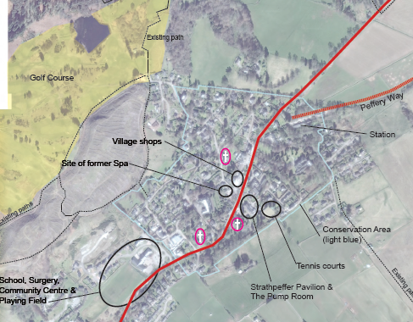

#### Strathpeffer Pavilion Floor Plans – ground floor

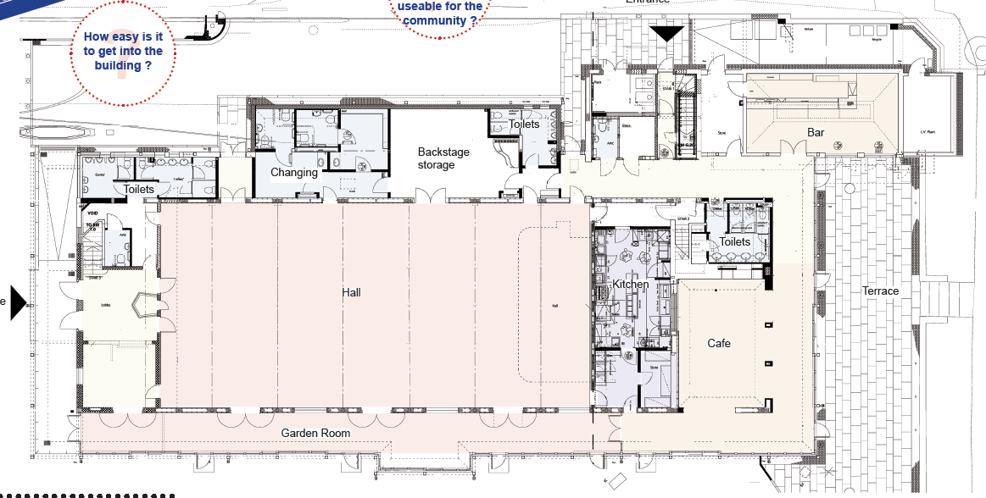

#### Strathpeffer Pavilion Gardens map

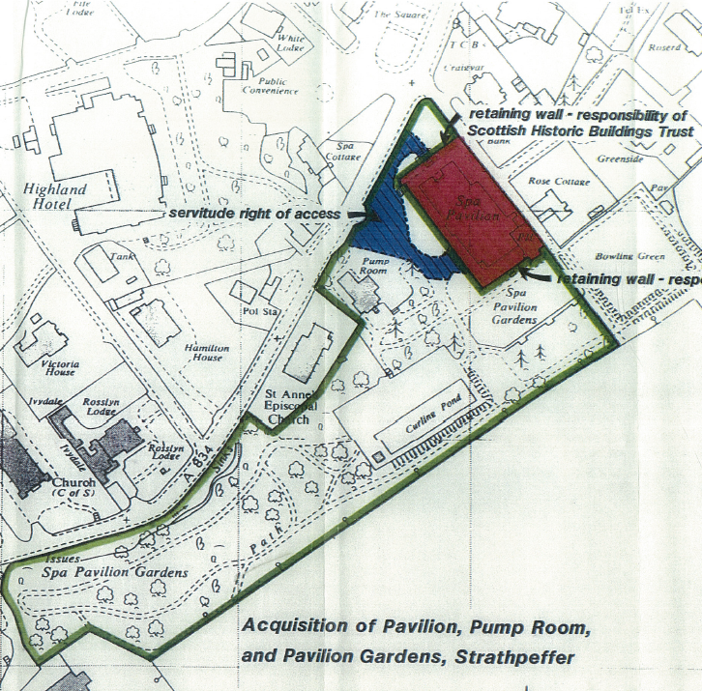

#### Board Skills Audit detail

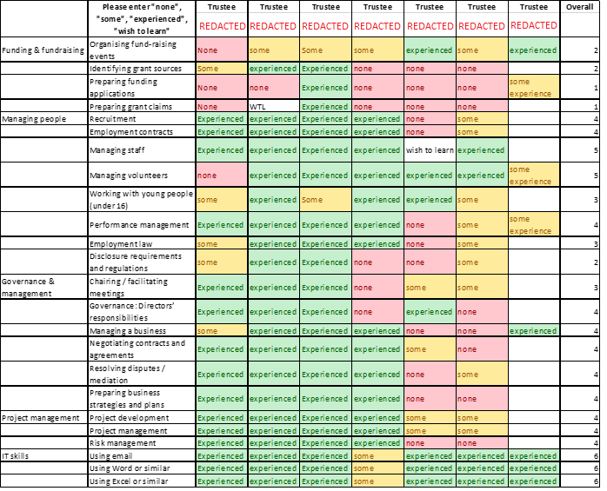

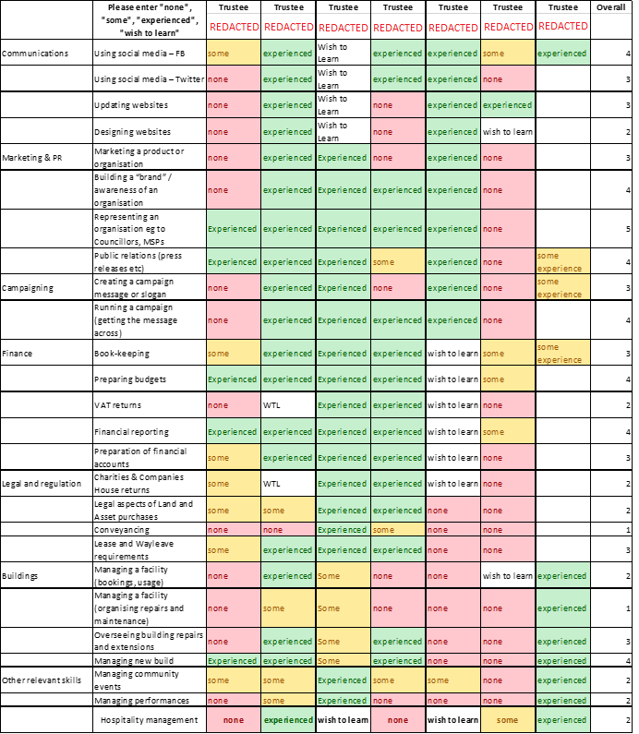

#### Financial Tables

1. Income and Expenditure



1. Cash Flow Statement



1. Balance Sheets



1. “Economic Impact of HLF funded project – an update”, Heritage Lottery Fund, 2013