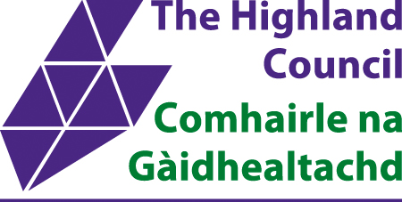

**Town and Country Planning**

**(Development Management Procedure)**

**(Scotland) Regulations 2013**

**Planning Application Pre-application Consultation**

The Highland Council are conducting a second pre-application consultation on the development proposal for construction of a new primary school at Ness Castle.

**Ness Castle Primary School, Ness Castle, Inverness**

**The general concepts for the proposed development along with initial site plans and building layouts will be on display at the drop-in session where members of the public can make comments on the proposal. Comments received from this pre-application consultation may be incorporated into the design development prior to submitting a Planning Application.**

**This pre- application session will take place on**

**Wednesday 21st August 2019**

**At Holm Primary School from 14:30 to 19.30**

**Details of the proposal will also be published on the Highland Council website** [**www.highland.gov.uk**](http://www.highland.gov.uk)

**Further information may be obtained from**

**Stallan-Brand, 80 Nicholson Street, Glasgow, G5 9ER**

**Those willing to make comments on the proposal may do so at the above event and/or in writing to**

**Stallan-Brand, 80 Nicholson Street, Glasgow, G5 9ER**

**and/or by email to**

[**kmonaghan@stallanbrand.com**](mailto:kmonaghan@stallanbrand.com) **no later than 30th August 2019**

Please Note: No Application has been submitted to the Highland Council, in relation to this proposal. Any comments made to the Council as prospective applicant at this time are not representations to the Council as Planning Authority and would not be considered as such as part of any future application(s). When the application is submitted, there will be an opportunity to make representations on those applications to the Council.