# BadgeArtwork-small

Strathnaver Museum

Redevelopment of Strathnaver Museum as a heritage hub for North West Sutherland

Business Plan

2018 – 2022

Version: 10 April 2019

**Contents**

**Executive Summary**

1. **Introduction p.1**
   1. Business planning process and review p.1
   2. Statement of purpose p.1
   3. Key achievements of Strathnaver Museum p.2
   4. Visitor figures p.4
2. **Situation Review p.6**
   1. Strathnaver Museum today p.6
      1. The Building p.6
      2. Highland Clearances p.7
      3. The Farr Stone and associated archaeology p.8
      4. The Clan Mackay Room p.10
      5. The Grimble Library and Archive p.10
      6. Temporary exhibitions p.10
      7. Education and outreach p.12
   2. Partnerships with other organisations p.13
   3. Management Structure and staffing p.14
   4. Our place in the community p.17
      1. Improve the visitor experience p.17
      2. Sustainability p.18
      3. Volunteer Development p.20
      4. Education and further outreach p.20
3. **Audiences and Market p.22**
   1. Visitor number trends 2000 to 2015 p.22
   2. Where do visitors to Strathnaver Museum come from? p.24
      1. The UK p.25
      2. Europe p.26
      3. North America and Australasia p.27
      4. Emerging Markets p.28
      5. Conclusion p.28
   3. How old are visitors to Strathnaver Museum? p.29
   4. Where do our visitors hear about us? p.30
   5. Visitor comments p.32
4. **Strategic aims and objectives p.34**
5. **Analysis of the current situation p.36**
   1. SWOT Analysis p.36
   2. PESTLE Analysis p.37
   3. Key Challenges facing Strathnaver Museum p.37
      1. Budget reductions p.37
      2. External funding reductions p.37
      3. The building’s condition p.37
      4. Collections p.38
      5. Community groups and other partners p.38
      6. Café p.38
      7. Event hosting p.38
      8. Centre for historic research p.38
      9. Rob Donn p.38
   4. Summary p.39
6. **Realising the ambition p.39**
   1. HLF pre-application and first-round application p.39
   2. Development phase p.40
   3. Delivery phase p.40
7. **Resources p.41**
8. **Conclusion p.42**

**Appendix 1: Budget Report 2016/17 p.44**

**Appendix 2: Budget Report 2017/18 p.45**

**Appendix 3: Budget Report 2018/19 p.46**

**Appendix 4: Budget Report 2019/20 p.47**

**Appendix 5: Refurbishment Project Budget 2019/20 p.48**

**Appendix 6: Budget Report 2020/21 p.49**

**Appendix 7: Capital Funding Package p.50**

**Appendix 8: Capital Expenditure 2019/20 p.51**

**Appendix 9: Budget Report 2021/22 p.52**

**Appendix 10: Budget Report 2022/23 p.53**

**Appendix 11: Budget Report 2023/24 p.54**

Executive Summary

*Strathnaver Museum’s* purpose is to preserve and promote the history and culture of the area for present and future generations by conserving, interpreting and augmenting the Museum’s collections together with the archaeological, historical and natural history of the area, for the public benefit, by running the museum and all its organised activities based on the best possible practices.

The Museum has an excellent track record of running innovative community outreach projects and events which has involved a diverse range of people from all ages and backgrounds. These events also help to attract visitors to the area and in 2016 visitor numbers to the Museum increased by 22%.

We also regularly work in partnership with other community groups and organisations to deliver our core purpose. In 2015 we worked with the traditional music group *Fèis air an Oir* to explore the impact of WWI through music. This has allowed us to engage more effectively with children and young people by delivering workshops exploring our history and heritage through activities the young people are already engaged in.

*Strathnaver Museum* supports the local economy through tourism development activities such as the creation of a smart phone heritage mobile application to promote heritage sites in Caithness and Sutherland. It is also an important visitor attraction for the area as one of the few wet weather activities in north west Sutherland. The increasing popularity of the NC500 means the presence of *Strathnaver Museum* as part of the infrastructure for this world class route is increasingly important.

To continue to deliver these services and continue to increase visitor numbers to the Museum for the benefit of the local economy we need to preserve our important B listed building for the future. The need to increase our income generation is also increasingly apparent to mitigate against impending core grant cuts.

*Strathnaver Museum* and the iconic church it resides in is at the heart of the history of the Clearances. This makes it culturally central to the story of the Highlands and of Scotland as a whole. But the Clearances don’t just relate to Scottish History – the repercussions of the Clearances echo across the world and have impacted on nations throughout the former British Empire. Our collections, humbly and lovingly curated by a dedicated host of volunteers, are internationally significant. The time has come to recognise this significance and to work towards a world class presentation of this astonishing story of resilience, greed, incompetence, cruelty and above all of survival.

To progress *Strathnaver Museum’s* vision of creating a heritage hub for north west Sutherland we secured £71,761 of development funding from Highland LEADER and the Architectural Heritage Fund. This pre-development stage allowed us to address *Heritage Lottery Fund* (HLF) advice to submit a successful first-round application. Ultimately this will allow us to access significant delivery funding of £1,524,401.

* Run by the community, for the community
* Strategically significant museum hub and focus of Mackay Country in ‘the middle’ of North Coast 500
* Impressive record of running programmes and events engaging with other groups and communities of all ages
* 22% increase in visitor numbers in 2016 – more growth expected
* One of very few in-door attractions in North Sutherland – providing a rare refuge from intemperate weather
* Developed smart phone ‘heritage app’ boosting visitor engagement across the region
* B-listed building in urgent need of improvement, for the survival of the collections and to maximise income potential
* £71,761 development funding secured to attract significant external funding
* Concept Design and detailed costings produced
* Planning Application submitted and validated

1. Introduction
   1. **Business planning process and review**

The aim of this Business Plan is to inform the work and development of *Strathnaver Museum* for the period April 2017 to March 2024.

The following tasks were undertaken in the process of developing this Business Plan:

* The current position of the Museum was determined to establish a baseline from which to develop the Museum and its services (Section 1 & 2);
* The broader strategic context within which the Museum operates was reviewed (Section 3 & 5);
* The results of research into the views of users were analysed (Section 4);
* The views of staff and other stakeholders were obtained (Section 4);
* A cashflow forecast for core cost and the refurbishment project have been compiled (Section 6).

At the annual review consultation data from the visitor survey, users, volunteers and stakeholders will be reviewed and updated to ensure the Business Plan and strategic direction of *Strathnaver Museum* continues to meet user needs and expectations.

* 1. **Statement of Purpose**

***Strathnaver Museum will preserve and promote the history and the culture of the area for present and future generations by conserving, interpreting and augmenting the Museum’s Collection together with the archaeological, historical and natural history of the area, for the public benefit, by running the Museum and all its organised activities based on the best possible practices.***

The Mission Statement sets out the purpose of the Museum as follows:

* To collect, preserve and display items relating to Strathnaver, the surrounding area and its people;
* To provide exhibitions and events;
* To carry out projects and outreach work;
* To help promote lifelong learning.

The aims of the Museum are:

* To provide an enjoyable experience;
* To provide a learning experience;
* To provide access for all regardless of age, background and ability;
* To address the cultural, creative and intellectual needs of the local community.
  1. **Key achievements of Strathnaver Museum 2017-2012**

|  |  |
| --- | --- |
| **Year** | **Achievement** |
| **2018** | Rob Donn Mackay community research project to celebrate the life and work of celebrated Gaelic bard:   * 10 x pieces of art created by local artists; * Wall hanging created by local crafters; * Interpretive Trail featuring 9 x panels; * School workshops using art and creative writing as inspiration.   Secured pre-development funding for the refurbishment project from Highland LEADER and private sources.  Retail sales increased by 23% on previous year. |
| **2017** | Ambitious partnership project with *Mackay Country Community Trust* celebrating the life of Gaelic bard Rob Donn Mackay developed.  Serving on Our Collective Future steering group.  Onsite visits up 9.6% on 2016-17 (48.6% increase since 2012-13).  Improvements to the retail area by the volunteers have increased sales by 47.5% on the previous year. |
| **2016** | Celebrated 40 years of *Strathnaver Museum* with a community curated exhibition.  Worked with *Flows to the Future* Project to create and install new interpretation exploring peat.  Worked with the *Pearls in Peril* Project to create and install new interpretation board and small exhibition exploring fresh water pearl mussels.  Secured a volunteer coordinator post for 2 years.  Preparatory work undertaken for the refurbishment project.  Improvements to educational offering and work with schools.  Developed *Highland Museum Forum* partnership project *Our Collective Future* as part of the HMF Committee.  Delivered 3 workshops for young people.  Onsite visits up 18% on 2015 (36% increase since 2013). |
| **2015**  **2015 cont.** | WW1 Centenary project *Pibrochs and Poppies* increased profile of *Strathnaver Museum* and successfully engaged young people.  Establishment of *Strathnaver Museum Youth Group*.  Mobile Heritage Application for Caithness and Sutherland developed.  Delivered 2nd community curated exhibition: *Alec: the Heilam Piper.*  Delivered 9 schools outreach events.  Increased onsite visits by 17% and attendance at events by 40%. The events programme delivered 49 events which 1,023 participants took part in.  Recruited 4 new volunteers. |
| **2014** | Established links with the *UHI Centre for History* and supported delivery of the academic conference *Strathnaver Conference: Land and People.*  *Portable Museum of Curiosity* used by 3 local primary schools as learning aid to explore their history using drama.  Supported Bronze *Duke of Edinburgh Award* Candidate through volunteering opportunity at the Museum.  Established regular events programme. This year’s theme was the *Bicentenary of the Strathnaver Clearances.* This included 39 events which attracted 981 participants.  Staged first community curated exhibition: *A Mackay Journey.*  Visitor numbers up 21% on last year.  Recruited 6 new volunteers. |
| **2013** | Secured funding for a 2 year consultants post to take forward the Museum’s Development Programme.  *Alan Joyce and Mary Beith* exhibition held in Melness which led to the donation of Mary Beith’s papers.  Census books for Kirkton, Farr and Strathy compiled and published by the Museum.  New website launched. |
| **2012** | Heritage Awareness project to develop Museum resources, including digitising, archiving and outreach activities, production of school resources. |

**Summary of achievements:**

In 2013 *Strathnaver Museum* secured funding from the:

* *Caithness and North Sutherland Fund*,
* *The Robertson Trust* and
* *The Highland Council*

towards the costs of a two-year Museum Development Project. The funding supported the appointment of a Development Manager to help maximise the potential of *Strathnaver Museum* for the social, economic and environmental benefit of the area and its people. The project ran from 1st December 2013 to 30th November 2015 and delivered several benefits relating specifically to education and further research, improving the visitor experience and the Museum’s future sustainability.

Key achievements over the period include:

* Visitors to the Museum increased by 22%
* Participants in activities and events up by 95%
* 80 events and activities were held
* Income from admissions up 29%
* Produced papers in support of redevelopment of *Strathnaver Museum*
* Creation of a heritage mobile application for Caithness and Sutherland
* Recruited an additional 10 regular volunteers
* Established *Strathnaver Museum Youth Group*
* Provided 187 training opportunities for volunteers through 37 events
  1. **Visitor figures**

As can be seen below visitors to *Strathnaver Museum* have increased steadily from 2009-10 and significantly over the last two years. This can be attributed to an increased outreach and events programme, improvements to our website and an increased presence on social media. The promotion of the *North Coast 500* has also had a positive impact on the number of visitors since its inception in 2015.

|  |  |  |  |
| --- | --- | --- | --- |
| **Year**  (1 Apr-31 Mar) | **Visits** | **Events** | **Total** |
| 2009-10 | 3,359 | N/A | 3,359 |
| 2010-11 | 2,791 | N/A | 2,791 |
| 2011-12 | 2,727 | N/A | 2,727 |
| 2012-13 | 2,855 | N/A | 2,855 |
| 2013-14 | 3,245 | 61 | 3,306 |
| 2014-15 | 3,405 | 981 | 4,386 |
| 2015-16 | 4,109 | 1,023 | 5,132 |
| 2016-17 | 5,026 | 217 | 5,243 |
| 2017-18 | 5,557 | 463 | 6,020 |
| 2018-19 | 5,256 | 562 | 5,818 |

Table 1: Museum visitor figures

A more detailed analysis of *Strathnaver Museum* Audience and Market is given at section 4.

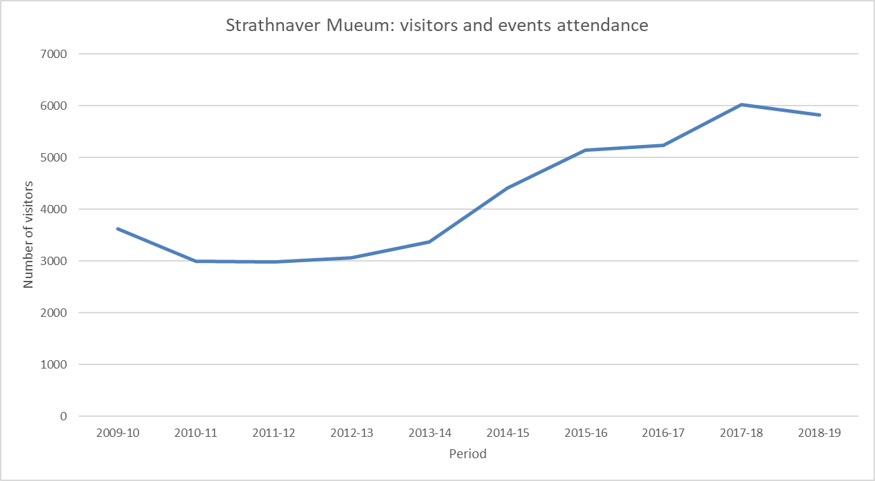

Figure 1: Number of visitors to *Strathnaver Museum* including events and activities

1. Situation Review
   1. **Strathnaver Museum Today**

*Strathnaver Museum* is an iconic visitor attraction located on the *North Coast 500* housed in the former Parish Church of St. Columba at Clachan, Bettyhill. It houses several permanent displays illustrating the social, agricultural and natural history of the ancient province of Strathnaver or *Mackay Country*. The Museum is open from 1st April to 31st October, 10am to 5pm, Monday to Saturday and there is a small charge for admission.

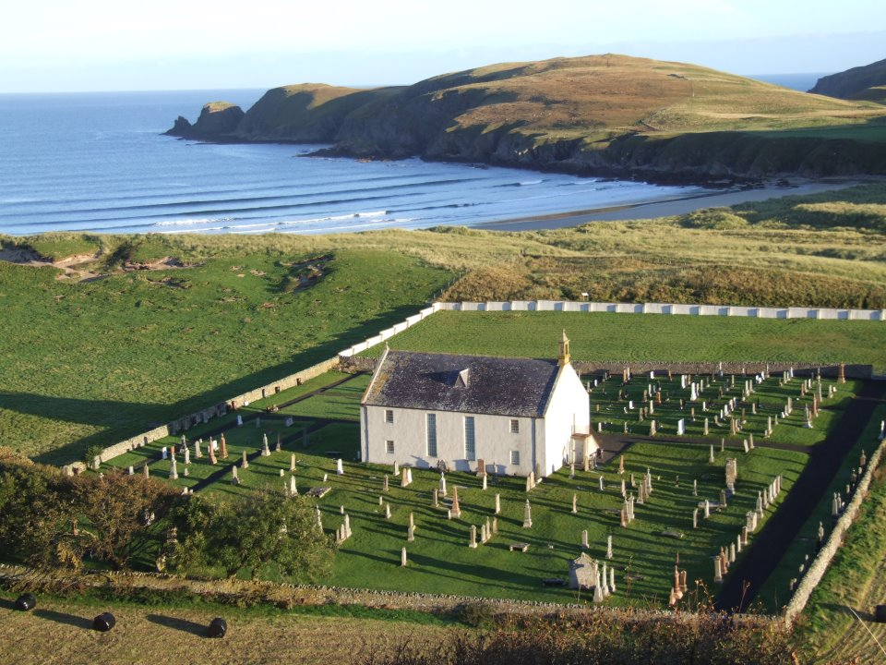

*Image 1: Strathnaver Museum*

* + 1. The Building

*Strathnaver Museum* is housed in the regionally important B listed former church of St Columba at Clachan. The former church sits on a site which is thought to have been a site of ecclesiastical significance for hundreds of years as the parish was first mentioned in the thirteenth century. The current building was built on the site of the former church in 1774 and accommodated a congregation of over 800. The architect / mason of the present building is not known for certain although James Boag or Boog of Dornoch was responsible for the building or re-casting of many Sutherland churches (such as Golspie, Rogart and Kildonan) in the latter half of the eighteenth century. This late 18th century church building is a archetypal example of ecclesiastical architecture and retains a traditional interior of timber-lined walls. The imposing 1774 pulpit is also still *in situ* on the south wall and casts an impressive and imposing presence.

* + 1. Highland Clearances

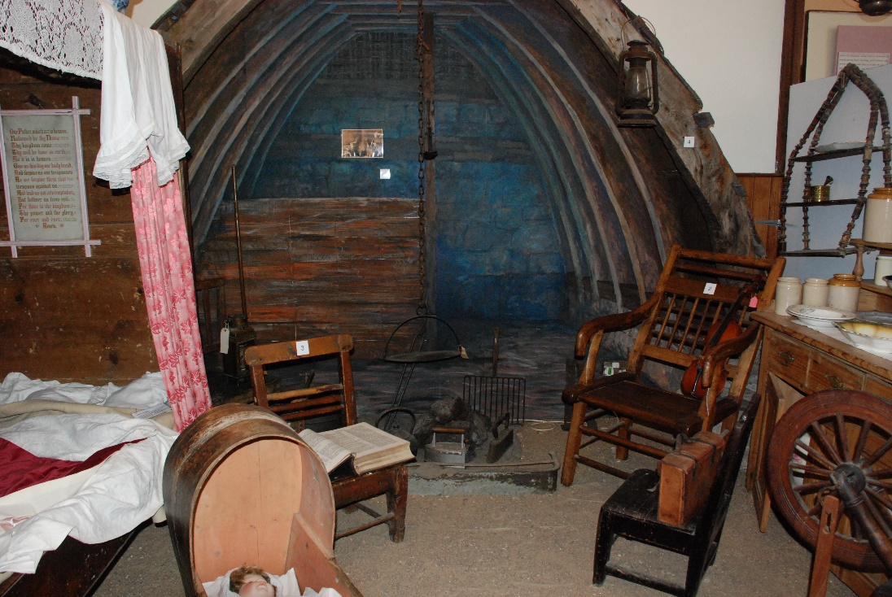

*Image 2: The reconstructed croft house scene*

The main story told by *Strathnaver Museum* is that of the Highland Clearances which is explored in the main room of the museum. Pre- and post- clearance life is examined and visitors are signposted to other sites of importance such as the remains of multiple pre- and post- clearance villages. The pulpit (Image 3) which dominates this room was where the Rev. David Mackenzie read out eviction notices to members of his congregation. The building's association with the Highland Clearances did not end in 1819, as it was within the church that the Napier Commission heard evidence from the people of north Sutherland in 1883. *The Napier Commission* resulted in significant improvements to the lives of crofters and other small tenants delivered through The Crofters’ Holdings (Scotland) Act 1886 and subsequent legislation.

***Strathnaver Museum* is properly the focus of interest in The Clearances and uses this to signpost visitors to other attractions in the area encouraging longer stays boosting the local economy.**

All the exhibits have been donated by the local community or by people with local connections. The local school made a large contribution to the displays through the production of a wall based panel/frieze detailing the story of “The Clearances”. “The Clearances” panel remains a very popular exhibit today.

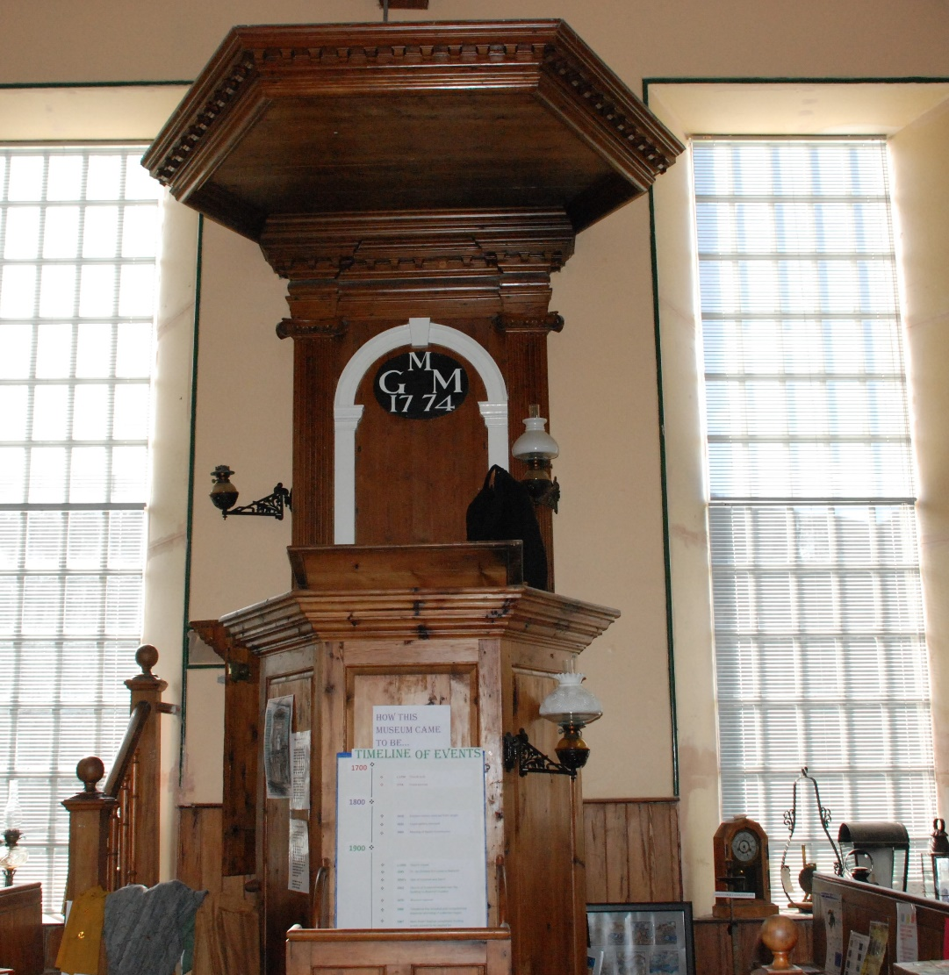

*Image 3: The pulpit in Strathnaver Museum*

* + 1. The Farr Stone and associated archaeology

*The Farr Stone* (Image 4) is a Scheduled Ancient Monument located by the west gable of the church. This Pictish cross-slab dates from approximately the eighth or ninth century AD and depicts an intricate interlacing pattern on a large slab of moine schist. It’s presence along with the adjacent small group of potentially early gravemarkers suggest that the use of the site goes back even further than the thirteenth century when the first mention of the parish is recorded (Hooper, 2006).

The ringed Celtic cross demonstrates that the influence of St Columba and the Christian church was felt even in this remote part of Pictland. While little is certain about the meaning of Pictish carvings, it is thought that the two intertwined birds at the foot of the cross may be swans, often a symbol of faithfulness as swans tend to mate for life. An alternative suggestion is that they are doves, a symbol of friendship.

The Museum Collection contains archaeological material excavated from Strathnaver including the early Bronze Age *Chealamy Beaker* and cist (Image 5). The find was uncovered by a *Highland Council* road crew during road widening works at Chealamy on the B871 in February 1981. The cist was excavated and reconstructed outside *Strathnaver Museum* with the N3 Beaker placed on display inside. Other notable items in the Collection include two small Early Christian monuments unearthed by Geologist and amateur archaeologist Kevin J O’Reilly at Grumbeg. The Museum also houses a fine collection of 17th and 18th century tacksmen’s gravemarkers; tacksmen played an important role in society prior to the Clearances.

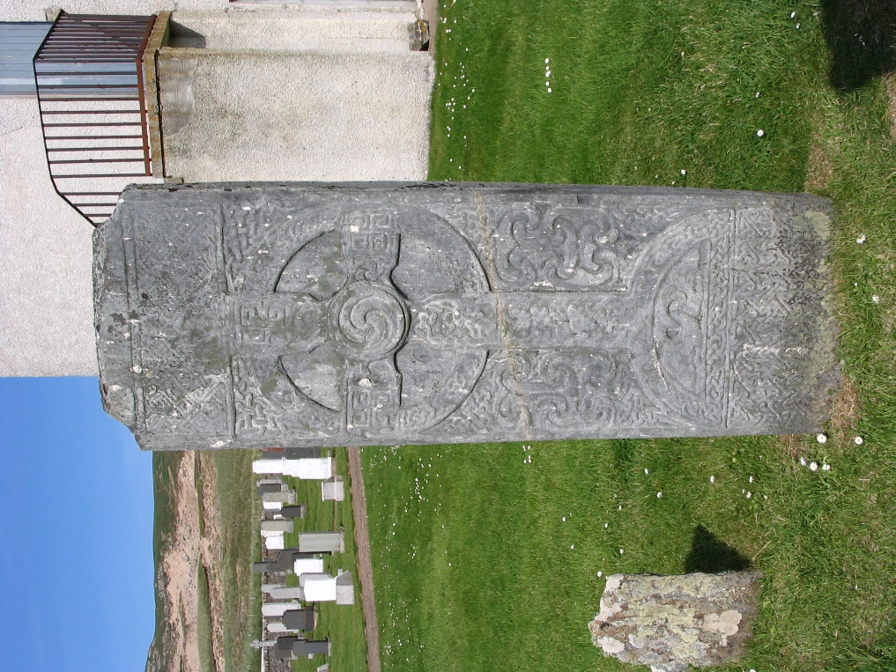

*Image 4: Farr Stone*

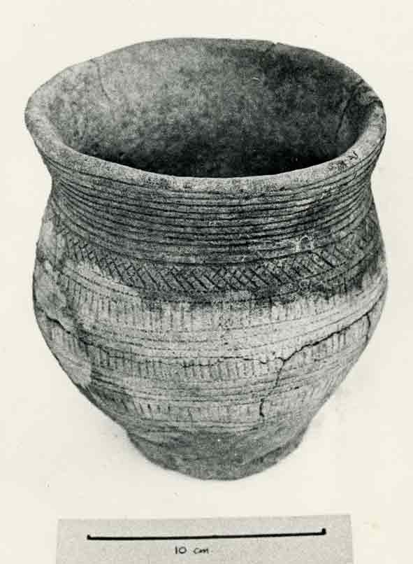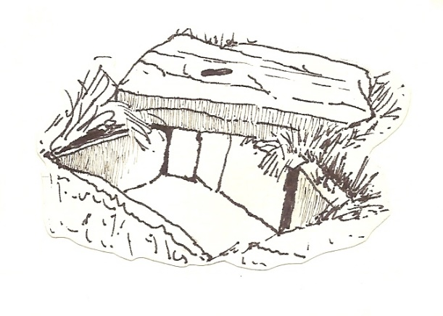

*Image 5: Bronze Age Chealamy burial beaker and cist*

There is a wealth of archaeological sites throughout the area and *Strathnaver Museum* is the start / end point on the popular *Strathnaver Trail* which comprises 29 sites of archaeological importance. It is also a point on the *Pictish Trail*.

* + 1. The Clan Mackay Centre

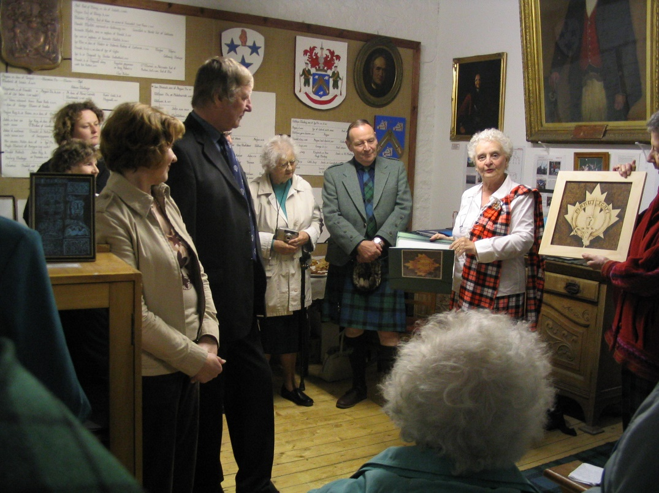

*Image 6: Clan Mackay Association of Canada presentation in the Mackay Room, 2004*

The Museum works in partnership with the *Clan Mackay Society* to preserve and present the collection of artefacts and archive of information housed in *the Scottish Clan Mackay Centre*. This can be found on the first floor of *Strathnaver Museum* and is the only dedicated Clan Mackay Centre in Scotland. Items include rare books, manuscripts, photographs and documents.

* + 1. The Grimble Library and Archive

Since *Strathnaver Museum’s* inception local people have donated a wealth of objects, oral testimonies and stories which help to tell the story of this area. This has been complemented by a wealth of research projects which have explored what life was like for the people in this area.

Broadcaster and historian Dr Grimble bequeathed his extensive library and some research papers to *Strathnaver Museum* on his death in 1995.

*Strathnaver Museum* also houses the extensive *Mackay Country Community Trust* Archive which contains thousands of images alongside many oral histories.

* + 1. Temporary exhibitions

Following curation training as part of the *My Heart’s in the Highlands Homecoming Initiative* in 2014 the volunteers have curated three well received temporary exhibitions.

* 2016 40 years of Strathnaver Museum
* 2015 *Alec: the Heilam Piper* part of the WWI Pibrochs and Poppies project
* 2014 *A Mackay Journey* to commemorate the bicentenary of the Strathnaver Clearances

Project supported exhibitions:

* 2012 *Moving Times and Museum Tales* a collaborative project with *the Mackay Country Community Trust*
* 2010 *Burr’s of Tongue* telling the story of Burr’s stores

From time to time the museum hosts temporary displays as part of specific project work. This has included:

* 2015 entries to the *Alan Joyce Young Environmentalist Competition*,
* 2014 *Strathnaver Clearances Bicentenary Patchwork,*
* 2013 *Wild North and Patchwork Meadows Exhibition* and
* 2012 Heritage Awareness Artist Residency exhibits.

During 2017 *Strathnaver Museum* and *Mackay Country Community Trust* worked with local people, community groups, schools and artists to create the Rob Donn Mackay exhibition. This has been installed by the volunteers in the Mackay Centre for the 2019 season.

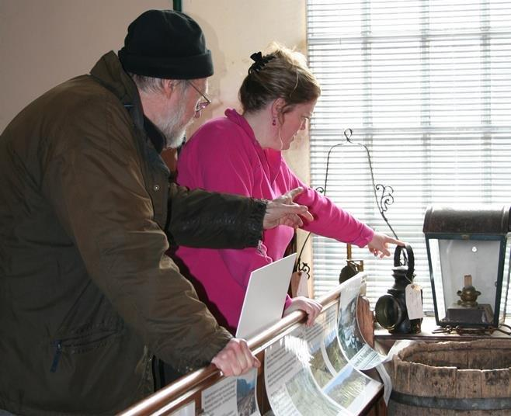 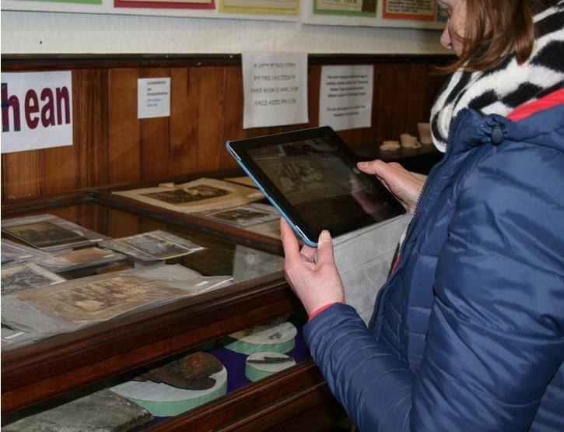

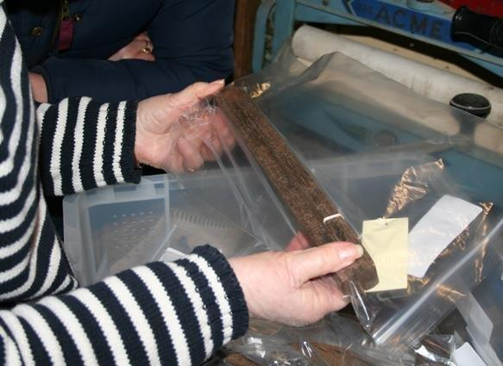 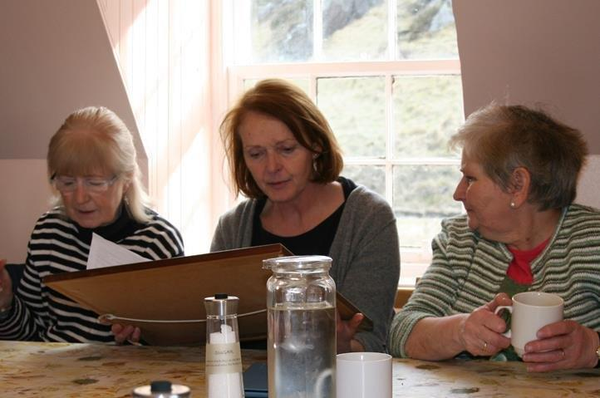

*Image 7: Curation training workshops as part of My Heart’s in the Highlands Homecoming Initiative, 2014*

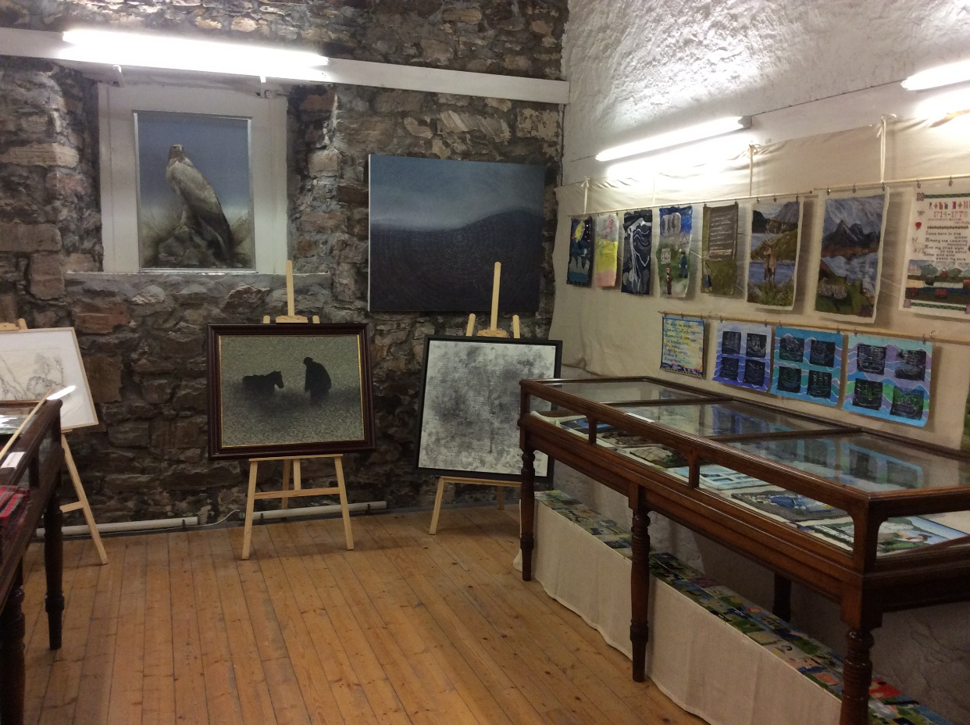

*Image 8: Some of the Rob Donn exhibition in the Mackay Centre, Strathnaver Museum*

* + 1. Education and outreach

As part of the Heritage Awareness project artist programme *The Portable Museum of Curiosity* (Image 9) was developed as an idea to introduce school children to *Strathnaver Museum’s* collection. Liaising closely with local teachers the artist, Joanne B Karr, developed the design to encourage children to explore the themes of the museum. *The Portable Museum of Curiosity* is regularly lent to local schools and has also been used as a key element in a *Strathnaver Museum* drama project with 3 local primaries exploring the history of Strathnaver.

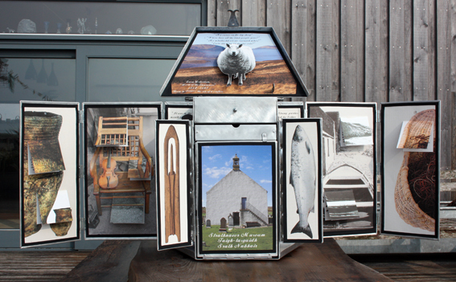

*Image 9: The Portable Museum of Curiosity*

The museum also received funding for an education officer who has worked with a group of students at *Farr High School* to identify ways the museum can become more relevant to children and young people. This delivered 9 workshops identified by the young people, an event, a new family area and activities and a short film exploring *Donald the Sailor’s* later life is also in production.

* 1. **Partnerships with other organisations**

In recent years the Museum has instigated a number of partnership projects with local arts and heritage groups including *Mackay Country Community Trust* and *Fèis air an Oir.* The WWI Centenary project *Pibrochs and Poppies* with *Fèis air an Oir* was especially rewarding and we are looking to develop a Phase II project using the musical outputs from Phase I to explore our heritage through dance.

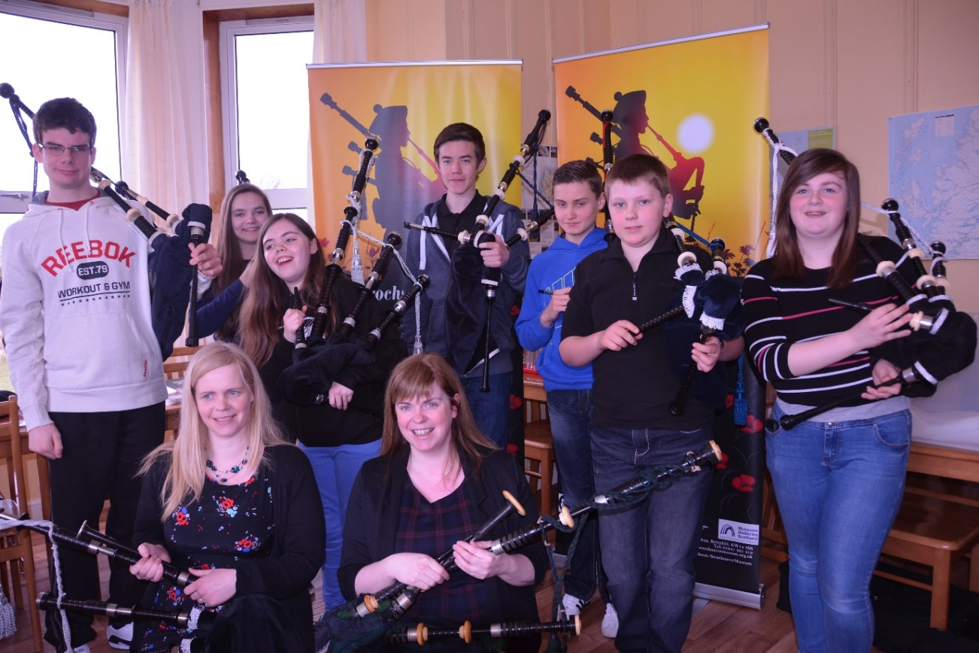

*Image 10: Tunes and Tales Workshop, Tongue March 2015*

*Strathnaver Museum* is a member of local groups and forums and regularly contributes to joint initiatives. These are local tourism groups *Venture North* and the *Caithness and Sutherland Visitor Attraction Group* as well as the *Highland Museum Forum* *(HMF)* and the North Highland Initiative (NHI) Tourism Board.

*Strathnaver Museum,* as a committee member of the *HMF*, has been involved in developing a partnership project for the independent museums in the Highlands to support the sectors sustainability. The project is funded by *Museum Galleries* *Scotland* and the *Heritage Lottery Fund* and saw the procurement of expert advice in the form of a Business Advisor and fundraiser to support improved partnership working, cost efficiencies as a sector and identified potential future projects.

The museum has close links with the *Clan Mackay Society* and houses their collection in the *Mackay Centre*. The museum is keen to strengthen this relationship and is developing links with Mackay’s throughout the world following the successful *Mackay Goes Global* project in 2009. The potential to increase income through a virtual community around *Strathnaver Museum* is another ambition.

The Museum has worked closely with the *High Life Highland Ranger Service* on several projects.

The development of the education programme has also strengthened our links with the local schools and the *Highlife Highland Youth Development Officer*.

The museum has also been working with the *Peatlands Partnership Flow to the Future* project. This included a partnership project to deliver the museum’s *Alan Joyce Young Environmentalist Programme* and the museum housed an interpretation panel for the project installed in 2017.



*Image 11: Forward Together: North West Sutherland Voluntary Sector Leaders Forum, 23 May 2016*

In 2016, in a unique collaboration with the *North West Sutherland Voluntary Sector Leaders Forum*, the museum reached out to other voluntary organisations in North Sutherland to explore innovative joint ventures to bring mutual benefit from museum developments across the wider locality. Several partnership opportunities have been identified and will inform the Activity Plan 2019-2022.

* 1. **Management structure and staffing**

*Strathnaver Museum* is a registered charity and limited company by guarantee managed by a voluntary Board of Trustees made up of 7 Directors. The Board has responsibility for the strategic leadership of the organisation, policy-making and budgetary control. Board meetings are held quarterly or more often as required. At each AGM a third of Directors who have served for the longest period of time shall be subject to retirement by rotation. Therefore, the average term of office is 3 years. Voluntary office bearers include the post of Chairperson, Vice Chairperson and Treasurer. A Secretary also sits on the Board but this person is not a Director. Three of our regular volunteers are Directors and anyone can stand for election to a Directorship.

*Strathnaver Museum* employs a part time museum administrator and development manager who are responsible for the operational and strategic management respectively. The museum has the services of a Museum Mentor who provides professional curatorial advice on a voluntary basis. It also appoints personnel for fixed term posts for the delivery of specific projects.

Over the years *Strathnaver Museum* has delivered a varied and successful series of events and projects exploring the arts, heritage and natural history of the area. Current project staff includes a volunteer coordinator and a project manager. During 2017 a variety of contract posts were appointed to support the *Rob Donn Country* projects which include, *Threading Rob Donn, Trailing Rob Donn* and *Re-Creating Rob Donn*.

*Strathnaver Museum* is an Accredited museum and as such meets national standards and has access to support and resources including training from *Museum Galleries Scotland*. The Museum Mentor ensures the requirements for accreditation are maintained. She supplies training in collections management, recording and accreditation standards. The museum has access to *Voluntary Groups Sutherland*, member of the Highland *Third Sector Partnership*, which provides support and help with requirements for regulation and governance.

|  |  |
| --- | --- |
| **Thomas Mackay** (Chair) | Personal information redacted by Highland Council |
| **Anne Buck** (Treasurer) |
| **Frances Gunn**  (Director) |
| **Dorothy Pritchard**  (Vice Chair) |
| **Robert Mackay**  (Director) |
| **Elliot Rudie**  (Honorary President) |
| **Sonya Anderson-Hughes**  (Director) |
| **Colin McDonogh**  (Director) |
| **Eileen Mackay**  (Director) |
| **Simon Lee**  (Volunteer Coordinator) |
| **Fiona Mackenzie**  (Development Manager & Project Manager) |
| **Vacant**  Administrator |

*Table 2: List of key staff*

* 1. **Our place in the Community**
     1. Improve the visitor experience

**Develop *Strathnaver Museum* into a heritage hub for north west Sutherland.** Enhance the Museum experience and environment for our volunteers and visitors to allow a more enjoyable experience which will encourage more people to visit and volunteer.

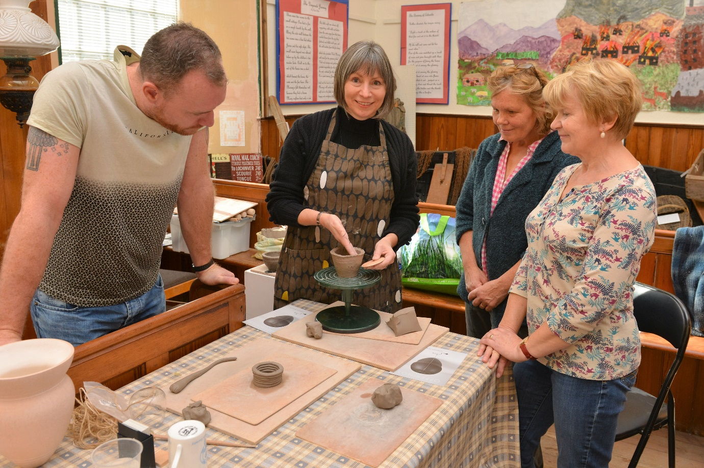

Image 12: Ceramic artist Lorraine Robson hosting a workshop in the Museum exploring Museum artefact Bronze Age Chealamy Beaker.

*Strathnaver Museum* has an excellent track record of delivering innovative and creative community projects. Over the last 5 years *Strathnaver Museum* has strengthened and developed a range of partnership projects (summarised at 1.3) which bring economic, social and educational benefits to our local community. This work has highlighted that there are deficiencies with our current building, layout and interpretation. For instance the work conducted with school children has highlighted that the current displays are not fit for purpose as the youngsters can not view the exhibits.

To ensure we meet the needs and expectations of our users *Strathnaver Museum* has identified a pressing need to improve the visitor experience by improving interpretation, engaging more effectively with children and young people, and providing better access to our collection and archive for visiting researchers.

Our ambition is to develop *Strathnaver Museum* as a community heritage hub for north west Sutherland. This will have social, educational and economic benefits as we will further develop our partnerships and seek to develop new partnerships. We will achieve this by:

* carry out essential repairs and maintenance to our building fabric;
* make more effective use of the internal space within the building to enable us to carry out our services more effectively eg. educational activities;
* take advantage of opportunities to improve our sustainability through income generation activities;
* carry out a programme of education activities to help people understand the heritage associated with the Museum.

The refurbishment and development of *Strathnaver Museum* would contribute towards establishing *Strathnaver Museum* as a destination venue as identified in the *HIE Cultural Infrastructure Report*. This would:

* bring significant economic benefit to north Sutherland as more visitors come to the area;
* provide more opportunities for local schools and continue to support the Curriculum for Excellence;
* continue to develop partnership projects with other community groups such as the 2015 projects Pibrochs and Poppies project with *Feis air an Oir* and the *Venture North* heritage mobile application for Caithness and Sutherland.
  + 1. **Sustainability**

**Ensure the sustainability of *Strathnaver Museum* through income generation and retention and attraction of volunteers.**

*Strathnaver Museum* has to become more sustainable by generating additional income. This would enable the Museum to retain the mission critical part time administrator. If the Museum were to close as a result of lack of essential administrative support the future of the building and collection would be put at considerable risk either as a result of deterioration or removal of the collection from public access in north Sutherland.

*Strathnaver Museum* plays an important role in the tourism infrastructure on the north coast of Sutherland as it is the only manned visitor attraction. Its inclusion in the NC500 Passport as the only attraction in north Sutherland highlights its importance to the route.

Opportunities for income generation have been identified within *Strathnaver Museum Development Plan 2015-2017* under Aim 2: Sustainability. These include:

2.1 Visitor numbers to the museum are increased

Visitor numbers to the Museum have increased year on year due to increased marketing activity both by *Strathnaver Museum* and to an increase in regional campaigns such as the NC500.

2.4 Develop genealogy and research service

As mentioned above we welcome a significant number of ancestral tourists but due to space constraints are unable to provide a dedicated research facility for public use. We have been supporting a University of Strathclyde Marketing Project My Ancestral Tourism to exploit this growing market.

2.5 Develop lines to be sold in an improved retail space

The retail space is inadequate and occupies a 1 metre by 0.5 metre space in the narrow entrance hall. This significantly limits our retail options and income generation and means we are not able to take advantage of opportunities such as stocking the NC500 product line.

2.8 Seek to attract increased revenue through commercial activities, sponsorship and fundraising

In 2016 and 2019 *Strathnaver Museum* hosted a vow renewal and wedding and we anticipate this could become an income stream. Couples are increasingly looking for unique wedding experiences and *Strathnaver Museum* could tap into this market. Currently the Museum is unable to properly exploit the commercial opportunities of using the building as a venue due to our layout and the need for improvements to the fabric.

2.14 Café acquisition

The *Bettyhill Café and Tourist Information Centre* is a vital resource to *Strathnaver Museum* and the village more widely as it encourages visitors to stop and explore. The threat of closure would have a detrimental impact on the Museum and impact on our visitor numbers. The opportunity to take on the Café as an asset transfer explored as a part of the Museums future sustainability. As such the Board decided to take forward a Community Asset Transfer with *Highland Council.* A decision is expected on 15th May 2019.

* + 1. **Volunteer Development**

**Enable our volunteers to develop their skills, knowledge and understanding and encourage knowledge exchange between the volunteers.**

Directors and volunteers bring a wealth of experience and skills to the organisation as they come from a diverse range of backgrounds (see 2.3). Our volunteers are integral to the successful running of the museum and the knowledge and skills they bring to the organisation has been built up over their many years’ service.

Currently we have 19 volunteers who are involved in a variety of volunteering activities including regular and more ad hoc activities.

We recruit from all backgrounds but we are conscious about the opportunities which we can provide, particularly to young people, to expand their skills, knowledge and experience to enable them to develop life skills and become economically independent.

Since 2013/14 we have:

* delivered 83 training opportunities for 327 people;
* delivered in-house training to 123 people;
* enabled 204 external training opportunities;
* delivered 9 workshops for young people during 2016;
* hosted 1 Duke of Edinburgh volunteering placement;
* created 2 student volunteer places during 2016;
* hosted 1 work experience placement for a young person with learning difficulties
  + 1. **Education and further research**

***Strathnaver Museum* works to increase knowledge and understanding of our local heritage and culture by providing more opportunities for everyone to take part in heritage related activities.**

We want to continue to provide opportunities for children and young people to tell their story as well as improving our interpretation and the events and activities we deliver for them.

The Museum event planning for our younger audience has improved significantly in recent years and this is reflected in increased engagement with kids and young people.

Creating fresh exhibitions and regular events will help to encourage engagement with local people and those residing within travelling distance of the Museum. Regular press releases to the local media detailing our events and projects help to engage with local people and encourage their participation. During 2014 through a series of special events to commemorate the *Bicentenary of the Strathnaver Clearances* weattracted almost 600 people to 18 diverse events that took place from March to November. Similarly in 2015 our WWI *Pibrochs and Poppies* project involved over 1,000 people of all ages across Caithness and north Sutherland. The events in the shoulder months were aimed specifically at local people to increase our profile and engagement locally.

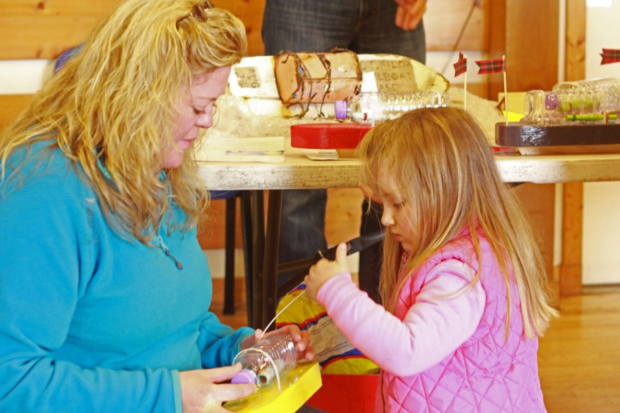

Image 12: Make your own St Kilda Mailboat as part of the Seashore Festival

Feedback from children on a recent visit, although positive, has identified that some of them missed our two WWI displays. For instance, one young boy commented ‘I would come back if you add WWI stuff’ and a young girl said ‘the museum…does not have WWI stuff’. The reason for the youngsters missing the WWI displays may be because of physically being unable to view the displays as they are in high cases or the story they told didn’t engage them. We want to develop interactive activities and displays within the Museum which will engage the youngsters more effectively.

The Museum has also received positive feedback on the educational elements we have previously delivered including the creation of school resource boxes and our portable museum of curiosity created by a local artist. However, there is much more that can be done to ensure we fully support the schools to deliver the curriculum for excellence by providing additional resource boxes accompanied by appropriate written resources or delivering educational events, activities and learning opportunities for all. We have been meeting regularly with a group of young people through *Farr High School* to discuss ways in which the young people can become more involved in the Museum and how they would like to see the Museum develop into the future.

1. Audiences and Market

*Strathnaver Museum* gathers quantitative and qualitative data from visitors in the form of entrance numbers and an annual visitor survey. The visitor survey is conducted throughout the year with a good rate of return. However, we realise this is problematic as it does not target a cross section of visitors, but only those who opt to complete a survey. We also monitor and respond to reviews on our social media pages (Facebook, Twitter, Instagram), Google and TripAdvisor. To gain a picture of how we are performing and who our visitors are, we examined trends in visitor numbers from 2000 to 2016 both at a local and national level. We then looked at the demographic data in more detail to establish where our visitors come from and who our current audience is.

* 1. **Visitor number trends 2000 to 2019**

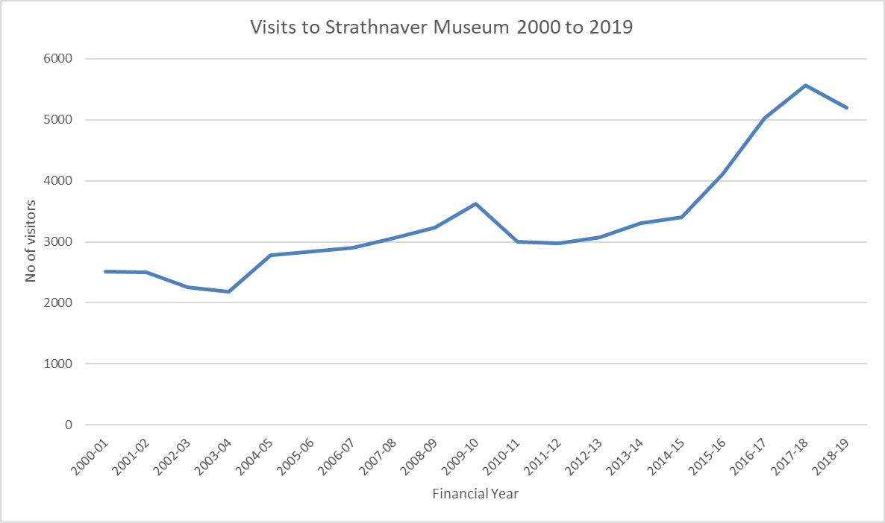

*Figure 2: Visitors to Strathnaver Museum 2000 to 2019*

Year after year *Strathnaver Museum* has out-performed Scottish national growth rates in visitor numbers. This growth, despite a lack of investment in fabric and collections and infrastructure provides a tantalising clue to the potential of the museum with the right investment package.

Figure 2 shows visitors to the Museum have largely increased year on year. The exceptions (2002, 2003, 2010, 2011 and 2018) mirror trends seen in national and international statistics[1].

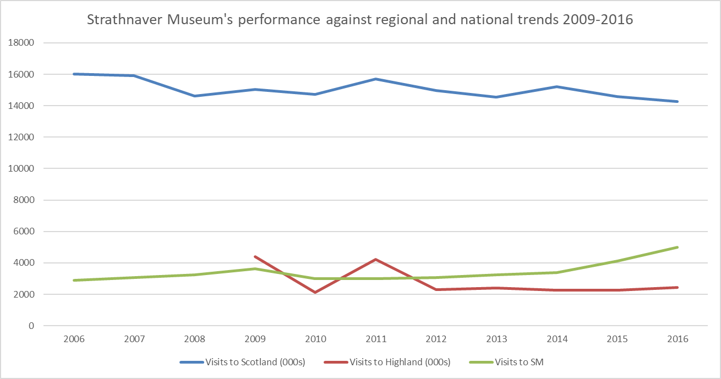

Figure 3: Number of visitors to *Strathnaver Museum* from 2009 to 2015 compared to trends at regional and national level

* In 2004 Scottish tourism recovered with a growth of 10% and *Strathnaver Museum* out performed this national trend with a 28% increase in visitor numbers.
* The next four years saw a steady increase of between 3 and 6% year on year.
* In the first year of *Homecoming in 2009* visitor numbers increased by 12% while across Scotland expenditure between July and September saw a 7% increase on the previous year’s performance. During the same period visitors to *Strathnaver Museum* increased by 11%.
* In 2010 there was a decline in visitors to the Museum by 17% on the previous year coinciding with a decline in overnight stays and tourism expenditure nationally. This decline can be attributed to a general lack of confidence in the global economic climate as people tightened their belts.
* In 2016 visits to the Highlands remain static while visits to Scotland have declined. In contrast visits to *Strathnaver Museum* have continued to increase.
* The reasons for the slight decline in visitor numbers during 2018 is less clear as visitors to Scotland appear to have increased during the same period. More analysis needs to be done to examine the regional picture.

In 2014 *Strathnaver Museum* increased visitor numbers by an impressive 21% and in 2015 by 22% on the previous year. Factors which can be attributed to this increase include *Homecoming 2014* and increased marketing activity by *Strathnaver Museum.*

Homecoming 2014 was a national marketing campaign, and a repeat of Homecoming 2009, which encouraged visitors to come to Scotland. Like 2009 visitor numbers increased significantly. However, the visitor number increase experienced in 2014 and 2015 can be attributed more to the increase in the number of events run by the Museum as part of the *Bicentenary of the Strathnaver Clearances* which attracted an additional 597 people and the *Pibrochs and Poppies* project which involved 1,022 participants. If we do not include attendees to special museum events visitor numbers per calendar year increased by almost 5% in 2014, 21% in 2015 and 22% in 2016.

Generally, visitor numbers to *Strathnaver Museum* have increased year on year and any declines in visitor numbers can be said to mirror trends at a national level as a result of factors outside of the control of the Museum Board. However, the importance of staging special events and attracting a local audience is also apparent and should be continued.

* 1. **Where do visitors to *Strathnaver Museum* come from?**

The majority of visitors to *Strathnaver Museum* are from the UK as can be seen in Figure 4 below.

*Figure 4: Percentage of visitors to Strathnaver Museum in 2018 by region*

The geographic spread of visitors to the Museum is varied and between 2013 and 2018 we received visitors from a range of countries as illustrated below in Figure 5.

Figure 5: No. of visitors to *Strathnaver Museum* in 2018 by country of residence

* + 1. **The UK**

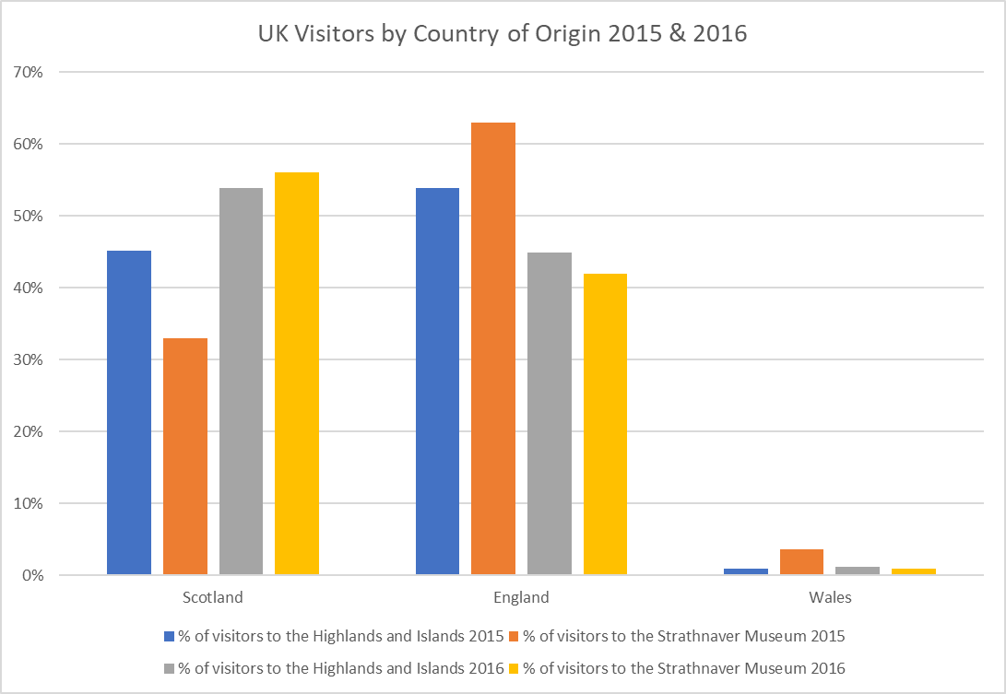

Figure 6: GB visitors by country of origin

At a regional level UK visitors to the Highlands and Islands equated to 81% in 2013 and 75% in 2015. GB visitors to *Strathnaver Museum* have mirrored this national trend as 66% of our visitors in 2018 were from the United Kingdom.

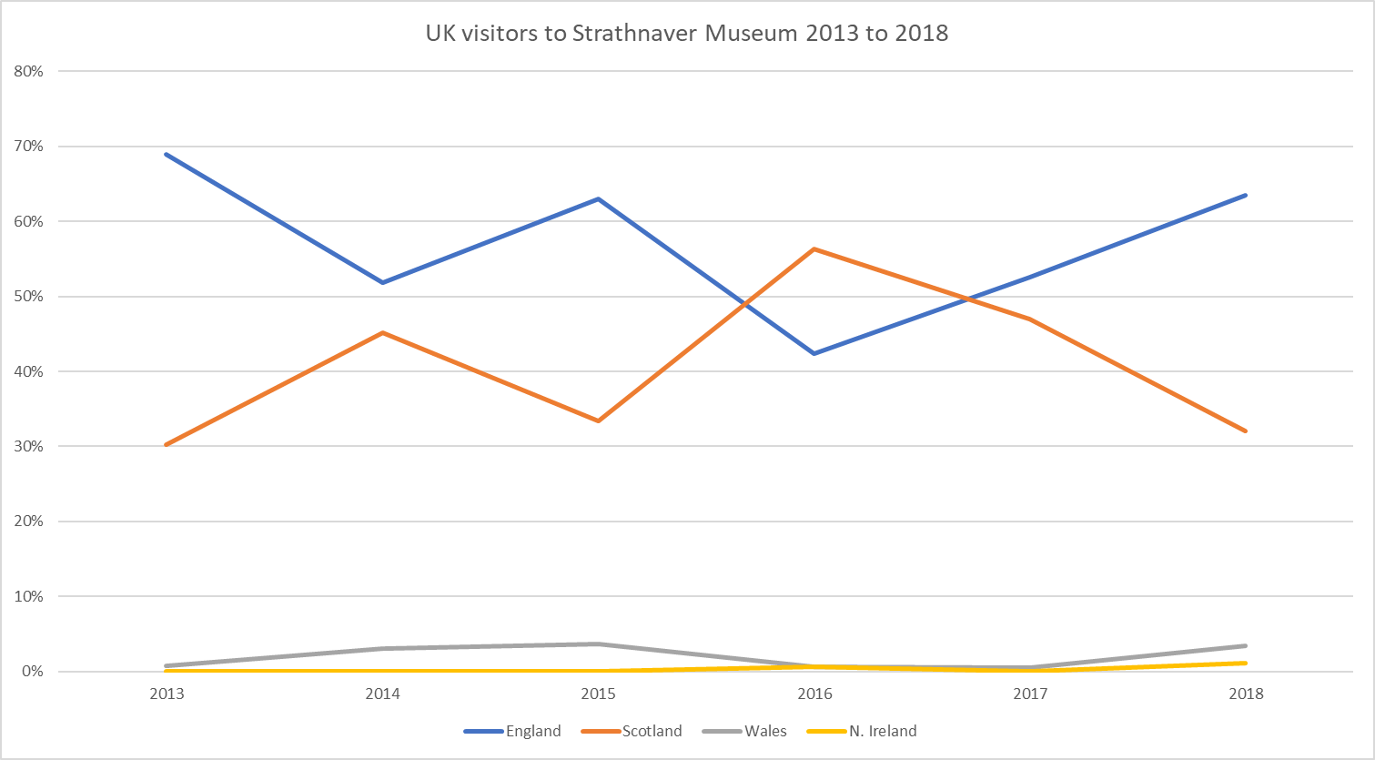

Figure 7: United Kingdom visitors 2013-2018

These trends may be indicative of the *NC500* encouraging more people to holiday closer to home coupled with the Museums work attracting more local people to visit.

* + 1. **Europe**

As can be seen in Table 2 and Figure 6 the percentage of visitors per European country to *Strathnaver Museum* is roughly on a par with the number of visitors per European country to the Highlands and Islands regionally. Currently we do not market the Museum at an international level other than via our website and social media presence. However, we do produce leaflets in several European languages including German, Dutch, Spanish, Italian and French.

|  |  |  |
| --- | --- | --- |
| **Country of Residence of Overseas Visitors** | **% of Visitors to the Highlands and Islands 2013** | **% of Visitors to Strathnaver Museum 2013** |
| USA | 14 | 11 |
| Germany | 17 | 10 |
| France | 11 | 8 |
| Netherlands | 8 | 4 |
| Ireland | 2 | 0 |
| Australia | 5 | 8 |
| Spain | 9 | 0.5 |
| Norway | 1 | 1 |
| Italy | 6 | 3 |
| Canada | 4 | 5 |
| Rest of World | 23 | 50 |

Table 2: Country of Residence of Overseas Visitors to the Highlands and Strathnaver Museum

Figure 8: Country of origin of visitors to Strathnaver Museum compared to origin of visitors to the Highlands

* + 1. **North America and Australasia**

The Museum attracts a good proportion of its visitors from North America and Australasia with 11% from Australia and New Zealand and 8% from the USA and Canada visiting in 2018. This is roughly on a par with the proportion of visitors from these countries to the Highlands and Islands as a whole. As mentioned above we do not market at an international level other than through our website and social media presence. Visit Scotland do promote the Highlands and Islands as a region and *Strathnaver Museum* appears on their website, within a Mackay Itinerary and from 2015 features in a travel trade itinerary for the Highlands which is available to tour and coach operators all over the world.

A significant proportion of our visitors from these areas have links to *Clan Mackay* or have ancestors who emigrated from Mackay Country. Ancestral tourism is a growing market and the Museum delivers services such as genealogical research on a limited scale. As detailed in the *Development Action Plan* this is an area which the Museum can develop. It has been estimated that ancestral tourism has the potential to grow significantly from 800,000 visitors per year (2013) to 4.3 million visitors by 2018. The creation of a dedicated research room and service will enable us to take advantage of these opportunities. At the moment, we do not have the necessary infrastructure to install a research room. The archive space will also allow us to make accessible our findings from community research projects.

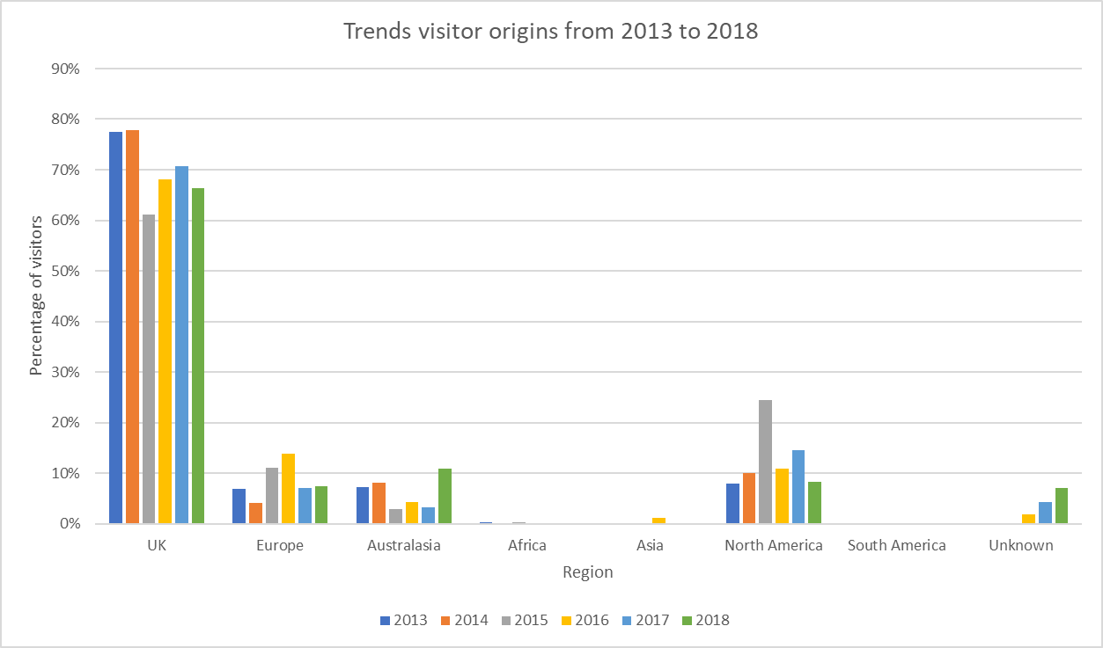

Figure 9: Percentage of visitors to Strathnaver Museum by region

* + 1. **Emerging Markets**

*Visit Scotland* have identified several emerging markets which they target by working with the travel trade as outbound holiday markets are at an early stage of development in these countries. The countries are China, India, Russia, Czech Republic, Hungary and Poland. Since 2013 we have had a handful of visitors from China, Poland, India and Hungry. As mentioned above we have been included in a travel trade itinerary produced by *Visit Scotland* for the Highlands and Islands and what impact this has will become apparent in years to come.

* + 1. **Conclusion**
* Strathnaver Museum attracts visitors from a diverse range of countries with a significant proportion of overseas visitors.
* much can be done to target more UK visitors to come to the Museum as 81% of the total number of visitors to the Highlands and Islands are UK nationals.
* we do well at attracting international visitors but we can further enhance our services and internet presence to encourage more visitors.
* engaging with the Scottish Diaspora through an enhanced genealogy service can generate revenue remotely and promote ancestral tourism to family history researchers.
* merchandising and marketing should be focussed on English speakers as this is our main market.
  1. **How old are visitors to Strathnaver Museum?**

Nationally visitors to Museums tend to be older with one report stating only 13% of visitors are under 24 while 27% are over 55. Our visitor numbers mirror the national trend as can be seen below in figure 10 where 12% of our visitors are under 24. However over 65% of our visitors are over 50 which is significantly more than the national average. We can therefore do more to attract adults under the age of 50.

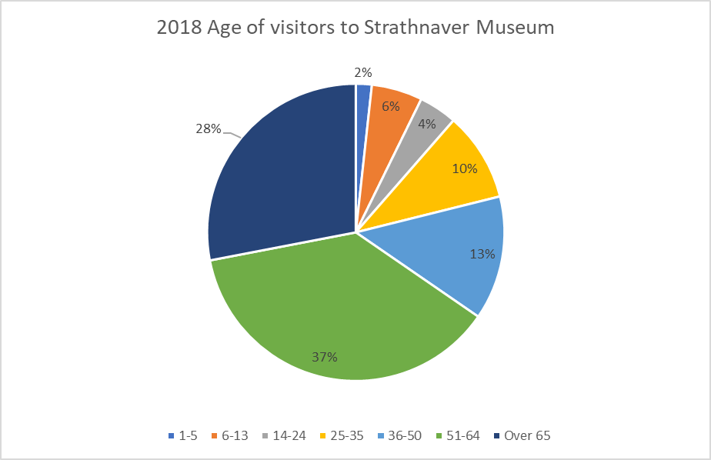

*Figure 10: Age of visitors to Strathnaver Museum*

When we look at attendance at events, some of which were specifically aimed at children, attendance by those under 24 amounts to just under 20%. During 2014 we ran 4 events specifically aimed at children and young people which increased the number of children and young people engaging with the museum. The Pibrochs and Poppies project which ran from October 2014 to October 2015 developed this further and increased engagement in the 6-13 age group to an average of 21% and in the 14 – 24 to 7%.

Evidence suggests that young people feel excluded from museums as ‘it is not for them’ or is perceived as ‘boring’. Therefore, we need to specifically develop activities and events which will encourage young people to visit and this is highlighted within the *Development Action Plan*. During 2014 and 2015 we significantly increased the number of children and young people engaging with the museum through running specific events. By creating specific projects targeted at children and young people and developing tailored activities we will engage more with this target group.

*Figure 11: Age and gender of visitors to Strathnaver Museum*

* 1. **Where did our visitors hear about us?**

As can be seen in figure 12 below visitors find us via a variety of methods. In recent years we have made a number of marketing improvements, specifically:

* improvements to the Museum website;
* increased activity on social media;
* targeted advertising in local guide books;
* a new flyer distributed in 2015, revised in 2019; and
* because of the NC500.

In response to visitor reports that it was not clear that the Church is now a museum we have commissioned a ‘Museum’ banner that is hung from the south wall to be visible to travellers coming from either direction.

North Coast 500 is having an impact, with 3% (or 128) visitors hearing about us via NC500 material in 2016 and by 2018 this had increased to 33% (Figure 12).

Strathnaver Museum is a site on the Strathnaver Trail and there are Brown Signs which advertise the Strathnaver Trail. At the turn off to Skelpick there are Brown Signs which can be seen from east, west and south and point south and west for the Strathnaver Trail. As you approach the A836 from the B871 there is also a Brown Sign pointing east for the Strathnaver Trail. The Strathnaver Trail itself also has signage which is uniform and is immediately identifiable from its lilac colouring.

Word of Mouth continues to be one of our most powerful attractors demonstrating that once people are here they value the experience.

Tourist Information Centres represent a lowly 7% of the source of visitors and this is likely to decrease considering the closure of local TICs in Wick, Thurso and Durness. Extra effort is needed to promote our attraction to TIC staff in Inverness on an on-going basis.

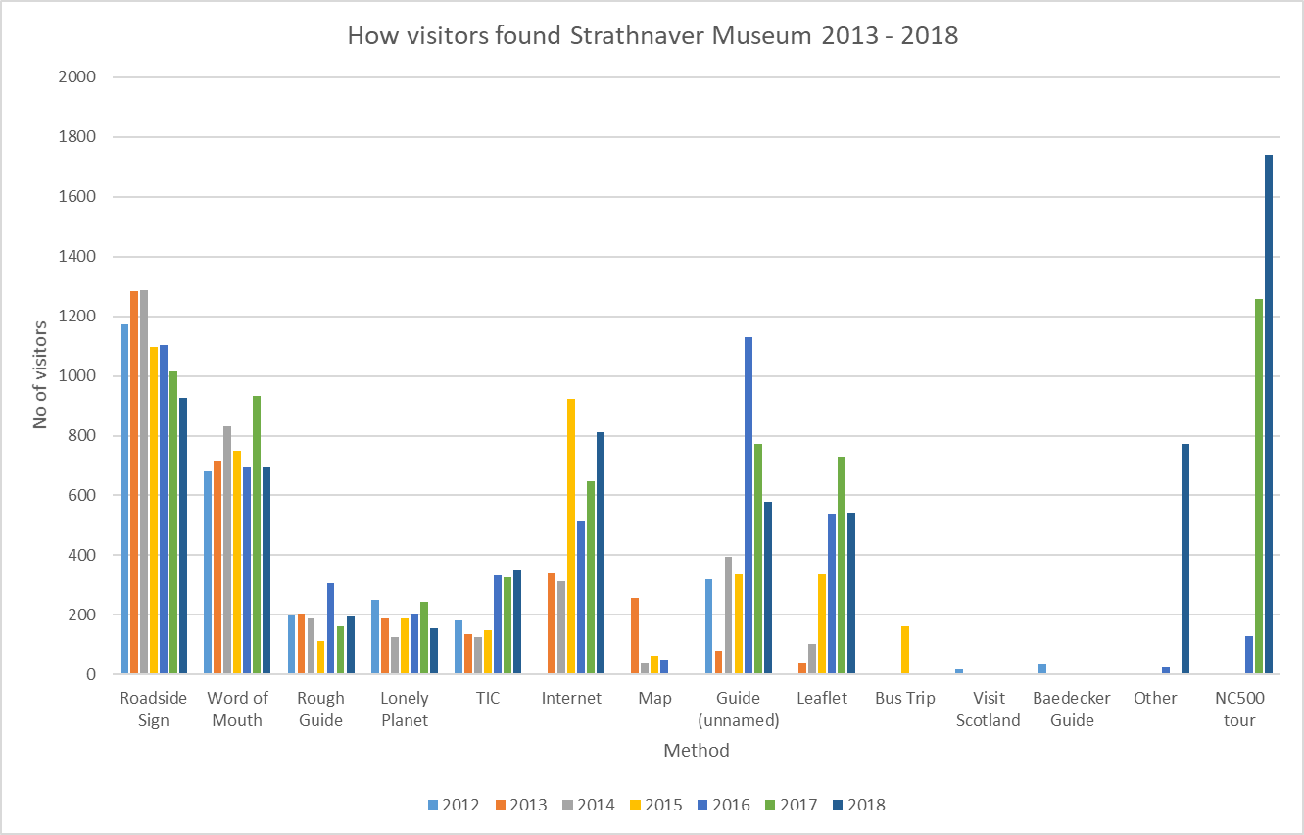

*Figure 12: How our visitors heard about us*

The internet is an increasingly important source of information for visitors.

* *Strathnaver Museum* is a member of *Venture North* which has produced a ‘one-stop-shop’ visitor website resource (http://www.venture-north.co.uk/plan/attractions/strathnaver-museum)
* *Strathnaver Museum* in partnership with *Venture North* has developed a heritage mobile phone app for Caithness and Sutherland which features the museum along with over 400 other heritage sites.

|  |  |
| --- | --- |
| **Year** | **% of repeat visitors** |
| 2013 | 14% |
| 2014 | 18% |
| 2015 | 14% |
| 2016 | 22% |
| 2017 | 19% |
| 2018 | 7% |

*Strathnaver Museum* attracts a good number of repeat visits as can be seen in the table above but 2018 saw a significant reduction in repeat visitors. Reasons for the reduction in repeat visits in 2018 may be as a result of the NC500 bringing a new type of visitor to *Strathnaver Museum*.

VisitScotland’s recent Visitor Survey for the Highlands conducted in 2011 found that 68% of visitors surveyed had previously visited the Highlands. This would imply that we should be attracting a higher percentage of repeat visitors. To increase the number of repeat visitors we need to invest in the asset to enhance its attractiveness. Improving the infrastructure will enable *Strathnaver Museum* to offer additional services, special exhibitions and refresh the existing exhibits. Repeat visitors are important not only because of the economic value they bring to the area but also as advocates of the area through the positive stories they tell about the area when they return home.

To encourage repeat visits it would be beneficial to keep previous visitors aware of activities at the Museum and also within the surrounding area. This will make them feel valued and part of an extended family. This is being achieved via social media and a regular e-newsletter. By developing and showcasing a varied programme of events and revising the exhibits regularly will keep them fresh for returning visitors.

Our surveys have failed to pick up how many visitors come to the museum because they stopped for the Bettyhill Café or TIC (with whom we share a car park). We believe this to be significant and we believe that we should be prepared to counteract the threat of closure to the café. Our 2018 survey identified 8% of our visitors stopped at the café and visited the museum as a result. Observational data carried out to support the CAT identified 5% of visitors who visited the café went on to the museum. This is very low and we anticipate museum ownership of the café could increase this to 20% (Bettyhill Café and Tourist Information Centre Business Plan 2019-22, 2018).

Given an overall trend of increasing visitor numbers it appears as though our marketing efforts are effective and should be maintained. We are beginning to suspect that the North Coast 500 is changing the *character* of our visitors and we need to remain vigilant and fleet footed to respond to changes in the market.

* 1. **Visitor comments**

Visitor comments are gathered via the guest book and the visitor survey and are generally extremely positive. Guest book data descriptions include ‘wonderful’, ‘interesting’, ‘fascinating’, ‘informative’ and ‘enlightening’. Emotive language is also prevalent ‘moving’, ‘sad’, ‘touching’ and ‘inspiring’.

|  |
| --- |
| Very nice museum. Fell in love with Strathnaver. |
| well worth a visit |
| hope to be back |
| I don't understand why but this country speaks to the most intimate part of me |
| really important |
| Most wonderfully done, had a fantastic time, thanks |
| Great Museum |
| Do you know Margery Harper's "Adventurers & Exiles" paperback of Scottish emigration she is an academic of Aberdeen |
| If you are to make alterations please enlist professional museum advice |
| Thank you for the insight into the horrors of the clearances |
| Live now in Australia will tell friends about the Museum |

The Museum recognises that there is plenty of room for improvement, particularly around interpretation and this is identified within the Redevelopment Project. As a result the suggestions below have been fed into the *Development Action Plan*, many of which have already been acted upon.

|  |  |  |
| --- | --- | --- |
| **Theme** | **Visitor Comment** | **DAP Ref** |
| Children | Could have a little more for children. | 1.4; 4.4 |
| Excellent maybe children dressing up etc | 1.4 |
| Collection | Would love there to be more emphasis on music and dance | 2.3 |
|  | Please number stones as info. Sheet difficult to match up with stones - only 1749 one really tied up. No note or label to say what the 2 wooden items on dresser are for. | 1.2 |
| Word display of clearances needs reading direction signs | 1.2 |
| Storyboard is so well done and easy to understand | 1.2 |
| Clearance story narrative to each room would be good. Slight modernisation to some exhibits and labelling would make it feel more modern | 1.2 |
| Display - info could be better. Like the schools involvement keep it up | 1.2 |
| Include info re. the numbers of people evicted in the clearances | 1.2 |
| It is a bit confusing to follow the story | 1.2 |
| Good addition to peat cutting area would be a video demo of the use of implements. Many people have never seen peats being cut | 1.2 |
| Map of clearance site showing where migrants landed. | 1.2 |
| Technology | Perhaps the MP3's be less fiddly or earphones at set places?? | 1.2 |
| I found the recording distracting, Highland Clearance details well done | 1.2 |
| Very interesting DVD excellent. Should have been allowed to keep its settled population. Many world gained! Scotland’s loss! | 1.2 |
| Other | If you are to make alterations please enlist professional museum advice | 1.2 |

1. Strategic Aims and Objectives

| **Aim** | **Objective** |
| --- | --- |
| Secure the future of our regionally important B listed historic building | Make the building weather proof |
| Secure the future of our collection within the community | Increase income generation |
| Improve the visitor experience | * Improve exhibitions and displays * Improve visitor flow * Widen the appeal paying more attention to the needs of: * children * older visitors * visitors unaware of the Clearances * Maximise use of technology to help bring our stories to life * Improve the museum retail experience |
| Secure the financial sustainability of Strathnaver Museum | * Improve the visitor experience * Improve marketing * Improve the retail offering * Provide excursions and experiences (eg. Weddings) * Catering |
| Ensure we look after our volunteers | * A warm office * Clean hygienic kitchen * Suitable toilet facilities * Effective IT infrastructure * Volunteer training and development |
| Engage and inspire our communities | * Create special exhibitions celebrating local stories * Outreach exhibitions * Artists residencies * Dementia Friendly work * Volunteering opportunities (eg. DOE, Saltire) * Supporting schools to deliver the CfE. |
| Securing our place in the world | * A hub for North Sutherland * Repository for Mackay Country Community Trust Archive * Starting point for Strathnaver Trail * Start of walks / excursions * Links to other attractions * Visitor centre to explain heritage of wider area * Importance as part of wider heritage offering across NC500 area * Centre for academic research * Ancestral home of Clan Mackay * Genealogy * Reaching out to the diaspora * Historical Mackay’s * Mid-point of North Coast 500. |

1. Analysis of the current situation
   1. **SWOT Analysis**

|  |  |
| --- | --- |
| **Strengths** | **Weaknesses** |
| * The Museum is situated within a beautiful and unspoilt yet fairly accessible location * A well-established Museum * Accredited Museum * Dedicated and committed Trustees, staff and volunteers * High levels of customer satisfaction achieved * Well established and trusted heritage provider * Good reputation * Support of local community * Free parking * Museum caters for a wide audience and offers a wide range of learning and outreach activities * Traditional Museum * Adjacent to a café and TIC | * The Museum has severely limited facilities and lacks adequate retail space and restricted opening times * Not a modern visitor attraction * Dated Museum displays * Lacking in technology - not interactive enough for a younger audience * Isolated location |
| **Opportunities** | **Threats** |
| * Museum location – halfway round the NC 500 * Increasing visitor numbers provide opportunities for increased merchandising sales * North Coast 500 * Diaspora * Potential to take on running of Bettyhill Café – opportunities to enhance visitor flow * Increased PR activity * Use of new technologies to assist with marketing and fundraising strategies and the delivery of lifelong learning activities * Redevelopment of the Museum displays and visitor facilities * Sponsorship opportunities * Third party partnerships working opportunities – no shortage of ideas! * High value individual events – eg weddings * Outreach to schools and community groups * Lottery funding etc * Partnership project being developed with Highland Museum Forum | * Competition with other leisure activities e.g. DIY and gardening * Competition from technology e.g. internet and playstations * Not moving with the times, we survive very well on the ‘quaintness’ of the attraction but this could easily and uncontrollably turn to ridicule * Little investment in the redevelopment of the Museum displays and visitor facilities * Admission/entrance fee charged * Government Agenda e.g. Free National Museums * Likely removal of SDA funding in the very near future * Running a café a potential distraction from core focus * Potential permanent closure of Bettyhill Café and TIC * Reduction in funding for local volunteer support eg. closure of CVS North |

* 1. **PESTLE Analysis**

|  |  |
| --- | --- |
| **Political/Legal/Legislative** | **Economic/Environmental/Ecological** |
| * Government legislation e.g. Free National Museums * Employment law, e.g., Health & Safety * Change of Government * Stakeholder influence * Local economy – scale of unemployment * Pensions * Brexit | * State of national economy * State of local tourism market * State of international markets, e.g., world recessions * Interest rates * Change in trends and visitor expectations * Unemployment |
| **Social/Socio-Cultural** | **Technological** |
| * Change in consumer tastes/preferences * Substitution – direct/indirect competition for time and disposable income * New culture – change in technology for new generation * More money = less time * Demographic structure – ageing population/decline in birth rates * Single person culture * Museum title = boring | * Pace of technological changes * New interactive and hi-tech Museums/visitor attractions * E-commerce * E-marketing |

* 1. **Key challenges and opportunities facing *Strathnaver Museum***

*Strathnaver Museum* faces several challenges in the forthcoming years.

* + 1. Budget reductions

Our core funding from *The Highland Council* is set to reduce significantly and will in all likelihood be removed completely. This will put increasing pressure on our volunteers who already give a significant amount of their time to the museum. The potential loss of professional staff will have a huge impact on the ability of the museum to deliver a high quality visitor focused service.

* + 1. External funding reductions

It is also anticipated that grant funding will be increasingly competitive and become much harder to access. This will have an impact on our ability to deliver events and activities as part of our outreach programme. It is hoped that working with our partners on larger more ambitious projects will help us to access funding.

* + 1. The building’s condition

To maintain the condition of the building and in turn the Museum’s Collections significant investment is required to repair and consolidate the condition of the building. A Conservation Report has been produced by a conservation architect which identifies a series of essential repairs and maintenance recommendations (Conservation Report, 2019).

* + 1. Collections

If nothing is done to improve the condition of the fabric of the historic category B listed building there is considerable risk to the long term sustainability of this regionally important building. This would also put the *Strathnaver Museum’s* Collection at considerable risk both due to the lack of storage and the potential damage to the collection caused by extreme temperatures, water ingress and pest infestations.

* + 1. Community Groups and other Partners

The outreach work carried out by the museum over the last 5 years has relied on partnerships with community groups and officers from *The Highland Council*. In the current economic climate the funding to some of these potential partners has been withdrawn and this may lead to a reduction in the number of groups with the capacity to work with the Museum to deliver projects.

* + 1. Bettyhill Café

*Strathnaver Museum* has been approached by *The Highland Council* regarding an asset transfer of the *Bettyhill Café and Tourist Information Centre* located next door to our building. This is an exciting opportunity for *Strathnaver Museum* to develop our site as a campus complimenting our overall strategic aim of creating a heritage hub for North West Sutherland. The café and carpark act as the ‘front door’ of the museum and is key to driving in some of our visitors.

Although the acquisition of a café is not without its challenges its position as a gateway to the museum is vital to the future of the museum.

* + 1. Event hosting

In 2016 and 2019 *Strathnaver Museum* hosted a vow renewal and wedding of couples with ancestral links to the area. The potential exists to market the museum as a venue but any commercial exploitation would be dependent on a refurbishment. This would allow us to accommodate larger parties and provide additional services such as a reception area in the proposed gallery space.

* + 1. Centre for historic research

Our founderDr Ian Grimble was conscious that the academic research carried out in Strathnaver should benefit the local people. With the support of a dedicated group of locals the museum opened its doors in 1976 and holds documents important to historical research. In 2015 we supported the *UHI Centre for History* to stage the Strathnaver Conference which brought academics from all over the world to Bettyhill. We established links with academics and are working to extend the academic papers we hold. In 2017 we worked with Rob Donn Mackay expert Dr Ellen Beard on an exciting Interpretive Trail exploring the work of this celebrated Gaelic bard.

* + 1. Rob Donn

In 2017 we have secured funding (£62,252) in partnership with the *Mackay Country Community Trust* for a series of exciting projects celebrating the life and times of renowned Gaelic bard Rob Donn Mackay. Rob Donn is an extremely important figure in the history of Gaelic literature and might arguably be as important to Gaelic poetry as his contemporary Robert Burns is to poetry in Scots. We anticipate this project will do for north west Sutherland what Robert Burns has done for Ayrshire.

* 1. **Summary**

The key challenges facing the Museum over the next five years are:

* How to maintain our services in light of falling public sector support and meet that challenge by generating additional funding through income generation (eg. Admissions, sales and services);
* How to continue to increase visitor numbers with limited staff capacity and marketing budgets;
* How to continue to work with all our partners and groups in the light of reductions in grant funding and the contraction of the voluntary and subsidised organisation;
* How to increase our income generation despite the problems we face with our building.

1. **Realising the Ambition**

The preceding analysis has highlighted the need for improvements to the museum offering. It is likely that these developments will attract significant external funding and to attract this funding *Strathnaver Museum* has carried out pre-development work. This has included the production of this business plan, a developed design and costings to enable approaches to funders.

Funding to produce the supporting documents was secured from the Architectural Heritage Fund £7,000 (Business Plan) and Highland LEADER £29,349 and our own resources £5,350 (architectural services to RIBA Stage 3).

* 1. **Background**

An application was made to Heritage Lottery Fund (HLF) in 2015 and although feedback was encouraging, we were unsuccessful. *Strathnaver Museum* was advised that to submit a successful first-round application we will have to have a more developed project. Specifically, that would include more informed and robust capital costs. This has now been achieved and a Planning Application based on the concept designs has been submitted to *Highland Council*.

As *Strathnaver Museum* is a community resource we gather feedback in a variety of ways from our visitors and users as discussed above. This was fed into the planning process alongside fresh opportunities for the community to inform and help shape the future of *Strathnaver Museum*. This included consultation meetings between the architect and volunteers to ensure the concept designs met expectations and user needs.

Outputs from this phase include:

* Architects Plans to RIBA Stage 3 and submission of a planning application;
* Quantity Surveyor costings to inform funding applications;
* Consultation events with stakeholders and the general public;
* Business Plan 2019-22;
* 3-year Activity Plan;
* Submission of funding application to Natural & Cultural Heritage Fund;
* Submission of match funding applications.

The timeframe for this work is detailed in the Gantt chart at Figure 13. We will be submitting an application to the Natural and Cultural Heritage Fund for the 22nd April deadline.

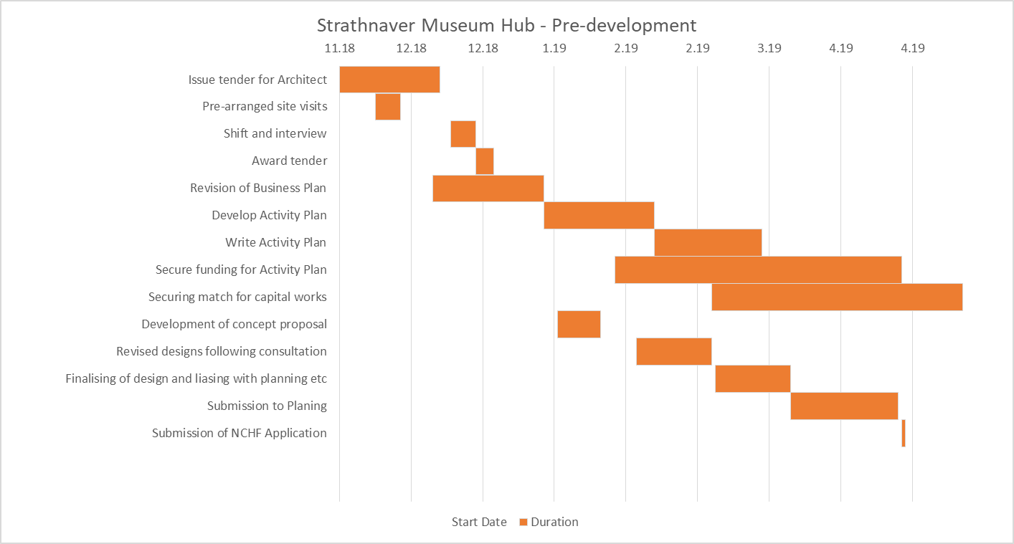

*Figure 13: Pre-development phase timescale*

* 1. **Development Phase**

If we secure funding from the Natural and Cultural Heritage Fund, awards announced end September 2019, there will be a short period of development. This will include agreeing contracts and meeting any pre-award conditions. This could include securing the final pieces of funding, supplementary supporting documents. It is anticipated that Planning Permission and Listed Building Consent will have been approved during the summer.

* 1. **Delivery Phase**

The Activity Plan details extensive outreach activities which will enable *Strathnaver Museum* to continue to deliver services. Partners will be sought to enable special pop up exhibitions throughout Mackay Country. The acquisition of Bettyhill Café and Tourist Information Centre will also enable us to carry out activities on site.

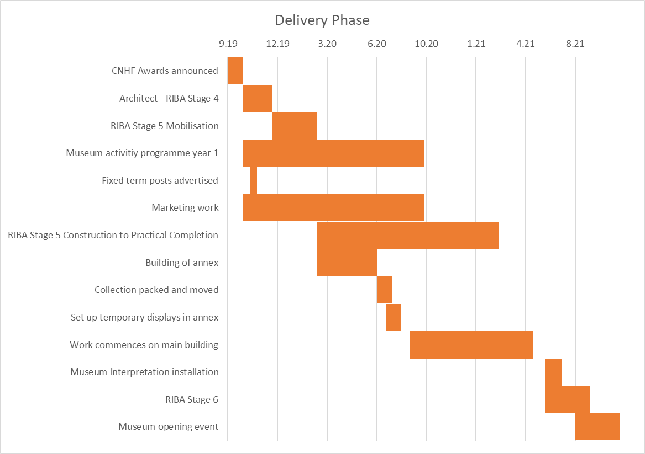

*Figure 15: Delivery Phase*

1. **Resources**

To deliver the pre-development phase we have secured investment funding to enable us to achieve our ambition of creating a world class museum for the north coast of Sutherland. This initial investment has secured the services of an architect, quantity surveyor and project manager to secure delivery funding.

The total cost of this phase is £71,761. We have secured £29,349 from *Highland LEADER* and £5,350 from our own resources. The 2 year Project Manager post has secured funding from SSE Strathy North Community Fund (£12,354), Caithness and North Sutherland Fund (£12,354), Tanlaw Trust (£2,500) and our own resources (£9,854).

*HIE* recognises that the tourism industry is crucial to the economy of the Highlands and Islands and 28% of visitors to Scotland come specifically to learn about our heritage and culture. In 2012 tourism in the Highlands’ was worth £913m generated from £740m of direct expenditure and a further £173m of indirect expenditure. This supports 20,000 jobs in Highland (14% of employment) as well as supporting a range of local services such as village shops or transport routes that may not be economical without the additional business that tourism brings. *The Highland Council* estimated that in 2011 overnight tourism in Caithness and Sutherland was worth £89.85 million, day visitors account for a further £5.67 million and that tourism sustains 2,205 jobs.

The development of tourism resources such as the services we provide is vital to developing this further. *Strathnaver Museum* plays a vital role in developing tourism resources which support the local economy. Our extensive programme of events and festivals help to attract visitors to the area, and our mobile heritage application promotes the whole area to visitors. We are the only centre for cultural and heritage activity and one of the few wet weather attractions in an economy that otherwise depends on outdoor tourist activities.

*Strathnaver museum* punches way above its weight in terms of the impact it creates versus the public resources needed to maintain it. But there is so much potential to do so much more and with the help of key organisations we aim to exploit these opportunities to the full.

The Redevelopment would crucially allow us to increase our income generation through increased visitors, an improved retail space and the provision of additional income generating services such as a genealogy service. Ultimately this would enable us to be less reliant on grant funding and more resilient. The reduction in core grant funding from *The Highland Council* would be replaced by increased revenue as a direct result of the redevelopment project as can be seen in Appendix 9-11.

The NC500 has increased visitor numbers to our area by 30% and we anticipate we will continue to increase our visitor numbers as a result. However, at the moment our ability to accommodate an increase is hampered by our infrastructure. This could be alleviated by building an annex and improving the internal layout. Following feedback we have increased our admission prices to £3 while children go free. If we improve our displays with professional help we feel we can increase our prices further to £4 or more which is on a par with *Caithness Horizons* and *Timespan Museum and Art Gallery*. This would increase our income from £26,897 in 2020 to £43,623 to 2021. This would help alleviate the reduction in *Highland Council* Funding through the Service Level Agreement.

*Strathnaver Museum’s* income and expenditure from 2016/17 to 2018/19 can be seen in Appendix 1-3. Detailed projections can be seen at Appendix 4-6 which explores core and project costs for 2019/20 to 2020/21.

The project income and expenditure are shown in Appendix 7 and 8.

1. **Conclusion**

The North Coast 500 is fast becoming one of the most popular driving routes in Scotland, if not the world. *Strathnaver Museum*, already a popular visitor centre, is a valuable asset within the tourism infrastructure of North West Sutherland. Given the right investment *Strathnaver Museum* has the potential to become a world class visitor centre to match this world class driving route.

*Strathnaver Museum* will provide the casual visitor with a high-quality visitor experience while enabling them to learn more about the areas culture and heritage. The importance of cultural work in relation to economic regeneration within Scotland’s communities has been noted at national level. Such resources are particularly of interest to the Scottish diaspora who wish to visit the areas their descendants came from and learn more about their lives. This has a significant economic benefit for the area both locally and regionally as well as at a national level. The increasing popularity of the North Coast 500 route is a key driver for our economic prosperity and *Strathnaver Museum* provides a valuable service to visitors.

By improving our physical infrastructure and the story we tell we will engage in a more effective way with local people, in particular children and young people. We will provide additional opportunities for learning and development both in a formal and informal setting. An extensive annual events programme will benefit both local people and visitors by providing rewarding experiences to all.

Importantly improving our income generation will enable us to become more resilient and sustainable ensuring *Strathnaver Museum* continues to deliver social, education and economic benefits into the future. This will be achieved through additional income generated through admissions, retail and services.

*Strathnaver Museum* and the iconic church it resides in is at the heart of the history of the Clearances. This makes it culturally central to the story of the Highlands and of Scotland as a whole. But the Clearances don’t just relate to Scottish History – the repercussions of the Clearances echo across the world and have impacted on nations throughout the former British Empire. Our collections, humbly and lovingly curated by a dedicated host of volunteers, are internationally significant. The time has come to recognise this significance and to work towards a world class presentation of this astonishing story of resilience, greed, incompetence, cruelty and above all of survival.

**Appendix 1: Budget Report 2016/17**

**Appendix 2: Budget Report 2017/18**

**Appendix 3: Budget Report 2018/19**

**Appendix 4: Budget Report 2019-20**

**Appendix 5: Refurbishment Project Budget 2019-20**



**Appendix 6: Budget Report 2020-21** 

**Appendix 7: Capital Funding Package**



**Appendix 8: Capital expenditure 2019-2021**



**Appendix 9: Budget Report 2021/22 (Year 1 post refurbishment)**



**Appendix 10: Budget Report 2022/23 (Year 2 post refurbishment)**



**Appendix 11: Budget Report 2023/24 (Year 3 post refurbishment)**



1. The decrease in visitors in 2002 and 2003 can be attributed to national and global events during 2001. In 2001 the Foot and Mouth outbreak had a devastating impact on agriculture across the British Isles but also had an impact on other industries including tourism. VisitScotland have estimated that the gross cost to Scottish tourism from the Foot and Mouth outbreak was between £200 to £250 million as fewer people visited the country. The terrorist attack on the World Trade Centre in September 2001 which shocked the world saw a reduction in demand for air travel globally. The following year the SARS outbreak which began in China has also been attributed as contributing to a downturn in Scottish tourism (Scottish Government, 2006).