**Proposal to dispose, by lease, of an area of common good land to East Sutherland Rescue Association**

**What is proposed?**

This proposal relates to a parcel of Common Good land of a total area of 1310 square metres or thereby lying adjacent to Beach Car Park, Dornoch, IV25 3QD. The area of the proposed disposal is shown outlined in red on the plan above.

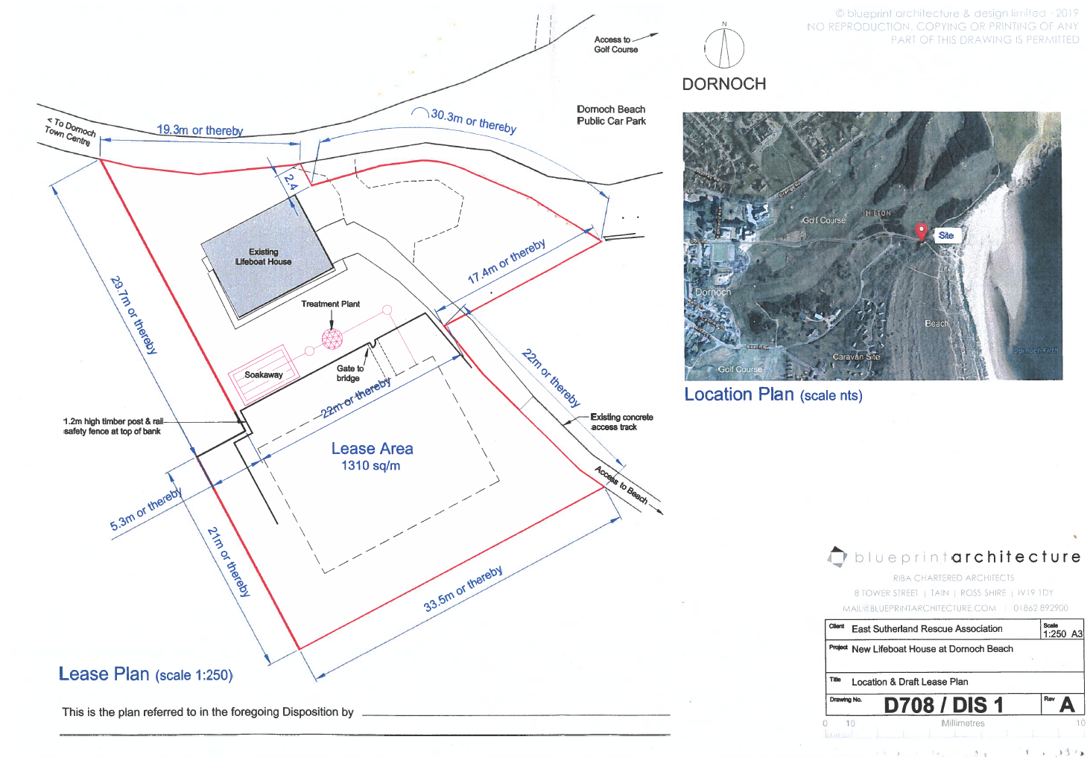

The East Sutherland Rescue Association (ESRA) currently lease a small area of land which includes the existing lifeboat shed indicated above. The Council is proposing to dispose, by lease, of a larger area of land to ESRA which will allow them to seek permission to build a bigger and improved lifeboat facility which will include a parking area for their use. It is proposed that the period of lease should be for 99 years and, as it will include an area of Common Good land currently used as public amenity land, it will constitute both a disposal and a change of use.

**Consultation**

Section 104 of the Community Empowerment (Scotland) Act 2015 requires the Council to consult local communities when considering disposing or changing the use of Common Good assets. This includes where the proposal is to grant a lease of over 10 years. Therefore, before taking any decision, and to inform the decision making process, we are keen to hear the views of the community, in particular:

* What are your views on the proposed disposal by lease of this piece of Common Good land?
* Do you have any views on potential benefits of the proposal?
* Do you have any issues or concerns arising from the proposal?
* Do you have any additional comments?

The Council will take all representations into account in reaching a decision.

Depending on the representations received the possible outcomes are:

1. The proposal goes ahead subject to:-
2. Consent by the Sheriff Court to the disposal by way of lease, and
3. Planning consent being issued by the Highland Council as Planning Authority.
4. The proposal is amended significantly and a fresh consultation takes place.
5. The proposal does not go ahead.

**Representations**

Consultation closing date – **11 September 2019**

Please submit written representations to:-

Email: [commongood@highland.gov.uk](mailto:commongood@highland.gov.uk)

Post: Sara Murdoch, Highland Council, Headquarters, Glenurquhart Road, Inverness, IV3 5NX.

**Additional information**

There are specific regulations governing the management of Common Good. This is to ensure protection for assets held. One such area is where property is considered ‘inalienable’. This means that there is a restriction regarding the property, its purpose is clearly stated in the deed or gift to the Common Good Fund (often specifically dedicated for public use) or it has to be used in a certain beneficial way for a lengthy period of time (time immemorial). Land that derives its Common Good title from the original Burgh Royal Charter is invariably considered to be inalienable.

The piece of land that is the subject of this proposal derives its title from the original Burgh Royal Charter dated 14 July 1628 and, with exception of the small area relating to the existing lifeboat shed, has been used as public amenity land for time immemorial and therefore, is considered by the Council to be inalienable. It will be necessary to seek the consent of the Sheriff Court to any proposed disposal. Any application to the Court will include information about this consultation and the responses received. It will also have an impact on any likely timescales involved with leasing the property should a decision be made to proceed with the proposal.