INVERNESS AND HIGHLAND CITY REGION DEAL
QPR Q1 19/20

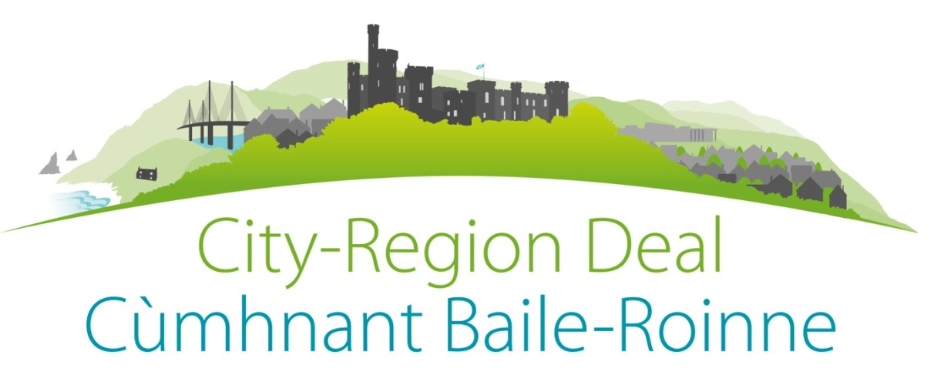

1 Contents

Content
Project | Page
Programme Overview | 3
Finance Overview | 4
Programme Level Risks | 6
Science Skills Academy STEMD | 7
Inverness Castle | 9
Affordable Housing | 11
Innovative Assisted Living (Fit House) | 13
Longman Junction | 15
East Link | 17
West Link | 19
UHI School of Health and Life Science | 20
Longman Land Remediation | 22
Northern Innovation Hub | 24
Joint Digital Programme | 26
Air Access | 28
Employability and skills | 30
Wi-Fi | 32
Tower | 33

Programme Overview Top

ID | Deliverables | Date | Status | Previous | Comments
1.1 | Benefits Realisation Plan | 01/11/18 | G | 01/11/18 | Up to date
1.2 | Implementation Plan | 28/06/19 | G | 01/11/18 | Up to date
1.3 | Quarterly Report (Q 1 19/20) | 12/07/19 | G | 14/04/19 | Up to date
1.4 | Annual Report | 31/07/19 | G | 18/01/19 | Up to date
1.5 | Updated Implementation plan | 28/06/19 | G | 01/09/19 | Up to date
1.6 | Monthly Fin Reporting (June) | 12/07/19 | A | 29/03/18 | Being Concluded
1.7 | Claim 1 for 19/20 | 28/06/19 | A | 12/04/19 | Being Concluded
1.8 | Comms meeting and actions | 23/04/19 | G | 25/01/19 | Up to date
1.9 | Inclusive growth and community Impact processes | 15/08/19 | A | 14/05/19 | Castle EQIA will take longer and therefore date changed. Others done but need written up
1.10 | Economic Dashboard | 15/08/19 | A | 30/05/19 | In the interim project leads have been asked to capture business case and other benefits. Engagement with other deals and both Governments will continue.

Programme RAG
ELEMENT | RAG Current | Trend Last | Trend Last +1 | Reason | Action
Financial | A | A | A | Need to pick up spend and Digital as “handbrake” | In particular work to get Land man Long Reclamation and Digital Commenced will change spedn.
Progress | A | A | A | 2 projects are complete 6 projects are green 4 amber and 1 red. 2 are not ragged | Remedial actions are in place for the amber projects. The RAD Rag for the Digital project and the Amber for Longman land remediation relate to external project deliverables.
Benefits | G | G | G | Projects that should be delivering benefits are | Need to ensure recording and updating in benefits register as more come on stream
Overall | A | A | A | General need to ensure pace improves. | No remedial action other than digital needed but need to reinforce message about pace and therefore spend.
Financial Overview Top
Qtr 1 represents claim totals as submitted to Central Government. 3 remaining qtrs have been adjusted but the spend against 19/20 has increased on profile sent at end of 18/19 financial yuear.

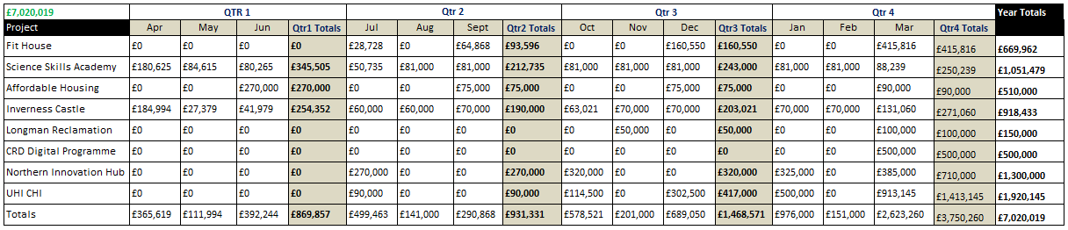

ROFILES Remaining Years

The major Issues remain the Digital Project and we will continue to work with both Governments to resolve the issue. Other changes to profiles will be reported in year through monthly financial management and qtly through this report.
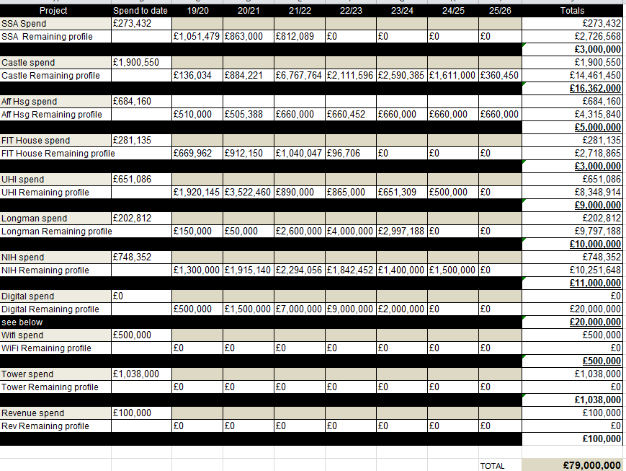

Risks and Issues Top
The Table below is a summary of Live current programme level risks. Please note a new column has been added to show the value of the risk as previously reported. This is to show any improvement of deriation in the risk as assessed by Programme Manager.

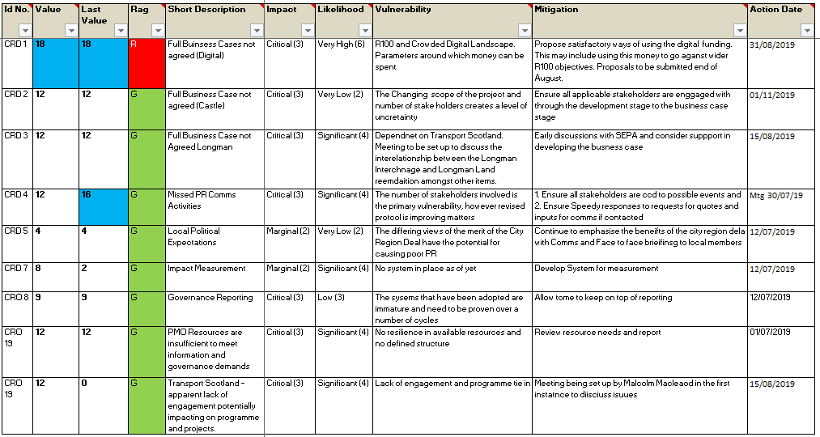

SCIENCE SKILLS ACADEMY STEMD Back to top
The project aims to redress the shortage of skills that are related to Science, Technology, Engineering, Mathematics and Digital (STEMD) disciplines. The Science Skills Academy (SSA) is a long term, innovative and ambitious programme. It will help to raise attainment in these disciplines, and increase the proportion of indigenous young people who are able to take advantage of the growing opportunities in life sciences, renewable energy and digital technologies.

RAG  G | Reason for RAG and response Action | Delays in bring rooms up to standards have created delays against spend profile. Issues are resolved and first two rooms will be complete at the turn of the year. Spend re-profile provided and the lessons learned from the first two Netwon rooms will be applied to remaining.
Lead Organisation | Highlands and Islands Enterprise |  | Project Lead | Emma Robertson
Business Case | Full Case Approved
Benefits Commenced | YES
Finance | QTR 1 QTR 2 QTR 3 QTR 4  Forecast £214,779 £212,735 £243,000 £250,239  Actual £345,505

ID No. | Milestone | Description | Last Date | New Date | Comment
1 | End of Pilot (Started Nov 2016) | Preliminary activities including: programme trials Skills Academy approach, interdisciplinary, innovative, catalytic, coordinating, inspirational and empowering | 31/05/17 |  | Complete
2 | Evaluation of Pilot | Understanding the lessons from the preliminary activity to inform the development of the SSA. | 30/06/17 |  | Complete
3 | Core Team Set up. | Director, Project Manager, STEM Engagement Manager, admin support and legal agreement in place | 31/03/19 |  | Complete
4 | 1st Newton Room Open | Including securing a venue kit out and putting in place the supporting processes. | 25/03/19 |  | Complete
5 | 2nd Newton Room Open | Including securing a venue kit out and putting in place the supporting processes. | 05/02/19 |  | Complete
6 | 3rd Newton Room Opens | Including securing a venue kit out and putting in place the supporting processes. | 30/10/19
7 | 4th Newton Room Opens | As Including securing a venue kit out and putting in place the supporting processes. | 01/04/20
8 | 5th Newton Room Opens | Including securing a venue kit out and putting in place the supporting processes. | 01/10/20
9 | Evaluation of Programme (part 1) | Source benchmark data against which outcomes will be measured | 01/07/19
10 | Evaluation of Programme (part 2) | Establish and record evaluation mechanism | 01/10/19

INVERNESS CASTLE Back to top
The Scottish Government has confirmed funding of a new Justice centre in Inverness providing an opportunity to create a must-see centre that innovatively celebrates the spirit of the Highlands: its creativity, culture, heritage and landscape. The centre will attract new and repeat visitors to the area, will be embraced by the people of the Highlands and will inspire all to visit other parts of the Highlands

RAG  G | Reason for RAG and response Action | As planned, an announcement in May confirmed that the contract for architect services for the next stage of the project had been awarded to LDN Architects, and the contract for creative design for the project to Creative Services (Scotland).  The project team continues to work with Scottish Futures Trust, LDN Architects, Creative Services and others to progress to the stage of firming up on what will be delivered through the project, as well as the likely timescales involved. This will include options for use of the castle from 2020 onwards (after it has been vacated by the SCTS), with a view to developing it into a visitor attraction. Meetings held with the co-chair of the Delivery Group, Minister for Rural Affairs, during May contributed to this process, as will a meeting with NLHF in June regarding the future nature of their funding support. The Project Board and Delivery Group met at the end of May and early June respectively, and received an update on the review of the master plan, including potential scenarios for phasing of the project if necessary. At the Delivery Group meeting, the chair of the Project Board confirmed that the funding was in place to complete the transformation of the north and south towers.  The Creative Director has begun a programme of meetings with organisations and individuals concerned with the content of the north and south towers of the Castle. Discussions are ongoing with the owners of an exhibition that may potentially be housed in the castle as the first major exhibition after opening. An engagement plan for the period to December 2019 will be shared with the Project Board and Delivery Group during July ‘19.
Lead Organisation | Highlife Highland |  | Project Lead | Fiona Hampton
Business Case | Part Business Case approved
Benefits Commenced | NO
Finance | QTR 1 QTR 2 QTR 3 QTR 4  Forecast £190,000 £203,021 £271,060  Actual £254,352

ID No. | Milestone | Description | Last Date | New Date | Comment
1 | Preparation and brief. |  |  | 29/03/19 | These are high level descriptions, a draft workin plan for south and north towever exists and once apprpoach confirmed will be used to populate earlier stages of project.
2 | Concept Design |  |  | 30/08/19
3 | Design Development |  |  | 17/01/20
4 | Technical Design |  |  | 02/10/20
5 | Construction |  |  | 07/01/22
6 | Handover and Close out |  |  | 07/01/22

AFFORDABLE HOUSING Back to top

To offer young people attractive, affordable housing in the Highlands to enable them to stay in the region, retaining a young, vibrant workforce for the Highlands. To deliver high quality housing for.

RAG  A | Reason for RAG and response Action | At present progress against timescales is good. This project is ragged as amber because of the risk of unavailability of affordable land for the project particularly in Inverness. Work to identify suitable land continues and is a risk to total numbers.
Lead Organisation | Highland Council |  | Project Lead | Allan Maguire
Business Case | Full Case Approved
Benefits Commenced | YES
Finance | QTR 1 QTR 2 QTR 3 QTR 4  Forecast £75,000 £75,000 £90,000  Actual £270,000

ID No. | Milestone | Description | Last Date | New Date | Comment
1 | Project Set up | Complete | Done | N/A | Complete
2 | Raining’s Stairs | Site Completed and allocated | Done | N/A | Complete
3 | Glendoe Terrace | Site Completed and allocated | Done | N/A | Complete
4 | Drumnadrochit | Site Completed and allocated | Done | N/A | Complete
5 | Munlochy | Site Completed and allocated | Done | N/A | Complete
6 | Balvonie | Site Completed and allocated | 31/12/19
7 | Ullapool | Site Completed and allocated | 30/06/19 | 31/10/19 | Site servicing delays
8 | Lochyside | Site Completed and allocated | 30/06/19 | 30/9/19 | Site servicing delays
9 | Balloan Road | Site Completed and allocated | 31/01/20 | 31/7/19
10 | Dulnain Bridge | Site Completed and allocated | 30/09/20
11 | Carrbiridge | Site Completed and allocated | 30/04/20 | 30/6/20 | Slight planning delays
12 | Academy Street Inverness | Site Completed and allocated | 30/06/20 | 31/7/20 | Slight planning delays
13 | Slackbuie | Site Completed and allocated | 30/06/20 | 30/9/20 | Contractor delays
14 | Croy | Site Completed and allocated | 31/03/20
15 | Alness Dalmore | Site Completed and allocated | 31/03/20
16 | Aviemore Burnside | Site Completed and allocated | 31/05/20
17 | Netwonmore | Site Completed and allocated | 31/05/20
18 | Inverness Stratton | Site Completed and allocated | 30/09/20
19 | Inverness Nairnside | Site Completed and allocated | 31/03/21
20 | Remaining Sites to be identified

INNOVATIVE ASSISTED LIVING (FIT HOUSE) Back to top
The project will create cost-effective design-led homes. It will include technology including innovative software that may prevent hospital admissions, predict health events and monitor the physiology of tenants. We will build robust innovative response systems to react to data produced from this technology.

RAG  A | Reason for RAG and response Action | Plan has been updated and improvements made to the project management arrangements for this project. That being said there are issues as shown against actions that may require escalation and a movement to red RAG.
Lead Organisation | Albyn Housing Society limited. |  | Project Lead | Graeme Hamilton
Business Case | Full Case Approved
Benefits Commenced | YES
Finance | QTR 1 QTR 2 QTR 3 QTR 4  Forecast £93,596 £160,550 £415,816  Actual £0

ID No. | Milestone | Description | Last Date | New Date | Comment
There were significant delays in providing the Modular Housing from supplier and a change of supplier and approach has been necessitated.

1 | Prototype monitoring system live | Installed in first 16 homes. Live data being generated and accessible via prototype interface to tenants and their families/carers and anonymously for predictive analytics research. | Done | N/A
2 | Prototype monitoring system live | Installed in first 16 homes. Live data being generated and accessible via prototype | Done | N/A
3 | Stage 1 Predictive Analytics Research | Initial report from Robert Gordon University on potential of Fit Home data to predict risk of falls. | Done | N/A
4 | Build Phase 1 Site Design (Nairn) | Audit of specifics of site and designing the optimum design solution in terms of configuration, number of units and type of unit. | Done | N/A
5 | Build Phase 2 Site Design | Audit of specifics of site and designing the optimum design solution in terms of configuration, number of units and mix required to agree valuation with Tulloch’s. | Done | N/A
6 | Build Phase 1 Consents Obtained | Statutory consents obtained, triggering start of procurement process. | 31/03/2019 | 31/12/19 | Submitted to Planning Committee for review 7th August.
7 | Build Phase 2 Site Purchase (Milton of Leys) | Potential mix on site and valuation agreed with site owner. Contract of purchase concluded. | 31/02/2019 | 31/07/19 | Knock-on delay from delay in agreeing site valuation.
8 | Build Phase 3 Site Agreed | Agreement between key stakeholders on next site for new build development. | 31/03/2019 | 31/03/19 | A meeting is planned for 29th April to narrow down potential sites and begin assessing feasibility.

LONGMAN JUNCTION Back to top
Improvements to Longman Roundabout will provide a new grade separated junction to replace the existing roundabout at the junction. This new grade separated junction will unlock significant areas of land which, once remediated (see below), will provide much needed capacity for industrial office and retail developments.

RAG  NO RAG | Reason for RAG and response Action | More detail on dates for the project would be welcomed. Joint working between partners remain productive
Lead Organisation | Transport Scotland |  | Project Lead | David Torrance
Business Case | N/A
Benefits Commenced | NO
Finance | N/A

ID No. | Milestone | Description |  | Last Date |  | New Date |  | Comment
It is not possible to provide detail management milestones and updates were not provided at last programme board or subsequently. The information below is form the last full update.
1 | Consultant appointed |  | To take forward the design and assessment of the scheme. |  | Complete |  |  |  | Complete
2 | DRMB stage 2 Start |  | Design Manual for Roads & Bridges (DMRB) Stage 2 option assessment well underway |  | Complete |  |  |  | Complete
 | DRMB stage 2 Option identified |  | DMRB Stage 2 option assessment process expected to identify preferred option early 2019. |  | 31/03/19
3 | Public Exhibitions held |  | To let the local community and road users view and comment on the options under consideration. |  | Complete |  |  |  | Complete
4 | Preliminary Ground Investigation site works commenced |  | Help inform the on-going options assessment process. |  | Complete |  |  |  | Complete
5 | Stage 3 Assessment |  | Detailed development and assessment of the DMRB Stage 3 assessment |  | 31/03/20
6 | Impact Assessmnet |  | Impact Assessment Report expected 2020 for formal comment.
7 | Publication of draft Orders and Environmental |  | Following publication of draft Orders further progress will be dependent on the public reaction to the published draft Orders and whether a public local inquiry is required.
8 | Construction |  | Construction timescales dependent upon preferred option but expected to be around 18 to 24 months?

EAST LINK Back to top
Transport investment is needed to promote growth and improve connectivity. The Inverness and Highland City‐Region Deal will support the development of the A9/A96 Inshes to Smithton Link Road (East Link) which will encourage more active use of the road network hierarchy, and thereby improve the operation of the network for longer distance and local journeys, providing relief to the A96 and the Raigmore Interchange.

RAG  NO RAG | Reason for RAG and response Action | More detail on dates for the project would be welcomed. Joint working between partners remain productive
Lead Organisation | Transport Scotland |  | Project Lead | David Torrance
Business Case | N/A
Benefits Commenced | NO
Finance | N/A

ID No. | Milestone | Description |  | Last Date |  | New Date |  | Comment
It is not possible to provide detail management milestones and updates were not provided at last programme board or subsequently. The information below is form the last full update.
 | Public Exhibitions |  | To give the public the opportunity to comment on the developing route options for the scheme. |  | Complete |  |  |  | Complete
 | The Design Manual for Roads and Bridges (DMRB) Stage 2 |  | route options assessment work |  | Complete |  |  |  | Complete
 | The Preferred Option |  | presented at Public Exhibitions |  | Complete |  |  |  | Complete
 | Further public events held |  | updated proposals for comment, including provision for cyclists and pedestrians and the preferred route option |  | Complete |  |  |  | Complete
 | Preliminary Ground Investigation |  | To inform the on-going investigation.
 | DRMB Stage 3 |  | On-going development and assessment of the preferred option (DMRB Stage 3 Assessment) culminating with the publication of draft Orders and Environmental Impact Assessment Report in 2019 for formal comment.
 | Delivery Commences |  | Following publication of draft Orders further progress will be dependent on the public reaction to the published draft Orders and whether a public local inquiry is required. Delivery of the scheme itself can only commence if the scheme is approved under these procedures and thereafter a timetable for progress can be determined. Construction timescales expected to be around 18 to 24 months.

WEST LINK Back to top
This West Link Project will allow the peripheral growth of Inverness and reduce traffic congestion in Inverness City centre. It will also reduce existing canal bridge delays and waiting times. The associated developments enabled by the West Link will expand the active travel network removing bottlenecks and barriers to cycling and walking and will release land for development identified in the local plan

RAG  G | Reason for RAG and response Action | Stage 1 complete and delivering benefits - stage 2 progressing to schedule
Lead Organisation | Highland Council |  | Project Lead | Bryan Stout
Business Case | Full Case Approved
Benefits Commenced | YES
Finance | N/A

ID No. | Milestone | Description | Last Date | New Date | Comment
1 | Stage 1 | The new Bridge, Connecting Road to Holm Mains, New Roundabout and Rugby Club. | 11/12/17 |  | Complete
2 | Stage 2 – Design | Design Complete | 31/10/18 |  | Complete
3 | Stage 2 – Tender Award | Self Explanatory | 05/04/19 |  | Complete
4 | Stage 2 – Constructions Starts | Self Explanatory | 20/05/19 |  | Complete
5 | Competition | Self Explanatory | 20/12/20
UHI CENTRE FOR HEALTH INNOVATION Back to top
The investment will establish in one custom built facility, with the academic, clinical and commercialisation capacity to deliver a pipeline of commercialisable projects in life sciences, and to take these projects to the point of exploitation and uptake, either in new products, new services, start-ups and licensing deals, or in clinical delivery quality improvements and new models of delivery. The facility will be co-located with a new NHS elective care and primary care centre on the new multi-disciplinary Inverness Campus.
RAG  G | Reason for RAG and response Action | The project is progressing against the milestones in the plan. The most significant delay is in regard to the Developer Agreement with NHSH. Whilst this does not stop build it has stopped the processing of invoices for spend already committed.
Lead Organisation | UHI |  | Project Lead | Ian Megson
Business Case | Full Case Approved
Benefits Commenced | YES
Finance | QTR 1 QTR 2 QTR 3 QTR 4  Forecast £0 £90,000 £417,000 £1,413,145  Actual £0

ID No. | Milestone | Description | Last Date | New Date | Comment
1 | Capital project  Concept design delivered | Appointment of UHI professional advisors.  Initial concept design available for use in procurement of full design team and contractors. | Done | N/A | Complete
2 | Revenue Project  Recruitment start | Appointment of technical staff for facility development, commercialisation staff and first clinical appointments selected | Done | N/A | Complete
3 | Commercialisation activities start | Innovation projects from existing collaborative activities start to be developed and made ready for productisation for when facility when built. | Done | N/A | Complete
4 | Procurement of design and build team | NHS approved framework for procurement of design and build contractor used to appoint the Principal Supply Chain Partner i.e. contractor. | Done | N/A | Complete
5 | Recruitment complete | All clinical and non-clinical staff in post, including the full complement of sessional clinical | Done | N/A | Complete
6 | First fully commercialised deliverables | First wave of commercial products and services graduate from the pre-incubator in readiness for establishing new companies or as validated healthcare improvements ready for uptake. | Done | N/A | Performance measurement being undertaking and reported on
7 | First phase legal agreements complete | Initial pre-contractual partnership agreements signed to allow design and procurement to proceed. | 28/06/19 | TBC | The Development Agreement has been put on hold until the three partners agree on a way forward to resolve the Target Price issue
8 | Final outcome of design stage | Costed-out technical design delivered (RIBA 4).  Final agreements with fixed prices between UHI and the developer and the contractor signed. | 30/11/18 | TBC | A first iteration of the Target Price was issued on 5 June 2019. Significant work needs to be done to take the price within budget.
9 | Site work commences | On-site works start, including clearing land, layout and on site logistics. | 15/10/18 | TBC | A 3-month delay had been notified by Balfour Beatty prior to the issue the Target Price, which now creating further delays until a solution is found to pursue with a plan within budget
10 | Building complete | Building commissioning completed for the UHI zone. UHI area occupied and ownership of the UHI area commences. | 30/09/19 | TBC | As above
LAND RECLAMATION Back to top
To ensure that there is sufficient land supply to enable Inverness and the Highlands to expand its economic activity and productivity by bringing into use large brownfield contaminated sites. To carry out remediation and site servicing works to release a strategic site to the market to meet the needs of both small and medium size businesses and the needs of larger inward investment companies.
RAG  A | Reason for RAG and response Action | This project is reliant on the Longman Interchange project and close liaison will be required. Although in the terms of the overall CRD programme the delays are manageable the general lack of progress has moved this project to amber.
Lead Organisation | Highland Council |  | Project Lead | Allan Maguire
Business Case | Part Business Case approved
Benefits Commenced | NO
Finance | QTR 1 QTR 2 QTR 3 QTR 4  Forecast £0 £0 £50,000 £100,000  Actual £0

ID No. | Milestone | Description | Last Date | New Date | Comment
1 | Intrusive Site Investigations | Investigations last a year to enable tide cycle | Complete
2 | End of initial Investigations | A further stage will be required | 23/01/18 | TBC | Because the inter-relationship between remediation activity SEPA licence and Longman Interchange site boundaries will change and further investigations will be needed
3 | SEPA In principle approval | Self Explanatory | 31/03/19 | 31/05/19 | Discussion continues with SEPA re the remediation and licensing of the land.
4 | Further Site investigations | For full business case | 30/03/20 | 31/05/19 | The ongoing discussions with SEPA have impacted on time scales
5 | Planning Application | Submit planning application for remediation works and site servicing masterplan. Instruct Transport Impact Assessment (TIA). | 31/03/19 | 31/09/19 | Significantly more investigative work will be needed
6 | Remainder Business Case | Outline full business plan submitted for remediation works. | 31/10/19 | 31/12/19 | Impacted by changes above
7 | Remediation works commence | Self Explanatory | 30/04/20 | 30/06/20 | Impacted by changes above
8 | Site Servicing Works commence | Self Explanatory | 30/04/22 | 30/04/22 | Impacted by changes above
9 | Site Marketed: | (subject to completion of Longman Interchange) | 30/04/24 | 3/04/24 | Impacted by changes above
10 | Intrusive Site Investigations | Investigations last a year to enable tide cycle | Complete

NORTHERN INNOVATION HUB Back to top
The Northern Innovation Hub will be delivered by Highlands & Islands Enterprise (HIE) in partnership with The Highland Council. It is designed to catalyse and transform levels of business innovation across the region, through a series of carefully targeted initiatives which combine to form a powerful driver of change.
RAG  G | Reason for RAG and response Action | Generally the project is on track and approval of the business case will be a major milestone development
Lead Organisation | Highland Council |  | Project Lead | Steven Hutcheon
Business Case | Full Case Approved
Benefits Commenced | NO
Finance | QTR 1 QTR 2 QTR 3 QTR 4  Forecast £0 £270,000 £320,000 £710,000  Actual £0

ID No. | Milestone | Description | Last Date | New Date | Comment
1 | Interim Project Manager appointed | PM appointed to oversee the development of the full business case and procurement process. | 24/12/16 | 31/12/16 | Complete
2 | NIH Programme announced | Following approval of the Full Business Case the broad details of the programme will be announced | 31/07/17 | 31/10/17 | Complete
3 | First Procurement exercise underway | HIE launches procurement exercises for the first elements of the NIH | 31/07/17 | 30/11/17 | Complete
4 | Initiative launch with social media push | The NIH programme is launched with publicity around the technology placements and promotion of the wider programme. | 31/08/17 | 30/11/17 | Complete
5 | NIH Staff in place | Four NIH staff employed by HIE to run the programme | 30/09/17 | TBC
6 | Technology Placement Programmes underway | The graduate and summer technology placements will be directly delivered by HIE following approval. | 31/10/17 | 31/07/18 | Complete
7 | 1st set of programme contracts | Life Sciences Pathfinder | 31/10/17 | 31/01/18 | Complete
8 | 2nd set of programme contracts | Tune in to Tourism | 31/10/17 | 31/05/18 | Complete
9 | 1st set of programmes begin | Life Sciences Pathfinder | 30/11/17 | 31/03/18 | Complete
10 | 1st set of programmes begin | Tune into Tourism | 30/11/17 | 31/08/18 | Complete
11 | 2nd set of programme contracts awarded | 30 under 30 (IMPACT30) | 24/12/17 | 31/08/18 | Complete
12 | 2nd set of programme contracts awarded | Creative Industries | 24/12/17 | 30/09/18 | Complete
13 | 2nd set of programme contracts awarded | Coding Academy | 24/12/17 | 31/08/18 | Complete
14 | Adventure Tourism contract awarded | Procurement complete for the Adventure tourism accelerator and contract awarded | 31/07/19 | TBC
15 | Contract awarded for Food and Drink Technology Centre | Technology centre capital project contract awarded | 31/03/18 | TBC
16 | Food and Drink Network contract | Contract awarded for the Highland Food and Drink Network – focussed on innovation and technology | 30/06/20 | TBC
17 | Next Generation Programme & 2nd phase of Network | Contract awarded for Food and Drink Next Generation Programme & second phase of Network | 31/09/21 | tbc
JOINT DIGITAL ACTION PLAN Back to top
To deliver a digitally capable region and stimulate economic growth.

RAG  R | Reason for RAG and response Action | No significant progress. A proposal for spending some of the funds is still on the table but dependent on discussions outside the control of the City Region Deal. Likewise the ways the remainder of the funding will be aligned with R100 is not yet know.
Lead Organisation | Highlands and Islands Enterprise |  | Project Lead | Stuart Robertson
Business Case | Part out line case submitted.
Benefits Commenced | NO
Finance | QTR 1 QTR 2 QTR 3 QTR 4  Forecast £0 £0 £0 £500,000  Actual £0

ID No. | Milestone | Description | Last Date | New Date | Comment
1 | Agree funding parameters | Agreed that a proportion will be aligned with R100 and a proportion be proposed for full fibre networks. | 02/06/17 |  | Complete
2 | Determine the CRD interventions areas | This is the areas where delivery will be accelerated of provision increased | TBD
3 | Full business case. | Will be developed in conjunction with R100 team | TBD
4 | OJEU launch | As per procurement rules | TBD
5 | ITT issue in February. | As per procurement rules | TBD
6 | LFFN Proposal to be submitted | Outline Business Case submitted – full business case 80% complete but must follow LFFN Project which is still going through due diligence | TBD
4 | OJEU launch | As per procurement rules | TBD
5 | ITT issue in February. | As per procurement rules | TBD
6 | LFFN Proposal to be submitted | Outline Business Case submitted – full business case 80% complete but must follow LFFN Project which is still going through due diligence | TBD

AIR ACCESS Back to top
Air connectivity of the region should recognise direct destination links with the region but is also a capacity,frequency and onward connections at destination airports; whilst reducing entry barriers for new routes.

RAG  G | Reason for RAG and response Action | This project has largely been overtaking by events. A watching brief and broad policy objective of sustaining air access and routes remains
Lead Organisation | Hitrans |  | Project Lead | Ranald Robertson
Business Case | N/A
Benefits Commenced | NO
Finance | N/A

ID No. | Milestone | Description | Last Date | New Date | Comment
1 | Skye Routes | The development of best value options for the re-introduction of air services to Ashaig Aerodrome on the Isle of Skye | Ongoing
2 | Highlands and Islands Exemption | Developing the case for the Highlands and Islands  exemption to be built into and expanded on in any new Air | Ongoing
3 | Departure Tax | Arrangements developed through the Scotland  Act powers. | Ongoing
4 | Aviation Strategy | Seeking engagement with the Department for Transport on the development of the UK Aviation Strategy to ensure the region’s voice is heard in the development of that important policy document. | Ongoing
5 | Air Discounts | Making the case for extension of the Air Discount Scheme for business use and student travel. | Ongoing

EMPLOYABILITY AND SKILLS Back to top
The Inverness and Highland Region City Region Deal when prepared and entered into, recognised the challenges in delivering skills and training across the region and acknowledged that the current approach adopted did not always serve businesses and individuals to best effect. To this end the Deal committed the Council together with the UK and Scottish Governments, to bring forward pilot innovatives and new approaches to the delivery of skills and training.

RAG  A | Reason for RAG and response Action | Work has progressed at national and local levels, with Council represented/active on the national Alignment Group with Scot Govt and meeting regularly with local JC+ and SDS colleagues to undertake complementary local actions. The new approach will be rolled out over the coming years, with Year 1 actions (2019/20) directed to Activity Agreement and SERI funding schemes and early efforts focused on shaping new grant award and activity plans.
Lead Organisation | Highland Council |  | Project Lead | Andy McCann
Business Case | N/A
Benefits Commenced | NO
Finance | N/A

ID No. | Milestone | Description | Last Date | New Date | Comment
1 | Pilot project completed | Fort William pilot to co-locate Council contracted employability services with JC+ to identify and support disengaged clients | 31/03/19 |  | Completed – demonstrated demand, clients accessing support
2 | ESF Funding secured | Secure ESF extension funding for Council and Third Sector employability activity | 31/01/19 | tbc | Applications submitted – decision had been expected June 2019 but now delayed due to national issue with ESF Pre-suspension
3 | Employability Framework providers appointed | Procurement exercise completed for employability service providers | 31/3/19 | Sept 2019 | Delay linked to ESF approval
4 | Project Viability | Highland Employability project: project viability/progression |  |  | Delete – see below
 | 2019/20 Offer Letter and Activity Template | Highland Employability Service (new Local Employability Model collaboration) requires year 1 grant offer to be received and resultant activity plan to be completed. |  |  | Awaiting Scot Govt Year 1 activity funding agreement
 | Pilot project completed | Fort William pilot to co-locate Council contracted employability services with JC+ to identify and support disengaged clients |  |  | Completed – demonstrated demand, clients accessing support

WiFi Back to top
£500, 000 of the original £3m tranche of money from the UK Government has been used to fund a Highland Wi-fi project. Starting and now established, in Inverness, this is being rolled out to another 14 settlements in the Highlands Under the HiFi Banner.

RAG  D | Reason for RAG and response Action | Complete
Lead Organisation | Highland Council |  | Project Lead | Stuart Black
Business Case | N/A
Benefits Commenced | YES
Finance | N/A

ID No. | Milestone | Description | Last Date | New Date | Comment
1 | Inverness | Inverness WiFi Complete | Complete |  | Complete
2 | Aviemore WiFi | Roll out | Complete |  | Complete
3 | Dingwall WiFi | Roll out | Complete |  | Complete
4 | Dornoch WiFi | Roll out | Complete |  | Complete
5 | Drumnadrochit | Roll out | Complete |  | Complete
6 | Fort William WiFi | Roll out | Complete |  | Complete
7 | Invergordon WiFi | Roll out | Complete |  | Complete
8 | Nairn WiFi | Roll out | Complete |  | Complete
9 | Portree WiFi | Roll out | Complete |  | Complete
10 | Tain WiFi | Roll out | Complete |  | Complete
11 | Ullapool WiFi | Roll out | Complete |  | Complete
12 | Wick WiFi | Roll out | Complete |  | Complete
13 | Alness WiFi | Roll out | Complete |  | Complete
14 | Fort Augustus WiFi | Roll out | Complete |  | Complete
15 | Thurso WiFi | Roll out | Complete |  | Complete

TOWER Back to top
Using a part pf the original £3m capital funding the decision was taken to develop the North Tower of the Castle as visitor centre, This would serve to start the process of changing the use of the Castle to a visitor centre, make a statement about intent and provide a quick win that would help provide momentum to the City Region Deal.

RAG  D | Reason for RAG and response Action | This project is concluded
Lead Organisation | Highlife Highland |  | Project Lead | Graham Watson
Business Case | Full Case Approved
Benefits Commenced | YES
Finance | N/A

