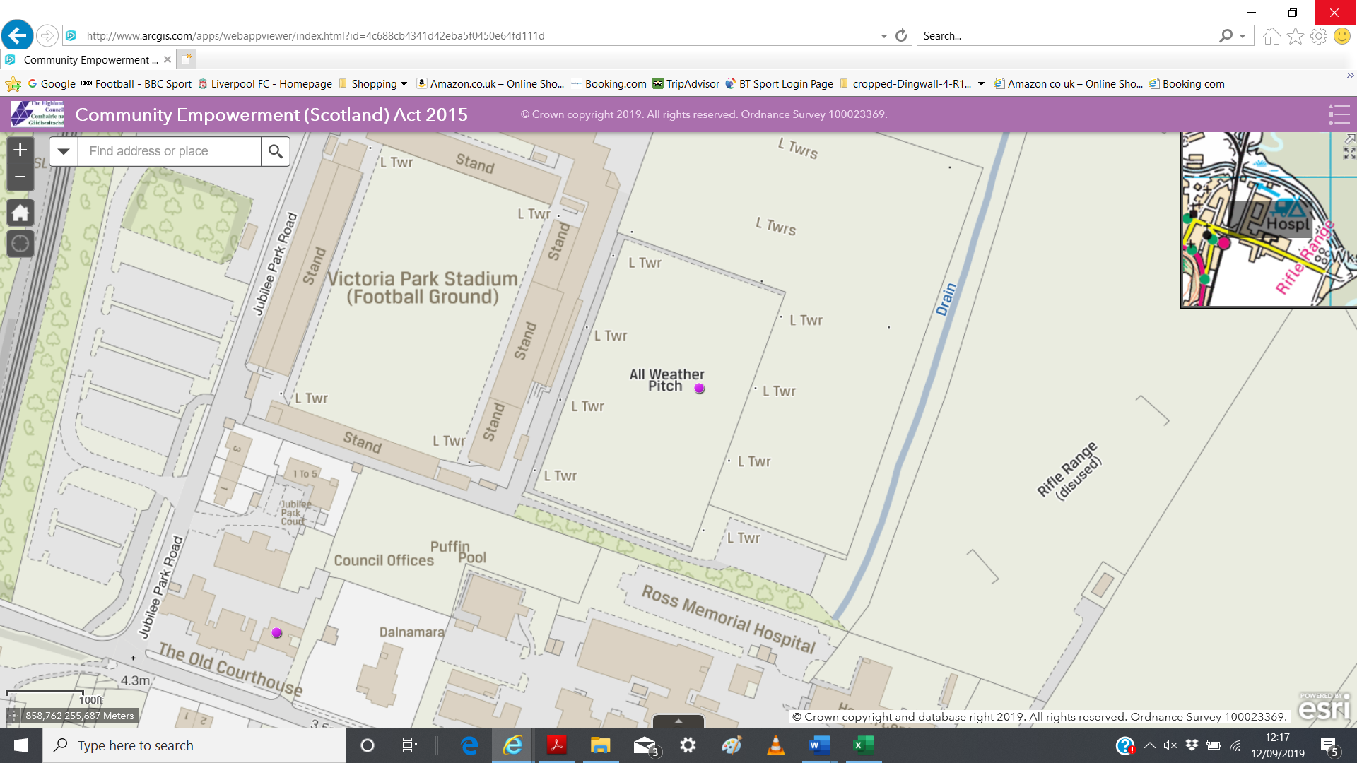

**Location of the Property taken from the Highland Council’s Map of Assets**

**Former Skate Park**