Proposal to dispose, by lease, of Fortrose Caravan Park (located on Common Good land) to the existing tenants.
What is proposed?
This proposal relates to a new lease to the existing tenants of Fortrose Caravan Park which is located on land which is understood to be Common Good land. The caravan park covers a total of 14515.95 square metres or thereby lying adjacent to the foreshore, Fortrose, IV10 3RX. It is bisected by the road known as Wester Greengates. The area of the proposed disposal is shown outlined in red on the plan below and shown in the aerial photograph.

Location of Fortrose Caravan Park

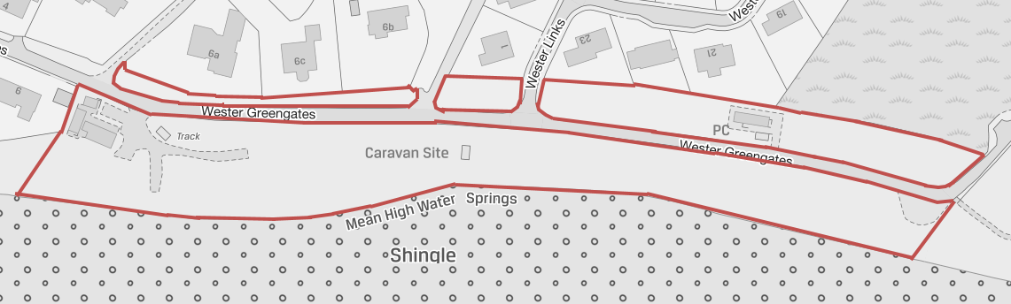

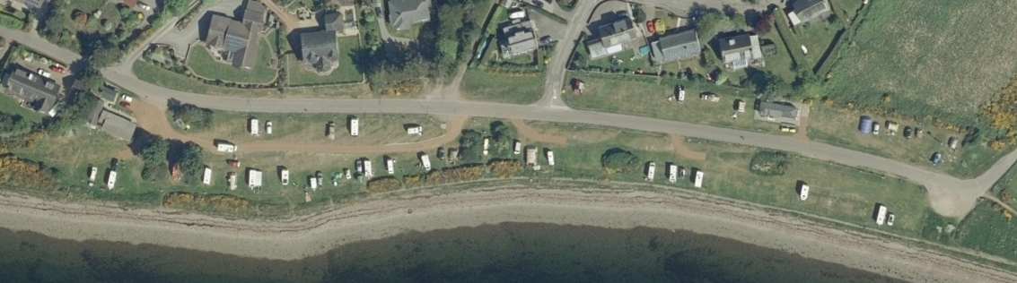

In 2004 a lease was granted in respect of Fortrose Caravan Park with a lease term until 2025. In 2015 the lease was assigned for the remainder of the lease term to the current tenants. Since acquiring the tenancy, the current tenants have undertaken extensive improvements, provided local employment and increased occupancy including with returning visitors. The current tenants have asked the Council to consider a new lease for a period of 30 years from the end of the present lease term which will give them the security to continue to invest in the caravan park, grow the business and see a return on their level of investment. The proposal would also provide Fortrose and Rosemarkie Common Good fund with security in knowing that the caravan park is being managed by tenants who are committed to seeing it thrive and develop.

The proposed terms of the new lease are that it should be for a term of 30 years from 2025 (end of the current lease), for an open market rent no less than the preceding passing rent, 5 yearly rent reviews to Retail Price Index or Market Rent whichever is higher and upwards only and subject to a permitted use of camp site with the tenants being responsible for maintenance, repair and insurance.

Consultation
Section 104 of the Community Empowerment (Scotland) Act 2015 requires the Council to consult local communities when considering disposing or changing the use of Common Good assets. This includes where the proposal is to grant a lease of over 10 years. Therefore, before taking any decision, and to inform the decision making process, we are keen to hear the views of the community, in particular:
- What are your views on the proposed disposal by new lease of Fortrose Caravan Park to the current tenants?
- Do you have any views on potential benefits of the proposal?
- Do you have any issues or concerns arising from the proposal?
- Do you have any additional comments?

The Council will take all representations into account in reaching a decision.

Depending on the representations received the possible outcomes are:
- The proposal goes ahead subject to consent by the Sheriff Court to the disposal by way of lease
- The proposal is amended significantly and a fresh consultation takes place.
- The proposal does not go ahead.

Representations
Consultation closing date – 29 November 2019.

Please submit written representations to:-
Email: commongood@highland.gov.uk
Post: Sara Murdoch, Highland Council, Headquarters, Glenurquhart Road, Inverness, IV3 5NX.

Additional information
There are specific regulations governing the management of Common Good. This is to ensure protection for assets held. One such area is where property is considered ‘inalienable’. This means that there is a restriction regarding the property namely; its purpose is clearly stated in the deed or gift to the Common Good Fund (often specifically dedicated for public use), it has been dedicated to public use after acquisition or it has to be used in a certain beneficial way for a lengthy period of time (time immemorial). Land that derives its Common Good title from the original Burgh Royal Charter is invariably considered to be inalienable.

The piece of land that is the subject of this proposal is believed to derive its title from the original Burgh Royal Charter dated 6 August 1590. Unfortunately this and other Charters have been missing for some time and investigations remain ongoing into their whereabouts however the Records of the Parliament of Scotland to 1707 contain a Ratification for the Burgh of Fortrose by Charles II dated 1 January 1661that confirms this Charter. The dedication and public use of this Common Good land as a caravan park is considered to raise a question of inalienability. Therefore, it will be necessary to seek the consent of the Sheriff Court to any proposed disposal. Any application to the Court will include information about this consultation and the responses received. It will also have an impact on any likely timescales involved with completing the extension to the new lease of the property should a decision be made to proceed with the proposal.

