Highland Council Asset Transfer Request Approach
Asset Transfer Request Form

This is an asset transfer request made under Part 5 of the Community Empowerment (Scotland) Act 2015.
- Information about the community transfer body (CTB) making the request

  - Name of the CTB making the asset transfer request
Kyle of Sutherland Hub Ltd
  - CTB address. This should be the registered address, if you have one.
Postal address:
South Bonar Industrial Estate, Ardgay, Sutherland

Postcode: IV243AW
  - Contact details. Please provide the name and contact address to which correspondence in relation to this asset transfer request should be sent.
Contact name: Hayley Bangs
Postal address: Kyle of Sutherland Hub, South Bonar Industrial Estate, Sutherland

Postcode: IV243AQ
Email:hayley.bangs@kyleofsutherland.com
Telephone:01863769170
x☐ We agree that correspondence in relation to this asset transfer request may be sent by email to the email address given above. (Please tick to indicate agreement)
You can ask the relevant authority to stop sending correspondence by email, or change the email address, by telling them at any time, as long as 5 working days’ notice is given.
  - Please mark an “X” in the relevant box to confirm the type of CTB and its official number, if it has one.
x | Company, and its company number is …………. | 501958
 | Scottish Charitable Incorporated Organisation (SCIO), and its charity number is ………………..
 | Community Benefit Society (BenCom), and its registered number is ………………………………
 | Unincorporated organisation (no number)

Please attach a copy of the CTB’s constitution, articles of association or registered rules.
  - Has the organisation been individually designated as a community transfer body by the Scottish Ministers?
No ☐x
Yes ☐
Please give the title and date of the designation order:

  - Does the organisation fall within a class of bodies which has been designated as community transfer bodies by the Scottish Ministers?
No ☐
Yes ☐x
If yes what class of bodies does it fall within?
Community controlled body

- Information about the asset requested

  - Please identify the asset - land or building(s) - which this asset transfer request relates.
You should provide a street address or grid reference and any name by which the land or building is known. If you have identified the land on the relevant authority’s register of land, please enter the details listed there.
It may be helpful to provide one or more maps or drawings to show the boundaries of the land requested. If you are requesting part of a piece of land, you must attach a map and full description of the boundaries of the area to which your request relates. If you are requesting part of a building, please make clear what area you require. a drawing may be helpful.
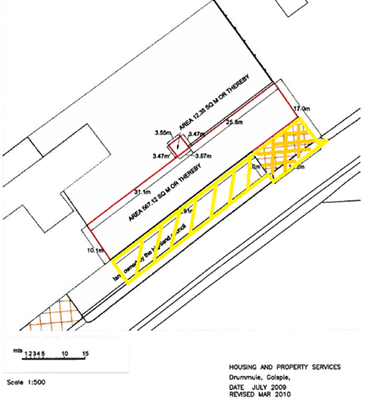
The area we wish for transfer is highlighted in horizontal ( not crisscross) yellow lines

  - Please provide the UPRN (Unique Property Reference Number), if known.
This should be given in the relevant authority’s register of land
UPRN:

- Type of request, payment and conditions

  - Please tick what type of request is being made:
x
for ownership (under section 79(2)(a)) - go to section 3A

for lease (under section 79(2)(b)(i)) – go to section 3B

for other rights (section 79(2)(b)(ii)) - go to section 3C

3A – Request for ownership
What price are you prepared to pay for the asset requested? :
Proposed price: £1 we have already contributed over £8,000.00 to the maintenance of the area
Please attach a note setting out any other terms and conditions you wish to apply to the request.

3B – Request for lease
What is the length of lease you are requesting?

How much rent are you prepared to pay? Please make clear whether this is per year or per month.
Proposed rent: £ per
Please attach a note setting out any other terms and conditions you wish to be included in the lease, or to apply to the request in any other way.

3C – Request for other rights
What are the rights you are requesting?
Full transfer of ownership

Do you propose to make any payment for these rights?
Yes ☐x
No ☐
If yes, how much are you prepared to pay? Please make clear what period this would cover, for example per week, per month, per day?
Proposed payment: £ 1 per
Please attach a note setting out any other terms and conditions you wish to apply to the request.

- Community Proposal

  - Please set out the reasons for making the request and how the land or building will be used.
This should explain the objectives of your project, why there is a need for it, any development or changes you plan to make to the land or building, and any activities that will take place there.
The council transferred ownership to our group, the Kyle of Sutherland Youth Development Group now called the Kyle of Sutherland Hub, the land marked in red on the plan some years ago to allow better access and parking facilities for a proposed new community build. Our new facility is now built and operational. We are requesting transfer of ownership of the area retained by the highland council ( marked as such on the plan) in line with the area marked in red which they would not transfer at the time

The reason for this request is for us to be able to ensure sufficient risk management of the site where families, children and young people are entering and leaving the site,for us to be able to maintain the area and to allow continued growth of the project. Please note the bottle banks have been moved from this site which was the original reason the council retained this strip. The Hub is a major employer and service provider to the community and visitors and we are seeing in excess of 4,000 visits to the project annually. The existing car park spaces are insufficient for the scale of visitors. Additionally, at present we have no jurisdiction over who parks in this area which is immediately in front of the Hub building and its car park spaces, or indeed how they do. This presents significant safety risks but also on many occasions prevents use of our own parking spaces. As highlighted in the pictures below
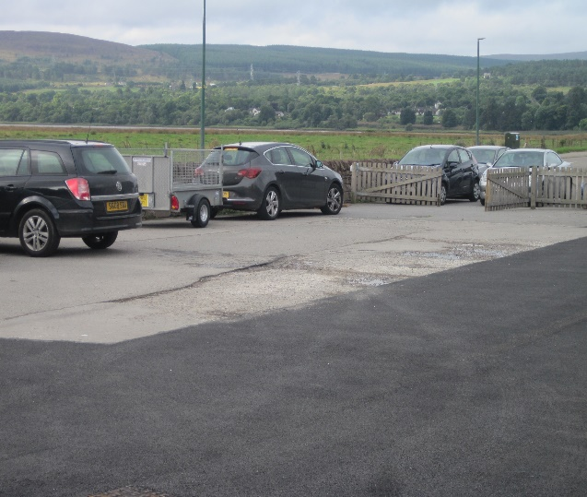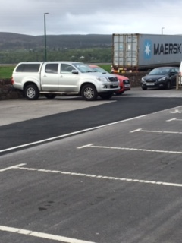

Benefits of the proposal
  - Please set out the benefits to the community that you consider will arise if the request is agreed to. This should include:- economic, regeneration, health, social wellbeing, environmental benefits; or how this will tackle inequalities.
This section should explain how the project will benefit your community, and others. Please refer to the guidance on how the relevant authority will consider the benefits of a request.

Increased safety of all community users
Increased safety of children & young people
Increased economic benefit through supporting continued growth
Greater maintenance of area and proper risk management

Restrictions on use of the land
  - If there are any restrictions on the use or development of the land, please explain how your project will comply with these.
Restrictions might include, amongst others, environmental designations such as a Site of Special Scientific Interest (SSI), heritage designations such as listed building status, controls on contaminated land or planning restrictions.

Area will only be used for car park spaces

Negative consequences
  - What negative consequences (if any) may occur if your request is agreed to? How would you propose to minimise these?
You should consider any potential negative consequences for the local economy, environment, or any group of people, and explain how you could reduce these

Capacity to deliver
  - Please show how your organisation will be able to manage the project and achieve your objectives.
This could include the skills and experience of members of the organisation, any track record of previous projects, whether you intend to use professional advisers, etc.
We have a proven track record in project management, meeting statutory obligations and overseeing a major capital build

- Level and nature of support

  - Please provide details of the level and nature of support for the request, from your community and, if relevant, from others.
This could include information on the proportion of your community who are involved with the request, how you have engaged with your community beyond the members of your organisation and what their response has been. You should also show how you have engaged with any other communities that may be affected by your proposals.

We have over 120 ordinary members who support the transfer
Huge community support for this project was evidenced for the build and at the time when we originally wanted the land transferred. That remains

- Funding

  - Please outline how you propose to fund the price or rent you are prepared to pay for the asset, and your proposed use of the asset.
You should show your calculations of the costs associated with the transfer of the land or building and your future use of it, including any redevelopment, ongoing maintenance and the costs of your activities. All proposed income and investment should be identified, including volunteering and donations. If you intend to apply for grants or loans you should demonstrate that your proposals are eligible for the relevant scheme, according to the guidance available for applicants.
The Hub has already funded £8,000 towards the maintenance of this area.

Signature

Two office-bearers (board members, charity trustees or committee members) of the community transfer body must sign the form. They must provide their full names and home addresses for the purposes of prevention and detection of fraud.
This form and supporting documents will be made available online for any interested person to read and comment on. Personal information will be redacted before the form is made available.

We, the undersigned on behalf of the community transfer body as noted at section 1, make an asset transfer request as specified in this form.
We declare that the information provided in this form and any accompanying documents is accurate to the best of our knowledge.
Name
Address

Date
Position
Signature

Name
Address

Date
Position
Signature

Checklist of accompanying documents

To check that nothing is missed, please list any documents which you are submitting to accompany this form.
Section 1 – you must attach your organisation’s constitution, articles of association or registered rules
Title of document attached: Article of Association

Section 2 – any maps, drawings or description of the land requested
Documents attached: attached

Section 3 – note of any terms and conditions that are to apply to the request
Documents attached:

Section 4 – about your proposals, their benefits, any restrictions on the asset or potential negative consequences, and your organisation’s capacity to deliver.
Documents attached:

Section 5 – evidence of community support
Documents attached:

Section 6 – funding
Documents attached:

Search “Privacy Notices” on the Highland Council website to read our Privacy Statement in regards to Asset Transfer Request forms.

