YOUR CASH YOUR CAITHNESS
How would you change Caithness?
Do you have an idea that will make Caithness a better place for everyone?
Do you need up to £1,000.00 to put your idea into action?
If your answer is YES then ‘YOUR CASH YOUR CAITHNESS’ is the opportunity for you to make your project happen.
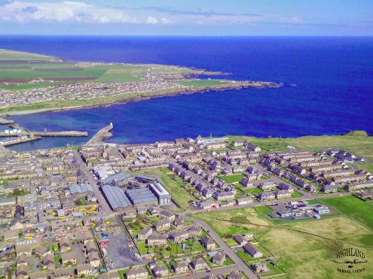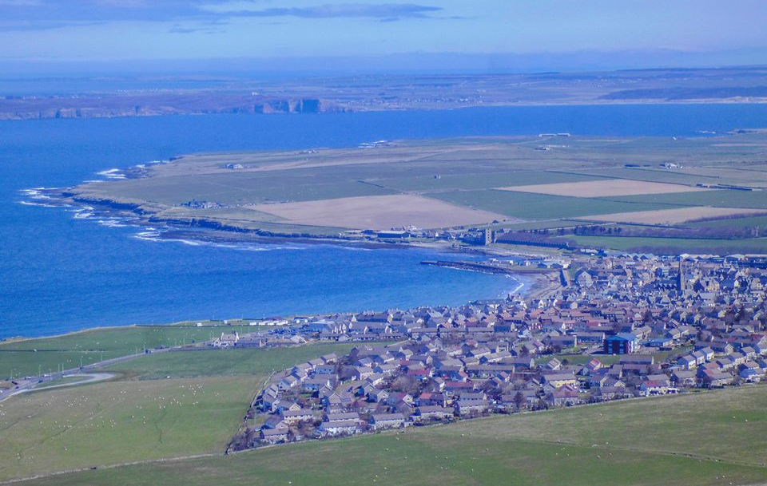
Deadline for applications is
Sunday 2 February 2020
If you need information or assistance with the application or if you have any concerns around public presentations, please contact
Yvonne@CVG.org.uk 01955 609960 Caithness Voluntary Group

Who can apply?
Any local community, voluntary or non-profit organisation – even informal groups– can apply for up to £1,000 to put ideas into action.

You don’t have to come from an existing organisation to apply for this fund but all activities will have to happen in Caithness and benefit local people. Only one application per group can be submitted.
Highland Council has set aside £10,000 and wants to put YOU in control of how it’s spent.
‘YOUR CASH YOUR CAITHNESS’ lets the local community decide for themselves which projects are needed in their area.
How do you apply?
To apply for the funding you must return this form before 5pm Sunday 2 February 2020. If your idea fits, the community will get to vote for the best ideas at an event to be held on Saturday 29 February 2020.

At the event you will be required to talk about your idea to the community. Those in attendance will then vote on all the applications and a decision will be made on the day.

Whether you want to organise a dance for young people, a healthy living project, a crime prevention idea, a lunch club for older residents, a community art project, the only limit is your imagination.

What can you apply for?
We need your ideas for projects that will:
- Benefit as many people as possible from across the community.
- Help to make Caithness a better place for everyone
- Any project large or small welcome.
REGISTER YOUR IDEA: APPLY TODAY

Your full name:
Address where we can write to you. (Your own address or the address of the organisation you represent)
Your postcode:
Telephone number:
Email:
If you represent an organisation what is its’ name?
What is the name of your project/idea?
Where in Caithness will the project take place?
Briefly describe the project you would like funding for:
How will the project make Caithness a better place for everyone?
How many people do you think will benefit from your project?
For Example this could be the number who will attend a lunch club weekly.
What particular need will it address for the community?
How much money do you require and what will you spend it on?
PLEASE GIVE A FULL BREAKDOWN OF THE COSTS OF YOUR PROJECT AND WHEN YOU EXPECT TO SPEND THE MONEY BY PLEASE DEATAIL ANY OTHER FUNDING SOURCES AND IF IT HAS BEEN CONFIRMED.

Please return this form via email to
Yvonne@CVG.org.uk
or post it to: CVG, Telford House, Williamson Street Wick KW1 5ES

DEADLINE FOR APPLICATIONS: 2 February 2020

