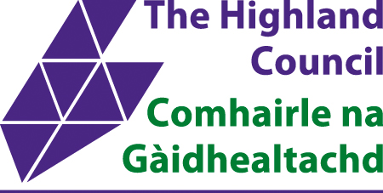

Application for Order to Exempt an Area of Land from Access Rights under Section 11 of the Land Reform (Scotland) Act 2003

Applicant:

Address:

Phone:

Email:

Are you the owner of the land where the exemption is being applied for | Yes |  | No
If “No” you MUST have written consent from the landowner to hold the event.

Please provide a copy of this consent or, if this is commercially sensitive, a cover letter from the landowner or agent stating permission has been given.

DETAILS OF THE AREA OF LAND EXEMPTION APPLIED FOR:

Location:

Description:

Are there any core paths in the area of land you want to exclude from access rights? See www.highland.gov.uk/corepathsmap

If the land to be exempted is not already contained/bounded by built or natural features please explain how the site will be marshalled to exclude the public. In particular where public access is possible from neighbouring paths, tracks or roads not covered by this exemption:

Map & OS grid reference: - please include an extract from an OS map at the appropriate scale clearly identifying the area of land to be excluded.

Reasons for exclusion:

Any arrangements for alternative access, also where car parks are closed any plans for alternative parking and/or traffic management. Please note an access exemption does not permit roads to be closed;

Start date and time for exclusion:
End date and time for exclusion**:
** Please note that applications for exclusions over 5 days will be determined by
Scottish Ministers

OFFICE USE ONLY | Date application received:
 | Ref no:
 | HC area:

