CONSULTATION on:-
a proposal to change the use of an area of Dornoch Links to a site for the location of a takeaway food van.
What is proposed?
A change of use of 256.4 square metres or thereby of land at Dornoch Links for the purpose of siting a takeaway food van. It is proposed that the location should be leased on a short term basis (less than 10 years) to the proprietor of the food van, Ewan Chisholm. An image of the food van is shown below. The food van is a temporary structure.

The site is located to the east of Beach Road adjacent to the passing place and approximately 168 metres south west of the beach car park. The area of the proposed location is shown on the plans below.

At this stage, the proposal relates to change of use only as any initial lease will only be of 12 months duration and, as such, does not constitute a disposal. Any subsequent lease exceeding 10 years would constitute a disposal and would need to be the subject of a separate consultation process.

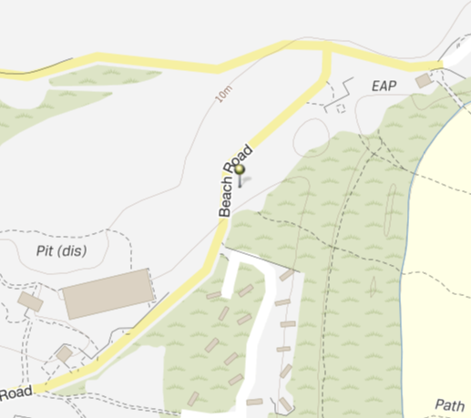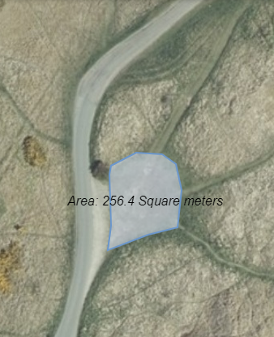

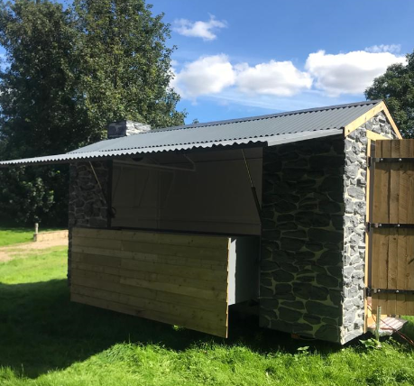
Consultation
Section 104 of the Community Empowerment (Scotland) Act 2015 requires the Council to consult local communities when considering disposing or changing the use of Common Good assets. Therefore, before taking any decision, and to inform the decision making process, we are keen to hear the views of the community, in particular:

- What are your views on the proposed change of use of this piece of Common Good land?
- Do you have any views on potential benefits of the proposal?
- Do you have any issues or concerns arising from the proposal?
- Do you have any additional comments?

The Council will take all representations into account in reaching a decision.

Depending on the representations received the possible outcomes are:
- The proposal goes ahead subject to consent by the Sheriff Court.
- The proposal is amended significantly, and a fresh consultation takes place.
- The proposal does not go ahead.

Representations
Consultation closing date – 9 December 2020

Please submit written representations to:-
Email: commongood@highland.gov.uk
Post: Sara Murdoch, Highland Council, Headquarters, Glenurquhart Road, Inverness, IV3 5NX.

Additional information

The Highland Council have a statutory obligation to seek court consent before changing the use (also known as appropriation) of Common Good land which may be ‘inalienable’.

In this context ‘inalienable’ refers to Common Good property that falls into at least one of the following categories: -

- The Title Deed of the property dedicates it to a public purpose, or
- The Council has dedicated it to a public purpose, or
- The property has been used for public purposes for many years (time immemorial) without interference by the Council

In this case the property is located on The Links at Dornoch which derived its title from the Royal Charter of King Charles II dated 14 July 1628 and, as such, it is considered that a question of alienability may arise. Therefore, the proposed change of use cannot take place until Sheriff Court consent has been obtained. If after this consultation, the proposal progresses to a court application the public will have a further opportunity to make representations within the Court process. A statutory advertisement will be placed in the Northern Times to inform the local public that the court process has been commenced.

