CONSULTATION on:-
- proposal to dispose, by lease, of the Links Tea Room, The Links, Nairn, IV12 4PW
- proposal to dispose, by demolition, of the old store, The Links, Nairn and to return the use of the area of land to public amenity
What is proposed?
This consultation document covers proposals in respect of the Links Tea Room and the old store (formerly known as the Store for the Links Tea Room) at the Links, Nairn.

- Links Tea Room
It is proposed to dispose, by lease, of The Links Tea Room which is located on Common Good property forming part of The Links, Nairn, IV12 4PW to John Main Bochel and Alexander Main Bochel.

The area to be leased is triangular in shape and bordered by footpaths on the north, east, south east and west. It is located 17 metres or thereby north of the cricket pavilion and adjacent to the new splashpad. The area of the proposed disposal is shown outlined in red on the plan below together with an aerial photograph of the site.

John and Alexander Bochel currently occupy the premises on the basis of a short lease. They have asked the Council to consider granting a 30 year lease as they wish to commit to a programme of investment in the site which may include the future replacement of the existing structure with a more modern building in keeping with the overall development proposals for the Links area. A longer lease would allow them to see a return on such a level of investment. The proposed longer lease would also result in an enhanced rental value which would be to the benefit of the Common Good Fund.

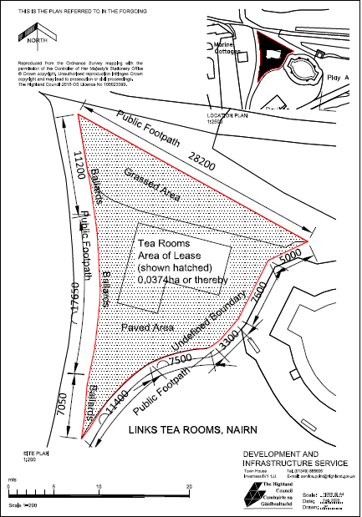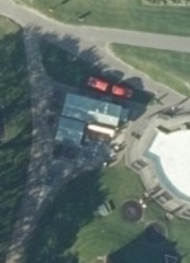
- The old store (formerly known as the Store for the Links Tea Room)
The old store is located a short distance from the Links Tea Room approximately 18 metres south of the West Beach Public Toilets and adjacent to a grass bank at the rear. The location of the store is shown in the plan and photograph below.

Historically the store has been leased together with the Tea Room however it is not included as part of the current lease. The building is run down and has not been used in any significant way since the late 1980’s. It is proposed that the old store should be demolished with the ground being landscaped and its use being changed back to open access public amenity land. The current electrical supply would be maintained in a secure unit on a concrete base for use when the Fair and Shows come to Nairn.

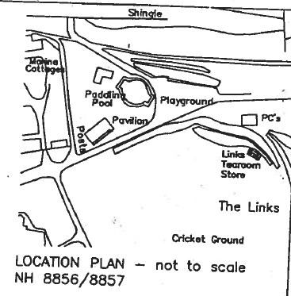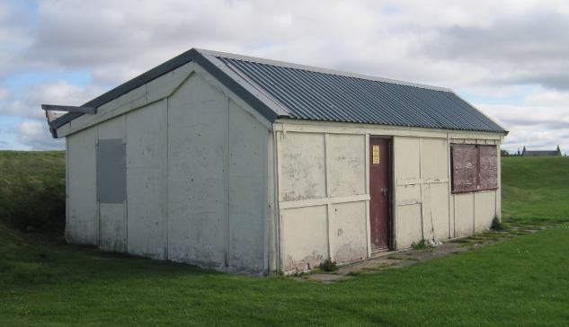

Consultation
Section 104 of the Community Empowerment (Scotland) Act 2015 requires the Council to consult local communities when considering disposing or changing the use of Common Good assets. This includes where the proposal is to grant a lease of over 10 years. As a result of a recent court case, a disposal now also includes demolition. Therefore, the consultation is seeking the views of the community in respect of both proposals in order to inform the decision making process in each case.

Key questions:
- What are your views on the proposed disposal by lease of the Links Tea Room?
- What are your views on the proposal to demolish the old store and change the use of the land back to open access public amenity space?
- Do you have any views on potential benefits of the proposals?
- Do you have any issues or concerns arising from the proposals?
- Do you have any additional comments?

The Council will take all representations into account in reaching a decision.

Depending on the representations received the possible outcomes are:
- The proposal goes ahead subject to consent by the Sheriff Court.
- The proposal is amended significantly, and a fresh consultation takes place.
- The proposal does not go ahead.

Representations
Consultation closing date – 6 January 2021

Please submit written representations to:-
Email: commongood@highland.gov.uk
Post: Sara Murdoch, Highland Council, Headquarters, Glenurquhart Road, Inverness, IV3 5NX.

Additional information

The Highland Council have a statutory obligation to seek court consent before disposing of Common Good land which may be ‘inalienable’.

In this context ‘inalienable’ refers to Common Good property that falls into at least one of the following categories: -

- The Title Deed of the property dedicates it to a public purpose, or
- The Council has dedicated it to a public purpose, or
- The property has been used for public purposes for many years (time immemorial) without interference by the Council

In this case the property is located on The Links at Nairn which derived its title from the Royal Charter of King James VI dated 15 October 1589 and, as such, it is considered that a question of alienability may arise. Therefore, the proposed lease cannot be concluded until Sheriff Court consent has been obtained. If after this consultation, the proposal progresses to a court application the public will have a further opportunity to make representations within the Court process. A statutory advertisement will be placed in the Nairnshire Telegraph to inform the local public that the court process has been commenced.

