CONSULTATION on:-
a proposal to change the use of the Wildlife Pond Kiosk, Tain Links to a cafe providing food and beverages.
What is proposed?
A change of use of the Wildlife Pond Kiosk at Tain Links to a café outlet providing food and beverages. The kiosk was previously used for hiring and storing boats for use on the Wildlife Pond but has lain empty for a significant period of time. The property has been marketed for lease for over two years and a proposal has now been received from a local couple to lease the kiosk for an initial period of 5 years for the purposes changing it into a café providing food and drinks.

The kiosk is located approximately 17.5 metres west of the Wildlife Pond. The area of the proposed site totals 230.58m²or thereby comprising the building (including toilets) and a 3 m circulation space. The kiosk and its location are shown in the images below.

At this stage, the proposal relates to change of use only as any initial lease will only be of 5 years duration and, as such, is not considered to be a disposal by Highland Council. Any subsequent lease exceeding 10 years would constitute a disposal and would need to be the subject of a separate consultation process.

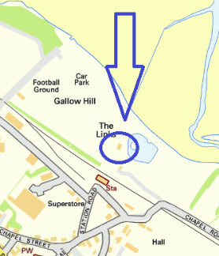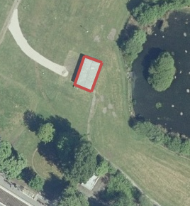

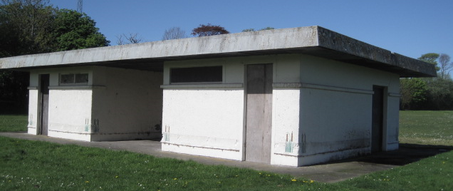

Consultation
Section 104 of the Community Empowerment (Scotland) Act 2015 requires the Council to consult local communities when considering disposing or changing the use of Common Good assets. Therefore, before taking any decision, and to inform the decision making process, we are keen to hear the views of the community, in particular:

- What are your views on the proposed change of use of the kiosk at the Wildlife Pond?
- Do you have any views on potential benefits of the proposal?
- Do you have any issues or concerns arising from the proposal?
- Do you have any additional comments?

The Council will take all representations into account in reaching a decision.

Depending on the representations received the possible outcomes are:
- The proposal goes ahead subject to consent by the Sheriff Court.
- The proposal is amended significantly, and a fresh consultation takes place.
- The proposal does not go ahead.

Representations
Consultation closing date – 19 January 2021

Please submit written representations to:-
Email: commongood@highland.gov.uk
Post: Sara Murdoch, Highland Council, Headquarters, Glenurquhart Road, Inverness, IV3 5NX.

Additional information

The Highland Council have a statutory obligation to seek court consent before changing the use (also known as appropriation) of Common Good land which may be ‘inalienable’.

In this context ‘inalienable’ refers to Common Good property that falls into at least one of the following categories: -

- The Title Deed of the property dedicates it to a public purpose, or
- The Council has dedicated it to a public purpose, or
- The property has been used for public purposes for many years (time immemorial) without interference by the Council

In this case the property is located on Tain Links which derives its title from the Royal Charter of King James VI dated 29 January 1587. Tain Links is considered to be inalienable. The principle of accession provides that, as the kiosk is built on the Links, it will derive its title from the Links. Therefore, it is considered that a question of alienability arises where the change of use (or appropriation) of the kiosk is concerned.

As a result, the proposed change of use cannot take place until Sheriff Court consent has been obtained. If after this consultation, the proposal progresses to a court application the public will have a further opportunity to make representations within the Court process. A statutory advertisement will be placed in the Ross-shire Journal to inform the local public that the court process has been commenced.

