CONSULTATION on:-
Proposal to dispose, by lease, and change of use of Common Good land at Dornoch Links to Royal Dornoch Golf Club (RDGC)
What is proposed?
- A disposal, by lease, of 85.629 hectares or thereby of Common Good property located at Dornoch Links to RDGC upon the surrender of the existing lease.
- Change of use of part of the land currently used for playing golf to allow the construction of a new clubhouse facility.
- Change of use of part of the Bowling Club land for improving access and change of use of part of the tennis court for car parking.

RDGC’s current occupation is governed primarily by a lease which was granted in 1973 (recorded 3 April 1974) for a period of 99 years at a fixed peppercorn rent of £150 per year. However, since the granting of the original lease, there have been additional areas leased as well as areas of land surrendered. As a result, the current area utilised does not accord to the plan appended to the original lease. The new area of 85.629 hectares now proposed to be leased is substantially smaller that the area of 123 hectares contained in the original lease.

In addition, RDGC now wish to undertake the construction of a new clubhouse that will provide larger and more up to date facilities for members and course visitors alike.

It is proposed that all existing leases should be surrendered, and a single new lease be granted which will allow for an accurate reflection of the land footprint and the negotiation of a more up to date rental arrangement.

Proposed new lease terms
- Lease term of 99 years with option to extend for a further 99 years on basis of future terms to be agreed.
- Subject to the outcome of this consultation and subsequent Court proceedings, the proposal is for the lease to commence in or around July 2021.
- A base rent of £25,000 per annum due from 1 January 2023 payable in arrears with first payment due on 31 December 2023.
- An additional £25,000 per annum rent will be payable upon breaking ground for the construction of the new clubhouse subject to visitor numbers being such as to allow RDGC to break even financially in that year.
- During the first 7 years of the lease no rent will be payable in any year when visitor numbers are less than that required for RDGC to break even financially in that year. The calculation of the break even point is to be based on a tapering off of the rent if visitor numbers fall from 7000 to 5000 or less in a year.
- Both elements of the rent will be subject to 5 yearly rent reviews to increase in line with CPIH.

The provision for reduced/no rent in the first 7 years reflects the intention of RDGC to utilise most of their profits for the developing of the new clubhouse facility and to allow the club some security in the event of ongoing or recurring restrictions for visitors as has happened this year with Covid19. In the absence of such difficulties, RDGC would expect to receive between 10,000 to 14,000 visitors per year.

Images of proposed area to be leased to RDGC and associated changes to the Bowling Club and area occupied by the current tennis court.
In addition to the rationalisation of the lease footprint and the proposed construction of the new clubhouse, this consultation also includes a change to the access road (see image 4). This will address any safety issues with the current access provision (any access rights for the Bowling Club will be dealt with in the proposed new lease). Also, RDGC would wish to layout additional and improved parking facilities.

It is proposed that the Bowling Green will be moved 4 metres to the east into part of the existing tennis court (see image 2). The remainder of the tennis court will form part of the new lease to RDGC and be incorporated into their parking area. The area of land surrendered by the Bowling Club be added to the width of the existing access road and also be included in the proposed new lease to the golf club.

RDGC will be covering the costs of the changed layout to the land in the area highlighted in image 2 and have also agreed to fund the construction of a new sports facility at Dornoch Academy campus subject to a cap of £100,000.

Image 1
This image shows the full area now proposed to be leased to Royal Dornoch Golf Club

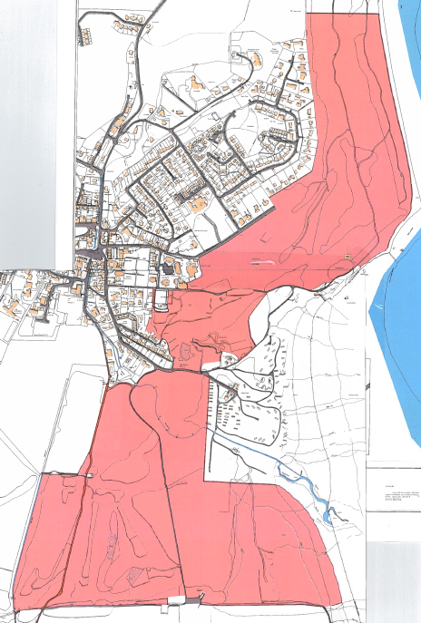

Image 2
This image shows the close up of the change proposed to the access road, Bowling Club and tennis court.
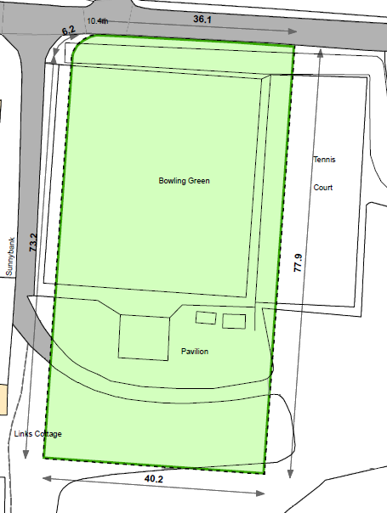

Image 3
This image relates to the parcel of land leased to RDGC in 2014 for the location and construction of the Green Keepers buildings. It is proposed that this lease will be surrendered, and this area of land incorporated into the new proposed lease.
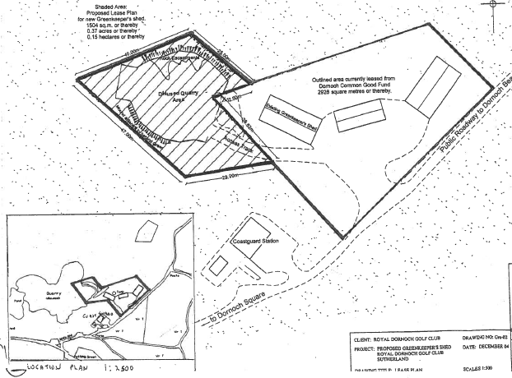

Image 4
This shows the planned location for the new clubhouse (lower right quadrant of the image) and also shows the proposed improved access and parking facilities.

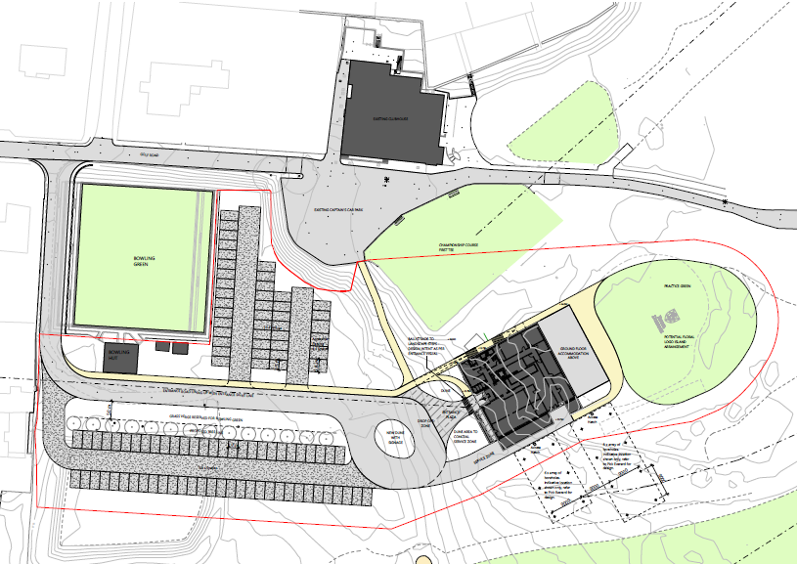

Consultation
Section 104 of the Community Empowerment (Scotland) Act 2015 requires the Council to consult local communities when considering disposing or changing the use of Common Good assets. This includes where the proposal is to grant a lease of over 10 years. Therefore, before taking any decision, and to inform the decision making process, we are keen to hear the views of the community, in particular:

- What are your views on the proposed disposal by lease of this piece of Common Good land?
- Do you have any views on potential benefits of the proposal?
- Do you have any issues or concerns arising from the proposal?
- Do you have any additional comments?

The Council will take all representations into account in reaching a decision.

Depending on the representations received the possible outcomes are:
- The proposal goes ahead subject to consent being given by the Sheriff Court
- The proposal is amended significantly, and a fresh consultation takes place
- The proposal does not go ahead

Representations
Consultation closing date – 12 March 2021

Please submit written representations to:-
Email: common.good@highland.gov.uk
Post: Sara Murdoch, Highland Council, Headquarters, Glenurquhart Road, Inverness, IV3 5NX.

Additional information
The Highland Council have a statutory obligation to seek court consent before disposing of Common Good land which may be ‘inalienable’.

In this context ‘inalienable’ refers to Common Good property that falls into at least one of the following categories: -
- The Title Deed of the property dedicates it to a public purpose, or
- The Council has dedicated it to a public purpose, or
- The property has been used for public purposes for many years (time immemorial) without interference by the Council.

The piece of land that is the subject of this proposal derives its title from the original Burgh Royal Charter dated 14 July 1628 and has been used for recreation purposes for time immemorial.
Therefore, the proposed lease and change of use cannot be concluded until Sheriff Court consent has been obtained. If after this consultation, the proposal progresses to a court application the public will have a further opportunity to make representations within that process. A statutory advertisement will be placed in the Northern Times to inform the local public that the court process has been commenced.

