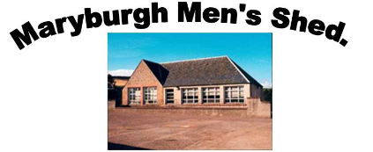

Community Benefit

Supporting Documentation

CONTENTS

- Introduction

- Common Highland Council & Government Outcomes

- SROI – Maryburgh Men’s Shed

- Maryburgh Men’s Shed Cash-Flow

- Appendices – Reference Documents

- The Highland Council - Corporate Plan 2017-2022

- The Scottish Government - A Connected Scotland

- Scottish Men’s Shed Association – SROI Westhill & District Men’s Shed

- Maryburgh Men’s Shed Estimated Cash-Flow Projection

- Age Scotland – Shedder Stories

- Introduction

The proposal of Maryburgh Men’s Shed to buy and utilise the former Maryburgh Primary School building will generate benefits, not just for the local Community but also for Highland Council and the Scottish Government in a wider context.
With the introduction of a Maryburgh Men’s Shed the benefits to the Community are many, including, living longer healthier lives, reducing isolation by contributing to their physical and mental wellbeing. Through our regular workshop sessions, we will reduce isolation and loneliness for older people and increase wellbeing, happiness and friendship, aligning with Highland Council and Government Policies.

The participants in the Men’s Shed will benefit:
- By improved self-esteem from using their skills for constructive purposes.
- By the opportunity to learn new skills and practice old ones.
- By having a place to go to spend time outside the home with people of similar interests.
- By overcoming isolation through getting out of the house and improved social interaction.
- By an improved awareness of medical issues important to aging members.

These benefits are directly in line with National Outcomes of:
- Living longer, healthier lives. We will work with NHS Community Health to promote healthy living campaigns.
- Sustainable places. We are providing a new Community led amenity, to address the needs of an aging population.
- Strong resilient and supportive communities. We are a volunteer group where people support each other, provide a better quality of life and help others lead healthier, more independent lives.
- Protect and enhance the environment. We will be involved with the Community, performing improvement projects in line with our skills.
- Reaching full economic potential. We plan to counter a drift into inactivity, particularly among older workers not currently in employment.
- An efficient and responsive public service. We will provide a link for our members to access public services and assist the public sector in the delivery of services.
- Fit for purpose Property Portfolio. We will remove a Council held liability, of an aging, empty and deteriorating asset.

- Common Highland Council & Scottish Government Outcomes

Maryburgh Men’s Shed will provide many social, health and wellbeing benefits within the Community of Maryburgh.
The Maryburgh area as part of the Highland Local Authority area has a higher percentage of older people than the Scottish average. Various interest groups share a common concern over the absence of activities for older people and the resulting deterioration in their health and wellbeing. A lack of social interaction results in some people becoming withdrawn and isolated from their community.
Our aim is to set up and operate a meeting place or collective “Shed” where members will be able to share skills, actively pursue hobbies, work on community projects and have a place to go and relax knowing they are among friends. The benefit for the members will be improved self-esteem, a chance to learn new skills and practice old ones, overcome isolation, improved social interaction and enjoy an active, healthy retirement.
Also, to get members out of their houses, mixing socially, learning new skills and mentoring others. We will work actively with NHS and community health organisations to promote members health issues and awareness. We intend to have talks from Clinical Nurses. We aim to boost feelings of self-worth through contributing to community projects, sharing skills and interests, assisting each other and enjoying fun and friendship.
In the first six months of operation we hope to attract one hundred visitors to The Shed and have forty of these become regular users. We will start by opening three days each week for five hours per day. There will also be an evening opening every Thursday from 7pm to 9pm. Our aim is to gradually move to opening every weekday and for longer hours.

Highland Council Corporate Plan -
The provision of Maryburgh Men’s Shed will align with Highland Council’s Corporate Plan and will deliver on The Council’s Strategic, Statutory and Operational Priorities in making the Highlands an even better place to live, contributing to the following common outcomes –

- 6.2 - A Place to Live - Outcome 2.2 - The Maryburgh Men’s Shed will provide the practical and emotional support required to enable older people to live longer more independent lives in their communities

- 6.3 – A Place to thrive – Outcome 3.1 - The Maryburgh Men’s Shed will create an open, welcoming space for all to visit and be involved in the various activities available, or simply enjoy a chat and cup of tea with new friends. Encouraging involvement together, for the improvement of each other’s health and wellbeing.

- 6.5 – A Welcoming Place – Outcome 5.3 – The Maryburgh Men’s Shed will Work on projects which will aid the community and help develop a positive sense of achievement. We will develop members interests through talks provided by local, interesting characters and encourage discussions at the presentations.

- 6.6 – Your Highland Council – Outcome 6.7 – The Maryburgh Men’s Shed will provide a much needed Community facility, through the Community Asset Transfer scheme, which will benefit many residents in the area by reducing loneliness, improving health and wellbeing and having a positive input and effect within the Community. While also reducing the Council’s liability on maintaining an aging, empty and deteriorating asset.

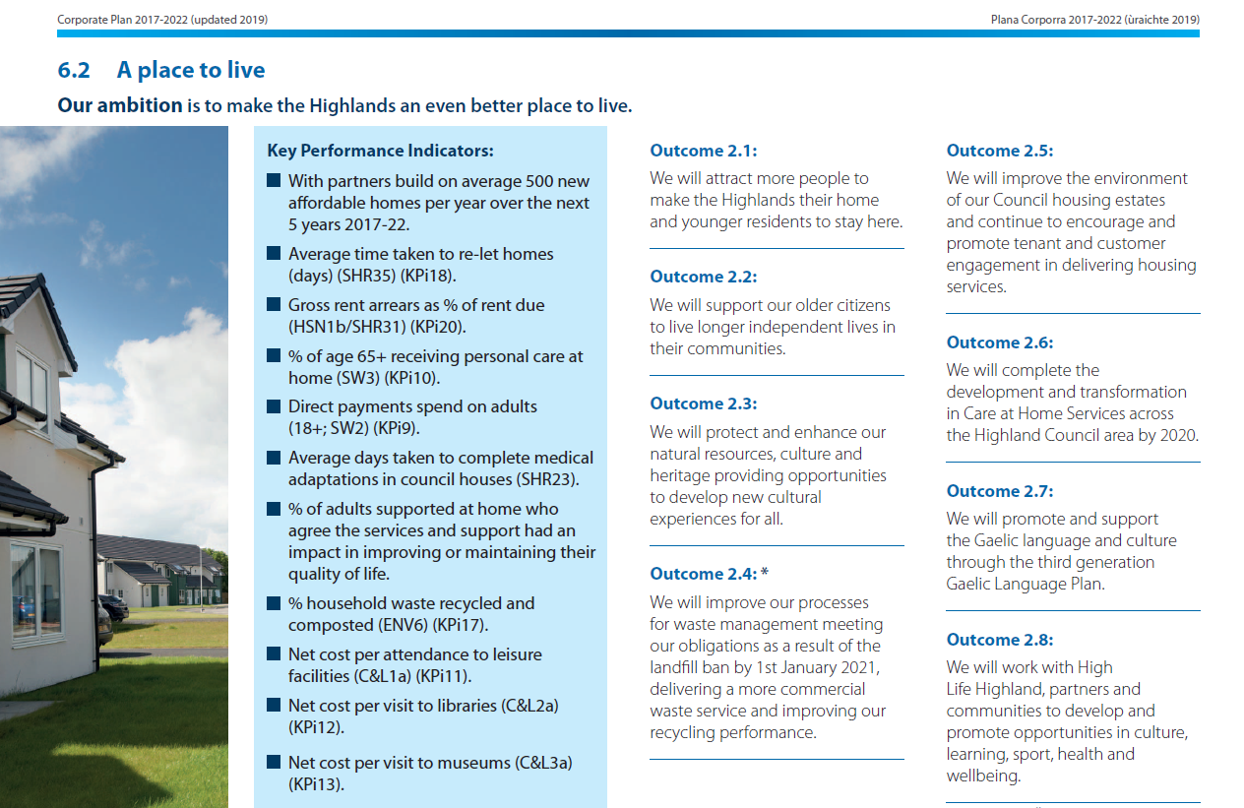

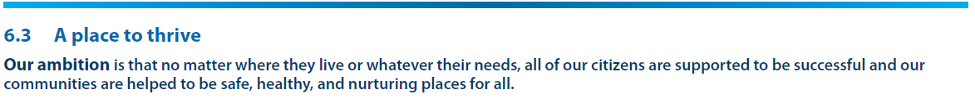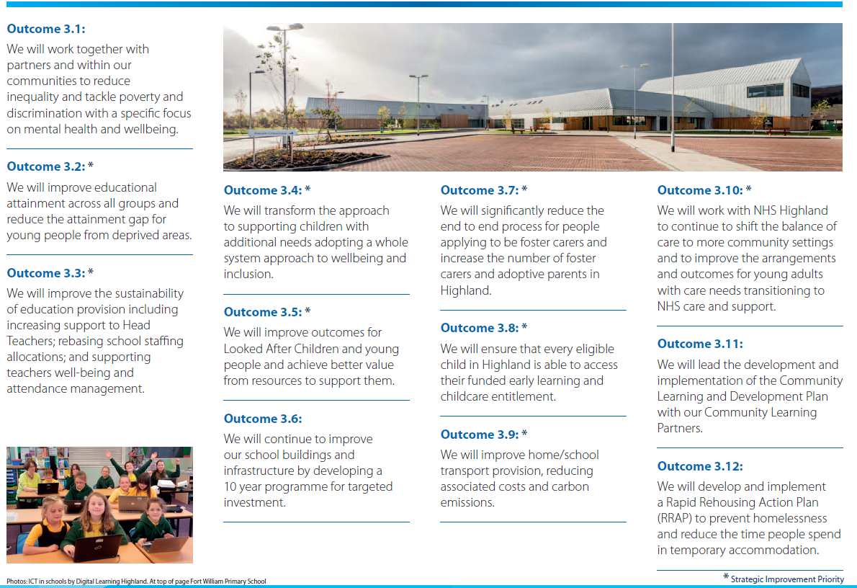
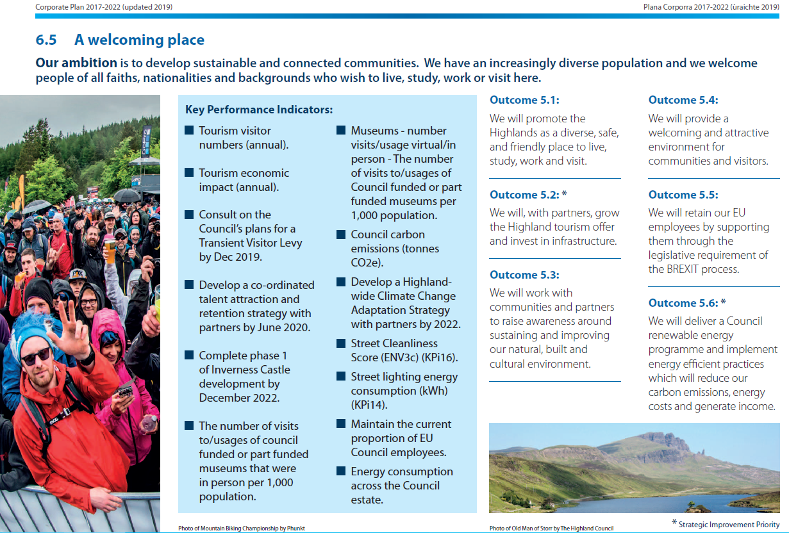

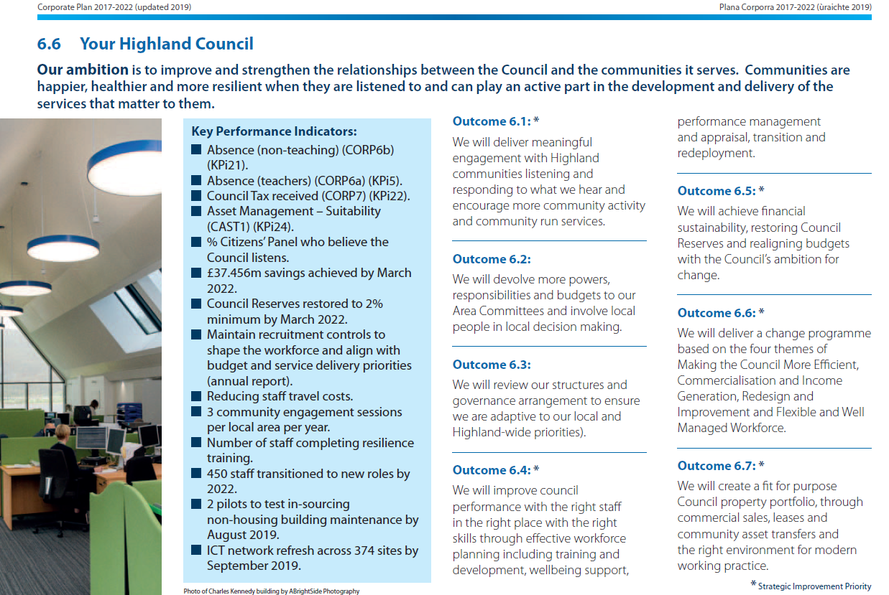

Scottish Government – CONNECTED SCOTLAND – Strategy for Social Isolation and Loneliness

The Maryburgh Men’s Shed aligns with National Government Strategy in the following Action Groups, noted within the Government Publication – Connected Scotland. The focus of the Men’s Shed is on helping older people connect with and support each other in the community – this will reduce social isolation and loneliness and help build meaningful and lasting social relationships.

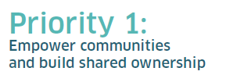
The Maryburgh Men’s Shed will, by encouraging the Community to become members, provide a facility to reduce social isolation and loneliness and improve social connectivity by meeting, to undertake creative, physical, purposeful and recreational activities which improves self-esteem and confidence.

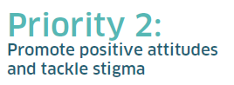
The Maryburgh Men’s Shed will promote positive attitudes by the improvement of health and wellbeing created by social involvement within a kind and welcoming environment, where everyone is equal, friendly and willing to share ideas and encourage discussion.

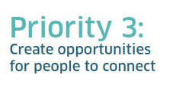
The Maryburgh Men’s Shed will hold sessions which will help older age groups understand how digital technology can add value to their lives. Providing voluntary support and encouragement to older people.

- SROI – Maryburgh Men’s Shed (MMS)

Social Return On Investment – SROI has been recognised widely as a measure of demonstrating, in monetary terms, the benefits of social improvements and improving personal health and wellbeing.
Case examples have been developed and used in the past to interrogate the obvious benefits to the Community and individuals, by the positive improvement in these areas with investment.
A similar case example in the Westhill and District Men’s Shed (WDMS) in Aberdeen can be compared to the Maryburgh Men’s Shed. The SROI for the WDMS was researched and compiled by Schroeder, Snowdon & Watt for the Scottish Men’s Shed Association, a copy is included in Appendix 5 iii) of this document.
In its conclusion it advises that with an operating expenditure of £5,000, an SROI value of £48,844 resulted. This equates to the combined benefit for four recognised beneficiary groups – 1) Those who attend the Shed; 2) Their partners and families; 3) Community planning partners such as NHS services; 4) The wider local Community.
This gives an SROI ratio (value of the benefits divided by the running cost) of 10:1 associated with a Men’s Shed of 34 members. MMS intend to exceed this number of members.
The WDMS SROI example clearly demonstrates the wider Health, Wellbeing, Social and Community benefits of a Men’s Shed in monetary terms. Mental health and wellbeing are improved for individuals by reducing isolation, offering opportunities for members to meet and undertake creative, physical, purposeful and recreational activities. This develops members capacity to share acquired skills and knowledge with others in the Maryburgh Community. This is well reflected within Maryburgh Men’s Shed Development Plan.

Shedder Stories
Appendix 5 v) Records ‘Shedder Stories’ from Age Scotland, which demonstrate further the benefits realised by the creation of a Men’s shed within a Community and how ‘The Shed’ can improve individuals feeling of wellbeing, mental health and happiness. All captured by individual personal ‘from the heart’ stories.

- Maryburgh Men’s Shed Estimated Cash-Flow Projection

The anticipated projected cash flow for Maryburgh Men’s Shed is shown in Appendix 5 iv).
This shows an improvement from our earlier initial estimates, provided in our Development Plan, for necessary capital expenditure to bring the building up to a safe and usable standard. This is because we have recently had a structural survey undertaken on the building, which has shown it to be in a better condition than initially thought. We have also had a significant very generous donation of machinery and tools, which will be of great benefit to the Men’s Shed and will allow us to commence as soon as possible, without the expenditure required to purchase new equipment in our early days. Also, the repairs highlighted from the structural survey have been clarified as being well within the abilities of our Men’s Shed members, who will provide these services and some of the materials free of charge. This will become an important initial Project for The Men’s Shed.
We have a committed income from rental associated with shared use of the building by Highland Woodturners and Maryburgh Matters. We anticipate revenue being generated from Project work, donations, crowdfunding and funding bodies. We are progressing applications to the following funding bodies to assist with start-up costs and our first year’s establishment costs –

- The Robertson Trust

- National Lottery Awards and The Community Fund

- Community Recovery Fund

- Age Scotland

- SSE Sustainable Development Fund

- The Highland Council

- Co-Op Community Funding

- Tesco Community Funding

Beyond our set-up stage we will have gained more experience on our spending costs and income. We feel incredibly positive and are encouraged by the support we have received from within the Community and elsewhere, giving us confidence we will be capable of generating income from our own abilities.
- Appendices

- The Highland Council - Corporate Plan 2017-2022

- The Scottish Government - A Connected Scotland

- Scottish Men’s Shed Association – SROI Westhill & District Men’s Shed

- Maryburgh Men’s Shed Estimated Cash-Flow Projection Year 1

- Age Scotland – Shedder Stories

