DORNOCH COMMON GOOD
PROPOSAL TO CHANGE THE USE OF AN AREA OF DORNOCH LINKS TO A SITE FOR THE LOCATION OF A TAKEAWAY FOOD VAN (site forms part of Dornoch Common Good)
REPRESENTATIONS AND RESPONSES
- Number of responses received
The public consultation period ended on 9 December 2020 with a total of 18 responses having been received.
These responses are broken down as follows:
- 6 supportive
- 6 objections
- 6 generally supportive in principle but raising some issues.

- Representations, questions and issues distilled from the responses received

- Supportive comments received
The types of supportive comments received can be summarised in the following examples:-
- Good to support smaller business in smaller, rural communities.
- Encourage visitors to location to buy food.
- Great to support local person.
- Will follow successful example of Seafood Shack in Ullapool.
- Location is low lying so will minimise visual impact.
- Very good for community and will increase the popularity of the Dornoch area.
- Idea of a takeaway van selling local quality produce is very positive for locals and tourists.
- There is nothing similar in the area.

- Objections or issues raised for response
The outright objections and the responses that supported in principle but raised issues were all focussed on similar areas namely – parking, litter/rubbish, location and impact on the surrounding area. The issues raised are summarised in the table below.
Questions/issues/concerns | Council’s suggested response
There are already issues with parking at the beach area particularly in high season. This proposal will increase these issues. | These concerns are accepted. A change of location for the proposed site is being considered – see below.
The road is narrow, and cars/campervans often struggle to pass each other. This was made worse by the erection of the bollards. This proposal could see cars parking along the road nearby which will make this problem worse and increase the potential for accidents to vehicles, children, pedestrians.  There is also a possibility that the road could become obstructed which would prevent access to the Coastguard and Lifeboat station and restrict access for play park users. | These issues have been noted and accepted as valid.  It has been agreed that the existing passing places will be extended, and additional ones added to ease the flow of traffic.  These issues could also potentially be mitigated by moving the proposed site to an alternative location – see below.
There will be an increase in litter. If the bins are not emptied regularly and often this could spread to the wider Links and beach area. It may also exacerbate the seagull problem.  Extra waste from packaging etc could have an environmental impact on the area. | Keeping the area around the food van clean, tidy and litter free will be the responsibility of the operator who will be expected to provide sufficient litter bins for the purpose.  A clause can be included in the lease detailing the tenant’s responsibility in this regard. In addition, such matters are usually contained in the licence to operate.
Increase of people in the area may result in extra wear and tear to existing paths to beach or the creation of new paths. There may be a need to factor remedial work into the project. | This will be addressed by a change in location for the food van site as direct access to the beach will then be along existing paths.
The food van will detract visually from the beach and surrounding area. | The current proposed location is low lying which should minimise any visual impact.
There are inadequate toilet facilities – this proposal will increase demand. | The nearest toilets are located opposite the entrance to the caravan park – approx. 200m from original site and approx. 300m from proposed alternative. There is no current proposal to increase toilet provision in this area.
This proposal will take business away from existing providers that are already struggling in the current times. | There is no evidence to indicate it will have this effect. Indeed, it is hoped it will encourage visitors to the town which in turn will benefit other businesses.
Common Good land should not be used for business concerns. | Common Good land is regularly used for business concerns across the Highlands. Income generation is beneficial to the sustainability of Dornoch Common Good.
Rather than allow the development proposed, the Council should focus on providing toilet facilities, more litter bins and facilities to address the existing problems. | Please see responses to issues above concerning toilet provision and litter.
2 responses suggested other locations:-  - Rear of overflow parking area.  - Opposite and west of 3rd tee on Struie Course. | The concerns regarding location have been noted and are valid. Suggestions of using an alternative location have been considered with the preferred proposal for the alternative site being the “overspill” car park. This has been discussed and agreed with the prospective tenant – see section on amendment to consultation below.

- Amendment to proposal
The concerns raised in the representation regarding the original location are accepted as being valid. Therefore, it is suggested that the proposal should be amended with the new location for the site being within the overspill car park. See images below.
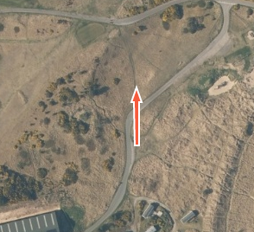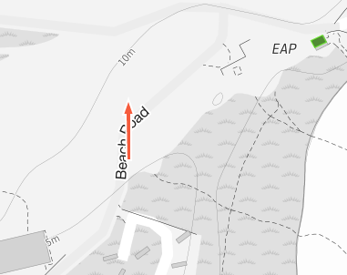
The difference in distance between the 2 locations is approximately 50 metres. In all other respects the proposal is identical. As a result, it is considered that this amendment is not a significant amendment and therefore, it will not trigger the requirement for a fresh consultation.

