**CONSULTATION on:-**

* **proposal to dispose, by sale, of approximately 49m² of land at 1 River Street, Dornoch, IV25 3LZ**
* **proposal to dispose, by sale, of 164 m² of land at 1 Well Street, Dornoch, IV25 3LU**

**What is proposed?**

This consultation document covers proposals in respect 2 small areas of land identified as forming part of Dornoch Common Good Fund.

1. **1 River Street, Dornoch**

It is proposed to dispose, by sale, of a small area of land measuring 49m² or thereby which will enable the correction of a conveyancing omission following the rerouting of River Street.

**Image 1 Image 2**

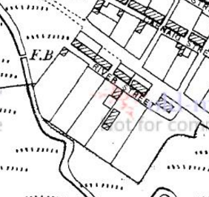 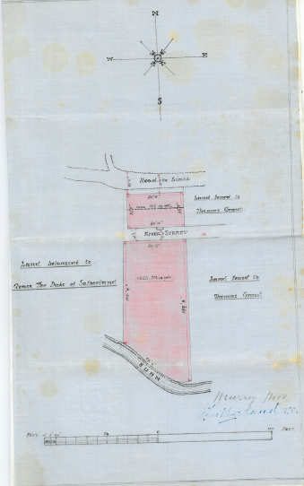

Image 1 shows the original location of River Street. Image 2 is the plan contained in the disposition by the Royal Burgh of Dornoch to the original purchasers in 1931. The property was sold in 2 parcels with River Street bisecting the land purchased.

At some point in the 1950’s/60’s River Street was rerouted to run to the north of the properties and the use of the original site of River Street as a road was discontinued – see image 3 below. This area of land fell into use as part of the properties concerned, but no conveyancing process occurred at the time to formalise the arrangement.

**Image 3 Image 4**

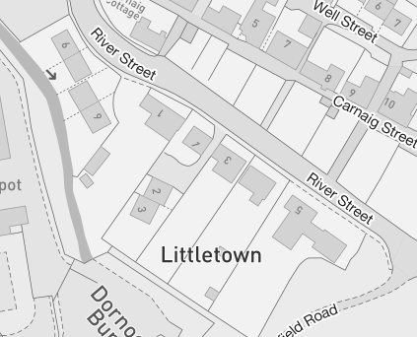 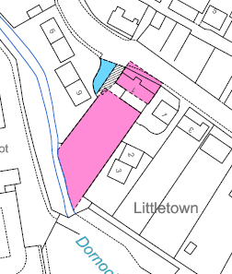

The property was purchased by the current owner in 1972 but that purchase did not address the issue of the land that had previously formed River Street. Image 4 is a composite plan produced by Registers of Scotland showing the current position with the white rectangle representing the area of land contained in this proposal.

The property is now part of an executory and the executors wish to transfer title to the property. When it became apparent that there was a deficit in the title, they asked the Council to consider disposal of the area of land in question to allow full title to be transferred.

When the property was originally sold in 1931 it was described as forming “part of the Burgh Lands of Dornoch” and, as a result, the area of land contained in this proposal has been assessed as now forming part of the Common Good of the former Royal Burgh of Dornoch.

The area of land in question measures 49m² or thereby and has been valued by the Council surveyor at £2000. Any sums received from the sale of this piece of land, if approved, would be paid into Dornoch Common Good Fund.

1. **1 Well Street, Dornoch**

It is proposed to dispose, by sale, of a small area of land measuring 164m² which is currently leased for use as a site for a domestic garage. See images below.

The current tenant has leased the land from Dornoch Common Good Fund for use as a garage site since 2007 with a lease term of 21 years at a rent of £60 per annum.

The tenant has asked the Council to consider the sale of the area of land currently being leased and this has been valued at £8,500 by the Council surveyor. Any sums received from the sale of this piece of land, if approved, would be paid into Dornoch Common Good Fund.

The land is part of the original Littletown land which is considered to be Common Good with title deriving from the original Royal Charter of 14 July 1628

**Image 1 – 2007 lease plan**

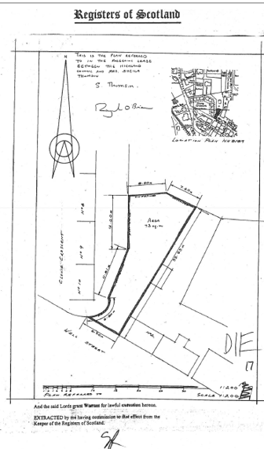

**Image 2 – modern plan** **Image 3 – aerial photograph**

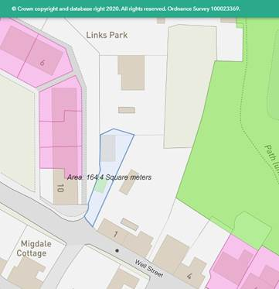 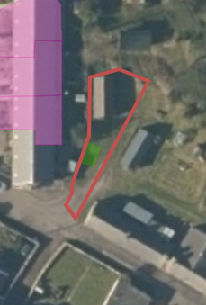

**Consultation**

Section 104 of the Community Empowerment (Scotland) Act 2015 requires the Council to consult local communities when considering disposing or changing the use of Common Good assets. Therefore, the consultation is seeking the views of the community in respect of both proposals to dispose by sale in order to inform the decision making process in each case.

**Key questions:**

* What are your views on the proposed disposal by sale of the areas at 1 River Street, Dornoch and 1 Well Street, Dornoch?
* Do you have any views on potential benefits of the proposals?
* Do you have any issues or concerns arising from the proposals?
* Do you have any additional comments?

The Council will take all representations into account in reaching a decision.

Depending on the representations received the possible outcomes are:

1. The proposal goes ahead.
2. The proposal is amended significantly, and a fresh consultation takes place.
3. The proposal does not go ahead.

**Representations**

Consultation closing date – **11 October 2021**

Please submit written representations to:-

Email: [common.good@highland.gov.uk](mailto:common.good@highland.gov.uk)

Post: Sara Murdoch, Highland Council, Headquarters, Glenurquhart Road, Inverness, IV3 5NX.

**Additional information**

The Highland Council have a statutory obligation to seek court consent before disposing of Common Good land which may be ‘inalienable’.

In this context ‘inalienable’ refers to Common Good property that falls into at least one of the following categories: -

* The Title Deed of the property dedicates it to a public purpose, or
* The Council has dedicated it to a public purpose, or
* The property has been used for public purposes for many years (time immemorial) without interference by the Council

In these cases, the use of the areas of land in question have been for private rather than public use. The Council does not consider that a question of alienability is raised in either case. As a result, in the event that the outcome of the consultation is to support disposal, the Council does not consider it will be necessary to also seek Sheriff Court approval.