CONSULTATION on:-
Proposal to dispose, by Community Asset Transfer lease, the area of Kingussie Common Good land known as Market Stance Playing Field, Ruthven Road, Kingussie, PH21 1EP to Kingussie Camanachd Club
What is proposed?
A disposal, by Community Asset Transfer lease, of 10,620m² or thereby of Common Good property located at Kingussie known as Market Stance Playing Field to Kingussie Camanachd Club. The extent of property included in the proposal is shown in the plans and images below.

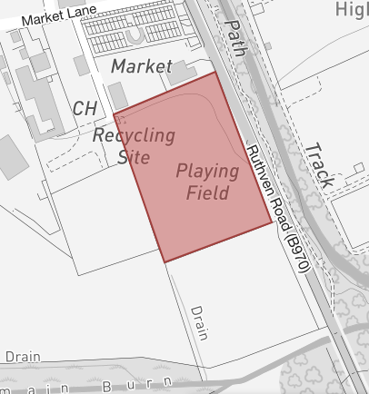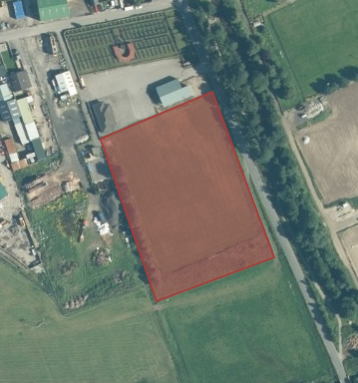

Background to the proposal
The Playing Field has been in a state of disrepair for more than a decade and, as a result, has been incapable of use.
The Market Stance Playing Field forms part and parcel of the land contained in the Feu Charter by the Trustee of James Evan Bruce Baillie (Nellie Lisa, Baroness Burton) to the Provost, Magistrates & Councillors of the Burgh of Kingussie recorded 23 January 1947. The land is subject to a condition that it is to be used as a Playing Field for the use of the inhabitants of the Burgh of Kingussie as well as for markets and travelling shows and for no other use without consent. As a result of investigations pursuant to section 102 Community Empowerment (Scotland) Act 2015, the Market Stance Playing Field has been identified as a Common Good asset of Kingussie.

Kingussie Camanachd Club are seeking to lead a project, on behalf of the whole community, to upgrade the Playing Field to a high standard including restorative ground works, fencing, portable goal posts and flood lights. The hope is that the Playing Field could accommodate a number of sports including shinty and football and be used for coaching and training as well as be available for use by the wider community. The Camanachd Club already own their clubhouse on land adjacent to the pitch which they consider puts them in the ideal location to assume responsibility for the renovation, maintenance, and management of the Market Stance Playing Field for the inhabitants of Kingussie both now and future generations.

The Camanachd Club propose using sponsorship money and income generated by use by other organisations towards ongoing maintenance but intend to submit funding applications in respect of the renovation and modernisations works required. The Club has asked that the Council consider a lease of 25 years under the Community Asset Transfer procedure contained in the Community Empowerment (Scotland) Act 2015 which would provide them with security of tenure and allow them to make the necessary funding applications.

Proposed terms for a lease have been discussed in the event that this proposal is supported. It would be proposed that the lease should be of 25 years duration at an annual rental of £1. The rental figure reflects the ongoing maintenance requirements, the fact it is a location without development potential and the continuing restriction that it be for sporting or recreational use only.

Consultation
The Community Asset Transfer (Lease) request has been subject to the required procedure pursuant to Part 5 of Community Empowerment (Scotland) Act 2015. This has been reported to Badenoch & Strathspey Area Committee on 9 August 2021 where Members approved the proposal in principle. However, as it is a Common Good asset it must also be subject to the requirement in section 104 of the Act to undertake a public consultation when considering disposing or changing the use of Common Good assets. This includes where the proposal is to grant a lease of over 10 years. Therefore, before taking any decision, and to inform the decision making process, we are keen to hear the views of the community, in particular:

- What are your views on the proposed disposal by Community Asset Transfer lease of this piece of Common Good land?
- Do you have any views on potential benefits of the proposal?
- Do you have any issues or concerns arising from the proposal?
- Do you have any additional comments?

The Council will take all representations into account in reaching a decision.

Depending on the representations received the possible outcomes are:
- The proposal goes ahead subject to consent being given by the Sheriff Court
- The proposal is amended significantly, and a fresh consultation takes place
- The proposal does not go ahead

Representations
Consultation closing date – 8 November 2021

Please submit written representations to:-
Email: common.good@highland.gov.uk
Post: Sara Murdoch, Highland Council, Headquarters, Glenurquhart Road, Inverness, IV3 5NX.

Additional information
The Highland Council have a statutory obligation to seek court consent before disposing of Common Good land which may be ‘inalienable’.

In this context ‘inalienable’ refers to Common Good property that falls into at least one of the following categories: -
- The Title Deed of the property dedicates it to a public purpose, or
- The Council has dedicated it to a public purpose, or
- The property has been used for public purposes for many years (time immemorial) without interference by the Council.

The piece of land that is the subject of this proposal derives its title from the Feu Charter by the Trustee of James Evan Bruce Baillie (Nellie Lisa, Baroness Burton) to the Provost, Magistrates & Councillors of the Burgh of Kingussie recorded 23 January 1947. It is subject to a condition that it is to be used as a Playing Field for the use of the inhabitants of the Burgh of Kingussie as well as for markets and travelling shows and for no other use without consent. As a result, it is considered that the Market Stance Playing Field is inalienable land.

Therefore, the proposed lease cannot be concluded until Sheriff Court consent has been obtained. If after this consultation, the proposal progresses to a court application the public will have a further opportunity to make representations within that process. A statutory advertisement will be placed in the Strathspey and Badenoch Herald to inform the local public that the court process has been commenced.

